DXL Quick Start Guide
  - Version 0.6 By LCPD15
DXL (DLSS eXtended Loader) expands on my previous RE DLSS5 Load Mod. It aims to make DLSS NR as easy as possible to enable across games. In supported games, it can use native motion vectors and work with frame generation for higher-quality results. Compatibility varies by game.
Previous mod on GitHub | Previous mod on Nexus Mods | DXL project

Install and start a game
1 Extract the complete release package and run DXL.exe. Keep all included files together.
2 Scan for installed games in Library, or use Add game to select the actual game EXE. Open its cover to check the path. Enter launch arguments only if the game requires them.
3 Start with Auto and choose Launch from tool. Alternatively, keep DXL and global monitoring on, then launch an added game through its platform or official launcher.
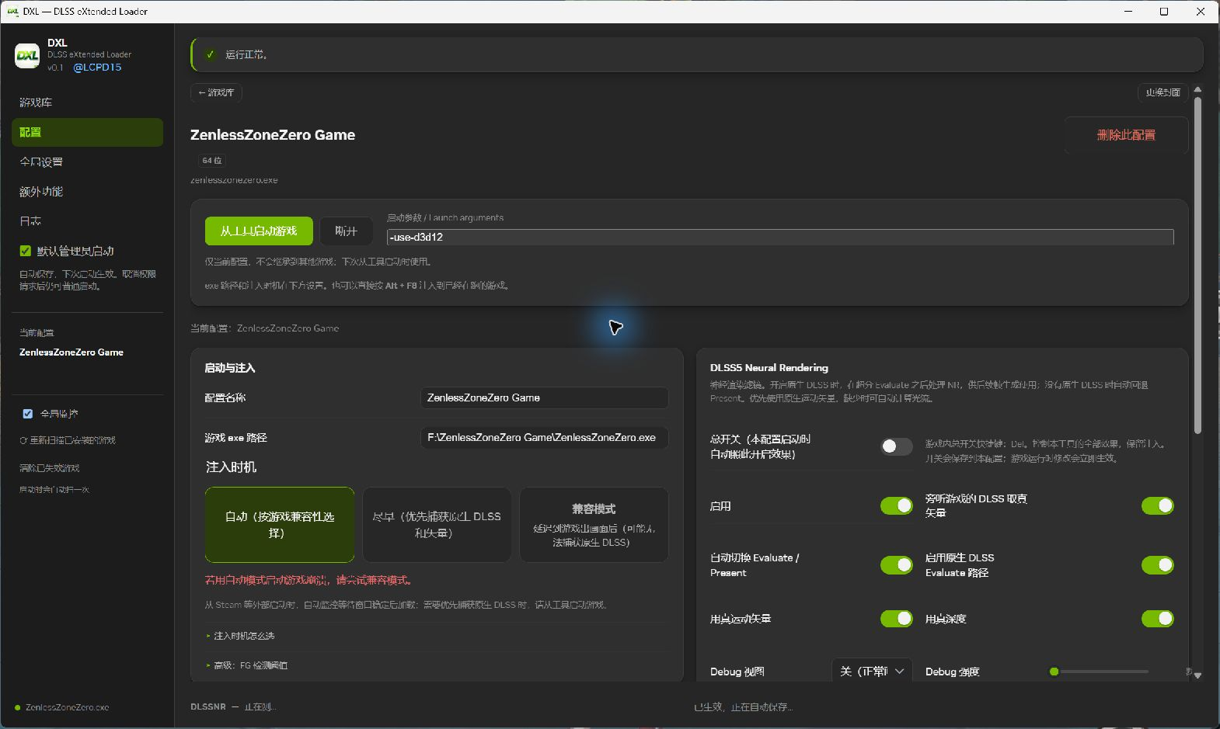
Launch from tool is the green button shown in this Chinese UI screenshot.
4 In the game, press Del to enable NR and End to open the panel. The master switch starts off for new profiles; your saved state is retained afterward. Parameters save automatically.

Game shortcuts
Del: toggle effects. End: toggle the panel. Alt + F8: try loading into the current game window. Esc or the panel’s × closes the panel. Change bindings in Global settings.
Injection timing, left to right: Auto, Early, Compatibility mode.
If loading has no effect or startup fails, exit the game and retry in Compatibility mode. This may miss native DLSS data. For frame generation, enable in-game DLSS upscaling and try Auto or Early first.

Adjust the NR effect
Press End, change one setting at a time in the same scene, then press Del to compare. Defaults below apply to new profiles.
Setting | Range and default | What it does
Intensity | 0–1 / 1 | Controls enhancement strength. Lowering it does not stop model computation.
Colour Strength | 0–1 / 1 | 0 retains original colour ratios while keeping NR brightness and detail; 1 keeps NR colours.
Style / Preset | Cinematic  Preset 0 | Compare Default, Natural and Cinematic styles. Leave the preset at its default to start.
Local Tone /  Local Structure | 0–2 / 1 | Adjust local tone response and structural enhancement separately.
Skin Strength | Panel: 0–1  Default: 0.6 | Adjusts skin-related structure. Higher is not always more natural.
NR Render Scale | 0.5–1 / 1 | Lowers NR processing resolution to save GPU time. Final game output resolution stays the same.
Self Layers | 1–3 continuous  Default: 1 | Amplifies the NR effect difference without extra model evaluations.
True NR Layers | 1–5 whole numbers  Default: 1 | Runs NR repeatedly in sequence, increasing GPU time and memory use.
Optical Flow | On by default  Balanced | Uses enabled, available native vectors first; otherwise estimates flow. Choose Performance, Balanced or Quality.

For better performance, set True NR Layers to 1 first, then lower NR Render Scale or flow quality. Leave Auto Mask and UI Correction at their defaults to start. Set Debug view to Off for normal viewing.

Semantic Mask is experimental
The complete package includes the recognition model. This feature starts off. Enable it, select categories such as People or Vehicles, then set their strength. Unselected objects use Background strength. Try Background 1 and People 0, and check alignment with Mask preview (R).
Strength ranges from 0 to 1. Mask feather defaults to 8 to soften edges. Recognition may be poor, especially for anime scenes, occlusion or small objects. Turn it off if it misidentifies objects or produces unnatural edges.

Color grading and filters
Press End and select Color Grading beside DLSSNR. Switches sit beside the values. Reset changes only the value, keeping the switch state. Settings are saved per game; disabled effects skip processing.

Basic adjustments
Exposure, contrast, saturation, temperature, tint, shadows, midtones and highlights adjust the game image. On the native SR route they usually run before game UI; later game exposure or tone mapping may affect them.

Final-image post-processing
LUTs, sharpening, bloom, vignette, film grain, monochrome and custom effects now process the final image, including game UI. They work independently of NR and its menu pauses when a safe presentation route is available; frame-generation safeguards still apply.
Sharpening and bloom strength range from 0 to 3. Expand Bloom details for Highlight threshold (0–2; default 0.65), Threshold softness (0–1; default 0.5), Glow radius (0.25–3; default 1), Scatter (0–1; default 0.7), and Glow saturation (0–2; default 1). These controls follow the bloom enable switch; each Reset restores only its value.

Using PNG LUTs
Put PNG lookup tables directly in the lut folder beside DXL.exe. Select a file in Color Grading, enable LUT and set its strength.
Neutral-16.png is a neutral template with no color change. Apply color-only edits in an image editor, then save under a new filename. Do not resize, crop, rotate or blur it. A normal photograph is not a LUT.
The template uses sixteen 16 by 16 tiles. See lut/README.md for supported layouts. Updates preserve added files; bundled examples may be replaced, so save edited copies under new names.
Open Extras > Post-processing. Add native ReShade .fx files with their .fxh includes and textures, keeping relative folders, then reload in Color Grading > Custom FX. Techniques have separate switches; parameters save per game and reset changes values only. DXL FX examples still work. DXL effects run first, then ReShade files alphabetically. Sources stay intact. Multi-pass effects and external textures work; game depth, motion vectors, add-ons and keyboard/mouse source uniforms are not provided. See post-processing/README.md for details.

