Report

I used pressure measurements taken from a vanEssen CTD Diver sensor and standard equations provided by manufacture to estimate depth of the sensor based on pressure measurements. The sensor was located at water quality station 3 as part of the Lone Cabbage oyster reef restoration project. I then compared these estimated depth measurements to the observed and predicted tidal fluctuations at the Cedar Key NOAA gauge (CDRF1) located approximately 10-km south. In general the amplitude of tidal change at the sensor is less than the observed and predicted tidal change at the Cedar Key gauge. Additionally, the sensor appears to experience low water (shallower depth) approximately 30-90 minutes later than the observations at the Cedar Key station.

## Elevation Formula as per Diver Sensor CTD Manual, below are the variables and equation specifics:

Ph= atmospheric pressure at elevation height at H  
P0= atmospheric pressure at reference height  
m= 28.8 *10^-3  
g= 9.81 m/s (standard gravity)  
R= 8.314 j/mol/k  
t= temperature in Kelvin  
H= height

Ph= P0*^- (M*g*H)/(R*T)

WQ 3 is -1.422m  
Cedar Key tide guage is at zero is -0.687

### January 1-2 2019

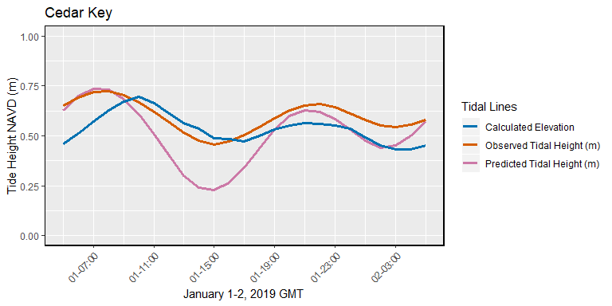

### February 1-2 2019

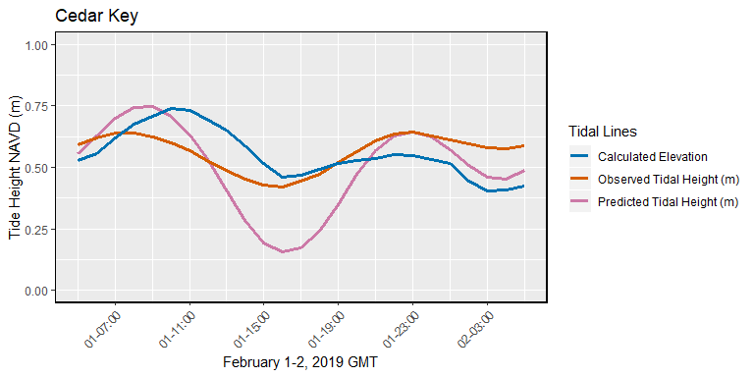

### March 1-2 2019

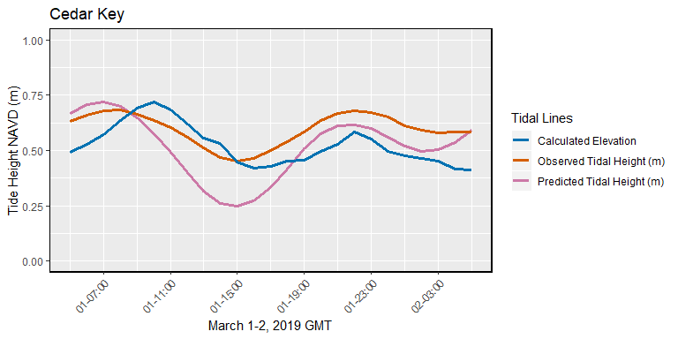

### April 1-2 2019

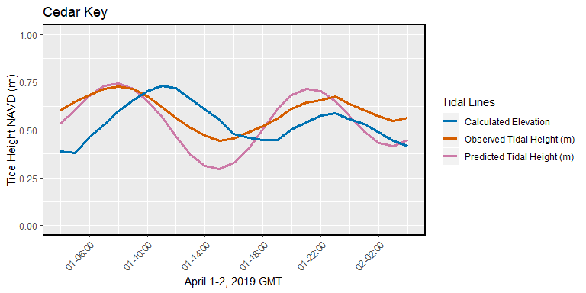

### April 29-30, 2019

