River Disharge Report

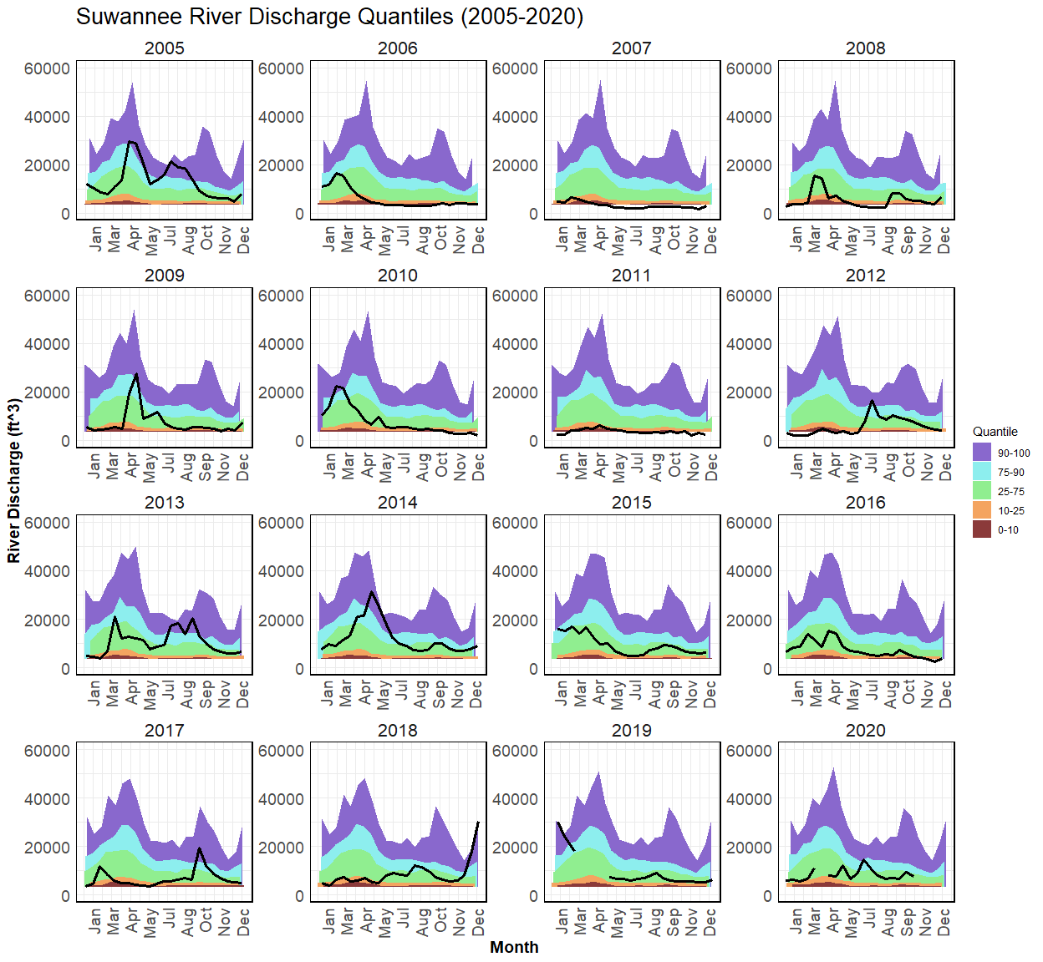

Figure 1- A percentile is a value on a scale of one hundred that indicates the percent of a distribution that is equal to or below it. For example, on the map of daily streamflow conditions a river discharge at the 90th percentile is equal to or greater than 90 percent of the discharge values recorded on this day of the year during all years that measurements have been made. In general,a percentile greater than 75 is considered above normal, a percentile between 25 and 75 is considered normal, and a percentile less than 25 is considered below normal. These data are retrieved via the waterData package in R made available by U.S. Geological Survey (USGS). These data are collected at the USGS 02323500 Suwannee River station near Wilcox, Florida. This site is located in Levy County, Florida (latitude 29.58968 and longitude -82.93651 in degrees). These data are from 2005 to 2020, all years separated.

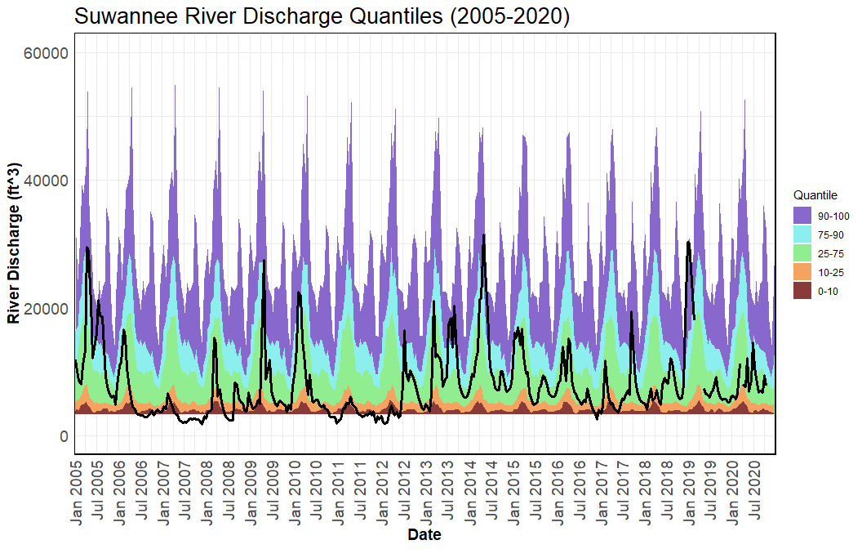

Figure 2- A percentile is a value on a scale of one hundred that indicates the percent of a distribution that is equal to or below it. For example, on the map of daily streamflow conditions a river discharge at the 90th percentile is equal to or greater than 90 percent of the discharge values recorded on this day of the year during all years that measurements have been made. In general,a percentile greater than 75 is considered above normal, a percentile between 25 and 75 is considered normal, and a percentile less than 25 is considered below normal. These data are retrieved via the waterData package in R made available by U.S. Geological Survey (USGS). These data are collected at the USGS 02323500 Suwannee River station near Wilcox, Florida. This site is located in Levy County, Florida (latitude 29.58968 and longitude -82.93651 in degrees). These data are from 2005 to 2020, all years together.

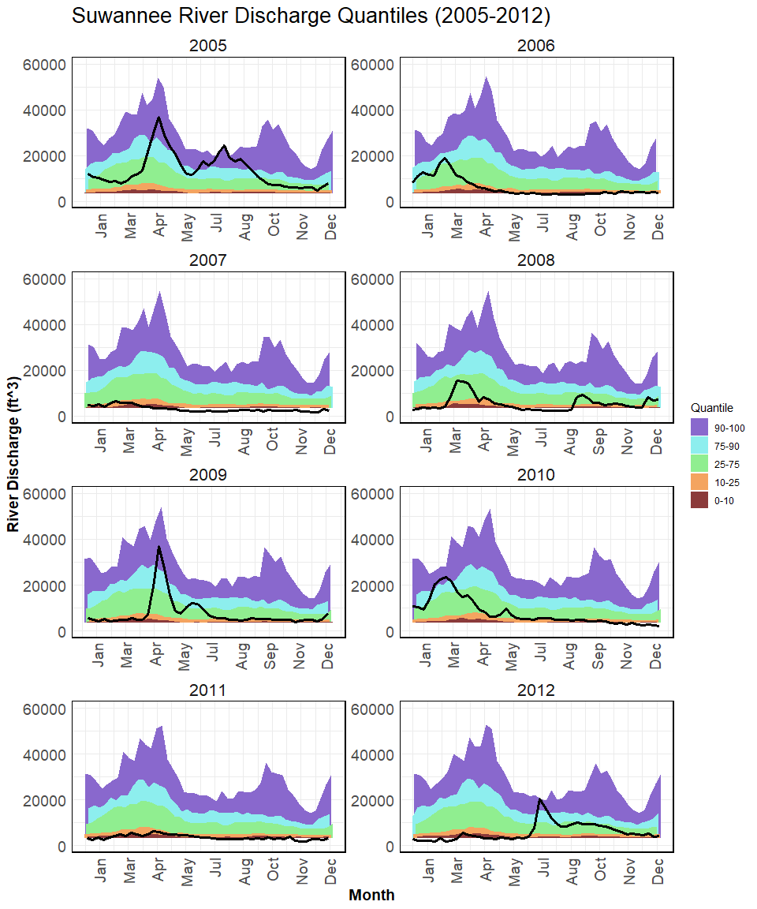

Figure 3- A percentile is a value on a scale of one hundred that indicates the percent of a distribution that is equal to or below it. For example, on the map of daily streamflow conditions a river discharge at the 90th percentile is equal to or greater than 90 percent of the discharge values recorded on this day of the year during all years that measurements have been made. In general,a percentile greater than 75 is considered above normal, a percentile between 25 and 75 is considered normal, and a percentile less than 25 is considered below normal. These data are retrieved via the waterData package in R made available by U.S. Geological Survey (USGS). These data are collected at the USGS 02323500 Suwannee River station near Wilcox, Florida. This site is located in Levy County, Florida (latitude 29.58968 and longitude -82.93651 in degrees). These data are from 2005 to 2012, all years separated.

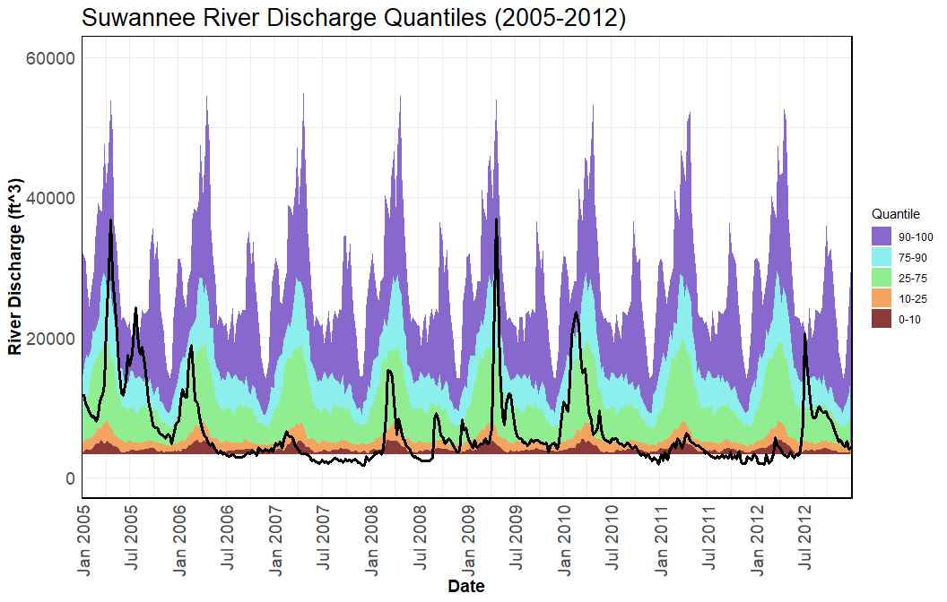

Figure 4- A percentile is a value on a scale of one hundred that indicates the percent of a distribution that is equal to or below it. For example, on the map of daily streamflow conditions a river discharge at the 90th percentile is equal to or greater than 90 percent of the discharge values recorded on this day of the year during all years that measurements have been made. In general,a percentile greater than 75 is considered above normal, a percentile between 25 and 75 is considered normal, and a percentile less than 25 is considered below normal. These data are retrieved via the waterData package in R made available by U.S. Geological Survey (USGS). These data are collected at the USGS 02323500 Suwannee River station near Wilcox, Florida. This site is located in Levy County, Florida (latitude 29.58968 and longitude -82.93651 in degrees). These data are from 2005 to 2012, all years together.

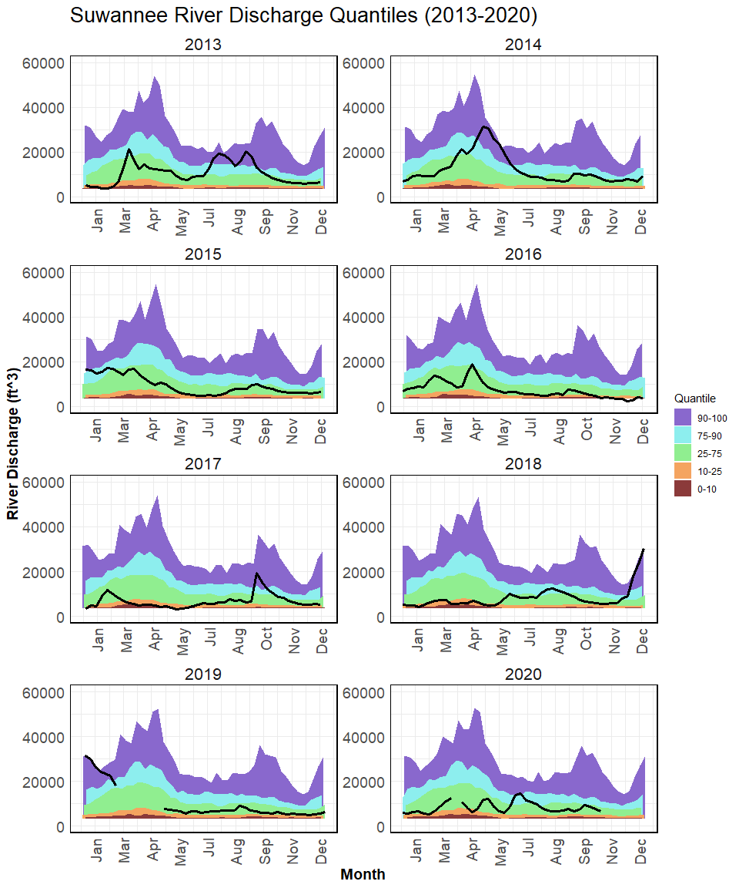

Figure 5- A percentile is a value on a scale of one hundred that indicates the percent of a distribution that is equal to or below it. For example, on the map of daily streamflow conditions a river discharge at the 90th percentile is equal to or greater than 90 percent of the discharge values recorded on this day of the year during all years that measurements have been made. In general,a percentile greater than 75 is considered above normal, a percentile between 25 and 75 is considered normal, and a percentile less than 25 is considered below normal. These data are retrieved via the waterData package in R made available by U.S. Geological Survey (USGS). These data are collected at the USGS 02323500 Suwannee River station near Wilcox, Florida. This site is located in Levy County, Florida (latitude 29.58968 and longitude -82.93651 in degrees). These data are from 2013 to 2020, all years separated.

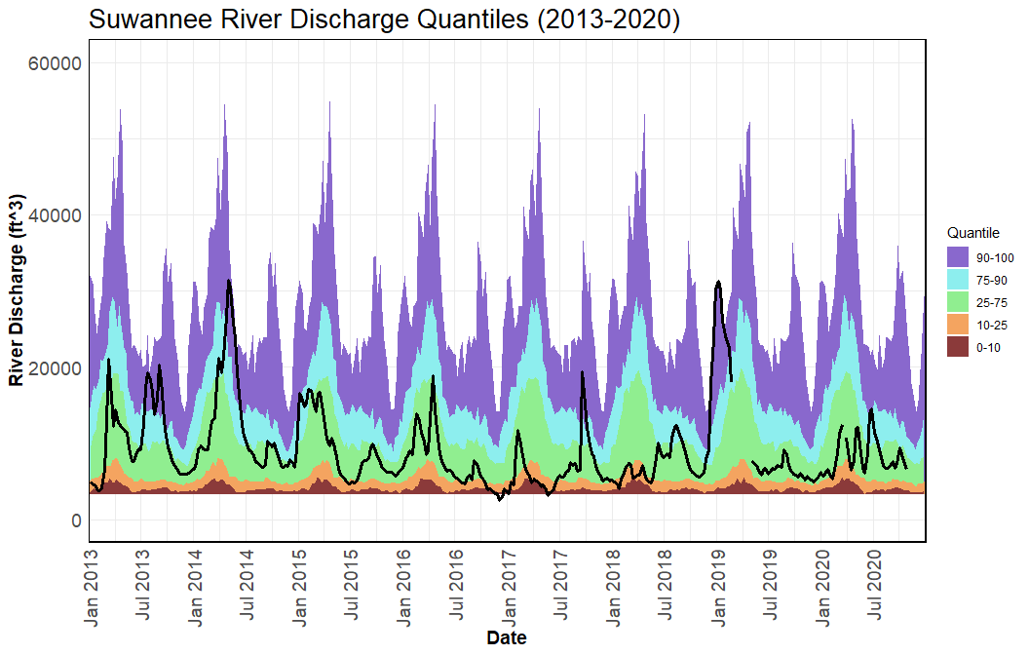

Figure 6- A percentile is a value on a scale of one hundred that indicates the percent of a distribution that is equal to or below it. For example, on the map of daily streamflow conditions a river discharge at the 90th percentile is equal to or greater than 90 percent of the discharge values recorded on this day of the year during all years that measurements have been made. In general,a percentile greater than 75 is considered above normal, a percentile between 25 and 75 is considered normal, and a percentile less than 25 is considered below normal. These data are retrieved via the waterData package in R made available by U.S. Geological Survey (USGS). These data are collected at the USGS 02323500 Suwannee River station near Wilcox, Florida. This site is located in Levy County, Florida (latitude 29.58968 and longitude -82.93651 in degrees). These data are from 2013 to 2020, all years together.