April 13, 2021

Jennifer Moore and Bill Pine

Analysis of the subtidal oyster data collected via tonging

*Background*

Subtidal oyster counts data were collected pre-harvest season on August 25 and 26, 2021. These data were collected by 5 vessels driven by: George Stevens, Gerald Allen, Jeanine Beckman, Jerald Beckham, and Jordan Adam. Each of the 5 vessels visited anywhere from 3 to 6 stations for sampling, with an average of 4.2 (sd = 1.10) stations per vessel. In total 17 stations were visited over these 2 days, with each station visited by between 1 and 4 vessels, with the majority of sites visited by a single vessel. Stations include one Lone Cabbage offshore site (LCO1001), 6 Lone Cabbage inshore sites (LCI1001-LCI1006), 6 Corrigan’s Reef nearshore sites (CRN1001-1006), and 3 Corrigan’s Reef offshore sites (CRO1001-1003). At each station the same crew member used tongs to take a single “lick” or grab sample with the tong and then transfer the contents to the cull board where oysters were sorted to size categories (1”, 2”- 3”, 3+”, nominal sizes familiar to commercial fishermen from harvest regulations, plus reference size sticks were provided for culling board) and counted by size category. The tong user would stand in the same spot on the boat each lick of the tongs, which essentially would create a removal effect of oysters in the area where the tong licks were removing oyster biomass. The boat operator was told to stay at a location until, if this were a normal fishing day, they would move to a different spot to mimic normal oyster fishing behavior.

*Analysis*

For each station, we plotted the mean oyster count averaged across all vessels (if multiple vessels sampled the same station) per lick (Figure 1). Only 2 stations – LCO1001 and CRN1001 – were sampled by multiple vessels. The mean counts show that there are similar oyster counts across the licks surveyed within a station. Additionally, at the majority of the sites, the lowest counts were for oysters of size class 3 (>3 inches), with the highest counts for either size class 1 (< 1 inch) or size class 2 (1-3 inches). The exception being sites LCI1001, LCI1001, and LCI1006 which had very few oysters in size class 1. Station LCI1003 is the only site with the fewest oysters in size class 2. Boats generally stayed at one location across all licks because oyster catch per lick was high enough to warrant continued fishing effort.

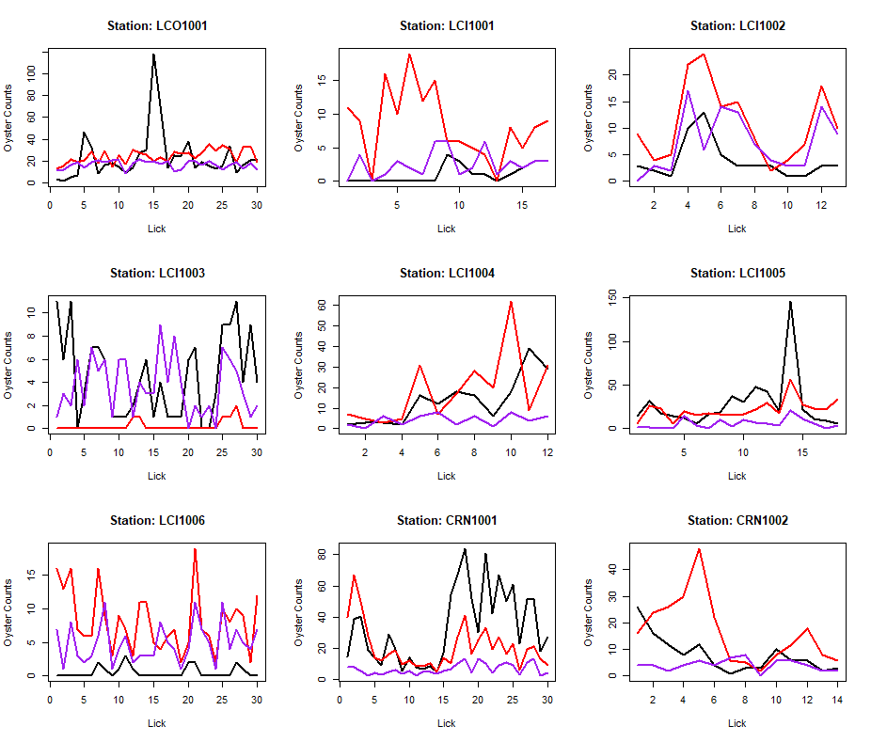

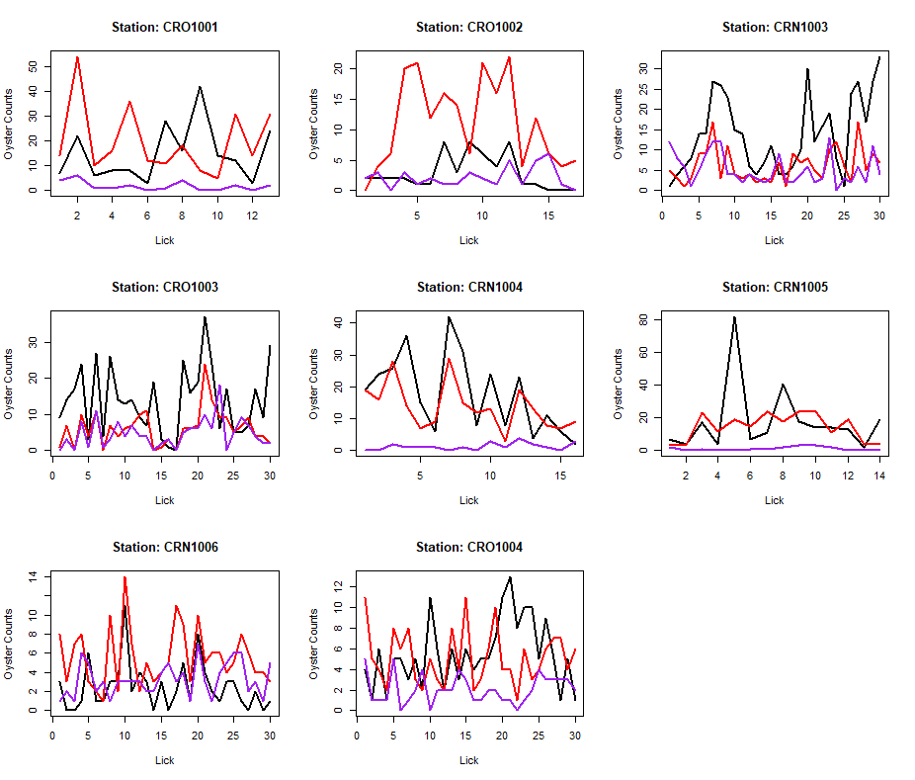

Figure : Mean number of oysters within each size class at each station per lick. Black lines correspond to oysters in size class 1 (< 1 inch), red lines correspond to oysters in size class 2 (1-3 inches), and purple lines correspond to oysters in size class 3 (> 3 inches).

We also plotted the cumulative counts per size class by lick for each station. If a station was visited by multiple vessels (LCO1001 and CRN1001) the counts were summed across all vessels for each lick. In 8 of the stations, the cumulative total oyster count was highest for size class 1 (< 1 inch) oysters. In 9 of the stations, oyster count was highest for size class 2 (1-3 inches) oysters. None of the stations had the highest oyster count for size class 3 (>3 inches) oysters. The cumulative plots are also a simple way to assess removal effects. If oyster biomass was depleted from a location after cumulative licks, we would expect an asymptote in the plot of cumulative removals. This asymptotic pattern is not evident at each of the stations or across vessels.

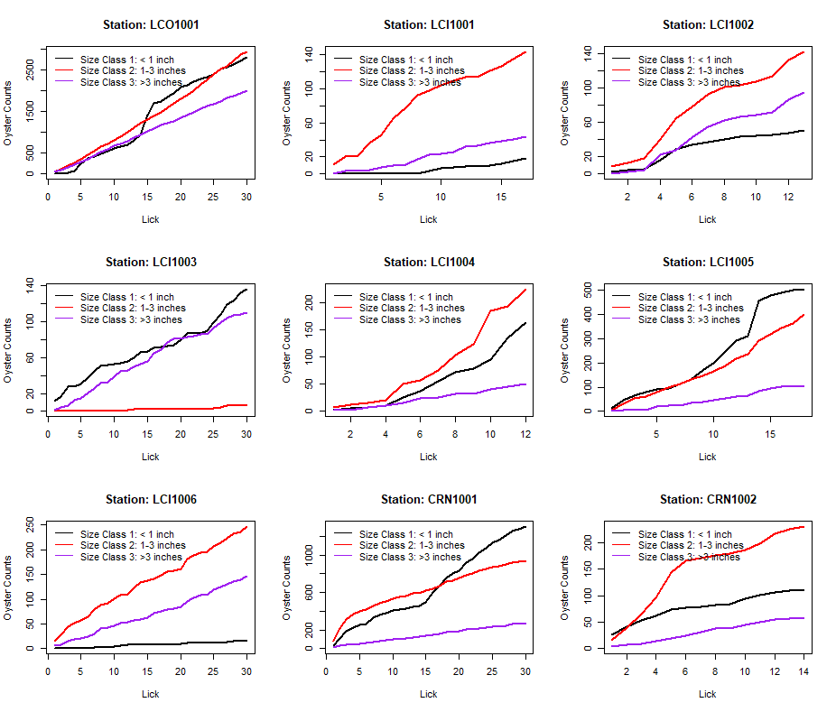

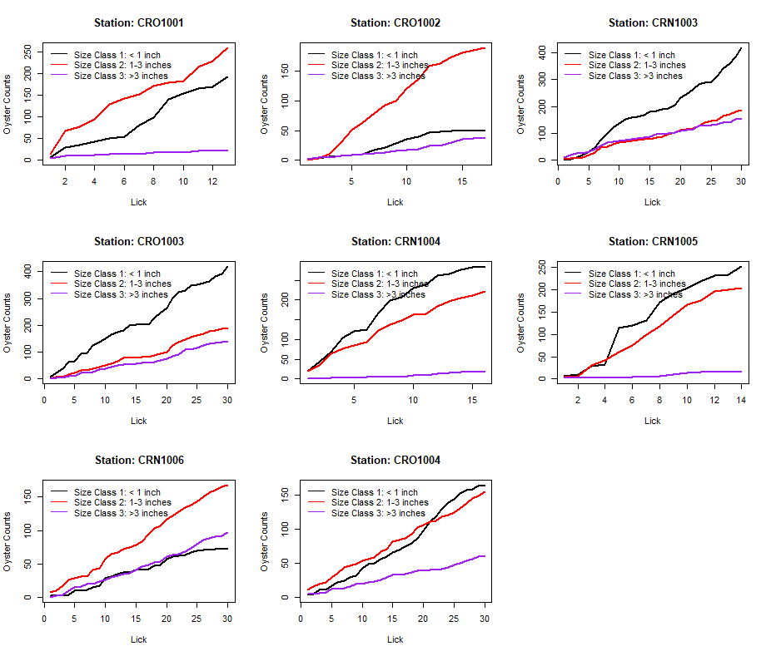

Figure : Cumulative oyster counts by oyster size class by station. Black lines correspond to oysters in size class 1 (< 1 inch), red lines correspond to oysters in size class 2 (1-3 inches), and purple lines correspond to oysters in size class 3 (> 3 inches).

*Discussion and Next-Steps*

This sampling should be conducted again post-season to compare counts between pre and post season to look for any difference in total counts between size classes or a change in the removal pattern. If post-season plots of cumulative oyster counts decline with increasing number of tong licks, this would suggest lower oyster counts for a given location than observed pre-season. One concern is that oysters may have recruited and grown into each size class during the open harvest season. This is essentially a violation of a closure type assumption for the population. However, a repeated sampling effort may still show differences pre and post-season that could be indicative of either fishery removals or natural mortality over this time period.

Data and code are found in this Github repository: <https://github.com/LCRoysterproject/oys_bb_subtidal_summary>