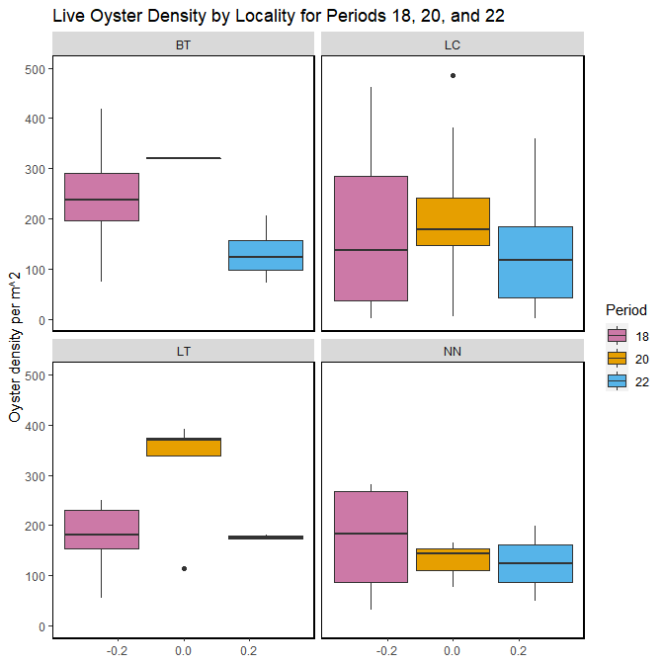 Figure- Calculated live oyster density by locality for periods 18 (Winter 2018-2019), 20 (Winter 2019-2020) and 22 (Winter 2020-2021) with the last sample date of period 22 as 2021-01-30.

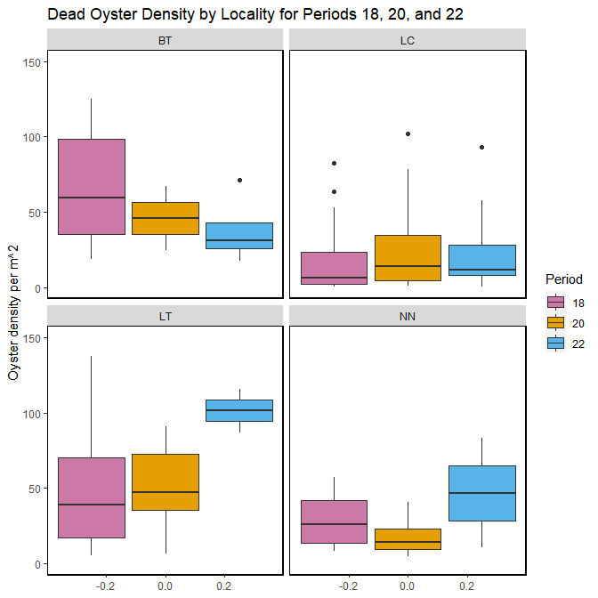 Figure- Calculated dead oyster density by locality for periods 18 (Winter 2018-2019), 20 (Winter 2019-2020) and 22 (Winter 2020-2021) with the last sample date of period 22 as 2021-01-30.

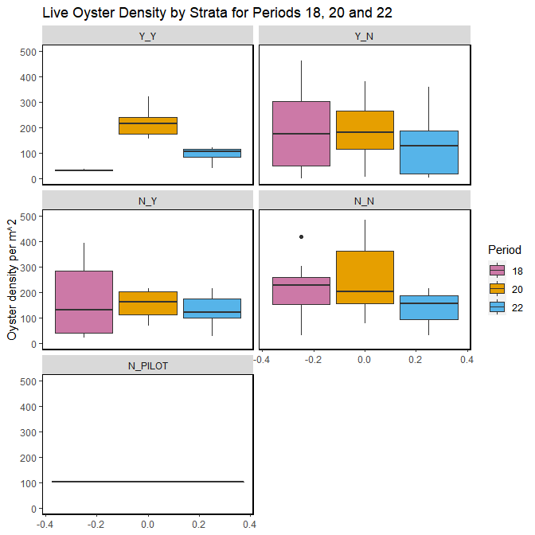 Figure- Calculated live oyster density by strata for periods 18 (Winter 2018-2019), 20 (Winter 2019-2020) and 22 (Winter 2020-2021) with the last sample date of period 22 as 2021-01-30.

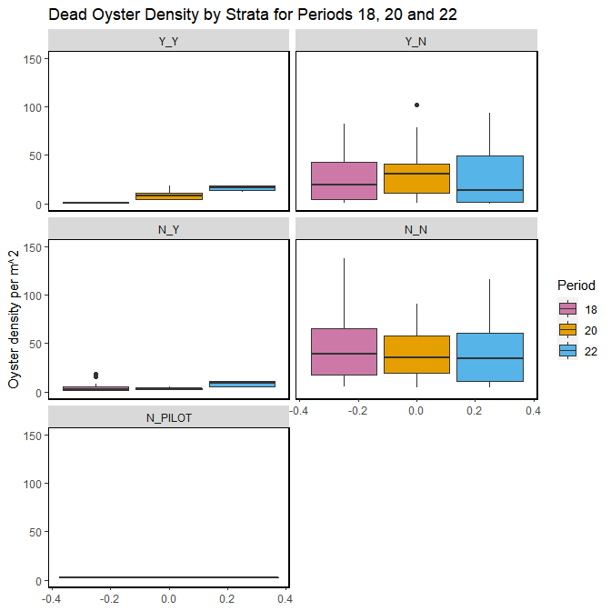 Figure- Calculated dead oyster density by strata for periods 18 (Winter 2018-2019), 20 (Winter 2019-2020) and 22 (Winter 2020-2021) with the last sample date of period 22 as 2021-01-30.