October 7, 2019

Jennifer Moore

Power analyses to estimate necessary sample size to detect differences between treatment (rocks) and non-treatment (no rocks) sites.

Take home: At least 14 treatment (rocks) and 26 non-treatment (no rocks; 40 total sites) sites should be sampled to have an average margin of error less than 25%. This corresponds to on average about 1809 meters surveyed.

Next steps will be to re-do these analyses over all strata instead of just rocks/no rocks to figure out suggested sample size for all strata.

These analyses use data collected from Winter 2017 to Summer 2019 (Table 1). The total number of transects sampled during this period was 77 (Table 2), with counts ranging from 64 to 3678 in rock sites, and 4 to 3988 in no rock sites. The average length of a transect in rock sites was 75 meters versus only 29 meters in non-rock sites (Table 3). This is important to note because the total number of transects walked needs to be multipled by these lengths to get a total number of meters that should be walked for treatment and non-treatment sites.

Table 1: Data table of the winter 2017-2019 data from the “collapsed” transects (data1 from data processing script). A transect is a collapsed transect when multiple transects on an individual bar are pooled, even if collected across multiple days. rocksBin is a binary variable representing whether the transect did or did not have rocks (i.e., treatment)

|  |  |  |  |  |  |  |  |  |  |  |  |  |  |
| --- | --- | --- | --- | --- | --- | --- | --- | --- | --- | --- | --- | --- | --- |
| X | year | season | period | treatment | station | count_live | tran_length | Area | density | strata | fishing | rocks | rocksBin |
| 1 | 2017 | winter | 14 | control | LCO10A | 79 | 66 | 10.06 | 7.85 | N_LG | N | LG | Y |
| 2 | 2017 | winter | 14 | control | LCO9C | 409 | 66 | 10.06 | 40.66 | N_LG | N | LG | Y |
| 3 | 2017 | winter | 14 | rocks | LCO10B | 1294 | 66 | 10.06 | 128.65 | N_LG | N | LG | Y |
| 4 | 2017 | winter | 14 | rocks | LCO11A | 1092 | 66 | 10.06 | 108.57 | N_LG | N | LG | Y |
| 5 | 2017 | winter | 14 | rocks | LCO11B | 64 | 66 | 10.06 | 6.36 | N_LG | N | LG | Y |
| 6 | 2017 | winter | 14 | rocks | LCO12 | 134 | 66 | 10.06 | 13.32 | N_LG | N | LG | Y |
| 7 | 2017 | winter | 14 | rocks | LCO8B | 322 | 66 | 10.06 | 32.01 | N_LG | N | LG | Y |
| 8 | 2017 | winter | 14 | rocks | LCO9A | 556 | 66 | 10.06 | 55.28 | N_LG | N | LG | Y |
| 9 | 2018 | winter | 16 | control | BTI1 | 897 | 23 | 3.51 | 255.91 | N_NA | N | NA | N |
| 10 | 2018 | winter | 16 | control | BTI2 | 1108 | 38.65 | 5.89 | 188.11 | N_NA | N | NA | N |
| 11 | 2018 | winter | 16 | control | BTI3 | 1326 | 39.9 | 6.08 | 218.06 | N_NA | N | NA | N |
| 12 | 2018 | winter | 16 | control | BTI4 | 628 | 55.8 | 8.5 | 73.79 | N_NA | N | NA | N |
| 13 | 2018 | winter | 16 | control | BTI5 | 3988 | 62.69 | 9.55 | 417.42 | N_NA | N | NA | N |
| 14 | 2018 | winter | 16 | control | LCN4 | 35 | 22 | 3.35 | 10.44 | Y_NA | Y | NA | N |
| 15 | 2018 | winter | 16 | control | LCN8 | 58 | 17.5 | 2.67 | 21.75 | Y_NA | Y | NA | N |
| 16 | 2018 | winter | 16 | control | LTI1 | 692 | 29.8 | 4.54 | 152.37 | N_NA | N | NA | N |
| 17 | 2018 | winter | 16 | control | LTI2 | 190 | 22.68 | 3.46 | 54.97 | N_NA | N | NA | N |
| 18 | 2018 | winter | 16 | control | LTI3 | 883 | 37.5 | 5.71 | 154.51 | N_NA | N | NA | N |
| 19 | 2018 | winter | 16 | control | LTI4 | 1323 | 34.84 | 5.31 | 249.17 | N_NA | N | NA | N |
| 20 | 2018 | winter | 16 | control | LTI5 | 1412 | 38.75 | 5.91 | 239.1 | N_NA | N | NA | N |
| 21 | 2018 | winter | 16 | control | LTI6 | 594 | 18.87 | 2.88 | 206.55 | N_NA | N | NA | N |
| 22 | 2018 | winter | 16 | control | NNI2 | 911 | 22.85 | 3.48 | 261.61 | N_NA | N | NA | N |
| 23 | 2018 | winter | 16 | control | NNI3 | 156 | 33 | 5.03 | 31.02 | N_NA | N | NA | N |
| 24 | 2018 | winter | 16 | control | NNI4 | 571 | 13.3 | 2.03 | 281.71 | N_NA | N | NA | N |
| 25 | 2018 | winter | 16 | rocks | LCO10A | 1619 | 113.4 | 17.28 | 93.68 | N_LG | N | LG | Y |
| 26 | 2018 | winter | 16 | rocks | LCO11B | 276 | 66.77 | 10.18 | 27.12 | N_LG | N | LG | Y |
| 27 | 2018 | winter | 16 | rocks | LCO12 | 358 | 111.86 | 17.05 | 21.03 | N_LG | N | LG | Y |
| 28 | 2018 | winter | 16 | rocks | LCO14 | 3060 | 70.11 | 10.68 | 286.44 | N_SM | N | SM | Y |
| 29 | 2018 | winter | 16 | rocks | LCO9C | 1161 | 111.2 | 16.95 | 68.51 | N_LG | N | LG | Y |
| 30 | 2019 | winter | 16 | control | BTI6 | 816 | 17.75 | 2.71 | 301.47 | N_NA | N | NA | N |
| 31 | 2019 | winter | 16 | control | LCI1 | 1650 | 45.39 | 6.92 | 238.53 | N_NA | N | NA | N |
| 32 | 2019 | winter | 16 | control | LCI10 | 1686 | 38.2 | 5.82 | 289.61 | Y_NA | Y | NA | N |
| 33 | 2019 | winter | 16 | control | LCI11 | 302 | 17.86 | 2.72 | 110.95 | Y_NA | Y | NA | N |
| 34 | 2019 | winter | 16 | control | LCI12 | 1106 | 36.09 | 5.5 | 201.09 | Y_NA | Y | NA | N |
| 35 | 2019 | winter | 16 | control | LCI13 | 3422 | 71.3 | 10.87 | 314.88 | Y_NA | Y | NA | N |
| 36 | 2019 | winter | 16 | control | LCI14 | 1501 | 22.75 | 3.47 | 432.93 | Y_NA | Y | NA | N |
| 37 | 2019 | winter | 16 | control | LCI15 | 638 | 20.8 | 3.17 | 201.27 | Y_NA | Y | NA | N |
| 38 | 2019 | winter | 16 | control | LCI16 | 428 | 24.04 | 3.66 | 116.69 | Y_NA | Y | NA | N |
| 39 | 2019 | winter | 16 | control | LCI17 | 189 | 14.65 | 2.23 | 84.65 | Y_NA | Y | NA | N |
| 40 | 2019 | winter | 16 | control | LCI18 | 1813 | 68.16 | 10.39 | 174.54 | Y_NA | Y | NA | N |
| 41 | 2019 | winter | 16 | control | LCI19 | 153 | 22.21 | 3.38 | 45.2 | Y_NA | Y | NA | N |
| 42 | 2019 | winter | 16 | control | LCI2 | 1534 | 32.2 | 4.91 | 312.6 | Y_NA | Y | NA | N |
| 43 | 2019 | winter | 16 | control | LCI3 | 1104 | 23.8 | 3.63 | 304.37 | Y_NA | Y | NA | N |
| 44 | 2019 | winter | 16 | control | LCI4 | 1909 | 22.5 | 3.43 | 556.72 | Y_NA | Y | NA | N |
| 45 | 2019 | winter | 16 | control | LCI5 | 942 | 20.4 | 3.11 | 303 | Y_NA | Y | NA | N |
| 46 | 2019 | winter | 16 | control | LCI6 | 454 | 21.5 | 3.28 | 138.56 | Y_NA | Y | NA | N |
| 47 | 2019 | winter | 16 | control | LCI7 | 853 | 21.66 | 3.3 | 258.41 | N_NA | N | NA | N |
| 48 | 2019 | winter | 16 | control | LCI8 | 96 | 19 | 2.9 | 33.15 | Y_NA | Y | NA | N |
| 49 | 2019 | winter | 16 | control | LCI9 | 695 | 22.24 | 3.39 | 205.05 | Y_NA | Y | NA | N |
| 50 | 2019 | winter | 16 | control | LCN1 | 109 | 29.86 | 4.55 | 23.95 | Y_NA | Y | NA | N |
| 51 | 2019 | winter | 16 | control | LCN2 | 693 | 32.77 | 4.99 | 138.76 | Y_NA | Y | NA | N |
| 52 | 2019 | winter | 16 | control | LCN3 | 146 | 19.9 | 3.03 | 48.14 | Y_NA | Y | NA | N |
| 53 | 2019 | winter | 16 | control | LCN5 | 700 | 21.75 | 3.31 | 211.18 | Y_NA | Y | NA | N |
| 54 | 2019 | winter | 16 | control | LCN6 | 2275 | 32.4 | 4.94 | 460.74 | Y_NA | Y | NA | N |
| 55 | 2019 | winter | 16 | control | LCN7 | 611 | 13.3 | 2.03 | 301.44 | Y_NA | Y | NA | N |
| 56 | 2019 | winter | 16 | control | LCN9 | 4 | 36.12 | 5.5 | 0.73 | Y_NA | Y | NA | N |
| 57 | 2019 | winter | 16 | control | NNI1 | 234 | 14.5 | 2.21 | 105.67 | N_NA | N | NA | N |
| 58 | 2019 | winter | 16 | rocks | LCO13 | 3678 | 62.55 | 9.53 | 385.83 | N_SM | N | SM | Y |
| 59 | 2019 | winter | 16 | rocks | LCO15 | 3390 | 169.84 | 25.88 | 130.99 | N_SM | N | SM | Y |
| 60 | 2019 | winter | 16 | rocks | LCO16 | 302 | 68.91 | 10.5 | 28.71 | N_SM | N | SM | Y |
| 61 | 2019 | winter | 16 | rocks | LCO17 | 209 | 45.37 | 6.91 | 30.23 | Y_SM | Y | SM | Y |
| 62 | 2019 | winter | 16 | rocks | LCO19 | 558 | 116.31 | 17.73 | 31.45 | Y_SM | Y | SM | Y |
| 63 | 2019 | winter | 16 | rocks | LCO2 | 945 | 20.86 | 3.18 | 297.26 | N_LG | N | LG | Y |
| 64 | 2019 | winter | 16 | rocks | LCO20 | 385 | 87.12 | 13.28 | 29 | Y_SM | Y | SM | Y |
| 65 | 2019 | winter | 16 | rocks | LCO21 | 714 | 129.01 | 19.66 | 36.32 | Y_SM | Y | SM | Y |
| 66 | 2019 | winter | 16 | rocks | LCO3 | 358 | 18.02 | 2.75 | 130.36 | N_LG | N | LG | Y |
| 67 | 2019 | winter | 16 | rocks | LCO4 | 953 | 22.1 | 3.37 | 282.95 | N_LG | N | LG | Y |
| 68 | 2019 | winter | 16 | rocks | LCO8A | 319 | 15.2 | 2.32 | 137.71 | N_LG | N | LG | Y |
| 69 | 2019 | winter | 16 | rocks | LCO9B | 674 | 115.78 | 17.64 | 38.23 | N_LG | N | LG | Y |
| 70 | 2019 | summer | 17 | control | LCI1 | 1289 | 19.75 | 3.01 | 428.25 | N_NA | N | NA | N |
| 71 | 2019 | summer | 17 | control | LCI2 | 1278 | 32.1 | 4.89 | 261.24 | Y_NA | Y | NA | N |
| 72 | 2019 | summer | 17 | control | LCI3 | 1157 | 23.6 | 3.6 | 321.69 | Y_NA | Y | NA | N |
| 73 | 2019 | summer | 17 | control | LCN1 | 24 | 29.75 | 4.53 | 5.29 | Y_NA | Y | NA | N |
| 74 | 2019 | summer | 17 | control | LCN2 | 455 | 32.8 | 5 | 91.02 | Y_NA | Y | NA | N |
| 75 | 2019 | summer | 17 | control | LCN3 | 74 | 19.9 | 3.03 | 24.4 | Y_NA | Y | NA | N |
| 76 | 2019 | summer | 17 | control | LCN6 | 1597 | 32.4 | 4.94 | 323.43 | Y_NA | Y | NA | N |
| 77 | 2019 | summer | 17 | control | LCN9 | 19 | 36.1 | 5.5 | 3.45 | Y_NA | Y | NA | N |

Table 2. Number of transects sample for treatment (rocks) and non-treatment (no rocks) sites each year.

|  |  |  |
| --- | --- | --- |
| **Sampling Period** | **Number of Transects (total length)**  **Treatment (rocks)** | **Number of transects (total length)**  **Non-treatment (no rocks)** |
| Winter 2017 | 0 | 8 (528) |
| Winter 2018-2019 | 44 (1294.23) | 17 (1344.41) |
| Summer 2019 | 8 (226.4) | 0 |

Table 3. Mean length (m) of collapsed transect.

|  |  |
| --- | --- |
| **Strata** | **Mean transect length (m)** |
| Rocks | 74.90 |
| No Rocks | 29.24 |

For the power analyes, we are interested in the total number of sites with and without rocks that need to be sampled. We decide how many sites to sample based on the precision of the coefficient estimate for the treatment (rocks/no rocks) in terms of the confidence interval (CI) width as per the example in Johnson et al. 2015. As suggested in this paper, we use a cutoff of a margin of error of 25%, with the margin of error calculated as the average distance from the 95% confidence limits to the estimate.

We ran 100 simulations for each combination of sample sizes between 10 and 100 for both rock and non-rock sites. This leads to 8281 possible combinations of sample sizes. If we want all 100 simulations to fall below the cutoff margin of error of 25%, our top scenario would be 54 rock sites and 98 non-rock sites for a total of 6910.12 meters (Table 3; Figure 1). However, this number is not logistically feasible in the field (last year about 2600 m were surveyed).

Table 4. Combination of sampling sizes for rock and non-rock sites with a maximum margin of error of less than 25% over all 100 simulations.

|  |  |  |  |  |
| --- | --- | --- | --- | --- |
| Rock Sites | Total Transect Length | Non-Rock Sites | Total Transect Length | Total Transect Length Combined |
| 54 | 54*74.90 = 4044.6 | 98 | 98*29.24 = 2865.52 | 6910.12 |
| 66 | 66*74.90 = 4943.4 | 88 | 88*29.24 = 2573.12 | 7516.52 |
| 86 | 86*74.90 = 6441.4 | 46 | 46*29.24 = 1345.04 | 7786.44 |

Figure 1. Maximum margin of error for all 100 simulations given a range of sample sizes for rock and non-rock sites. Squares in red have margin of error less than 25%.

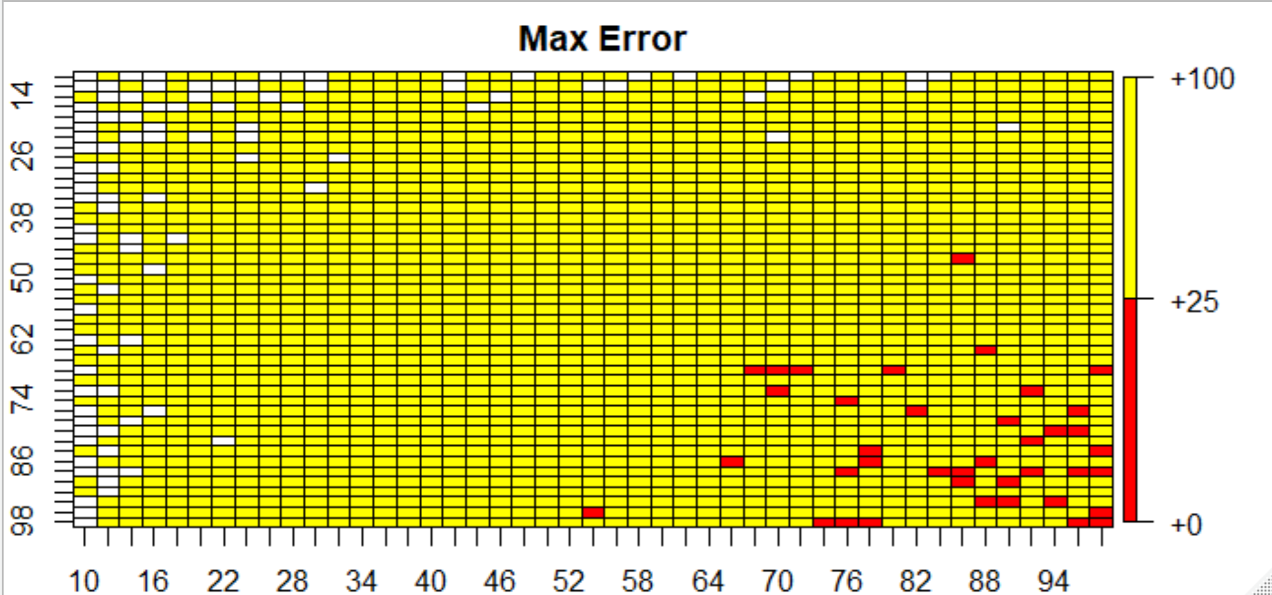

Next, we took the average margin of error over the 100 simulations, and looked for sampling site combinations with the average less than 25%. With this criteria, the top scenario would be sampling 14 rock sites and 26 non-rock sites for a total of 1808.84 meters. This scenario is feasible based on the distance surveyed last year. If we want to sample more sites than this, the next scenario would be to survey 16 rock sites and 58 non-rock sites for a total average distance of 2894.32 meters. This is a little higher than the distance surveyed in the past year.

Table 5. Combination of sampling sizes for rock and non-rock sites with an average margin of error of less than 25% over the 100 simulations.

|  |  |  |  |  |
| --- | --- | --- | --- | --- |
| Rock Sites | Total Transect Length | Non-Rock Sites | Total Transect Length | Total Transect Length Combined |
| 14 | 14*74.90 = 1048.6 | 26 | 26*29.24 = 760.24 | 1808.84 |
| 16 | 16*74.90 = 1198.4 | 58 | 58*29.24 = 1695.92 | 2894.32 |
| 68 | 68*74.90 = 5093.2 | 16 | 16*29.24 = 467.84 | 5561.04 |

Figure 2. Average margin of error for all 100 simulations given a range of sample sizes for rock and non-rock sites. Squares in red have average margin of error less than 25%.

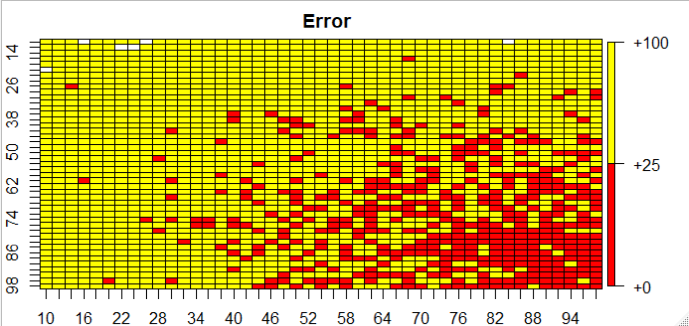

Just for a comparison if we run the power analyses as we did last year, where we estimated a sample size for rock and non-rock sites based on difference in density between the two groups and the variance of these estimates with a confidence level of 95% and a power of 80%, we estimate a sample size of 18.23 sites per group. This would be on average 18 rock site (18*74.90 = 1348.2 meters) and 18 non-rock sites (18*29.24 = 526.32 meters) for a total distance of 1874.52 meters total. This is just a little higher than our estimate based on the margin of error of a total of 1808.84 meters surveyed. However, this power analyses requires an equal number of sites to be surveyed in each group, while using margin of error we can have unequal sample sizes. Because the average transect length for rocks sites is about 2.5 times higher than the average transect length of non-rock sites, it makes sense to survey more non-rock sites than rock sites as suggested by the optimal sample sizes from the margin of error analyses.