February 9, 2019

Here are a few graphs and tables to update the last bit of sampling (samples collected through February 7, 2019).

Take home: Y_SM and N_SM are likely targets for additional sampling IF that is a key comparison of interest. Will be interesting to see what happens with additional Y_SM sampling. At N_SM with additional sampling the variance may only increase making power lower. Y_NA and N_NA are too similar in mean and too high in variance to detect difference with much power no matter how much sampling occurs based on what I’ve seen so far.

These tables and estiamtes are different than the ones from last week because of additional sampling + a correction in one of the names on a sampling location. Differences are mostly from additional sampling.

To review the naming, we are sampling with strata defined by whether the area is open or closed to fishing (Y/N) or the status of rocks (Large[LG], Small [SM], or wild without rocks [NA].

Possible strata

Strata Description

N_LG No harvest, large rock

N_NA No harvest, no rock (wild bar)

N_SM No harvest, small rock

Y_NA Yes harvest, no rock

Y_SM Yes harvest, small rock (has not been sampled)

Y_LG Yes harvest, large rock (not a possibility as large rocks only used in closed harvest areas)

This is what these data from winter 2018-2019 look like (data1 from data processing script). These are the “collapsed” transects such that multiple transects on an individual boar are pooled.

|  |  |  |  |  |  |  |  |  |  |  |  |  |  |
| --- | --- | --- | --- | --- | --- | --- | --- | --- | --- | --- | --- | --- | --- |
| day | month | year | season | treatment | locality | site | bar | station | count_live | tran_length | area | density | strata |
| 8 | 12 | 2018 | Winter | control | BT | I | 1 | BTI1 | 897 | 23.0 | 3.5 | 255.9 | N_NA |
| 7 | 12 | 2018 | Winter | control | BT | I | 2 | BTI2 | 1108 | 38.7 | 5.9 | 188.1 | N_NA |
| 7 | 12 | 2018 | Winter | control | BT | I | 3 | BTI3 | 1326 | 39.9 | 6.1 | 218.1 | N_NA |
| 8 | 12 | 2018 | Winter | control | BT | I | 4 | BTI4 | 627.5 | 55.8 | 8.5 | 73.8 | N_NA |
| 22 | 12 | 2018 | Winter | control | BT | I | 5 | BTI5 | 3988 | 62.7 | 9.6 | 417.4 | N_NA |
| 5 | 1 | 2019 | Winter | control | BT | I | 6 | BTI6 | 815.5 | 17.8 | 2.7 | 301.5 | N_NA |
| 6 | 2 | 2019 | Winter | control | LC | I | 1 | LCI1 | 1650 | 45.4 | 6.9 | 238.5 | N_NA |
| 7 | 2 | 2019 | Winter | control | LC | I | 2 | LCI2 | 1534 | 32.2 | 4.9 | 312.6 | Y_NA |
| 7 | 2 | 2019 | Winter | control | LC | I | 3 | LCI3 | 1104 | 23.8 | 3.6 | 304.4 | Y_NA |
| 23 | 1 | 2019 | Winter | control | LC | I | 4 | LCI4 | 1909 | 22.5 | 3.4 | 556.7 | Y_NA |
| 7 | 2 | 2019 | Winter | control | LC | I | 5 | LCI5 | 942 | 20.4 | 3.1 | 303.0 | Y_NA |
| 13 | 1 | 2019 | Winter | control | LC | I | 6 | LCI6 | 454 | 21.5 | 3.3 | 138.6 | Y_NA |
| 7 | 2 | 2019 | Winter | control | LC | I | 7 | LCI7 | 853 | 21.7 | 3.3 | 258.4 | N_NA |
| 13 | 1 | 2019 | Winter | control | LC | I | 8 | LCI8 | 96 | 19.0 | 2.9 | 33.2 | Y_NA |
| 7 | 2 | 2019 | Winter | control | LC | I | 9 | LCI9 | 695 | 22.2 | 3.4 | 205.1 | Y_NA |
| 6 | 2 | 2019 | Winter | control | LC | I | 10 | LCI10 | 1686 | 38.2 | 5.8 | 289.6 | Y_NA |
| 6 | 2 | 2019 | Winter | control | LC | I | 11 | LCI11 | 302 | 17.9 | 2.7 | 111.0 | Y_NA |
| 5 | 2 | 2019 | Winter | control | LC | I | 12 | LCI12 | 1106 | 36.1 | 5.5 | 201.1 | Y_NA |
| 22 | 1 | 2019 | Winter | control | LC | I | 13 | LCI13 | 3421.5 | 71.3 | 10.9 | 314.9 | Y_NA |
| 23 | 1 | 2019 | Winter | control | LC | I | 14 | LCI14 | 1501 | 22.8 | 3.5 | 432.9 | Y_NA |
| 23 | 1 | 2019 | Winter | control | LC | I | 15 | LCI15 | 638 | 20.8 | 3.2 | 201.3 | Y_NA |
| 4 | 2 | 2019 | Winter | control | LC | I | 16 | LCI16 | 427.5 | 24.0 | 3.7 | 116.7 | Y_NA |
| 4 | 2 | 2019 | Winter | control | LC | I | 17 | LCI17 | 189 | 14.7 | 2.2 | 84.7 | Y_NA |
| 5 | 2 | 2019 | Winter | control | LC | I | 18 | LCI18 | 1813 | 68.2 | 10.4 | 174.5 | Y_NA |
| 5 | 2 | 2019 | Winter | control | LC | I | 19 | LCI19 | 153 | 22.2 | 3.4 | 45.2 | Y_NA |
| 7 | 2 | 2019 | Winter | control | LC | N | 1 | LCN1 | 109 | 29.9 | 4.6 | 24.0 | Y_NA |
| 7 | 2 | 2019 | Winter | control | LC | N | 2 | LCN2 | 693 | 32.8 | 5.0 | 138.8 | Y_NA |
| 7 | 2 | 2019 | Winter | control | LC | N | 3 | LCN3 | 146 | 19.9 | 3.0 | 48.1 | Y_NA |
| 29 | 12 | 2018 | Winter | control | LC | N | 4 | LCN4 | 35 | 22.0 | 3.4 | 10.4 | Y_NA |
| 13 | 1 | 2019 | Winter | control | LC | N | 5 | LCN5 | 700 | 21.8 | 3.3 | 211.2 | Y_NA |
| 23 | 1 | 2019 | Winter | control | LC | N | 6 | LCN6 | 2275 | 32.4 | 4.9 | 460.7 | Y_NA |
| 7 | 2 | 2019 | Winter | control | LC | N | 7 | LCN7 | 611 | 13.3 | 2.0 | 301.4 | Y_NA |
| 29 | 12 | 2018 | Winter | control | LC | N | 8 | LCN8 | 58 | 17.5 | 2.7 | 21.7 | Y_NA |
| 4 | 2 | 2019 | Winter | control | LC | N | 9 | LCN9 | 4 | 36.1 | 5.5 | 0.7 | Y_NA |
| 27 | 11 | 2018 | Winter | rocks | LC | O | 12 | LCO12 | 358.5 | 111.9 | 17.0 | 21.0 | N_LG |
| 23 | 12 | 2018 | Winter | control | LC | O | 14 | LCO14 | 4612 | 70.1 | 10.7 | 431.6 | N_SM |
| 7 | 1 | 2019 | Winter | rocks | LC | O | 15 | LCO15 | 1506 | 43.2 | 6.6 | 228.5 | N_SM |
| 21 | 1 | 2019 | Winter | rocks | LC | O | 20 | LCO20 | 385 | 87.1 | 13.3 | 29.0 | Y_SM |
| 22 | 1 | 2019 | Winter | rocks | LC | O | 21 | LCO21 | 714 | 129.0 | 19.7 | 36.3 | Y_SM |
| 8 | 11 | 2018 | Winter | rocks | LC | O | 10A | LCO10A | 1098 | 67.2 | 10.2 | 107.2 | N_LG |
| 9 | 11 | 2018 | Winter | rocks | LC | O | 10A | LCO10A | 521 | 46.2 | 7.0 | 74.0 | N_LG |
| 9 | 11 | 2018 | Winter | rocks | LC | O | 11B | LCO11B | 276 | 66.8 | 10.2 | 27.1 | N_LG |
| 6 | 1 | 2019 | Winter | rocks | LC | O | 9B | LCO9B | 674.5 | 115.8 | 17.6 | 38.2 | N_LG |
| 7 | 11 | 2018 | Winter | rocks | LC | O | 9C | LCO9C | 905 | 66.6 | 10.1 | 89.2 | N_LG |
| 8 | 11 | 2018 | Winter | rocks | LC | O | 9C | LCO9C | 256 | 44.7 | 6.8 | 37.6 | N_LG |
| 30 | 1 | 2018 | Winter | control | LT | I | 1 | LTI1 | 445 | 27.5 | 4.2 | 106.2 | N_NA |
| 22 | 12 | 2018 | Winter | control | LT | I | 1 | LTI1 | 692 | 29.8 | 4.5 | 152.4 | N_NA |
| 23 | 12 | 2018 | Winter | control | LT | I | 2 | LTI2 | 190 | 22.7 | 3.5 | 55.0 | N_NA |
| 23 | 12 | 2018 | Winter | control | LT | I | 3 | LTI3 | 883 | 37.5 | 5.7 | 154.5 | N_NA |
| 22 | 12 | 2018 | Winter | control | LT | I | 4 | LTI4 | 1323 | 34.8 | 5.3 | 249.2 | N_NA |
| 22 | 12 | 2018 | Winter | control | LT | I | 5 | LTI5 | 1412 | 38.8 | 5.9 | 239.1 | N_NA |
| 22 | 12 | 2018 | Winter | control | LT | I | 6 | LTI6 | 594 | 18.9 | 2.9 | 206.6 | N_NA |
| 5 | 1 | 2019 | Winter | control | NN | I | 1 | NNI1 | 233.5 | 14.5 | 2.2 | 105.7 | N_NA |
| 23 | 12 | 2018 | Winter | control | NN | I | 2 | NNI2 | 911 | 22.9 | 3.5 | 261.6 | N_NA |
| 23 | 12 | 2018 | Winter | control | NN | I | 3 | NNI3 | 156 | 33.0 | 5.0 | 31.0 | N_NA |
| 23 | 12 | 2018 | Winter | control | NN | I | 4 | NNI4 | 571 | 13.3 | 2.0 | 281.7 | N_NA |

Simple table defining strata and information on total transect length sampled, number of collapsed transects, mean length of collapsed transect. A collapsed transect occurs when multiple transects are measured on one reef in a given sampling trip. Those transects are then summed by length and counts and considered one transect.

|  |  |  |  |  |  |
| --- | --- | --- | --- | --- | --- |
| Fishing (Y/N) | Rock (LG/SM/NA) | Strata | Total tran sampled (m) | N collapsed transects completed | Mean collapsed transect length m |
| N | LG | N_LG | 519.01 | 7 | 74.14 |
| N | NA | N_NA | 598.4 | 19 | 31.49 |
| N | SM | N_SM | 113.35 | 2 | 56.67 |
| Y | NA | Y_NA | 723.3 | 26 | 27.82 |
| Y | SM | Y_SM | 216.13 | 2 | 108.06 |

Estimated number of collapsed transects required for given power

|  |  |  |  |  |
| --- | --- | --- | --- | --- |
|  | N_LG | N_NA | N_SM | Y_NA |
| N_LG |  |  |  |  |
| N_NA | 7 |  |  |  |
| N_SM | 4 | 19 |  |  |
| Y_NA | 19 | 10607 | 19 |  |
| Y_SM | 2 | 2 | 2 | 2 |

The best way to interpret this is that it is really hard to detect a difference between Y_NA and N_NA. This is because the variance is so high (see below). For Y_SM don’t be misled, there have been few samples (2 collapsed) and the variance is less than the mean. Maybe that will hold and that makes it easier to detect differences. Maybe it won’t hold. Y_SM needs more sampling.

A graph of density by station color/shape coded by strata. I think this is what Peter was sort of asking for.

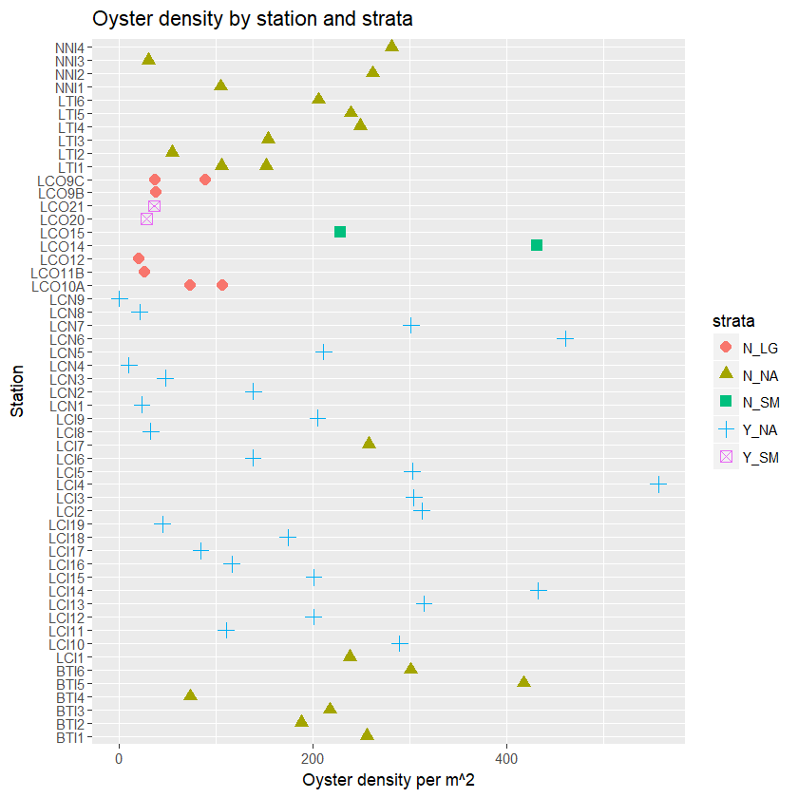

This is important because it shows the “spread” within each strata (shape and color). So for Y_NA the density estimates are highly variable, that’s why there is a huge spread. Compare that to Y_SM (but note only 2 samples taken). N_NA seems to perhaps be falling out a little bit between BTI complex and NN/LT complex. You can sort of see this bifurcation in the histogram in the next plot. This is where the spatial autocorrelation in the samples will be important to incorporate.

Below is just a histogram of density by collapsed transect

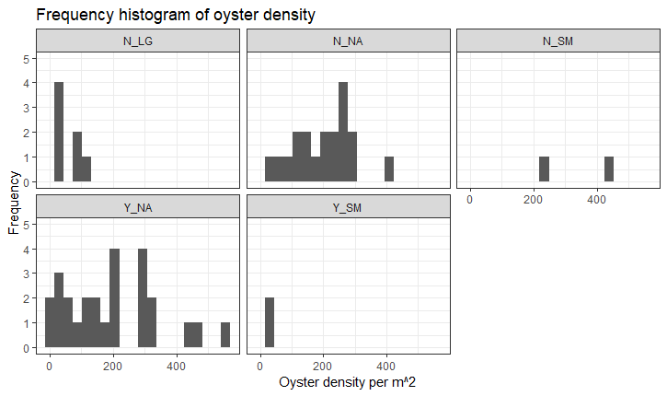

Simple summary stats of oyster density (per m^2) overall (all strata combined)

|  |  |  |  |  |  |  |  |  |  |  |  |
| --- | --- | --- | --- | --- | --- | --- | --- | --- | --- | --- | --- |
| NobsTotal | Mean | Median | Sd | Var | CV | Se | L95se | U95se | Bstrapmean | L95bstrap | U95bstrap |
| 56 | 177.8 | 164.52 | 132.61 | 17584.6 | 0.75 | 17.72 | 143.07 | 212.53 | 177.31 | 145.98 | 210.74 |

Simple summary stats by strata of oyster density (per m^2). Note I calculate t-test based confidence intervals and bootstrap based intervals.

|  |  |  |  |  |  |  |  |  |  |  |  |  |
| --- | --- | --- | --- | --- | --- | --- | --- | --- | --- | --- | --- | --- |
| .id | NobsTotal | Mean | Median | Sd | Var | CV | Se | L95se | U95se | Bstrapmean | L95bstrap | U95bstrap |
| N_LG | 7 | 56.35 | 38.23 | 33.57 | 1126.76 | 0.6 | 12.69 | 31.48 | 81.22 | 56.84 | 36.38 | 81.18 |
| N_NA | 19 | 199.71 | 218.06 | 96.63 | 9337.32 | 0.48 | 22.17 | 156.26 | 243.16 | 198.12 | 153.24 | 241.56 |
| N_SM | 2 | 330.09 | 330.09 | 143.62 | 20626.19 | 0.44 | 101.55 | 131.04 | 529.13 | 331.61 | 228.54 | 431.64 |
| Y_NA | 26 | 193.94 | 187.81 | 150.2 | 22560.13 | 0.77 | 29.46 | 136.2 | 251.67 | 194.28 | 138.14 | 252 |
| Y_SM | 2 | 32.66 | 32.66 | 5.17 | 26.78 | 0.16 | 3.66 | 25.48 | 39.83 | 32.52 | 29 | 36.32 |

Box plot 1. Oyster density by locality. Remember how to interpret a box plot, these are not confidence intervals. The top/bottom of the box tells you that 25% of the data are greater than this value. So the top of the box is the upper quartile and the bottom of the box is the lower quartile. The median line inside the box tells you that 50% of the data are greater than this value. The top/bottom of the whisker are the greatest value excluding outliers. Outliers are defined as dots above the whisker and those are 1.5 times the upper quartile.

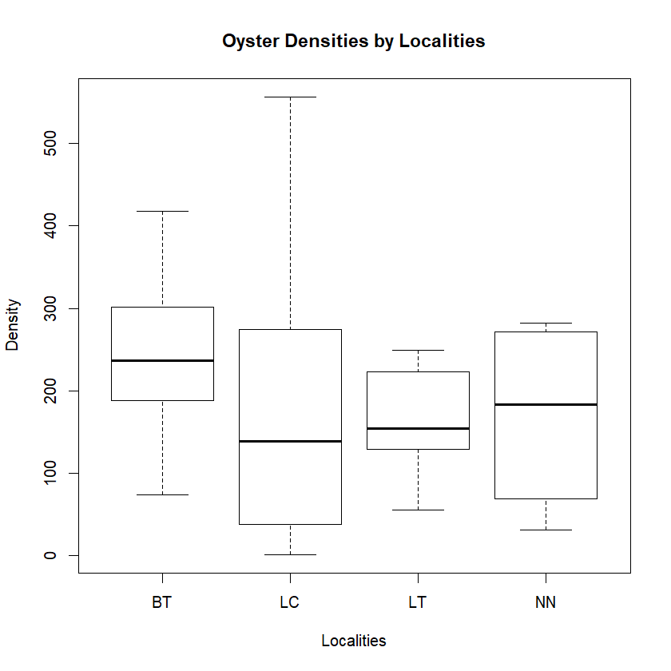

Box plot 2 density by “treatment”. Note this is only based on winter 2018-2019 samples for Lone Cabbage/Suwannee Sound. Remember how to interpret a box plot. The top/bottom of the box tells you that 25% of the data are greater than this value. So the top of the box is the upper quartile and the bottom of the box is the lower quartile. The median line inside the box tells you that 50% of the data are greater than this value. The top/bottom of the whisker are the greatest value excluding outliers. Outliers are defined as dots above the whisker and those are 1.5 times the upper quartile.

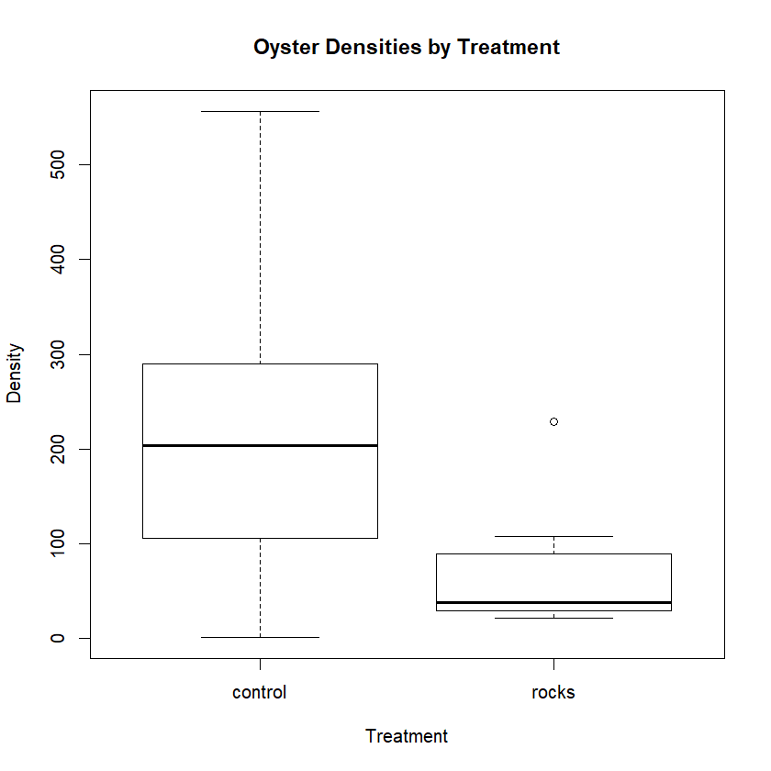

Box plot 3. Oyster density (m^2) by “Site”, Inshore, Nearshore, Offshore. Note this is only based on winter 2018-2019 samples for Lone Cabbage/Suwannee Sound. Remember how to interpret a box plot. The top/bottom of the box tells you that 25% of the data are greater than this value. So the top of the box is the upper quartile and the bottom of the box is the lower quartile. The median line inside the box tells you that 50% of the data are greater than this value. The top/bottom of the whisker are the greatest value excluding outliers. Outliers are defined as dots above the whisker and those are 1.5 times the upper quartile.

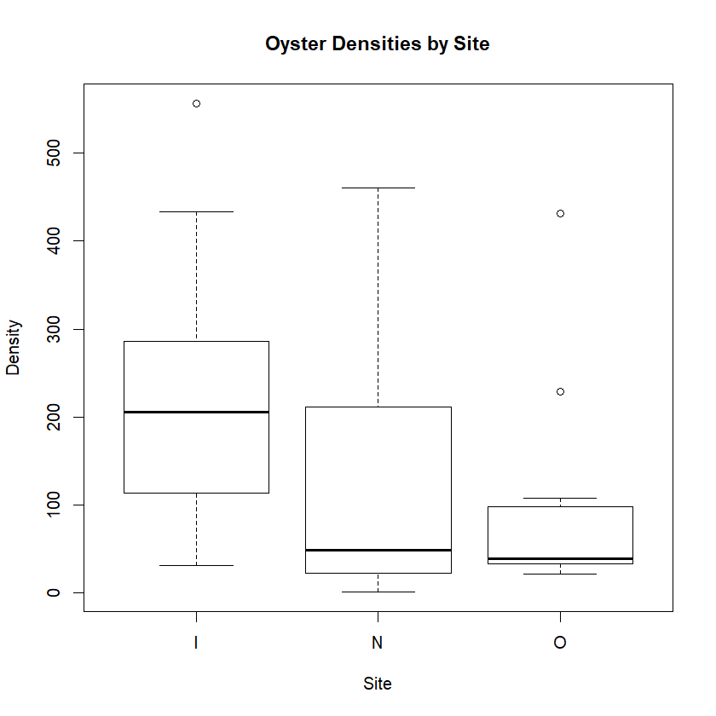

Figure. Oyster density (m^2) by locality over time for winter 2018/2019.

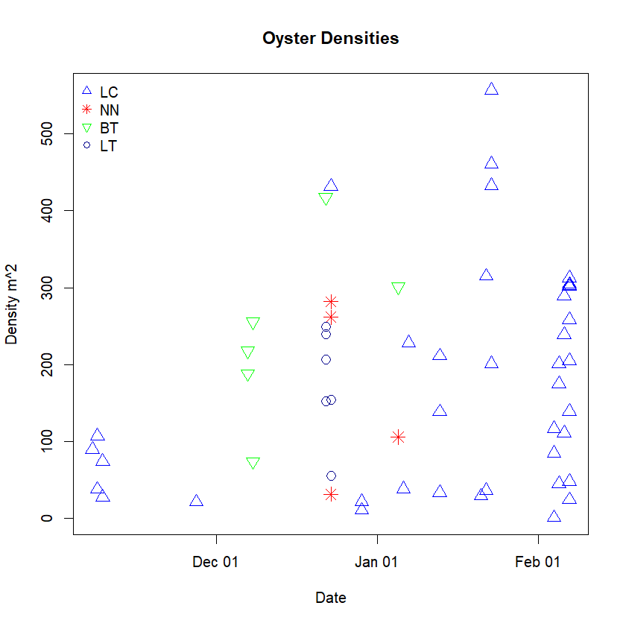

Here is another box plot (using ggplot style for fun). I turned this box plot “on its side” so density is on the “x” and the graph orients such that zero is bottom left. Other box plot aspects are the same

