Transect Report

## Transect Overview

This report consists of summary statistics and figures for ongoing transect sampling. The report include sampling observations from 2010-05-27 to 2019-11-15. A total of 84 days have been sampled between the sampling date range.

## Summary of Efforts

These effort summaries are tables for total number of transects walked per locality, strata, locality per period, and strata per period.

[1] "Effort Per Locality"  
 locality num_transects  
1 BT 6  
2 CK 26  
3 CR 46  
4 HB 45  
5 LC 138  
6 LT 9  
7 NN 5  
  
[1] "Effort Per Strata"  
 strata num_transects  
1 N_LG 13  
2 N_NA 82  
3 N_PILOT 12  
4 N_SM 5  
5 Y_NA 159  
6 Y_SM 4  
  
[1] "Effort Per Period"  
 period num_transects  
1 1 42  
2 2 30  
3 3 25  
4 6 33  
5 7 8  
6 10 9  
7 11 8  
8 16 8  
9 18 61  
10 19 35  
11 20 16  
  
[1] "Effort Per Locality Per Period"  
 period locality count_live  
1 18 BT 6  
2 1 CK 9  
3 6 CK 8  
4 19 CK 9  
5 1 CR 10  
6 2 CR 9  
7 3 CR 9  
8 6 CR 9  
9 19 CR 9  
10 1 HB 12  
11 2 HB 11  
12 3 HB 7  
13 6 HB 6  
14 19 HB 9  
15 1 LC 11  
16 2 LC 10  
17 3 LC 9  
18 6 LC 10  
19 7 LC 8  
20 10 LC 9  
21 11 LC 8  
22 16 LC 8  
23 18 LC 45  
24 19 LC 8  
25 20 LC 12  
26 18 LT 6  
27 20 LT 3  
28 18 NN 4  
29 20 NN 1  
  
[1] "Effort Per Strata Per Period"  
 period strata count_live  
1 18 N_LG 9  
2 20 N_LG 4  
3 1 N_NA 8  
4 2 N_NA 8  
5 3 N_NA 8  
6 6 N_NA 8  
7 7 N_NA 8  
8 10 N_NA 5  
9 11 N_NA 4  
10 16 N_NA 4  
11 18 N_NA 18  
12 19 N_NA 5  
13 20 N_NA 6  
14 10 N_PILOT 4  
15 11 N_PILOT 4  
16 16 N_PILOT 4  
17 18 N_SM 4  
18 20 N_SM 1  
19 1 Y_NA 34  
20 2 Y_NA 22  
21 3 Y_NA 17  
22 6 Y_NA 25  
23 18 Y_NA 26  
24 19 Y_NA 30  
25 20 Y_NA 5  
26 18 Y_SM 4

## Summary Tables

These summaries display total counts by locality, strata, and period.

[1] "Total Counts Per Locality"  
 locality count_live.total count_live.sd  
1 BT 8762.0000 1261.5902  
2 CK 22293.0000 1091.2989  
3 CR 47188.5000 1035.4528  
4 HB 39674.0000 1043.4502  
5 LC 104094.5000 783.9842  
6 LT 10621.0000 801.6566  
7 NN 2380.5000 300.2271  
  
[1] "Total Counts Per Strata"  
 strata count_live.total count_live.sd  
1 N_LG 13037.0000 590.2345  
2 N_NA 74873.0000 855.3088  
3 N_PILOT 13237.0000 617.8435  
4 N_SM 11761.5000 1496.9988  
5 Y_NA 120239.5000 937.3639  
6 Y_SM 1865.5000 217.9340  
  
[1] "Total Counts Period"  
 period count_live.total count_live.sd  
1 1 58957.50000 1287.60691  
2 2 25805.00000 943.02789  
3 3 17705.00000 813.63167  
4 6 13412.00000 527.23927  
5 7 404.00000 56.44719  
6 10 9659.00000 702.57309  
7 11 7089.00000 678.01800  
8 16 3950.00000 466.74886  
9 18 59925.50000 935.27179  
10 19 19423.00000 573.08935  
11 20 18683.50000 689.39925

## Plots

Figures displayed include histograms, box plots, and scatter plots for all transect sampling.

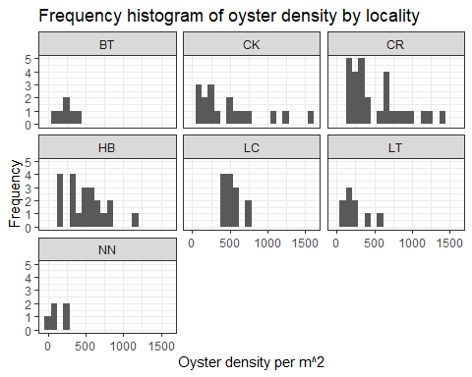 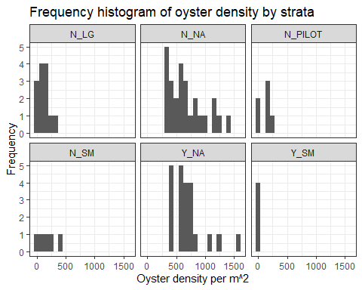 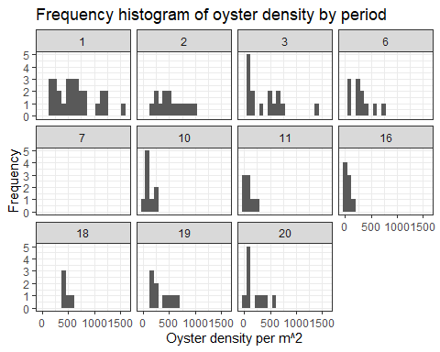 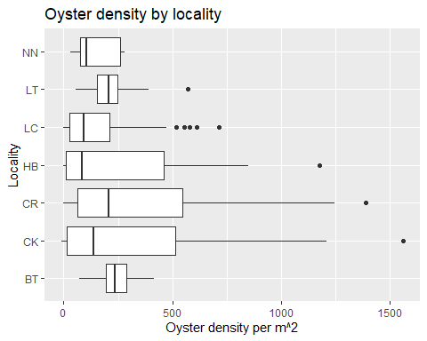 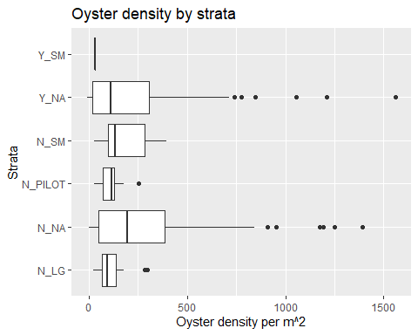 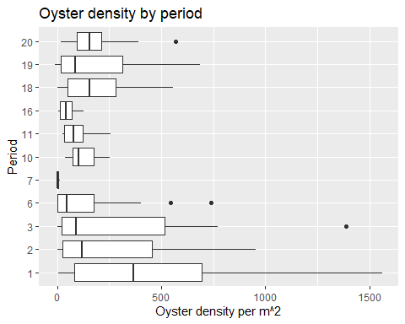 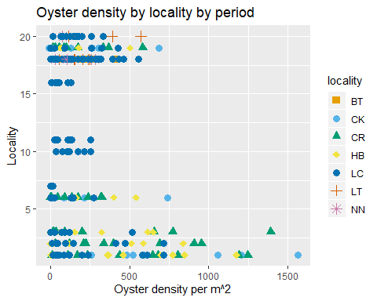 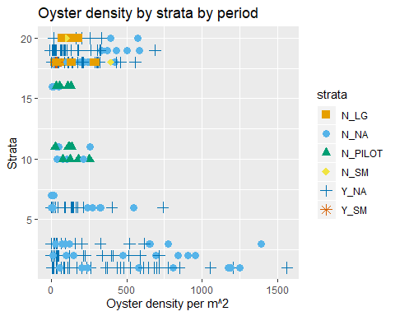

## Pilot Sites

These are figures for oyster counts and oyster density for stations LCO10B, LCO11A, LCO8B, LCO9A. 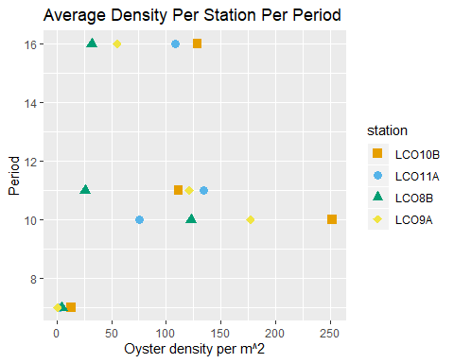 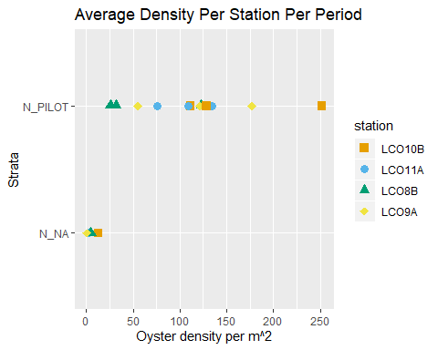

## Progress Bar

The progress bar displays the percentage of the transect sampling progress in relation to the power analysis objective for the current period.

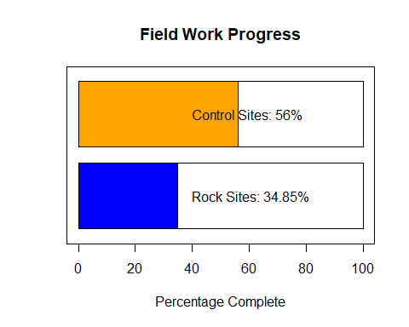

## Latest data entered

Displayed are the entries for the last date of sampling.

## date station tran_length count_live count_dead treatment season  
## 1 2019-11-15 LTI8 2.5 153 11 control winter  
## 2 2019-11-15 LTI8 5.0 185 28 control winter  
## 3 2019-11-15 LTI8 7.5 207 31 control winter  
## 4 2019-11-15 LTI8 10.0 221 27 control winter  
## 5 2019-11-15 LTI8 12.5 228 42 control winter  
## 6 2019-11-15 LTI8 15.0 224 52 control winter  
## 7 2019-11-15 LTI8 17.5 219 38 control winter  
## 8 2019-11-15 LTI8 20.0 301 50 control winter  
## 9 2019-11-15 LTI8 22.5 280 35 control winter  
## 10 2019-11-15 LTI8 25.0 282 51 control winter  
## 11 2019-11-15 LTI8 27.5 139 22 control winter  
## 12 2019-11-15 LTI8 30.0 141 27 control winter  
## 13 2019-11-15 LTI8 32.0 203 28 control winter  
## 14 2019-11-15 LTI9 2.5 52 6 control winter  
## 15 2019-11-15 LTI9 5.0 49 2 control winter  
## 16 2019-11-15 LTI9 7.5 37 1 control winter  
## 17 2019-11-15 LTI9 10.0 54 9 control winter  
## 18 2019-11-15 LTI9 12.5 50 2 control winter  
## 19 2019-11-15 LTI9 15.0 55 2 control winter  
## 20 2019-11-15 LTI9 17.5 78 4 control winter  
## 21 2019-11-15 LTI9 20.0 76 3 control winter  
## 22 2019-11-15 LTI9 22.5 59 3 control winter  
## 23 2019-11-15 LTI9 25.0 30 1 control winter  
## 24 2019-11-15 LTI9 27.5 38 2 control winter  
## 25 2019-11-15 LTI9 30.0 60 3 control winter  
## 26 2019-11-15 LTI9 32.5 39 2 control winter  
## 27 2019-11-15 LTI9 35.0 11 0 control winter  
## 28 2019-11-15 LTI9 37.5 25 0 control winter  
## 29 2019-11-15 LTI9 40.0 12 0 control winter  
## 30 2019-11-15 LTI9 42.5 25 2 control winter  
## 31 2019-11-15 LTI9 42.8 0 0 control winter  
## 32 2019-11-15 NNI3 2.5 10 0 control winter  
## 33 2019-11-15 NNI3 5.0 17 2 control winter  
## 34 2019-11-15 NNI3 7.5 10 1 control winter  
## 35 2019-11-15 NNI3 10.0 33 3 control winter  
## 36 2019-11-15 NNI3 12.5 76 6 control winter  
## 37 2019-11-15 NNI3 15.0 19 1 control winter  
## 38 2019-11-15 NNI3 17.5 19 1 control winter  
## 39 2019-11-15 NNI3 20.0 40 3 control winter  
## 40 2019-11-15 NNI3 22.5 39 1 control winter  
## 41 2019-11-15 NNI3 25.0 18 1 control winter  
## 42 2019-11-15 NNI3 27.5 20 1 control winter  
## 43 2019-11-15 NNI3 30.0 12 0 control winter  
## 44 2019-11-15 NNI3 32.5 64 3 control winter  
## 45 2019-11-15 NNI3 35.0 42 1 control winter  
## 46 2019-11-15 NNI3 37.5 20 2 control winter  
## 47 2019-11-15 NNI3 40.0 30 3 control winter  
## 48 2019-11-15 NNI3 42.5 32 0 control winter  
## 49 2019-11-15 NNI3 43.1 8 0 control winter  
## strata rocks harvest  
## 1 N_NA NA N  
## 2 N_NA NA N  
## 3 N_NA NA N  
## 4 N_NA NA N  
## 5 N_NA NA N  
## 6 N_NA NA N  
## 7 N_NA NA N  
## 8 N_NA NA N  
## 9 N_NA NA N  
## 10 N_NA NA N  
## 11 N_NA NA N  
## 12 N_NA NA N  
## 13 N_NA NA N  
## 14 N_NA NA N  
## 15 N_NA NA N  
## 16 N_NA NA N  
## 17 N_NA NA N  
## 18 N_NA NA N  
## 19 N_NA NA N  
## 20 N_NA NA N  
## 21 N_NA NA N  
## 22 N_NA NA N  
## 23 N_NA NA N  
## 24 N_NA NA N  
## 25 N_NA NA N  
## 26 N_NA NA N  
## 27 N_NA NA N  
## 28 N_NA NA N  
## 29 N_NA NA N  
## 30 N_NA NA N  
## 31 N_NA NA N  
## 32 N_NA NA N  
## 33 N_NA NA N  
## 34 N_NA NA N  
## 35 N_NA NA N  
## 36 N_NA NA N  
## 37 N_NA NA N  
## 38 N_NA NA N  
## 39 N_NA NA N  
## 40 N_NA NA N  
## 41 N_NA NA N  
## 42 N_NA NA N  
## 43 N_NA NA N  
## 44 N_NA NA N  
## 45 N_NA NA N  
## 46 N_NA NA N  
## 47 N_NA NA N  
## 48 N_NA NA N  
## 49 N_NA NA N