**Manuscript Title:**

GEOTHERM: a finite difference code for testing metamorphic P–T–t paths and tectonic models

**Code file names:**

1. compare.m
2. init.m
3. inputcall.m
4. kappa.m
5. lowercrust.m
6. M.m
7. petrology.m
8. ni.m
9. tectonic.m
10. thermobarometry.m
11. VSH.m
12. GEOTHERM.m (mainscript)
13. nature.m
14. thermobarometry.xls
15. petrology.xls
16. data.xls
17. experiment.avi (output)

**Programmer Details:**

Leonardo Casini, associate research (faculty staff), DipNeT University of Sassari

Via Piandanna, 4, Sassari, 07100 Italy

Email: [casini@uniss.it](mailto:casini@uniss.it)

**USER MANUAL**

1. **OS compatibility/system requirements:**

GEOTHERM has been developed in Matlab 7.10.0 (R2010a) on a PC equipped with 64-bit processor and Windows7 OS. The code has been successfully tested on Windows XP (32-bit processor), although numerical simulation of experiments with high-resolution time stepping (>300 time steps) are comparatively slower. GEOTHERM might works as well either on Windows and Mac OS, provided that both Matlab and Excel (’97-2003) are installed on your computer.

1. **Getting started** 
   1. ***Installation***

GEOTHERM is a Matlab-derived software package, however the standard usage of the code as described in the accompanying paper is very simple and does not requires knowledge of Matlab functioning. Yet, running GEOTHERM is not possible unless your pc is provided with Matlab 7.10.0 (R2010a or successive) and Windows Office (1997-2003 or successive versions). Note that Matlab advanced-level users may optionally decide to customize the functions and internal variables, as the code is not compiled.

To be started, simply copy the GEOTHERM folder and all files therein in a directory of your computer. Then, launch Matlab and set the current folder in the Command Window to the appropriate path. Note that changing file paths, folder or directory names will return error.

* 1. ***Basic principles of GEOTHERM functioning***

The code is composed of 13 Matlab ‘m-files’ that accomplish the specific tasks required by the experiment. The script ‘GEOTHERM.m’ is the main script that controls automatically the other sub-scripts. Once launched GEOTHERM (see section 2.4 of the manual), the main script calls first the sub-script ‘inputcall.m’ that load the model inputs stored into ‘data.xls’ file. Then, the main script calls sequentially the other sub-scripts (‘init.m’, ‘kappa.m’, ’lowercrust.m’, ‘M.m’, ‘petrology.m’, ‘ni.m’, ‘tectonic.m’, ‘VSH.m’, ‘nature.m’) which calculates the thermal structure. The sub-functions ‘thermobarometry.m’ and ‘compare.m’ load P-T-t constraints stored into ‘thermobarometry.xls’ spreadsheet, pass these inputs to the main script and compare the degree of fitting between the geotherm extrapolated from best fitting to P-T-t constraints and the geotherm calculated numerically. Finally, the main script displays the results as movies on the screen, and allow the user to save the current movie in the GEOTHERM folder.

Users that are familiar with Matlab coding can easily customize the sub-functions to change/add specific functions, as the code is not compiled. Yet, knowledge of Matlab coding is not required to run the code, so users not aware of the Matlab language may as well do experiments using GEOTHERM.

As a general suggestion, the data should be added to the spreadsheets ‘data.xls’ and ‘thermobarometry.xls’ before launching the code. However, after launching the code a dialog box prompt the user to fill the spreadsheets . For a rigorous treatment of the mathematical background including algorithms, parameters and approximation used by the code, the reader is referred to the related paper.

* 1. ***Load inputs***

The code is designed to read and import input data from specific excel (version ’97-2003) spreadsheets, included by default into the GEOTHERM folder. These are ‘data.xls’ and ‘thermobarometry.xls’ files. The first excel spreadsheet stores information on the structure of the layered model, the duration of the experiment, the initial, final and, eventually, transient thickness of the model. Optionally, the users can set up a range of parameters that are used to simulate the tectonic evolution of the model. The latter spreadsheet may be filled to store user-defined P-T-t constraints that are eventually used to compare the results of numerical experiments with observations.

Detailed instruction on how to set up input data is provided in the header of each table, and it is briefly described below.

* + 1. *Data.xls spreadsheet (Table 1: ‘Model Evolution’)*

Table 1 allow the user to set up the simplified tectonic evolution of the model crust. The table support up to ten age/thickness constraints which are used to extrapolate the relevant exhumation/burial history of the model crustal section. Ages must be specified in Ma, and bulk crustal thickness [Km]. Note that at least two pairs of constraints are required (green fields) to run simulations.

* + 1. *Data.xls spreadsheet (Table 2: ‘Model Initial Geometry’)*

The initial geometry of the model crust can be specified in table 2. The code accept up to three crustal layers. Each layer is assumed to be internally homogenous and characterized by specific thickness ([Km]), median heat production rate due to radiogenic decay of heat-producing elements (H, [Wm-3]) and standard deviation to H (sdH, [Wm-3]). A fourth layer (not editable) is used to simulate the distribution of heat producing elements in the lithospheric mantle.

* + 1. *Data.xls spreadsheet (Table 3: ‘Tectonic setting’)*

Two distinct tectonic events such as: i) the impingement of mantle plume, or ii) break off of an oceanic slab can be optionally simulated with GEOTHERM by filling table 3 as required. Note that users must specify the age at which the selected tectonic event has to begin (type 0 if no event is required). Note that one of either events is allowed once.

* + 1. *Data.xls spreadsheet (Table 4: ‘Deformation’)*

Table 4 allow the users to simulate up to 10 distinct shearing events. The duration of each of these events can be set by specifying the relevant ages ([Ma]) in the columns ‘start’ and ‘end’ of table 4, respectively. A nominal strain rate ([s-1]) must also be specified for each event in the latter column of the table.

* + 1. *Thermobarometry.xls*

The spreadsheet ‘thermobarometry.xls’ stores information on the user-defined P-T-t data set, which is eventually used to calculate the relative error between the numerically calculated geotherm and the best fit to petrologic constraints at each time step. Fill the table with the required number of petrologic constraints following units as specified in the table header: average temperature (av T, [K]), standard deviation to average temperature (T sd, [K]), average pressure (P, [GPa]), standard deviation to average pressure (P sd, [GPa]), average age (age av, [Ma]), and its standard deviation (age sd, [Ma]). Each constraint stored within ‘thermobarometry.xls’ is automatically shown while running GEOTHERM. Note that the position of markers and the size of error bars depend on the standard deviation of temperature and pressure, while their appearance and lifetime is calculated from the age and standard deviation.

* 1. ***Run GEOTHERM – how do experiments in 4 steps***

Once the installation is completed:

1. **Launch GEOTHERM**: type ‘GEOTHERM’ at the command window of Matlab and click ENTER to run numerical simulations; please, note that script names are case-sensitive in Matlab, therefore use of capitals letters is required. After launching the code, a dialog box (see Fig. 1) prompt the user to fill the spreadsheet ‘data.xls’ with appropriate values, and make the execution of the script to be paused (Fig. 1).

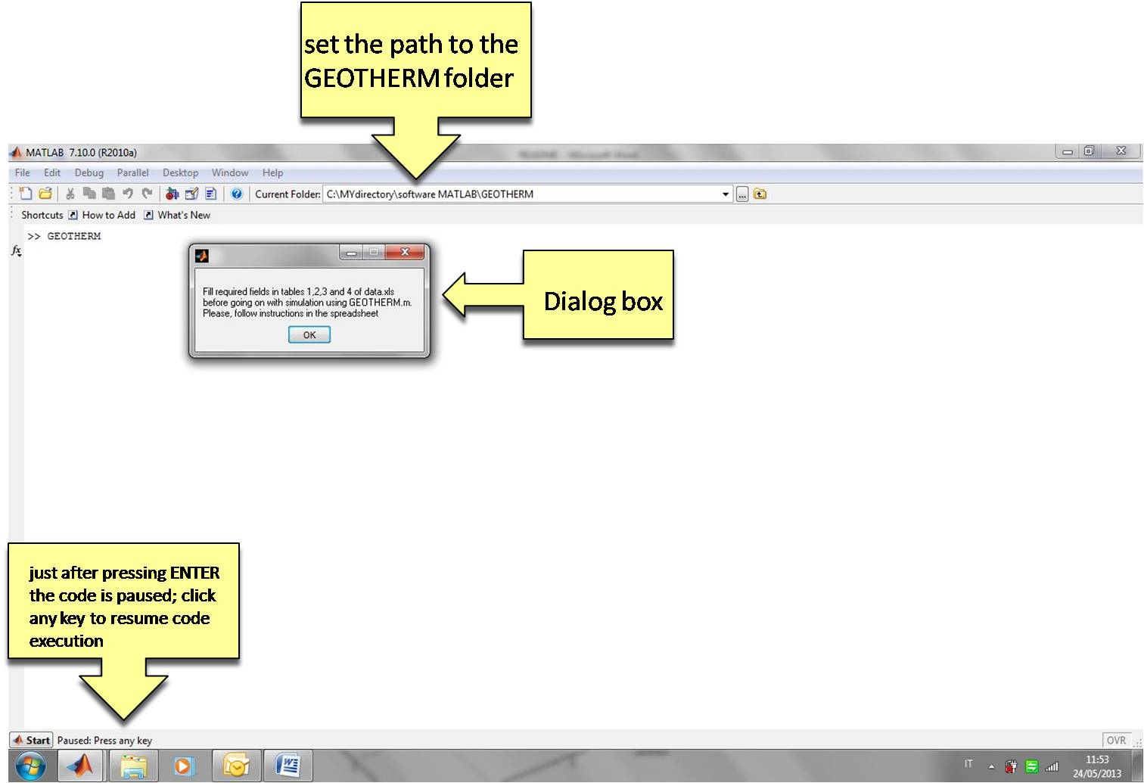

**Fig. 1**. Screen outputs once launched GEOTHERM

1. **Set time steps to be computed**: Once filled the excel spreadsheets click ENTER to resume code execution. The command window asks for the user to set the number of time steps to be computed (Fig. 2) and displayed as movie frames (note that the number of time steps effectively computed is the user’s choice + 1, so typing 69 makes the code to evaluate 70 time steps, i.e.: for an experiment starting at 350 Ma and ending at 280 Ma, the selection of 69 time steps cause the movie to be updated for increments of 1 Ma). If the user make no selection, clicking ENTER cause the software to use a default value of 100 time steps. In both cases, entering the number of time steps cause the code to be paused again. Note that increasing the number of time steps will results in higher resolution of the experiment but longer computation times.

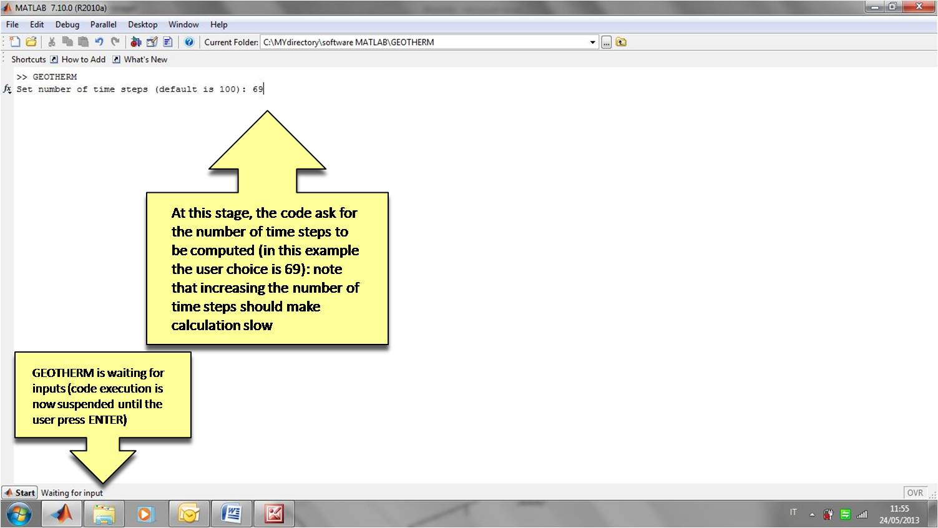

**Fig. 2.** The code asks for inputs (number of time steps to be computes)

1. **View the results**: click any key on the keyboard to resume code execution; at this stage, the code opens a new window and display the results as movie (Fig. 3).

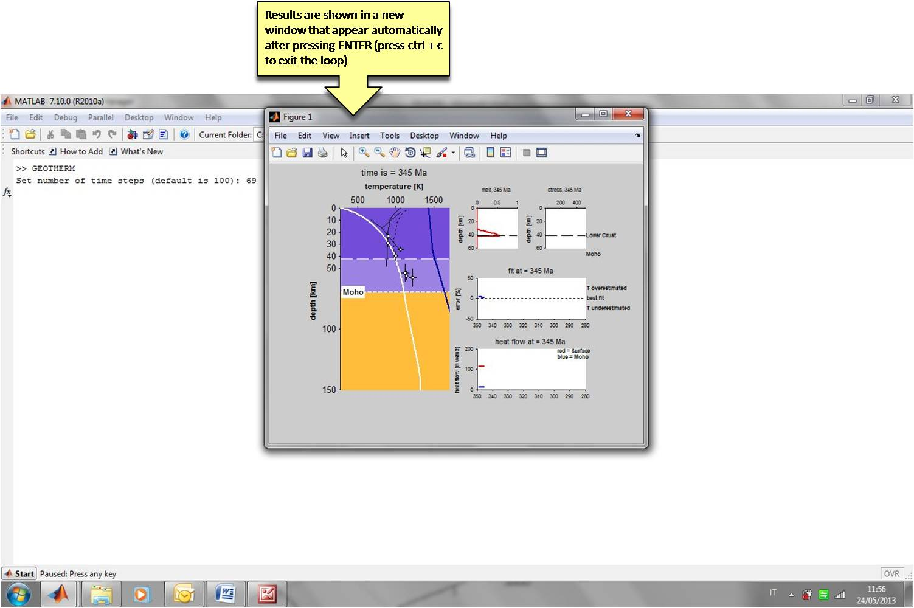

**Fig. 3.** GEOTHERM display the results in a new window

1. **Save the results**: at the end of code execution, the command window asks for the ID number of the experiment. The number entered is used to save the current movie as ‘experiment_IDnumber.avi’ file (Fig. 4).

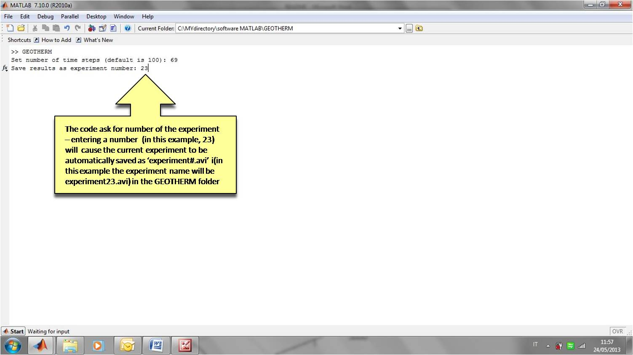

**Fig. 4.** Save the results as avi file.

1. **Example output (experiment R13):**

See tables 2, 3 for set up of experimental parameters; the following pictures show three screenshots (345, 325 and 305 Ma) of a demo movie ‘experiment.avi’, which is included in the GEOTHERM folder

