第一题：

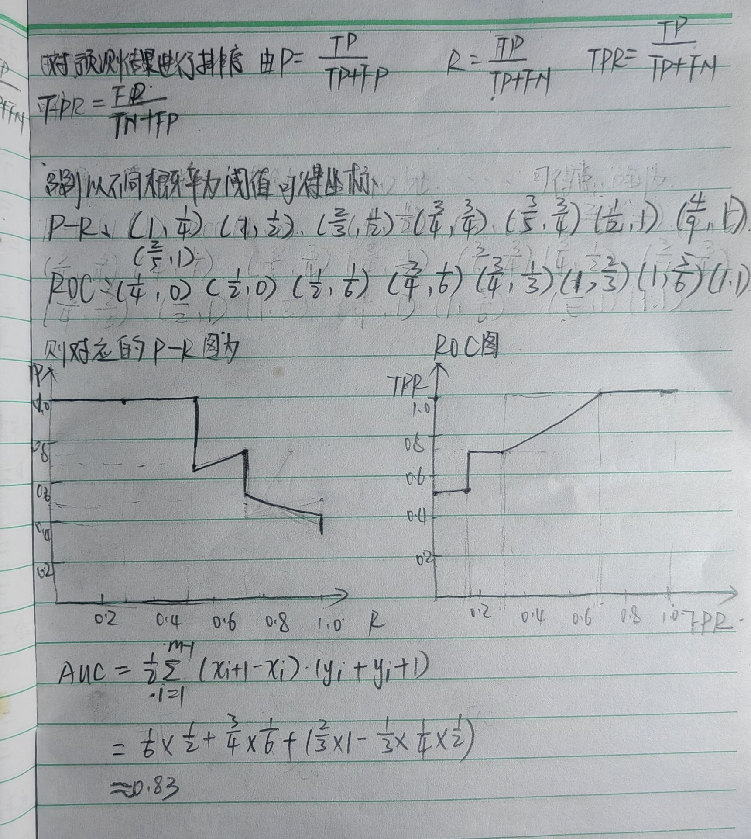

第二题：

import numpy as np

import matplotlib.pyplot as plt

from sklearn.metrics import roc_curve, auc

# 真实标签和预测分数

y_true = np.asarray([[0, 0, 1], [0, 1, 0], [1, 0, 0], [0, 0, 1], [1, 0, 0], [0, 1, 0],

[0, 1, 0], [0, 1, 0], [0, 0, 1], [0, 1, 0]])

y_pred = np.asarray([[0.1, 0.2, 0.7], [0.1, 0.6, 0.3], [0.5, 0.2, 0.3], [0.1, 0.1, 0.8],

[0.4, 0.2, 0.4], [0.6, 0.3, 0.1], [0.4, 0.2, 0.4], [0.4, 0.1, 0.5],

[0.1, 0.1, 0.8], [0.1, 0.8, 0.1]])

# 计算每个类别的ROC曲线和AUC值

n_classes = len(y_true[0])

fpr = {}

tpr = {}

roc_auc = {}

for i in range(n_classes):

fpr[i], tpr[i], _ = roc_curve(y_true[:, i], y_pred[:, i])

roc_auc[i] = auc(fpr[i], tpr[i])

# 计算微平均ROC曲线和AUC

fpr["micro"], tpr["micro"], _ = roc_curve(y_true.ravel(), y_pred.ravel())

roc_auc["micro"] = auc(fpr["micro"], tpr["micro"])

# 绘制每个类别的ROC曲线

plt.figure()

colors = ['aqua', 'darkorange', 'cornflowerblue']

for i, color in zip(range(n_classes), colors):

plt.plot(fpr[i], tpr[i], color=color,

label=f'Class {i} (AUC = {roc_auc[i]:.2f})')

# 绘制微平均ROC曲线

plt.plot(fpr["micro"], tpr["micro"], color='green',

linestyle='-', label='Micro-average ROC curve (AUC = {0:0.2f})'

''.format(roc_auc["micro"]))

plt.plot([0, 1], [0, 1], 'k--', label='Random Guessing ')

plt.xlim([0.0, 1.0])

plt.ylim([0.0, 1.05])

plt.xlabel('FPR')

plt.ylabel('TPR')

plt.title('ROC')

plt.legend(loc="lower right")

plt.show()