**Design rationale**

**Overall UML Class Diagram**

Insert UML Class Diagram here once we are all done

**Status Enum Class**

This class is created to keep track of the dinosaurs’ statuses, such as pregnant, baby and so on. This is used by the dinosaur class, and its subclasses. Could be included inside the dinosaur class itself, or split into multiple enum classes.

**Gender Enum Class**

This enum class is used in determining dinosaurs’ genders. Is a separate enum class from Status as we need to lock what type of enum is it when creating dinosaurs.

**Dinosaur Abstract Class Extends Actor**

The class was created to have a generalisation of what things are to be processed each turn for the dinosaur (playTurn() method), such as hunger(HP), age, pregnancy, as well as going through the behaviour ArrayList to find an action to do. When extended, the extended class should call its parent’s playTurn() method, reducing repeated code. This class should have various helper methods that can be accessed by other classes too. Would also have many attributes, and static final attributes that help in playTurn() and other classes, such as age, pregnantAge, unConsciousTime, HUNGRY_INT, CORPSE_ROT_TIME. Will also have an ArrayList of behaviour that is used in playTurn(). The constructor of this class should initialise the age and gender, and add WanderBehaviour, and more can be added to the front of the ArrayList in extended classes, to show more behaviours in a dinosaur. There should be two constructors where one is an one parameter constructor that takes in gender from the status enum class, and will add the gender enum(MALE or FEMALE) into capabilities depending on the gender, and automatically initialises age to the adult age. The other constructor will take in age and gender (or just age and randomise the gender), and initialises the dinosaur normally, with an inputted age, as well as gender.

**HerbivoreDinosaur Abstract Class Extends Dinosaur**

This class is created so that we can generalise the herbivore food behaviour. This class will extend its parent’s constructors and add the necessary behaviours, BreedBehaviour and HerbHungerBehaviour in the constructor, to give HerbivoreDinosaurs breeding and feeding behaviour which simulates the dinosaur’s breeding and feeding. This class is here just in case we may want to introduce more Herbivore Dinosaurs, and when we do, it will reduce repeated codes.

**CarnivoreDinosaur Abstract Class Extends Dinosaur**

This class is created to generalise Carnivore food behaviour. This class will extend its parent’s constructor and add BreedingBehaviour and CarniHungerBehaviour which simulates the dinosaurs breeding and feeding. This is created in case we may want to introduce more Carnivore Dinosaurs, and when we do, we will reduce repeated codes.

**Stegosaur Extends HerbivoreDinosaur**

This class is used to represent a Stegosaur. Should have its own starting HP, max HP, adult age that is unique to Brachiosaur. All of the necessary behaviours are already in the parent’s code. The constructor should add a short_neck enum which will be used in HungryHerbivoreBehaviour. Default constructor should call super and initialise the Stegosaur with its starting HP and age. Will initialize final static attributes inherited from Dinosaur.

**Brachiosaur Extends HerbivoreDInosaur**

Used to represent a Brachiosaur. Should have its own starting HP, max HP, adult age that is unique to Brachiosaur. All of the necessary behaviours are already in the parent’s code. The constructor should add a long_neck enum which will be used in HungryHerbivoreBehaviour. Default constructor should call super and initialise the Stegosaur with its starting HP and age. Will initialize final static attributes inherited from Dinosaur.

**Allosaur Extends CarnivoreDinosaur**

Used to represent an Allosaur. Constructor will add PredatorBehaviour to the front of the behaviour ArrayList to simulate the Allosaur attacking adjacent Stegosaurs. Will have a hashmap to keep track of the Stegosaur it has attacked. playTurn() is overridden, and we will loop through the hashmap and increment the turns elapsed since Stegosaur attacked in it. If it’s more than 20, we will remove it, then we call super’s playTurn(). Will initialize final static attributes inherited from Dinosaur.

**General Interaction Diagram of Dinosaurs**

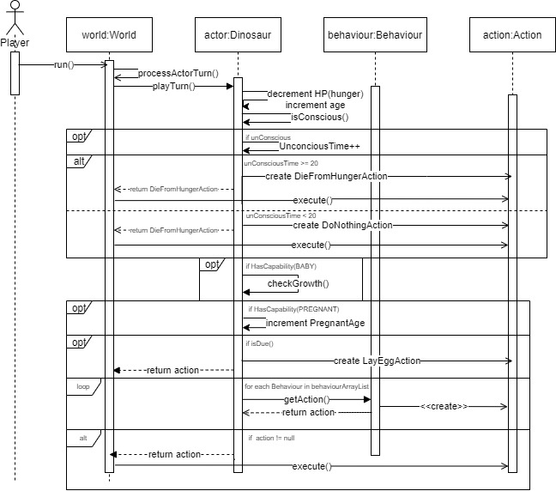

**JurassicParkLocation Extends Location**

Used to represent a location in our Jurassic Park game. This is used so we can check whether a bush can grow in the tick() method, as well as implementing the chance a bush dies if there’s a brachiosaur on it. This is the same as how the Conway demo implemented it.

**JurassicParkGameMap Extends GameMap**

Used to represent a GameMap in our Jurassic Park game. This is used so we create a JurassicParkLocation instead of a standard location. This is the same as how the Conway demo implemented it.

**Interaction Diagram of Location**

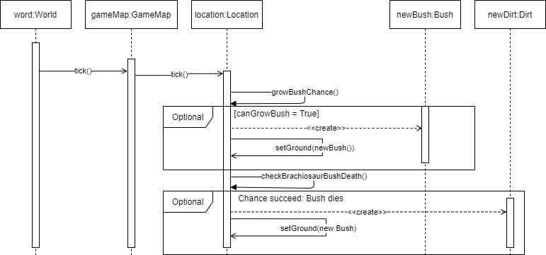

**Growable Abstract Class extends Ground**

Used to represent anything that can grow fruit. We will override tick() so we can add a check to see if we can grow fruit. This class will have a final static variable to store the chance of growing the fruit and the check will use that variable. By doing this, we can easily extend the class to add things like bushes and trees that grow fruits, where they can override the growth chance, and the chance is still passed over to the parent Growable class. The class should also keep track of how many ripe fruits are there (integer). Should have helper methods for the number of ripe fruits.

**Interaction diagram of Growable**

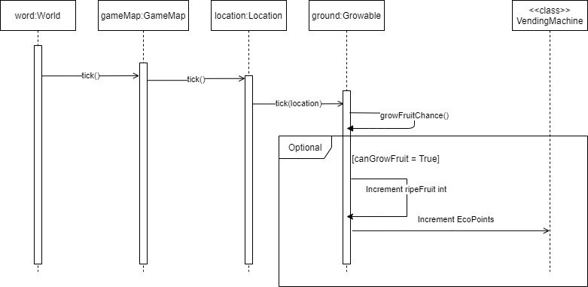

**Bush extends Growable**

Represents a bush. Would just call super’s constructor to indicate its character on the map. Everything here should be done in the parent’s code already. The only thing to override is allowableActions, in which we would add an EatFromBushAction (If actor has short neck) and PickFruitAction (If actor is the player). The grow chance should be set to something like 0.1, which when tick() is called, will be used in chance calculation.

**Tree extends Growable**

Represents a tree. Calls super constructor to indicate its character. This class will add a final static dropFruitChance. The tick() method is overridden and we will call super’s tick() to run the fruit growth chance, and run something like a dropFruitCheck(), which takes dropFruitChance and sees if a fruit will drop, by looping through numberOfRipeFruit. Also will have age and will increment age and change the character on the map. The allowableAction is also overridden and adds pickFruit (If is player) and eatFromTreeAction (If has long neck). The grow chance would also be set here, like 0.5, and will be used in super’s tick().

**Interaction Diagram for Tree**

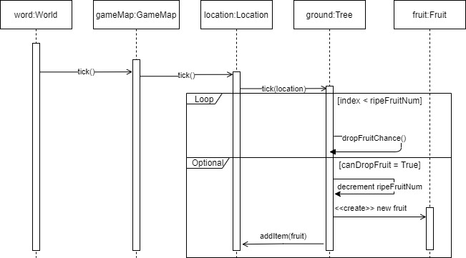

**Design Rationale for Items and Vending Machine**