印尼某红土矿硫酸加压浸出矿物组成变化研究
雷蒙恩，马保中，陈永强，邢鹏，王成彦，吕东亚
(北京科技大学冶金与生态工程学院，北京 100083)

摘要：印尼苏拉威西岛La-paopao矿区红土镍矿储量约7326万吨，含镍约为1.25%，以此红土镍矿为对象，系统分析了矿样中主要矿物的种类、赋存状态及产出特征。结果表明：矿样含Fe (40.15%)，Ni（1.42%)，Co(0.15%)，Mg (0.37%)，SiO₂ (6.92%)（质量分数），是典型的褐铁型红土镍矿；组成矿物主要为针铁矿、水针铁矿、高岭石、硬锰矿等；镍钴主要以类质同象或在结晶过程中以机械夹杂形式分布于褐铁矿中，其次分布于硬锰矿中，还有部分以独立矿物镍钴土矿形式存在。基于矿物特征，采用硫酸高压浸出工艺处理该红土镍矿，在最佳工艺条件下，镍浸出率超过96%，钴浸出率在97%以上，铁浸出率小于1%，实现了镍钴选择性提取。最后分析了渣中残余镍、钴未能浸出的原因以及各金属的浸出行为。未浸出镍钴部分可能存在于锰土矿中，另一部分则在Fe³⁺和Al³⁺高温水解沉淀过程中被夹带进入浸出渣。在高温下Fe³⁺强烈水解并释放出酸，Al³⁺大部分水解并释放出酸，并沉淀入渣。
关键词：红土镍矿；矿物学分析；镍；钴；选择性提取
doi: 10.13373/j.cnki.cjrm. XY19060024
中图分类号：TF803.21 文献标识码：A 文章编号：1000–4343 (2012)–0283–05

镍作为重要的战略金属，因其特殊的物理、化学性质，广泛应用于国防、航空航天、交通运输、石油化工、能源等领域，是生产不锈钢、镍基喷镀材料、原子能反应堆部件等的重要原材料。近年来镍钴锰三元锂离子正极电池材料的应用和发展更带动了镍在电池行业的消耗。我国原生镍消费量从2008年的32.4万吨增至2016年的108.5万吨，年均递增16.2%，高居世界首位，其中不锈钢行业用镍一家独大。2016年我国不锈钢行业用镍占镍消费总量的85%，远远高于欧美等发达国家65%平均水平。此外，随着新能源汽车的快速发展，未来电池领域将是镍消费增速最快的行业^{[1-4]}……
1 实 验
1.1 实验原料
实验用红土镍矿来自印度尼西亚La-paopao矿区，含水为33.3%。代表性矿石样品的化学成分分析结果如表1所示。……

表1 试验用红土镍矿干基化学成分分析
Table 1 Chemical analysis of laterite ore used in the experiment （%，mass fraction）
Elements | Ni | Fe | Co | Al | Mg | Mn
Content | 1.42 | 40.15 | 0.15 | 6.24 | 0.37 | 0.85
Elements | Cr | Ca | SiO₂ | Cu | Zn | Sc (g·t⁻¹)
Content | 1.04 | 0.34 | 6.92 | 0.03 | 0.005 | 56
1.2实验方法
首先对原矿矿物组成、物相产出及成分特征等进行分析，基于系统工艺矿物学分析结果，采用HPAL工艺。……
2 结果与讨论
2.1原矿工艺矿物学研究
2.1.1 X-射线衍射(XRD)分析
实验用褐铁型红土镍矿样品的XRD图谱如图1所示。
……
2.1.2 ……
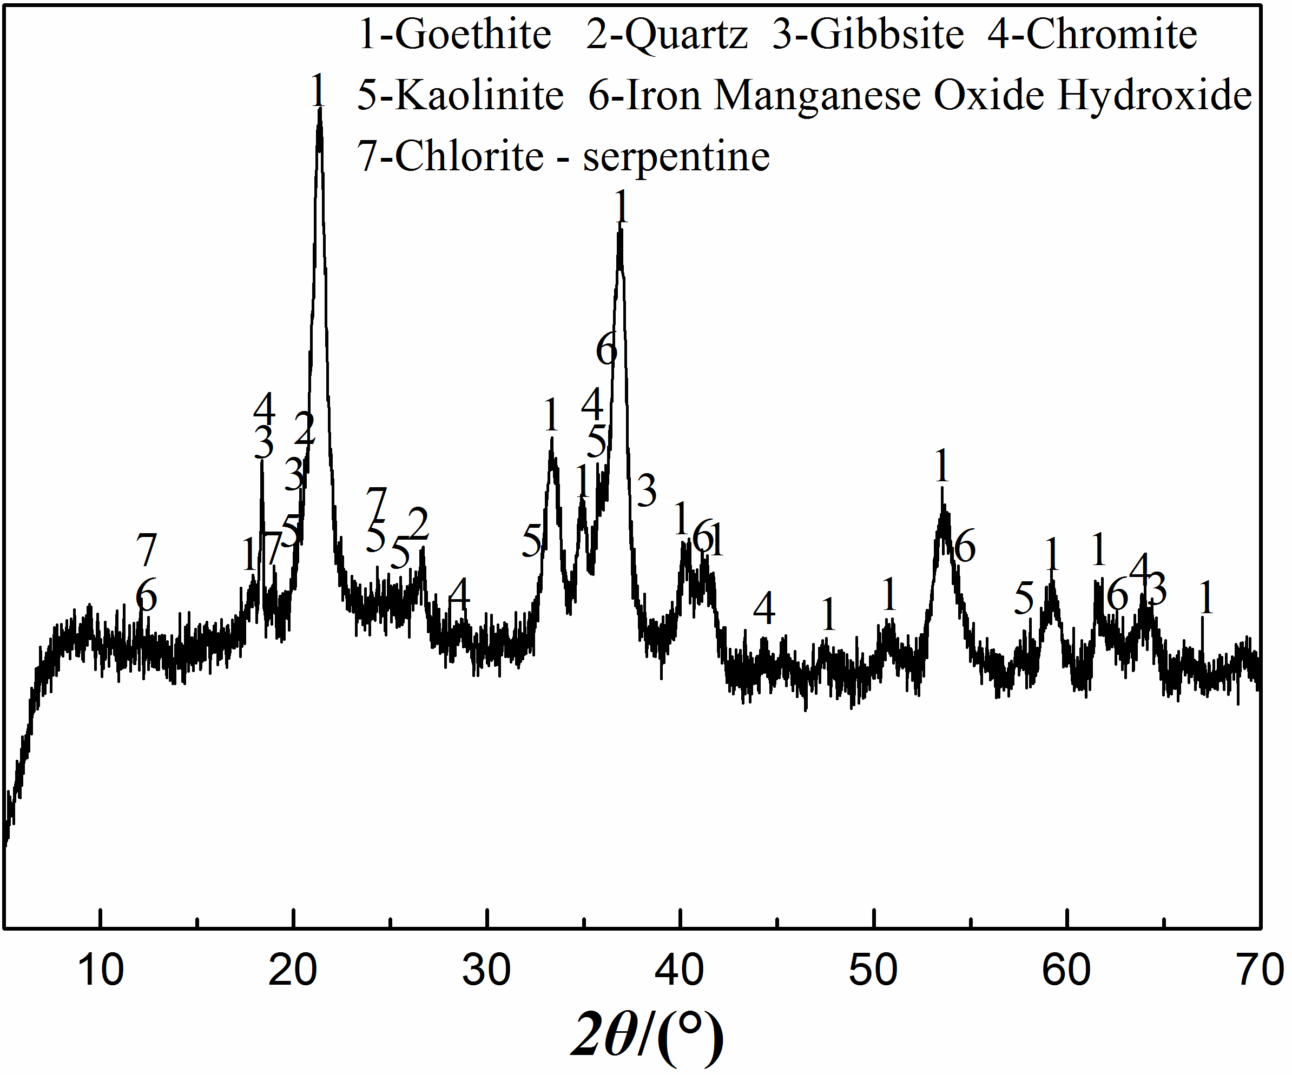
图1 试验用红土镍矿的XRD图谱
Fig.1 XRD pattern of laterite ore used in the experiment

2.1.3 ……
……
2.2 ……

2.3 ……

2.4 ……

3 结 论
为实现印尼La-paopao红土镍矿区镍钴等资源高效利用，对该地矿样进行系统矿物学分析后选择HPAL工艺处理该矿石，结论如下：

参考文献：
[1] Ma B Z, Wang C Y, Yang W J, Wei Y G, Wang H. Process and improvement of Yunnan magnesium-rich nickel oxide ore metalized reduction using coal as reductant[J]. Chinese Journal of Rare Metals, 2017, 41(4):429.
（马保中, 王成彦, 杨玮娇, 魏永刚, 王华. 云南镁质氧化镍矿煤基金属化还原过程及优化[J]. 稀有金属, 2017, 41(4): 429.）
[2] Ma B Z, Jin B J, Pei Y L, Yang W J, Wei Y G, Wang C Y. Process and mechanism study on activation pretreatment of limonitic laterite ores at low temperature[J]. Chinese Journal of Rare Metals, 2017, 41(10):1159.
（马保中, 金炳界, 裴彦林, 杨玮娇, 魏永刚, 王成彦. 褐铁型红土镍矿硫酸熟化过程及其机制研究[J]. 稀有金属, 2017, 41(10): 1159.）
[3] Chen B Y, Liu H T, Yang P, Sun Y. The basic metallogenic regularity of global lateritic nickel ore deposits[J]. Acta Geoscientica Sinica, 2013, 34(1): 202.
[4] Senanayake G, Childs J, Akerstrom B D, Pugaev D. Reductive acid leaching of laterite and metal oxides–A review with new data for Fe(Ni,Co)OOH and a limonitic ore[J]. Hydrometallurgy, 2011, 110(1–4): 13.
[5] Rubisov D H, Krowinkel J M, Papangelakis V G. Sulphuric acid pressure leaching of laterites–universal kinetics of nickel dissolution for limonites and limonitic/saprolitic blends[J]. Hydrometallurgy, 2000, 58(1): 1.
[6] Yuan F G., Liu X H. Leaching kinetics of nickel extraction from low nickel matte by sulfuric-nitric acid mixture[J]. Chinese Journal of Rare Metals, 2019, 43(10):1075.
（袁飞刚，刘旭恒.低冰镍硫-硝混酸浸出动力学[J].稀有金属, 2019, 43(10):1075.）
[7] Chen Y., Mariba E R M, Van D L. A review of non-conventional metals extracting technologies from ore and waste[J]. International Journal of Mineral Processing, 2011, 98(1-2): 1.
[8] Thorne R L, Roberts S, Herrington R. Climate change and the formation of nickel laterite deposits[J]. Geology, 2012, 40(4): 331.
[9] Brand N W, Butt C R M, Elias M. Nickel laterites: classification and features[J]. AGSO Journal of Austalian Geology & Geophysics, 1998, 17(4): 81.
[10] Thorne R L, Herrington R, Robert S. Composition and origin of the Caldag oxide nickel laterite, W. Turkey[J]. Mineralium Deposita, 2009, 44: 581.
[11] Xu Y B, Xie Y T, Yan L, Yang R D. A new method for recovering valuable metals from low grade nickel ferrous oxide ores[J]. Hydrometallurgy, 2005, 80(4): 280.
[12] Whittington B I, Johnson J A, Quan L P, Mcdonald R G. Pressure acid leaching of arid-region nickel laterite ore Part II. Effect of ore type[J]. Hydrometallurgy, 2003, 70 (1-3): 47.
[13] Whittington B I, Muir D M. Pressure acid leaching of nickel laterites: a review[J]. Mineral Processing and Extractive Metallurgy Review, 2000, 21 (6): 527.
[14] Harris C T, Peacey J G, Pickles C A. Selective sulphidation of a nickeliferous lateritic ore[J]. Minerals Engineering, 2011, 24(7): 651.
[15] Ma B Z, Wang C Y, Yang W J, Chen Y Q, Yang B. Comprehensive utilization of Philippine laterite ore, part 1: Design of technical route and classification of the initial ore based on mineralogical analysis [J]. International Journal of Mineral Processing, 2013, 124(22):42.
[16] Georgiou D, Papangelakis V G. Sulphuric acid pressure leaching of a limonitic laterite: Chemistry and kinetics[J]. Hydrometallurgy, 1998, 49(1):23.
[17] Su R C. Experimental study on pressure leaching of Yuanjiang laterite-nickel ore[J]. Nonferrous Metals（Extractive Metallurgy), 2012，(9):7.
（苏瑞春. 元江红土镍矿加压浸出试验研究[J]. 有色金属(冶炼部分), 2012，(9):7
……

Mineral Components Transformation of a Laterite from Indonesia by Sulfuric acid Pressure Leaching
Lei Mengen, Ma Baozhong, Chen Yongqiang, Xing Peng, Wang Chengyan, Lv Dongya
(School of Metallurgy and Ecological Engineering, University of Science and Technology Beijing, Beijing 100083, China)
Abstract：With the gradual depletion of nickel sulfide ore, the supply of nickel was gradually changing to nickel laterite ore, and the proportion was increasing year by year, which has reached more than 50%. High pressure acid leaching (HPAL) had become a hot spot in the treatment of low-grade nickel laterite ore in recent years. HPAL can recover nickel, cobalt and other elements efficiently and comprehensively, and the product can be either nickel(cobalt) metal or nick-el(cobalt) sulfate, which can be used in steel enterprises or battery industry. However, the composition of laterite ore in different areas was complex and changeable. It was necessary to systematically explore the changes of composition minerals before and after leaching in order to obtain the optimum conditions when HPAL was used to treat nickel laterite ore. The nickel laterite ore deposit in La-paopao mining area on Sulawesi island of Indonesia had a reserve of about 73.26 million tons, containing about 1.25% nickel, which had important development and use value. The types, occurrence states and production characteristics of the main minerals in the samples were systematically analyzed by means of chemical analysis, X-ray diffraction analysis (XRD), microscope analysis, scanning electron microscope (SEM) and energy dispersive analysis (EDS). In addition, the effects of leaching temperature, sulfuric acid dosage, leaching duration and slurry liquid-solid ratio on the leaching process were explored. Based on the analysis of the metals leaching behavior and the mineral composition changes of raw materials and leach residue, the optimum conditions for treating nickel laterite ore deposit in La-paopao mining area by HPAL were determined. The results showed that the ore sample was a typical limonitic laterite ore containing Fe (40.15%), Ni (1.42%), Co (0.15%), Mg (0.37%), SiO2 (6.92%) (mass fraction). The main components minerals were goethite, hyrogoethite, kaolin, and psilomelane etc. Nickel and cobalt were mainly distributed in limonite in the form of isomorphism or mechanical inclusion via the crystallization process, followed by psilomelane, and nickel and cobalt could also be found in nickel asbolane as the independent mineral. The leaching rates of Ni and Co in nickel laterite ore were obviously affected by temperature. With the increase of temperature, the leaching rate of Ni and Co increased significantly and reached a peak at 255 °C. At this time, the leaching rates of Ni and Co were 96.1% and 97.7%, respectively. When the sulfuric acid dosage reached 330 kg/t-ore, the leaching rates of Ni and Co tended to stabilize, and the leaching rates of Ni and Co were 95.8% and 97.2%, respectively. When the leaching duration was 45 min, the leaching rates of Ni and Co were 95.8% and 97.2%, respectively. With the extension of leaching duration, the leaching rate of Ni and Co tended to be stable. When the slurry liquid-solid ratio was 2 m³-water·t-ore⁻¹, the leaching rate of Ni and Co was higher than 96%. The leaching rates of Mn and Mg were sensitive to temperature changes. The leaching rate of Al decreased as the temperature increased, and the leaching rate of Fe was about 1%. By comparing the composition minerals before and after leaching, the optimum conditions of HPAL were determined as follows: sulfuric acid dosage of 330 kg·t-ore⁻¹, leaching temperature of 255 °C, leaching duration of 45 min and slurry liquid-solid ratio of 2 m³-water·t-ore⁻¹. It had been experimented that under the optimal technological conditions, the leaching rates of Ni, Co could be more than 96% and 97%, while that of Fe was less than 1%, which ensured the selective extraction of Ni and Co. In the process of HPAL, the leaching rates of Ni, Co and Mn were almost the same with the change of conditions, this was because they had a common carrier mineral, which was manganite. When the temperature was lower than 220 °C, the structure of laterite was not completely destroyed, which leaded to the failure leaching of part of nickel and cobalt. After the temperature raised, the structure of the nickel-cobalt-containing iron minerals that were difficult to handle under normal temperature and pressure can be destroyed, thereby increasing the nickel and cobalt leaching rates. When the leaching rate of nickel and cobalt reached the peak, it doesn't change much with the increased of acid dosage, temperature and leaching duration. At this time, the part of non-leaching nickel and cobalt may exist in the manganese ore, and the other part may be into the leach residue because of the Fe³⁺ and Al³⁺ hydrolysis and precipitation. When the leaching duration was 30 min, most of the nickel and cobalt existing in the iron mineral have been leached, and the leaching rate of nickel and cobalt was about 90%, which indicated that the iron mineral was decomposed rapidly by sulfuric acid under high temperature and high pressure. But the leaching rate of Fe always remained at a low level, which was due to the Fe³⁺ had been transformed into hematite precipitation at a low temperature (180 °C) and short time (30 min).
Key words: Nickel laterite ore; Mineralogical analysis; Nickel; Cobalt; Selective extraction
doi: 10.13373/j.cnki.cjrm. XY19060024

