Radiation Pulse Analyzer

Software Design Document

Louie Cueva

PHYS 434

November 11, 2015

Contents

1. Introduction 3

a. Purpose 3

b. Scope 3

c. Definitions and Acronyms 3

2. System Overview 3

3. System Architecture 3

a. Architectural Design 3

b. Design Rationale 3

4. Human Interface Design 3

a. Overview of User Interface 3

b. Screen Images 3

# Introduction

## Purpose

This software design document describes the architecture and system design of and radiation pulse analyzer.

## Scope

This program is designed for radiation effects testing (Single Event Effects) using a 10 MeV linear accelerator in a pulsed mode. The RDS is comprised of a pin diode is used to detect and measure the radiation pulse. Attributes of this pulse are processed to determine the dose-rate to the part for a single pulse on the order of microseconds. This program is able to query a Tektronix DPO 4400 Digital Oscilloscope and obtain the waveform data. This program can be manipulated to utilize other manufacturers’ oscilloscope. This would require basic modification to utilize equipment specific variables. For compatibility purposes this program is saved in a LabView 2011 file format.

RDS: Radiation Detector Setup

LINAC: linear accelerator

NG: Neutron Generator

LV: LabView 2011 32-bit

# System Overview

The primary use for this program would be in conjunction with radiation test devices to determine radiation effects on electronic parts. The test environment for this program will utilize a 10 MeV electron linear accelerator and a 14 MeV Neutron Generator. The LINAC is a pulsed machine that produces pulses of radiation on the order of 100 µs while the NG is a machine that produces CW neutron radiation.

# System Architecture

## Architectural Design

The modularity of this program will implement a sequence structure to sequentially query and read specific data from the oscilloscope to ultimately construct the pulse waveform. Current lab oscilloscopes save pulse data in a binary format. This requires a more rigorous design to query all waveform information. Sub-vi’s are used to enable a modular architecture for oscilloscopes from manufacturers other than Tektronix.

## Design Rationale

The detector information will be specific to each individual detector as energy response, response time, and physical detection mechanisms will vary. Many other factors would need to be taken into account in order to determine the dose to a test part. The ability to change detectors for testing is predicated on the ability for the test to utilize a digital oscilloscope to capture the pulse data.

# Human Interface Design

## Overview of User Interface

The user can access this program from the project file Tektronix DPO4000-acquire diode.lvproj.

The main user interface for this program is the vi titled BuildWave-DPO4000.vi From this interface the user is able to select the specific oscilloscope hardware name, the IP address, data width and the channel on the oscilloscope that captured the pulse waveform information

To provde feedback the interface displays the values of the queried scope variables such as data scalars (e.g. vertical position, vertical scale, sampling interval, vertical offset, number of data points, total bytes, and other header information). This program ultimately will be incorporated into a future vi that is able to graphically construct the waveforms by interpreting the binary data extracted from the oscilloscope.

## Screen Images

Interface screen images

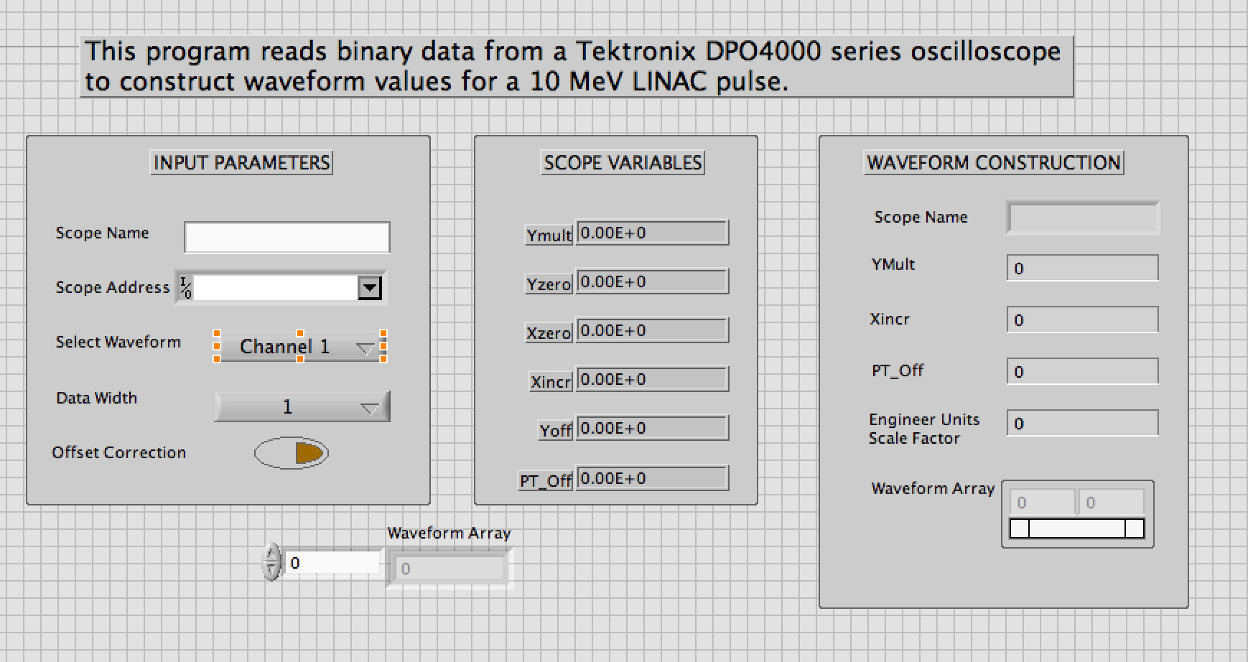

The sub-vi that acquires the waveform binary data:

