Example Word Document Content
This is a sample document with various elements that can be percieved by the indexer

Document Title and Introduction
Document Title: Project Proposal: Office Renovation Plan
Date: November 1, 2027
Author: Jane Smith, Facilities Manager

Section 1: Project Overview
The office renovation project aims to modernize our downtown headquarters to improve employee productivity and accommodate our growing team. The current layout is outdated and doesn't support our collaborative work culture.

Subsection 1.1: Objectives
- Increase collaborative workspaces by 40%
- Upgrade lighting to energy-efficient LED fixtures
- Improve accessibility compliance with ADA standards
- Reduce noise pollution in work areas

Text Box Example
This is a text box that contains content that should be discovered by the indexer

Table Example
Table 1: Renovation Timeline
Phase | Tasks | Start Date | End Date | Responsible Party
1 | Planning & Design | Nov 1, 2027 | Dec 15, 2027 | Facilities Team
2 | Demolition | Dec 16, 2027 | Jan 15, 2028 | Contractor A
3 | Electrical & Plumbing | Jan 16, 2028 | Feb 28, 2028 | Contractor B
4 | Interior Finishing | Mar 1, 2028 | Apr 30, 2028 | Contractor A
5 | Furnishing & Setup | May 1, 2028 | May 15, 2028 | Facilities Team

Section 2: Budget Considerations
The estimated total cost for the renovation is $275,000, broken down as follows:
- Design services: $25,000
- Demolition: $35,000
- Construction materials: $120,000
- Furniture and fixtures: $75,000
- Contingency (10%): $20,000

Section 3: Example image
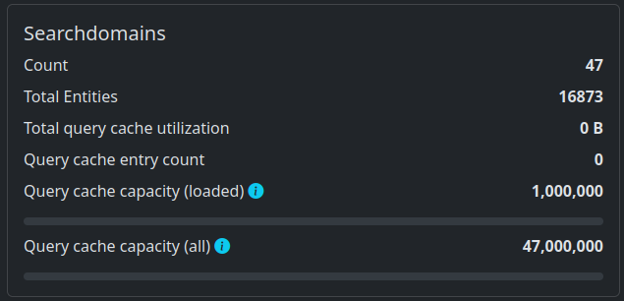Figure 1: Test caption

Conclusion
The proposed office renovation will significantly improve our work environment and support our company's growth objectives. We recommend moving forward with Phase 1 planning as scheduled.

