**Dayu Liu**

**Homework 1**

**0028021243**

**Note: <> means ≠ (not equal to)**

Question1

1. Find the snames of the students who registered in the course with cname "Database"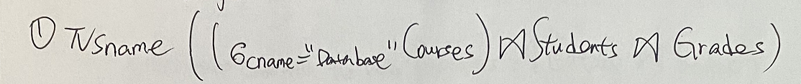

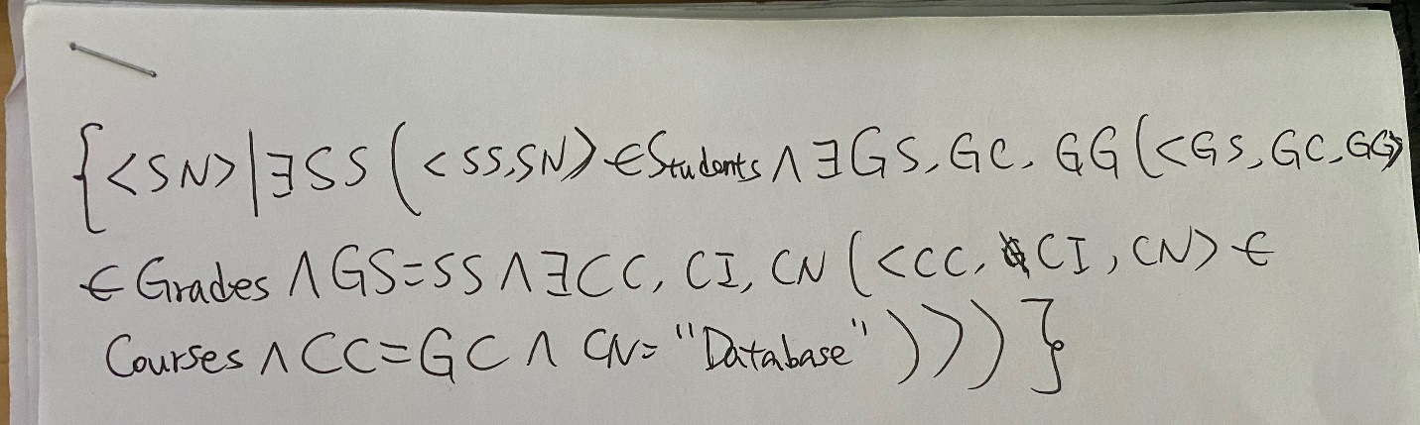2. Find the snames of students who got a ggrade "A" in all courses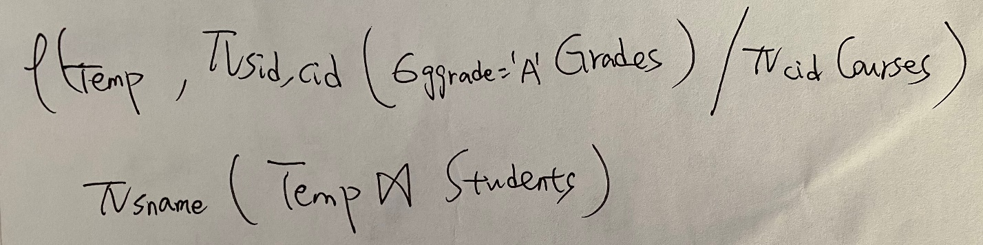

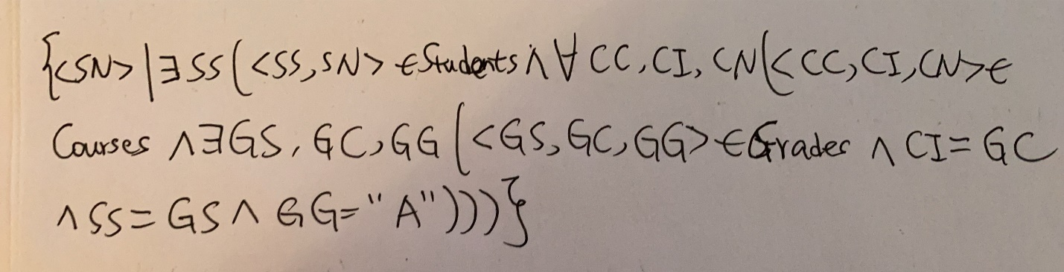

3. Find the cids of courses taught by at least two different instructors 

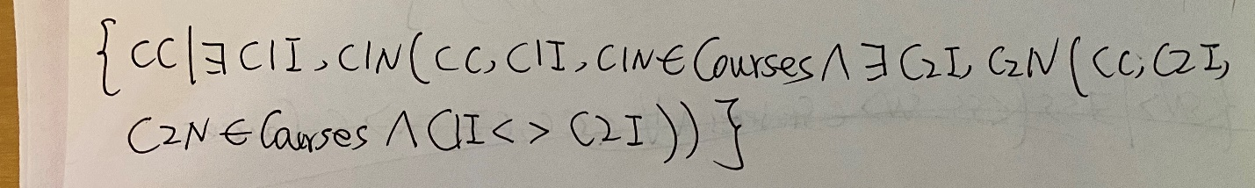

4. Find the sids of students who never received a ggrade "D" 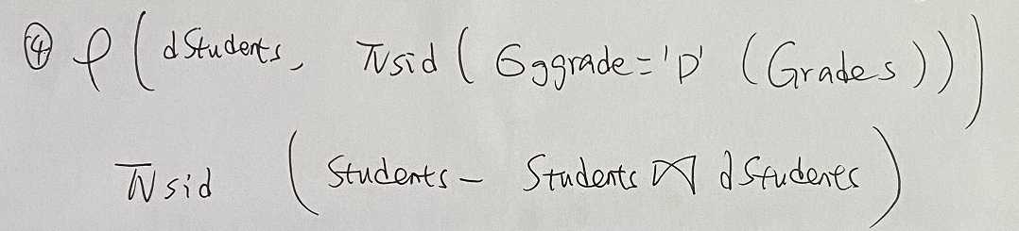

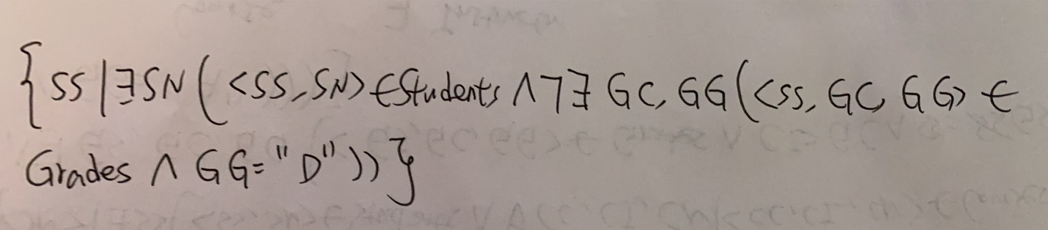

5. Find the sids of students who received the highest grade 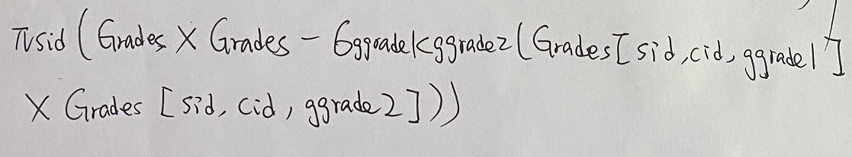

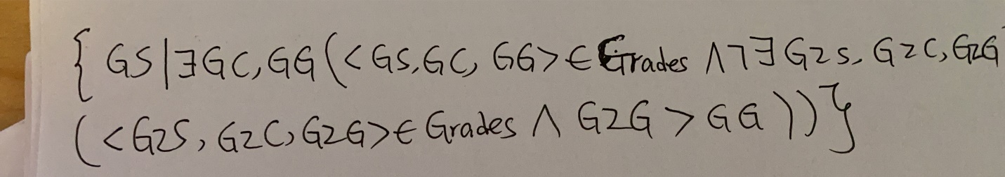

Question2

1.Find the name of the books which genres are fiction and prices are greater than 30 and publishers are Pottermore.

2.Find the pid of publisher who has a book that charges more than any other books published by other publishers.

3.Find the pid of publisher who has a book that charges less than any other books published by other publishers.

4.Find the pid of publish who has a book that charges more than any other books published by other publishers.

5. 