OCTAVA – Optical Coherence Tomography Angiography Vascular Analyser
OCTAVA is an open-source software designed for the automated extraction and quantitative analysis of OCTA-derived microvascular metrics from en-face images downloaded from the OCTA camera. OCTAVA provides a user-friendly graphical interface that facilitates detailed, non-invasive analysis of retinal, optic nerve head, and skin blood vessels, which is crucial for studying and diagnosing vascular diseases. The software does not provide automated image quality assessment; users are therefore responsible for evaluating image quality independently.

When using OCTAVA, cite the following peer-reviewed articles:
Untracht, G. R., Durkee, M. S., Zhao, M., Kwok-Cheung Lam, A., Sikorski, B. L., Sarunic, M. V., Andersen, P. E., Sampson, D. D., Chen, F. K., & Sampson, D. M. (2024). Towards standardising retinal OCT angiography image analysis with open-source toolbox OCTAVA. Scientific reports, 14(1), 5979. https://doi.org/10.1038/s41598-024-53501-6
Untracht, G. R., Matos, R. S., Dikaios, N., Bapir, M., Durrani, A. K., Butsabong, T., Campagnolo, P., Sampson, D. D., Heiss, C., & Sampson, D. M. (2021). OCTAVA: An open-source toolbox for quantitative analysis of optical coherence tomography angiography images. PloS one, 16(12), e0261052. https://doi.org/10.1371/journal.pone.0261052

How to Use OCTAVA
OCTAVA Graphical User Interface (GUI) is an intuitive interface featuring buttons, dropdown menus, and real-time visualisation panels for seamless user interaction.

PICTURE and DESCRIPTION HERE

The user first selects the image type for analysis: Retina, optic nerve head (ONH), or skin and insert image size The image is then processed with a series of image-processing techniques to generate OCTA microvascular metrics and, where applicable, foveal avascular zone metrics.

First, vessels in the image are segmented using filtering and binarisation techniques. Filtering enhances vessel visibility while reducing noise, improving overall image quality. The binarisation step then classifies pixels, assigning white to vessel structures and black to background noise. In the current version of OCTAVA, we use ……

Raw Image, Binarised Image and Skeletonised Image Figure Panel Here

OCTAVA supports both single- and batch-processing, enhancing its utility for handling large-scale studies.

OCTAVA OUTPUT
OCTA-derived Microvascular Metrics
OCTAVA can calculate multiple OCTA-derived metrics, summarised in the table below. The metrics are saved in an Excel file to facilitate easy compilation of data from multiple subjects. When batch processing is selected, multiple input images can be analysed automatically. For each image, a separate output folder is created to store the corresponding results. Additionally, a summary Excel file is generated that consolidates the output data from all processed images. For sub-region analysis, if the analysed image is de-centred and the sector is lacking more than 20% of the defined sub-region, the metrics for that sector are marked as NA.

Metric (abbreviation) | Unit | Analysed image | Description and importance | Illustration
Vessel area density (VAD) | % | Binarised | Perfused blood vessel area (white pixels) in the binarised OCTA MIP image divided by total image area (all pixels) multiplied by 100. Can be used to demonstrate ischemia.
Vessel length density (VLD) | % | Skeletonised | Total vessel length multiplied by the width of one pixel (i.e., total area of skeletonised vessels) divided by the total image area and multiplied by 100. Length measurements are calculated from the skeletonised OCTA MIP image. More sensitive than VAD to perfusion changes at the capillary level.
Mean, median, and distribution of vessel diameter | μm | Binarised | Mean, median, and distribution of diameter measurements are acquired using a Euclidian distance transform applied to the binarised OCTA MIP. The mean (median) diameter is the mean (median) for a single vessel, including one value for each identified segment. Can inform on dilation, sprouting, or vessel regression.
Total, mean, median, and distribution of vessel length (VL) | μm | Skeletonised | Total, mean, median, and distribution of the single-vessel centreline lengths including one value for each identified segment measured from the skeletonised image. Network interconnectivity and branching patterns can indicate oxygenation/nutrient delivery dysfunction.
Branchpoint density (BD) | nodes/mm | Skeletonised | Number of identified nodes divided by total vessel length. May indicate resilience to occlusion or blockage of blood flow.
Mean (MeanT) and distribution of vessel tortuosity | 1 | Skeletonised | Tortuosity is calculated from the arc length-over-chord ratio. Can inform on pathological microvascular remodelling and/or ischemia.
Fractal dimension (D_{F}) | 1 | Binarised | Indication of how the network fills space on variable length scales, calculated using the box counting method. FD is commonly reported as FD ± FD_{error}. Altered spatial distribution of the capillary network is an indicator of impairment of oxygenation and nutrient delivery.
Foveal avascular zone area (FAZA) | mm² | Binarised | Total area of black pixels enclosed by the FAZ segmentation contour. Changes in the FAZA can be indicative of macular oedema or ischemia and changes in retinal thickness.
FAZ perimeter | mm | Binarised | Length of the perimeter of the FAZ segmentation contour. It provides an additional metric about the change in FAZA.
FAZ axis ratio | 1 | Binarised | Ratio between the major and minor axis of the ellipsoidal best fit to FAZ outline shape. Elongation of the FAZA can be indicative of changes in retinal thickness.
FAZ circularity | 1 | Binarised | FAZ area multiplied by 4p divided by FAZ perimeter. Indicates elongation of the FAZ, which can be indicative of changes in retinal thickness.
FAZ acircularity index | 1 | Binarised | Ratio between the measured perimeter and the perimeter of a circular area of the same size. Indication of elongation of the FAZ.
Foveal avascular density 300 (FD-300) | % | Binarised | Percentage of the area occupied by vessels (white pixels) divided by the area in a 300-μm width rim surrounding the FAZ. This rim width value was originally chosen based on the relationship between FAZ and ganglion cell complex thickness in normal eyes to better distinguish between normal variations in FAZ and those due to pathology.

SOFTWARE AVAILABILITY and INSTALLATION
MATLAB source code:
Python source code:
PC Stand-alone version:
Mac Stand-alone version:
Dataset with OCTAVA-generated output for testing:

AUTHORS:
The following individuals made substantial intellectual contributions to the design, implementation, and maintenance of the OCTAVA 3.0 software and take responsibility for its content:
- Danuta Sampson (Lions Eye Institute)
- Mila Zhang (Lions Eye Institute)
- Dayu Liu (Lions Eye Institute)
- Gavrielle Untracht (Technical University of Denmark)
- Madeleine Torcasso (University of Chicago)

CONTRIBUTORS:
We gratefully acknowledge the following individuals for their contributions to this project, including code translation and advancement, testing, debugging, and discussions:
- Martin Utrera (University of Chicago); partial code translation and extensions
- Jiashuai Chai (Lions Eye Institute); partial code translation and extensions
- Laurel Chow (University of Western Australia); partial code translation and extensions
- Ishita Sharma (Lions Eye Institute); partial code translation and extensions
- Simon Hoffman (Karlsruhe Institute of Technology); discussions; documentation feedback
- Ondine Gordon (Western Australia; consumer feedback); discussions; documentation feedback
- Tim Benson (Western Australia; consumer feedback); discussions; documentation feedback

CONTRIBUTION TAXONOMY:
Conceptualisation: Sampson, Untracht & Torcasso
Software architecture: Zhang and Untracht
Core implementation: Binarisation (Zhang), Skeletonisation (Utrera & Chai), FAZ segmentation (Chow and Liu; ONH Module (Chai)
Validation and testing: Sampson & Zhang
Documentation: Sampson, Zhang, Untracht & Torcasso
Consumer feedback: Hoffmann, Gordon & Benson
Supervision: Sampson

SOME NOTES FROM THE PREVIOUS OCTAVA IN MATLAB – THAT CAN BE USEFUL
Batch processing:
One image size in the folder | Variable image size in the folder *
- Set Frangi Parameters (max and min).  - Select the segmentation method.  - Select Twig size (or AT kernel size (if your segmentation method is adaptive thresholding). Note: Fuzzy means is recommended over AT  - Insert image size (the length of the scan in mm).  - Select the path for the Raw data folder.  - Tick Batch resize to 1000 if your input data not scaled to 1000 × 1000 pixels.  - If you aim to undertake regional analysis and segment FAZ make sure that these are ticked in Batch Processing section.  - If all images to be analyzed are the same size, the variable img size should be unticked and process from folder should be selected.  - Select the path for the save folder. Note: All numerical values (excel file) and images will be saved automatically to your selected folder.  - Select the eye you analyse (left/right).  - Select the grid type in the regional analysis if your aim is sub-regional analysis. The type of grids implemented are shown at the bottom of this document.  - Press: Start batch process. | - Set Frangi Parameters (max and min).  - Select the segmentation method.  - Select Twig size or AT kernel size (if your segmentation method is adaptive thresholding). Note: Fuzzy means is recommended over AT  - Insert image size (the length of the scan in mm).  - Select the path for the Raw data folder.  - Tick Batch resize to 1000 if your input data not scaled to 1000 × 1000 pixels.  - If you aim to undertake regional analysis and segment FAZ make sure that these are ticked in Batch Processing section.  - If images to be analyzed vary in size, ensure the variable img size is ticked and process from the list selected. *  - Select the path for the save folder. Note: All numerical values (excel file) and images will be saved automatically to your selected folder.  - Select the eye you analyse (left/right).  - Select the grid type in the regional analysis if your aim is sub-regional analysis. The type of grids implemented are shown at the bottom of this document.  - Press: Start batch process. The software will ask to provide directory to excel file in which information about each image size is stored. Then the software will ask which regional analysis to select.

* For variable image size analysis, you must create an Excel file that includes two columns. Column (name) and column (size). The first column lists all OCTA images for analysis, and the second one each image size (scan length in mm). Make sure that the structure is as below; both “name” and “size” should include only lowercase letters.
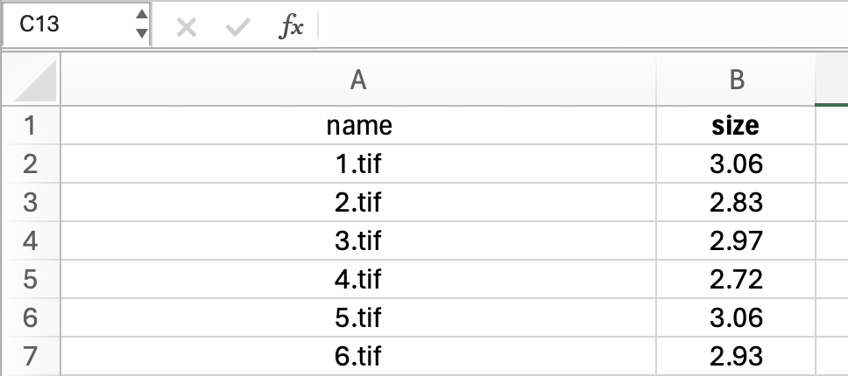

SUB-REGIONAL ANALYSIS: ZONE DEFINITIONS

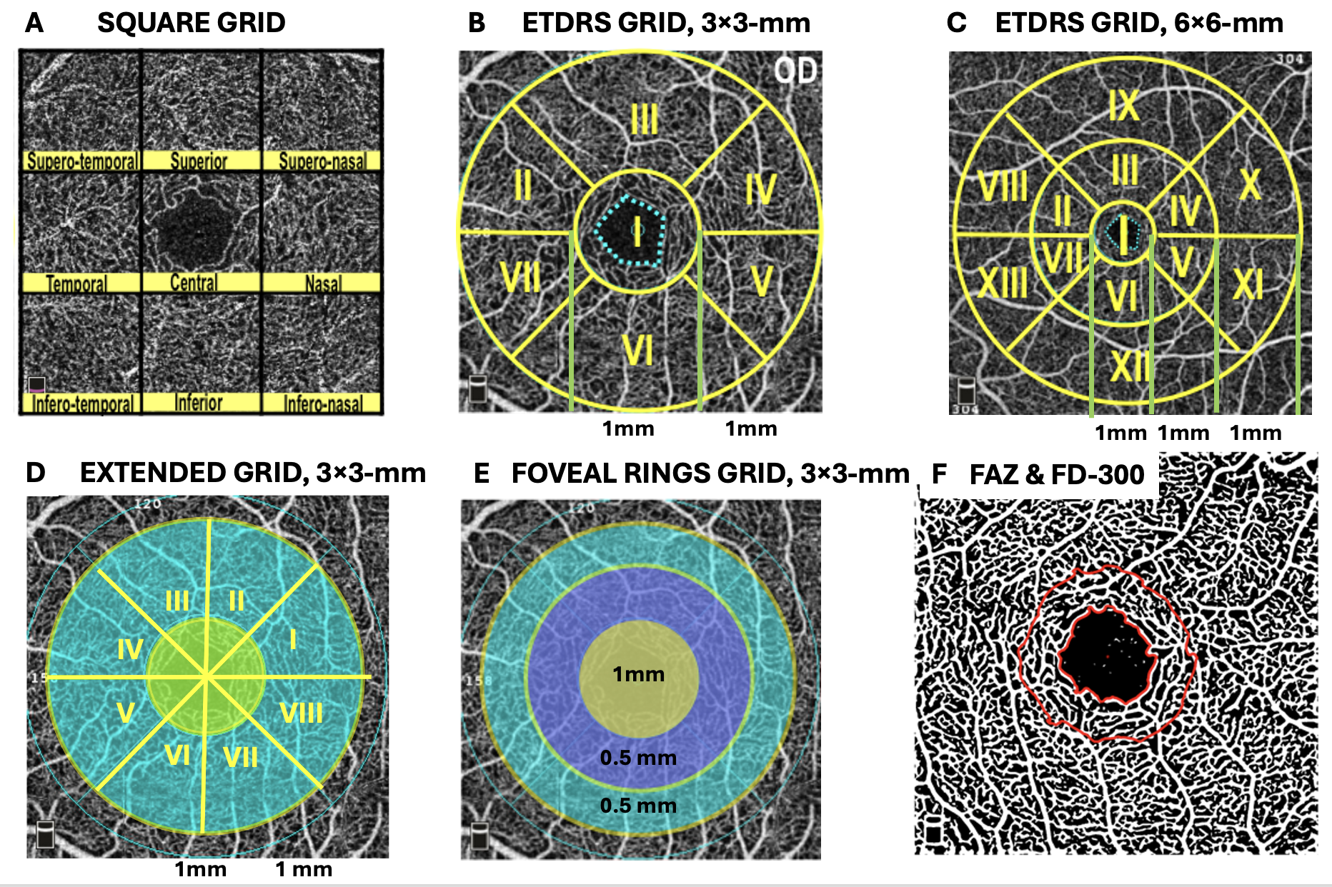

RETINA: ETDRS GRID 3$×$3-mm
 | OD RIGHT EYE | OD LEFT EYE
Section | Zone | Zone
Whole image | All | All
Foveal circle | I | I
Parafoveal rim | II-VII | II-VII
Superior hemisphere | II-IV | II-IV
Inferior hemisphere | V-VII | V-VII
Temporal | II & VII | IV & V
Superior | III | III
Nasal | IV & V | II & VII
Inferior | VI | VI

