

M MINISTRY OF EDUCATION AND TRAINING

**UNI UNIVERSITY OF ECONOMICS AND FINANCE**

**PROJECT REPORT**

# Desktop Application Development

**TOPIC**

**Billiard Management Program**

Major: **Information Technology**

Minor: **Software engineering**

**Ho Chi Minh City, 2023**

MINISTRY OF EDUCATION AND TRAINING

**UNIVERSITY OF ECONOMICS AND FINANCE**

**PROJECT REPORT**

# Desktop Application Development

**TOPIC**

**Billiard Management Program**

Major: **Information Technology**

Minor: **Software engineering**

**Supervisor**: Hoang Van Hieu

**Student ID 1**: 195050974 **Student’s name 1**: Le Tan Dat

**Student ID 2**: 215052247 **Student’s name 2**: Nguyen Viet Hoa

**Student ID 3**: **Student’s name 3**: Nguyen Ngoc Thinh

**Class:** A04E

**Ho Chi Minh City, 2023**

**TABLE OF CONTENTS**

**Chapter 1: Overview of the research** 1

1.1 Reasons for choosing the topic 1

1.2 Introduction of the problem and some related research 1

1.2.1 Introduction to the problem 1

1.2.2 Related studies 2

1.2.3 Challenges in the problem 2

1.2.4 Approach to solving problems 3

1.3 Objectives, objects, scope of research 3

1.3.1 Research objectives 3

1.3.2 Subjects of study 4

1.3.3 Scope of research 4

1.4 Research content and methods 4

1.4.1 Research contents 4

1.4.2 Research methodology 5

1.5 Contributions 5

**Chapter 2: System Design Analysis** 6

2.1 Analysis and design of information systems 6

2.2 Approaches and development of an information system 6

2.3 Development steps of an information system 7

2.4 Some development models of an information system 8

2.5 Methods of structurally oriented design analysis 8

2.6 Description of management process and tools of Science and Technology Department 10

2.6.1 Process of registration, approval, acceptance and liquidation of student scientific research projects 10

2.7 System design analysis 11

2.7.1 Status analysis 11

2.7.2 Define requirements 11

2.1 Functional requirements 11

2.2 Non-functional requirements 11

3.1 Schema of data tables 12

3.2 List and functionality of main data tables 13

**Chapter 3: Building and Experimenting Systems** 14

3.1 System functions 15

3.1.1 Login 15

3.1.2 Manage guest playtime 16

3.1.3 Food management 16

3.1.4 Revenue management 17

3.1.5 Add, delete, edit account information 17

3.1.6 Payment 18

3.2 Program interface 18

3.2.1 Login interface 19

3.2.2 Guest playtime management interface 20

3.2.3 Food management interface 20

3.2.4 Revenue management interface 21

3.1.5 Interface add, delete, edit account information 21

3.1.6 Payment interface 22

**Chapter 4 Conclusion and development direction** 22

4.1 Conclusion 23

4.2 Development direction 24

**Bibliography** 24

**LIST OF ABBREVIATIONS**

|  |  |  |
| --- | --- | --- |
| **ST** | **Abbreviations** | **Description** |

**Chapter 1: Overview of the research**

### 1.1 Reasons for choosing the topic

Billiards is a sport with a touch of art, loved by many people and played in their spare time. Nowadays, when human life is more advanced, people need more than material things and many people also look to billiards, as a form of entertainment and relaxation after stressful working hours. Therefore, billiards bars and clubs are growing and attracting many customers.

However, managing a billiards bar is not simple, as it involves many activities such as billing, maintenance, statistics, searching, printing receipts, etc. If only using traditional methods such as books, tables, calculators, etc., it will face many difficulties and inconveniences, such as lost time, errors, difficult to control, difficult to update, etc.

* To solve the above difficulties, we chose the topic of billiards bar management project to apply the knowledge of information technology to solve practical problems of billiards bars and clubs. This project is highly practical, creative, attractive and challenging.

### 1.2 Introduction of the problem and some related research

### 1.2.1 Introduction to the problem

The problem of billiards bar management is the problem of applying information technology to solve practical problems of billiard bars and clubs, such as billing, maintenance, statistics, searching, printing invoices, etc. This problem can be defined as follows:

* Input: is the information of billiards bars and customers using billiards services, such as name, address, phone number, billiard table number, hourly table rental, table rental hours, payment amount, etc.
* Output: are web-based billiards bar management functions, such as login and logout, billiards bar management, customer management, cash register, bill printing, statistics, search, etc.
* The goal: is to help users manage billiards bars more efficiently and conveniently than traditional methods. This problem has implications for practice and theory as follows:
  + For practicality: is to help users save time, effort and costs in managing billiards bars. This problem also contributes to improving service quality and customer satisfaction when using billiards services.
  + For theory: is to contribute to the development and application of knowledge of information technology to solve practical problems. This problem also opens up new and exciting research directions for scientists and students in this field.

### 1.2.2 Related studies

Studies related to billiards bar management are studies on how to open, operate and develop billiards bars and clubs, as well as how to apply information technology to billiards bar management.

### 1.2.3 Challenges in the problem

The challenges in billiards bar management are the difficulties, limitations, risks and obstacles that we have to face and solve when implementing this topic. Some of the key challenges are:

* Data collection and processing: is the search, collection, storage, processing and analysis of data of billiards bars and customers using billiards services. Data collection and processing requires us to have the appropriate skills and tools to ensure the full range of features required during operation and operation.
* Application design and construction: is the selection and use of the window form c# language. This application must meet the analyzed functional and non-functional requirements. The application must also have a user-friendly and easy-to-use interface. Designing and building applications requires us to have knowledge and experience in programming and application management.
* Application testing and deployment: is the testing and evaluation of the performance and accuracy of the application through criteria such as processing time, memory capacity, number of errors, etc. There is also the implementation of the application for some actual billiards bars to test the effectiveness and applicability of the application. Application testing and deployment requires us to have supporting methods and tools to ensure the quality and safety of the application.

### 1.2.4 Approach to solving problems

* Requirements analysis: is the study of billiards management problems, defining the objectives, objects, scope of research and functional and non-functional requirements of the application.
* Data collection and processing: is the use of tools to search, collect, store, process and analyze data of billiards bars and customers using billiards services.
* App design and construction: We will follow the principles of interface design and object-oriented programming to ensure the aesthetics and functionality of the application.
* Application testing and deployment: is the use of methods and tools such as white box testing, black box testing, system testing, user acceptance testing, etc. to test and evaluate the performance and accuracy of the application. There is also the implementation of the application for some actual billiards bars to test the effectiveness and applicability of the application. We will collect user and customer feedback to improve and improve the app.

### 1.3 Objectives, objects, scope of research

### 1.3.1 Research objectives

Our research goal is to build a billiards bar management application in the form of c#, which has basic functions such as login and logout, billiards management, customer management, cash register, bill printing, statistics, search, etc. We want to achieve the following results:

* Complete the billiards bar management application according to the analyzed functional and non-functional requirements.
* Evaluate application performance and accuracy through criteria such as processor time, memory capacity, number of errors, etc.
* Compare and evaluate the advantages and differences of the application compared to other billiards bar management software on the market.
* Recommend and implement the app for some actual billiards bars to test the effectiveness and applicability of the app.

### 1.3.2 Subjects of study

Our research subjects were billiards bars and billiards customers. We want to build an app that suits the needs and tastes of both of these audiences. We will collect information and opinions of billiards bars and customers to analyze requirements and design applications. We will also test and evaluate the application on the basis of feedback from these subjects.

### 1.3.3 Scope of research

The scope of our research is limited to a few billiards bars in the area We will select a number of billiards bars that are representative of different types of billiards bars, such as size, business model, target audience, etc. We will conduct research on the basis of information and data of these billiards bars. We do not apply the app to billiards bars

### 1.4 Research content and methods

### 1.4.1 Research contents

* Requirements analysis: is the study of billiards management problems, defining the objectives, objects, scope of research and functional and non-functional requirements of the application.
* Data collection and processing,
* Design and build apps,
* Application testing and deployment

### 1.4.2 Research methodology

Our research methodology includes the following:

* Documentary research methods
* Survey methodology
* Programming methods
* Test methodology
* Implementation methods

### 1.5 Contributions

The contribution of the project is the benefits and differences that the project brings to the field of information technology and billiards management. Let me summarize the contributions of the topic as follows:

* For the field of information technology: is to contribute to the development and application of knowledge and skills in window form c# programming, databases, interface design, application testing, etc. to solve practical problems. The topic also opens up new and exciting research avenues for scientists and students in this field.
* For billiards bar management: is to help users manage billiards bars more effectively and conveniently than traditional methods. The application also contributes to improving service quality and customer satisfaction when using billiards services.
* Compared to related studies: the topic has the following advantages and differences:
  + The topic has a new approach to using information technology to build a billiards bar management application based on window form c#, while related studies only focus on the billiards business aspect.
  + The topic is more comprehensive and detailed, covering work from requirements analysis, data collection and processing, application design and construction, application testing and deployment, while related research provides only basic and useful information.
  + The topic is highly scientific and empirical, using methods of documentary research, survey, programming, testing, implementation, while related studies are based only on the author's personal experience and views.

## Chapter 2: System Design Analysis

### 2.1 Analysis and design of information systems

**- Definitions**

- A system is a collection of elements that are organically related to each other, acting to govern each other according to certain laws to become a whole. From this comes a new property called the emergence of the system that each individual element does not have or has is negligible.

An information system is a system consisting of interrelated elements that collect, process, store and distribute information and data and provide a feedback mechanism to achieve a predetermined goal. Organizations can use information systems for a variety of purposes.

- Management Information System is a system that provides information for the management of the organization. The system consists of people, equipment and processes that collect, analyze, evaluate and distribute necessary, timely and accurate information to decision makers in the organization.

### 2.2 Approaches and development of an information system

* PDA (Process-Driven Approach): This is an approach that focuses on the design and development of systems based on the organization's business processes and processes. PDAs place great emphasis on optimizing and improving business processes before building information systems. The main goal is to create systems to support and optimize business activities.
* DDA (Data-Driven Approach): In this approach, the focus is on managing and using data effectively. Data is considered the heart of the information system. DDA places a focus on building robust databases and managing data carefully to ensure accuracy and readiness for business decisions.
* SDA (Service-Driven Approach): This approach focuses on building information systems using independent services. Each service can perform a specific task and is reusable. SDA promotes easy integration and expansion using already existing services.
* OOA (Object-Oriented Approach): This is an object-oriented approach in which information systems are constructed using objects and object classes to represent concepts and functions. OOA helps create logical relationships between objects and easily manage source code.

### 2.3 Development steps of an information system

* **Survey:** Gather information about project needs and requirements. It is necessary to understand the objectives of the system and gather information from end users, management, and stakeholders to clearly define what the system needs to accomplish.
* **System analysis: Detailed analysis** of system requirements. This includes defining the necessary functions and processes, evaluating the overall architecture of the system, and defining data flows and relationships between components.
* **System design:** Build the detailed architecture of the system. Designing databases, data schemas, user interfaces, and defining development standards and rules helps create a detailed blueprint for the system.
* **Building information systems:** Program applications and system components based on the created design. Build a database and implement a data processing workflow, then integrate components together.

**Installation and maintenance:**  Deploy the system into a production environment, train end users on how to use the system, and conduct maintenance and management of the system throughout its lifecycle. Maintenance ensures confidentiality and compliance with rules and regulations.

### 2.4 Some development models of an information system

* Waterfall Model (Downflow)
* Agile Paradigm
* Spiral Model (Spiral Model)
* V-Model (V-shaped model)
* Incremental Model (Partial Integration)
* RAD (Rapid Application Development) model

### 2.5 Methods of structurally oriented design analysis

Databases

* **Data:** Includes clauses that reflect reality. A large classification of important propositions in practice are measurements or observations of a variable quantity
* **Database:** A database is an organized collection of interrelated data, usually stored and accessed electronically from a computer system.
* **Relational database: A relational**  database is a type of database that stores and provides access to data points that are related to each other.
* **How to form a relationship:**
* **Data binding:** In order to ensure that data storage is suitable for the object in practice, the three most basic types of constraints can be said
* Type constraints
* Analytic constraints
* Logical constraints
* **Operations on relational databases: Databases** frequently change thanks to mathematical operations.
* **Insert: Is** the permission to add a new set to a certain relation.
* **Delete - Delete:** An delete from any set relation.
* **Change:** Modify the contents of any set.

|  |  |  |
| --- | --- | --- |
| Step | Order of execution | Responsibility |
| 1 | Approve  Failed  Do not sign contract  Failed  Approve  Cancel  Not Approve    Approve    Sign  Contract  Approve  Review  Review  Review  Apply  Review  Review | * Department of Science and Technology * Dean/Deputy Dean in charge of Science and Technology |
| 2 | * Dean/Deputy Dean in charge of Science and Technology   Notice of registration of the topic   * Instructors * Project Leader |
| 3 | * Dean/Deputy Dean in charge of Science and Technology * Faculties Review Board * Department of Science and Technology |
| 4 | * Department of Science and Technology * Project Leader * Instructors * Dean/Deputy Dean in charge of Science and Technology |
| 5 | * Department of Science and Technology * Project Leader * Instructors * Dean/Deputy Dean in charge of Science and Technology |
| 6 | * Dean/Deputy Dean in charge of Science and Technology * Department of Science and Technology * Project Leader |
| 7 | * Dean/Deputy Dean in charge of Science and Technology * Department of Science and Technology * Project Leader * Instructors |
| 8  Settlement | * Department of Science and Technology * Science and Technology Department * Project Leader |

### 2.6 Description of management process and tools of Science and Technology Department

### 2.6.1 Process of registration, approval, acceptance and liquidation of student scientific research projects

The process of registration and approval of student scientific research projects is developed clearly and in detail by the Department of Science and Technology. With that information in mind, the team modeled the process as follows:

Process of registration, approval, acceptance and liquidation of student scientific research topics: Lecturers or students or faculty secretaries will enter the topic information on behalf and proceed to submit the topic for approval. GauzeWhen submitting topics, the list of topics will be transferred to the department level for review. If the topic is approved, it will be forwarded to the Science and Technology Department for review. If the topic is approved, the research team will proceed with the project. On the contrary, topics that are not reviewed at the faculty or science and technology level will be notified of corresponding edits.

### 2.7 System design analysis

### 2.7.1 Status analysis

Currently, the demand for playing billiards is increasing, billiards bars are constantly being opened, so the need to manage the bar effectively is also increasing, so we have written a billiards bar management program to serve and manage billiards bars effectively.

### 2.7.2 Define requirements

### 2.1 Functional requirements

The system is built for the following groups of users:

* **Manager:**
* View revenue
* Add, delete, edit feed information
* Add, delete, edit account information
* Calculate playtime
* Order food
* Bill payment
* **Employee:**
* Calculate playtime
* Order food
* Bill payment

### 2.2 Non-functional requirements

System requirements

* Decentralization

The system is assigned permissions according to user groups. With the manager with the highest authority, have the right to update and edit price information, view revenue, order food and pay bills for guests. Staff have the right to add orders and pay bills for guests.

* Experimental configuration

The group gives a computer configuration that has at least the following configuration:

* Laptop with minimum Core i3 configuration
* 4GB RAM
* Stable Internet connection.
* Install Microsoft Visual Studio software from version 2010 or later.
* Software implementation tools:
* Use C#
* Programming tools: Visual Studio 2017
* Microsoft SQL Server 2016 Database Management System

### 3.1 Schema of data tables

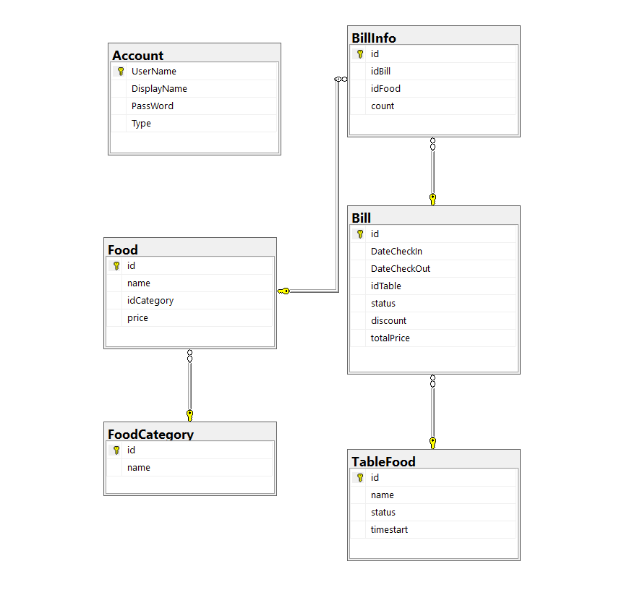

### 3.2 List and functionality of main data tables

Table 1: List and functions of revised tables

|  |  |  |
| --- | --- | --- |
| STT | TABLE NAME | DESCRIBE |
| 1 | Account | Store login account information |
| 2 | TableFood | Store information of the current table |
| 3 | FoodCategory | Information storage of foods |
| 4 | Food | Store information about foods and prices |
| 5 | Bill | Store invoice information |
| 6 | BillInfo | Store invoice information for each table |

## Chapter 3: Building and Experimenting Systems

**3.1 System functions**

**3.1.1 Login**

Logon functionality is the process by which users authenticate their identity by providing credentials such as a username and password to access a system or application.

**3.1.2 Manage guest playtime**

The guest play time management feature in the billiards management software allows recording the time each customer uses the pool court. This helps calculate costs and ensures that people pay based on actual play time, at the same time Help manage billiards bars effectively, monitor yard usage.

**3.1.3 Food management**

The food management function in billiards management software is not to record and time billiards, but rather to manage and track the food orders that customers place in the billiards bar. This function helps record menu lists, update, add, delete and edit food lists, calculate total amounts, and ensure that customers are served food efficiently and accurately.

**3.1.4 Revenue management**

Delegation management functionsRevenue in billiards bar management software aims to record, calculate and track all income from transactions, including proceeds from playing billiards, ordering food, beverages and other services, to ensure effective revenue tracking and management.

**3.1.5 Add, delete, edit account information**

Account management functions in a billiards bar management software include adding (registering) new accounts, deleting unnecessary accounts, and correcting users' personal information.

**3.1.6 Payment**

Payment functions In the billiards bar management software allows customers to pay for services and products that they have used or purchased in the billiards bar.

**3.2 Program interface**

**3.2.1 Login interface**

Login: when launching the application, the login form appears, enter your username and password. There are 2 types of accounts: admin and staff. Clicking the login button will log in to the form, the exit button to exit the program.

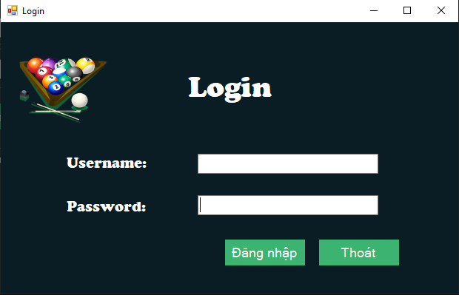

**3.2.2 Guest playtime management interface**

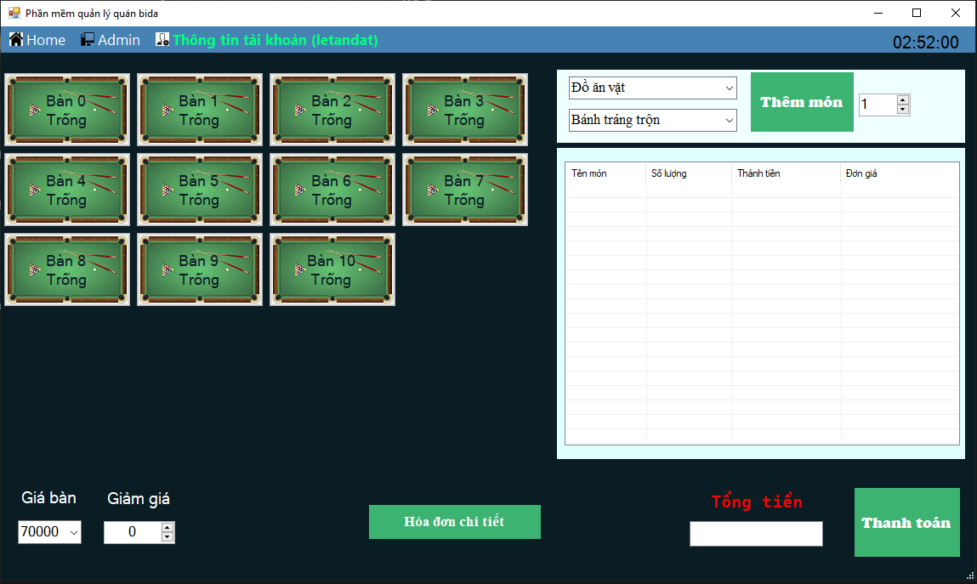

When logging in Success will show the form. Select the table, then select food and drinks, then click start timer, the time will be displayed in the txt box, the start time and start timer. When the payment button is finished, the end time txt box will display the play time and show the payment box

**3.2.3 Food management interface**

After clicking to select the table, you can choose the type of food and drink as well as the name of the dish in the 2 boxes below, the number box next to it is the quantity, after choosing the dish, click more dishes. If you order th.At the time of calculation, just click Add default value none

The table below is a list of available items. When logged in with an admin account, we can track the list as well as perform operations of adding, deleting, editing dishes and searching for food

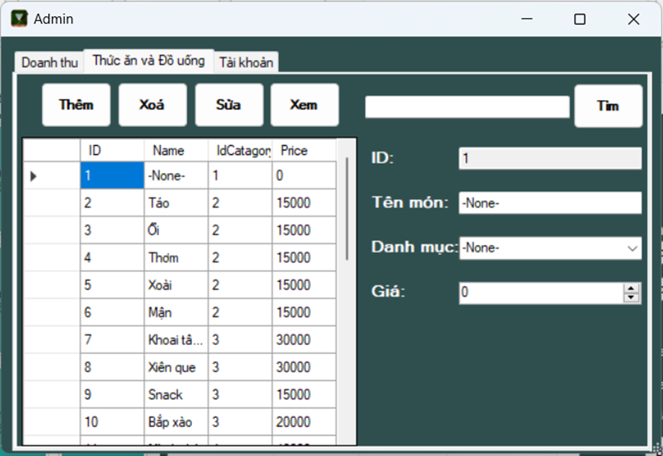

**3.2.4 Revenue management interface**

When logging in with tk admin, we Revenue can be tracked by day or by month when clicking on the Start and end date boxes, the default values will be the first day of the month and the last day of the month. Then click statistics, the bill information for the month will appear

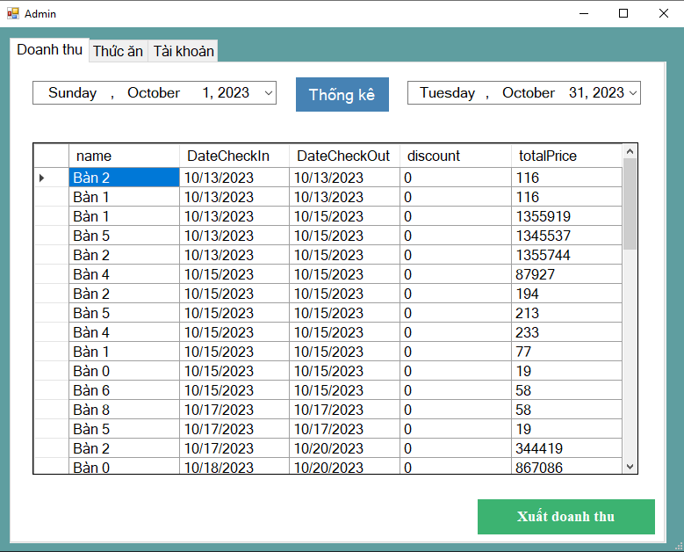

**3.1.5 Interface add, delete, edit account information**

When logging in with tk admin, we can go to the tk section to keep track of the display name and username of the tk as well as can add, delete and edit that tk but cannot change mk

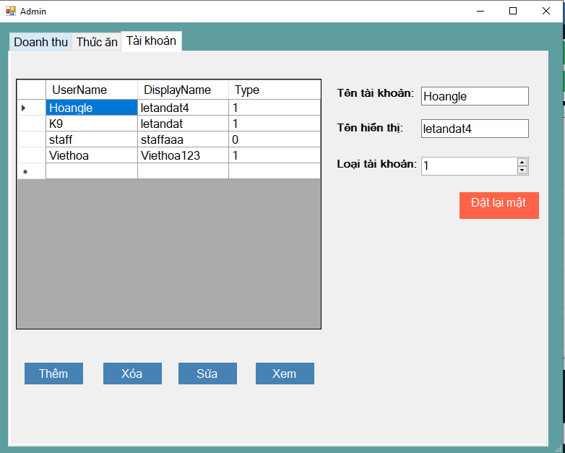

Outside the main interface, there will be a personal information section. In this section, we can track the lower information of the account we log in and can use the desired mk.

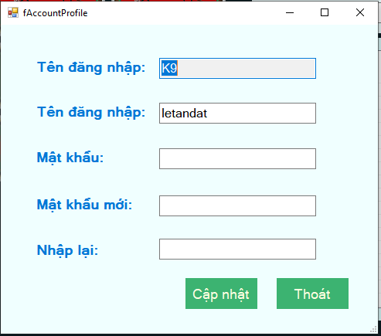

**3.1.6 Payment interface**

After selecting the table and discounting (if any), we click the payment button, it will display a box announcing the amount and save all data to the database

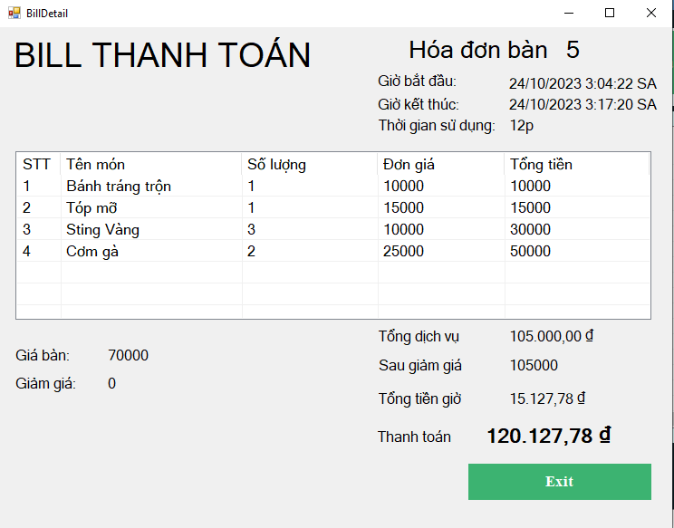

After selecting a table and clicking the payment button

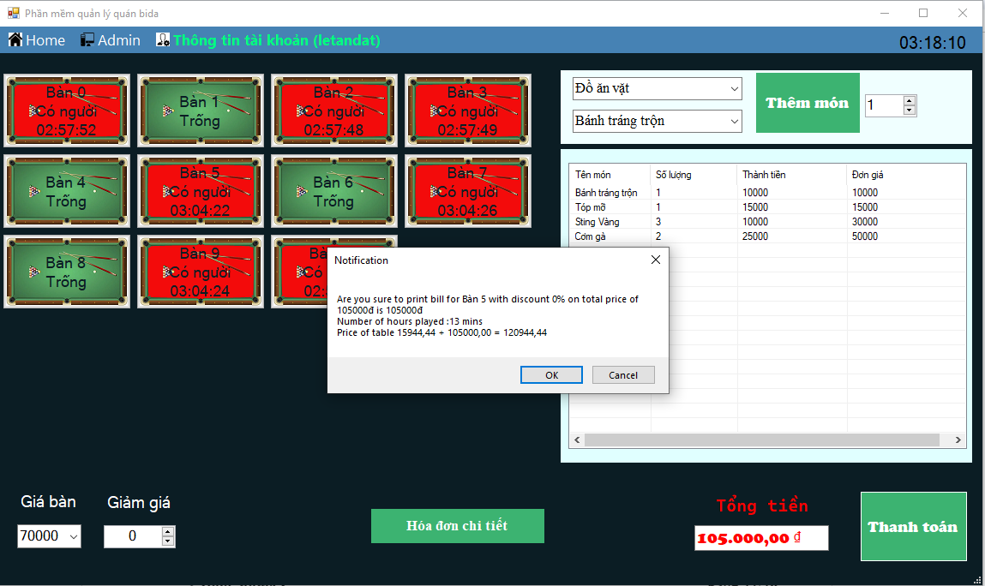

## Chapter 4 Conclusion and development direction

**4.1 Conclusion**

The project has researched and built a billiards bar management system. The system has been completed and is awaiting approval. The system helps employees as well as managers conveniently manage and monitor operation of the shop. In addition, the program can also help staff more quickly check payment and make it more convenient for customers to serve customers.

In addition to management support, the program revenue management desk tracking also has can expand the functions of archiving, statistics, printing and issuing invoices, managing the frequency of customer visits, checking VIP guests, creating customer memberships, etc

**4.2 Development direction**

In addition to the results achieved, the topic still has some unresolved issues get

* Optimizing table reservations: how to optimize the reservation process and arrange billiards schedules so that they make the most of the pool court without causing time conflicts.
* Human resource management: Manage employees and shifts, as well as integrate employee work schedules into the system to ensure a sufficient number of employees on each shift.
* Data analysis and performance evaluation: How to collect and analyze data from business operations and use them to evaluate performance, anticipate customer needs, and improve management.
* Customer engagement: Engage with customers through the mobile app, announce play-ready times, book remote tables, and the ability to evaluate services.

In the coming time, the team will continue to research to overcome, limit and expand new functions.

## Bibliography

[1] Programming C# Winform café management software

<https://www.youtube.com/watch?v=tu2k9ZrDlWA&list=PL33lvabfss1xnPhBJHjM0A8TEBBcGCTsf>

[2] Stored Procedure

<https://viblo.asia/p/gioi-thieu-stored-procedure-trong-sql-server-m68Z0VpM5kG>

[3] SQL basic

https://www.w3schools.com/sql/