- Access: localhost: 8080/StudentManagementlab/
1.1 All request will pass through filter.AuthFilter
@WebFilter(filterName = "AuthFilter", urlPatterns = {"/*"})
1.2 AuthFilter detect public url. If user is not logged in, redirect to login
“String loginURL = contextPath + "/login";
httpResponse.sendRedirect(loginURL);”
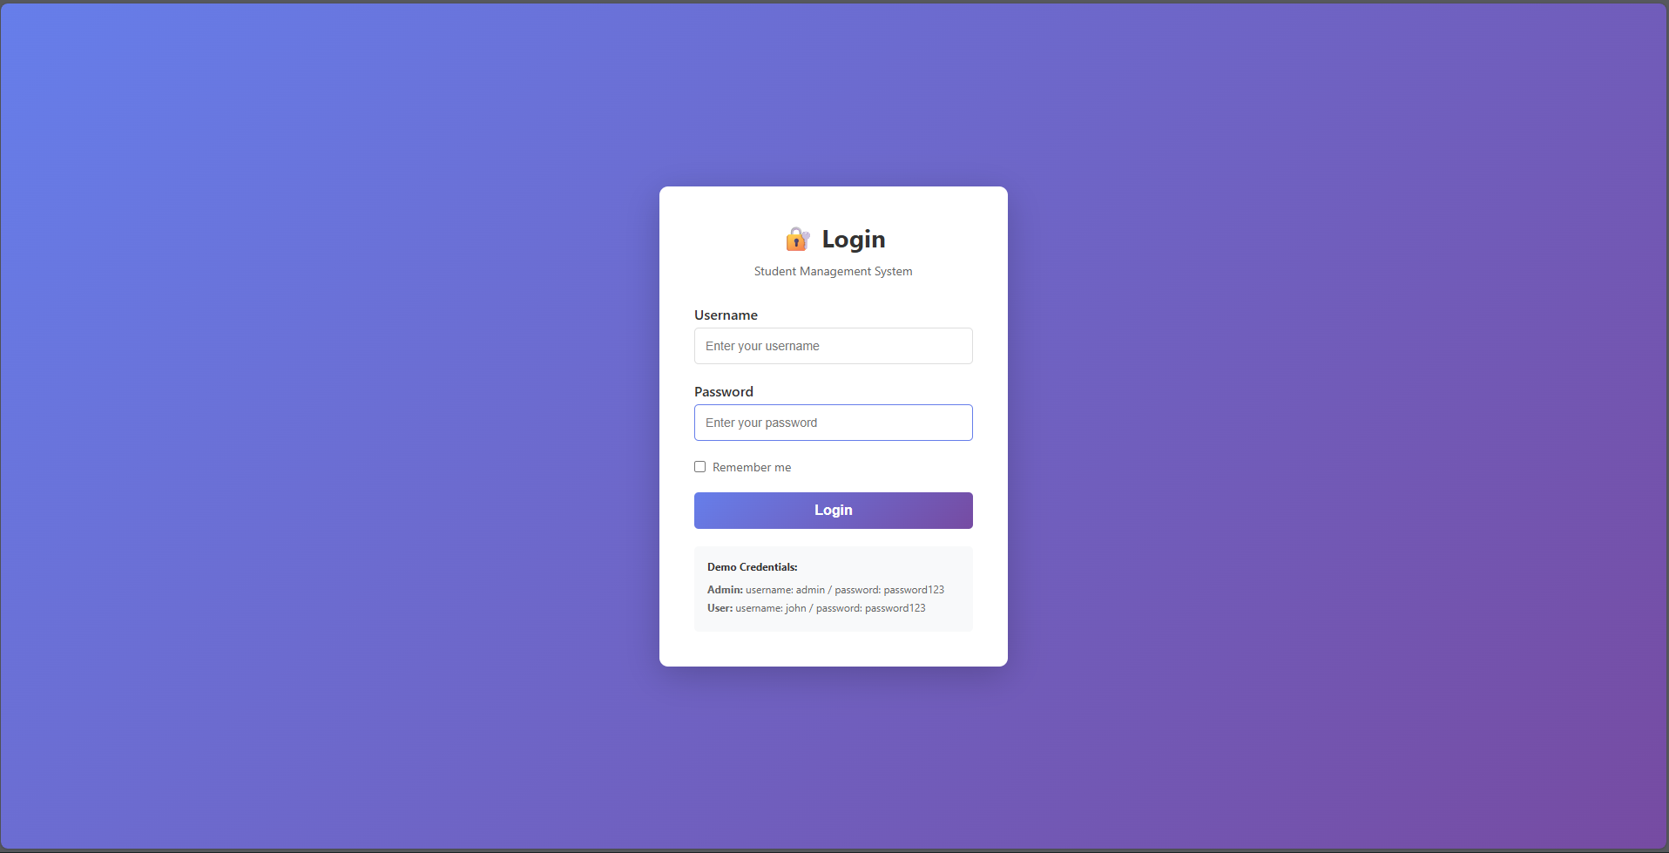

- Login with: admin / password123 (Admin case)
  - user enter the username and password. After click “login” button, the login page with send request method “POST” to LoginController.java

  - LoginController get parameter and call dao.UserDAO.authenticate(username, password)
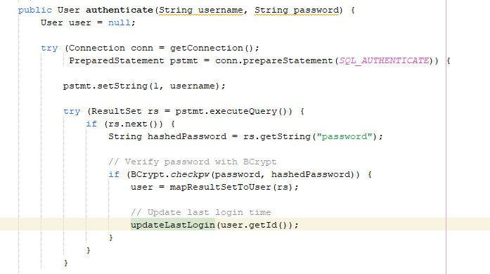
Note: use BCrypt to verify stored harshes.
  - On success, old session will be invalidate to prevent session fixation
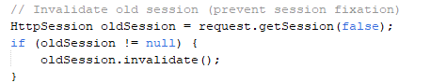
  - Create new session
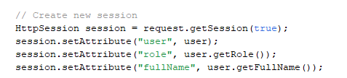
  - LoginController check whether the user is admin or not. If yes, Redirect to dashboard
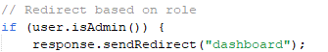
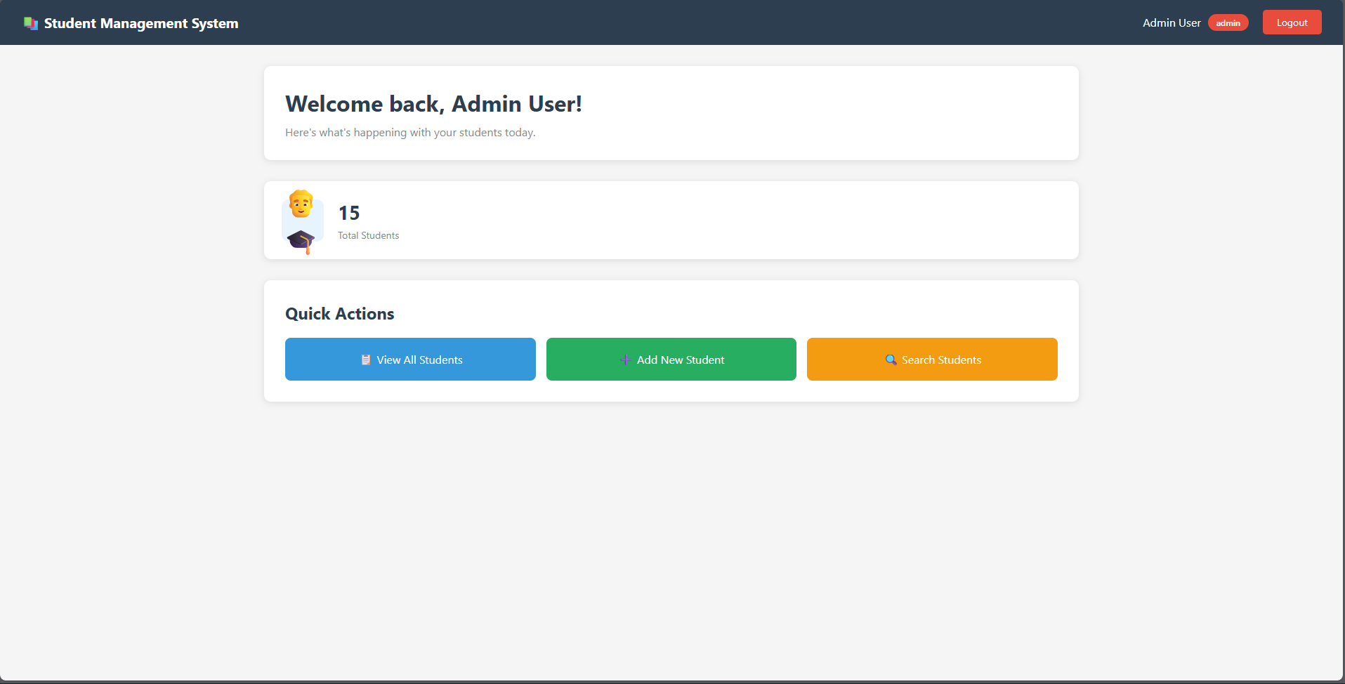
- Click “View All Student”
  - point to student?action=list
  - StudentController.java read student?action=list and call listStudents(…)
  - StudentController use StudentDAO to fetch students and forward to student-list.jsp
RequestDispatcher dispatcher = request.getRequestDispatcher("/views/student-list.jsp");
dispatcher.forward(request, response);
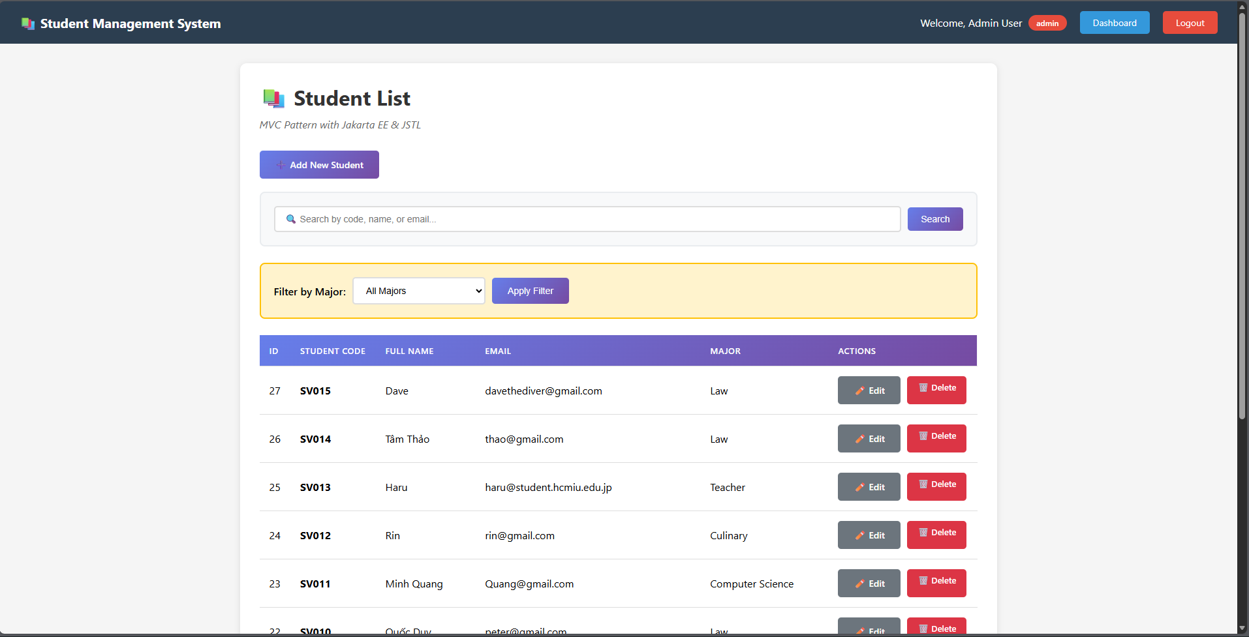
  - student-list.jsp check <c:if test="${sessionScope.role eq 'admin'}"> show the add/edit/delete button.
- Logout
  - User click “log out” button (<a href="logout" class="btn-logout">Logout</a>) -> direct to LogoutController
  - LogoutController invalidate the current session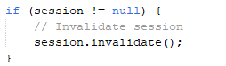
  - Redirect to login.jsp
- Login with: john / password123 (User case) Similar to 2.
  - user enter the username and password. After click “login” button, the login page with send request method “POST” to LoginController.java
  - LoginController get parameter and call dao.UserDAO.authenticate(username, password)
  - On success, old session will be invalidate to prevent session fixation
  - Create new session
  - Login Controller check whether the user is admin or not. If not, redirect to student-list.jsp
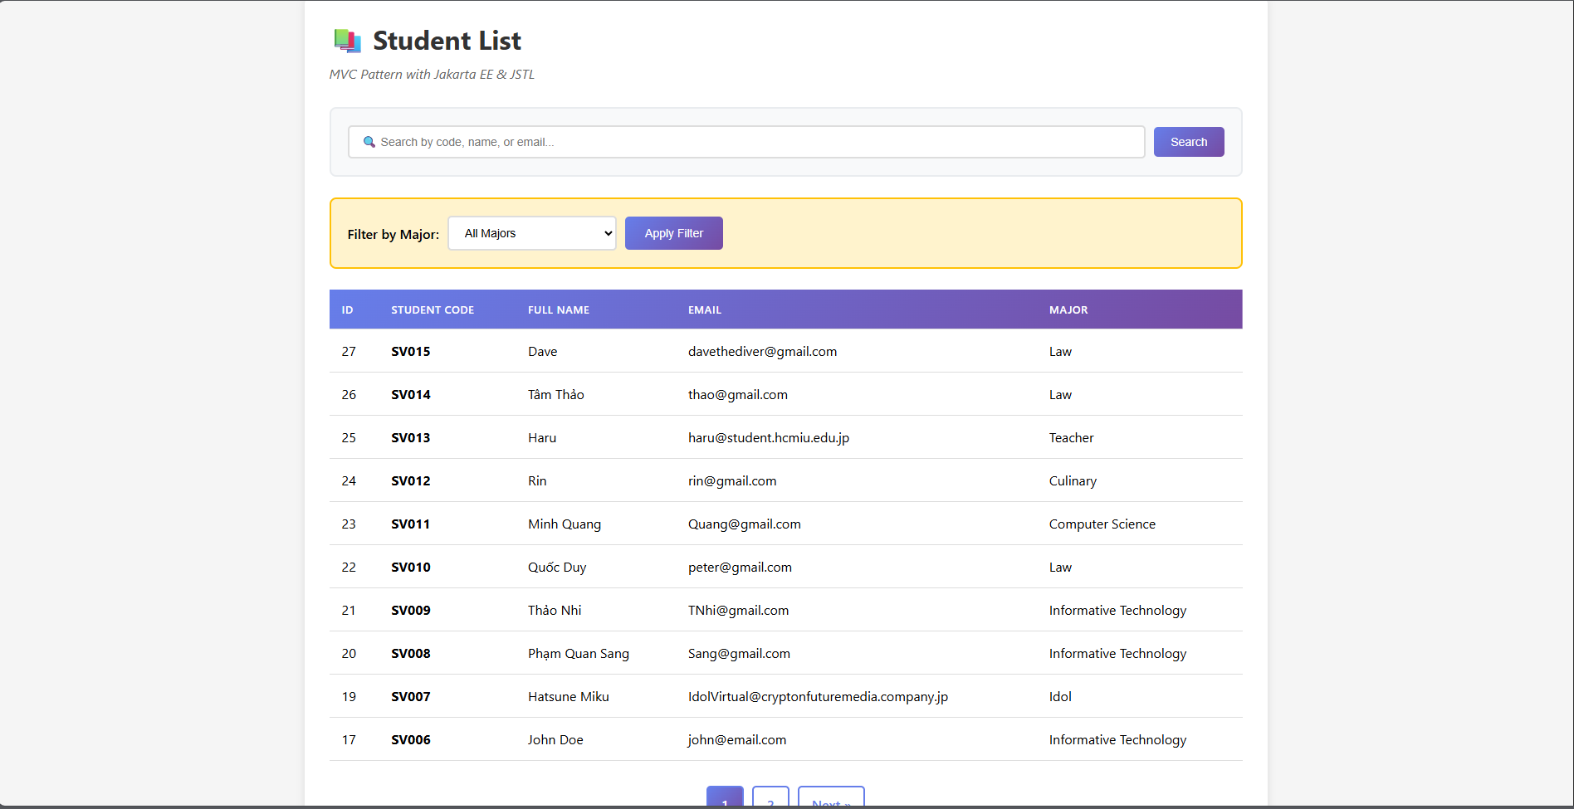
  - Since the student-list.jsp check sessionScope.role >< admin -> hide add/edit/delete button.
- What if: trying to access add action through /student?action=new
  - AdminFilter run through @WebFilter(filterName = "AdminFilter", urlPatterns = {"/student"})
  - AdminFilter get the request and check if the logged user are admin or not. Since the user are not the admin. AdminFilter redirect back to student-list.jsp and show error log
