- List.
  - User access webpage to url in thier browser (localhost:8080/products)
  - The request will be handled by controller
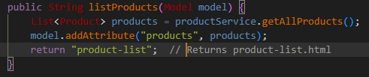
- Controller will call service through “List<Product> products = productService.getAllProducts();”
- Serrvice will call List<Product> getAllProducts(); to get the data from the database.
  - Controller will add the data into the list making it available for view
  - Return to product-list.html -> show the html page with list of product
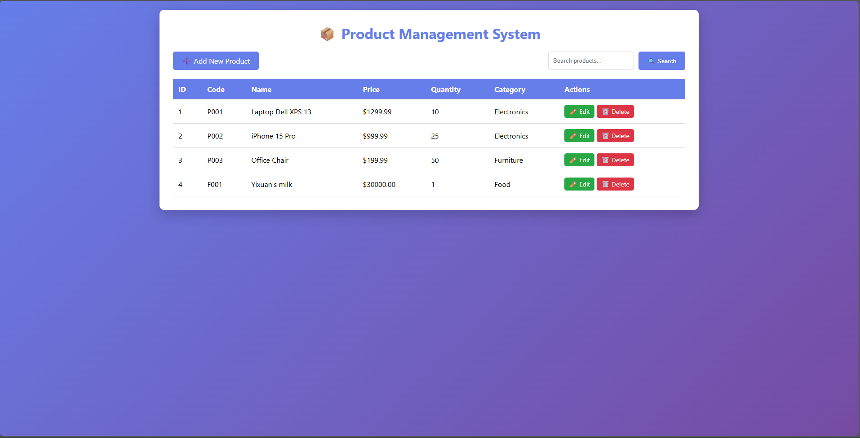
- Add
2.1 When user click “add new product” button, it will send a get request to the controller through “<a th:href="@{/products/new}" class="btn btn-primary">➕ Add New Product</a>”
2.2 The controller will call showNewForm(Model model) -> create new item on the list -> return to product-form.html
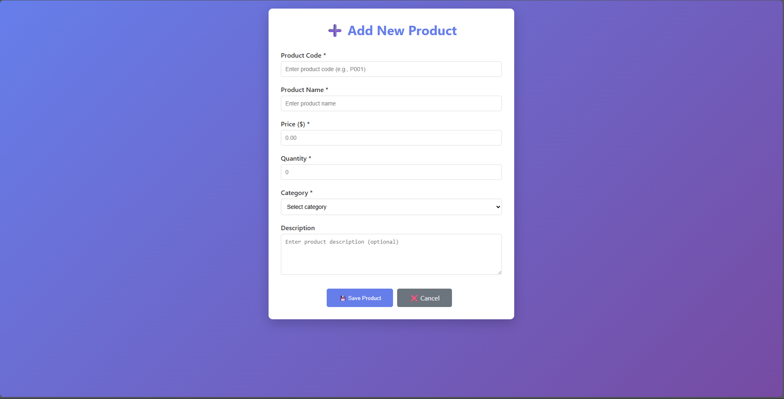
2.3 when user fill the form and click “save product” -> form will send a POST request to the controller -> controller call service through “productService.saveProduct(product);”
–> service call “Product saveProduct(Product product);” -> save the data into the list and database -> redirect to the list and show message
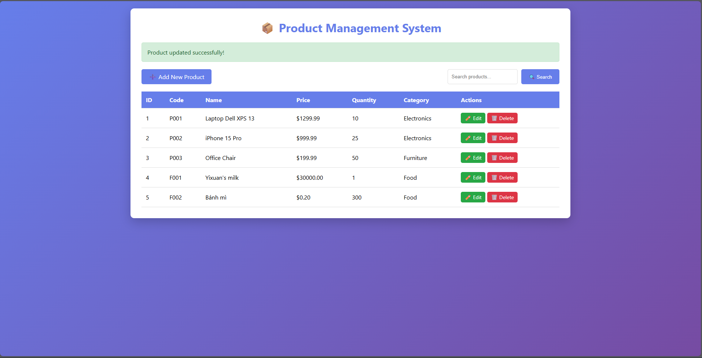

- Edit
3.1 when user click “edit” on a product it will send a get GET request to controller through /products/edit/{id}(id=${product.id}
3.2 controller will call function showEditForm(…) by calling the service “productService.getProductById(id)” to get product information, if successful, it will direct to product-form with information on them, if not controller will redirect to product-list with error.
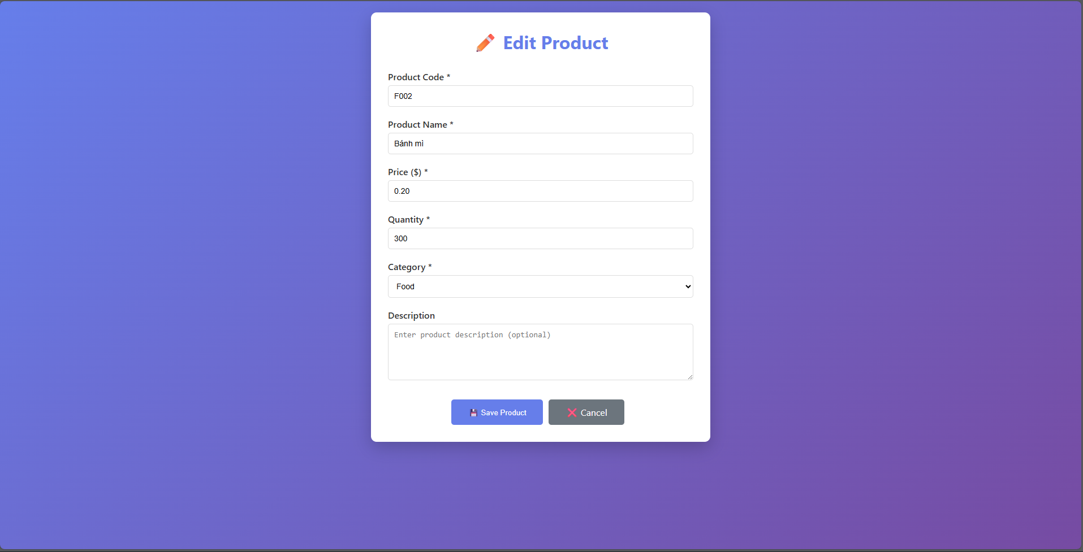
3.3 When user done editing the information, click save button -> send POST request to controller (@{/products/save}) -> controller will call service to save the information on the object and then return to product-list.hmtl with success message.
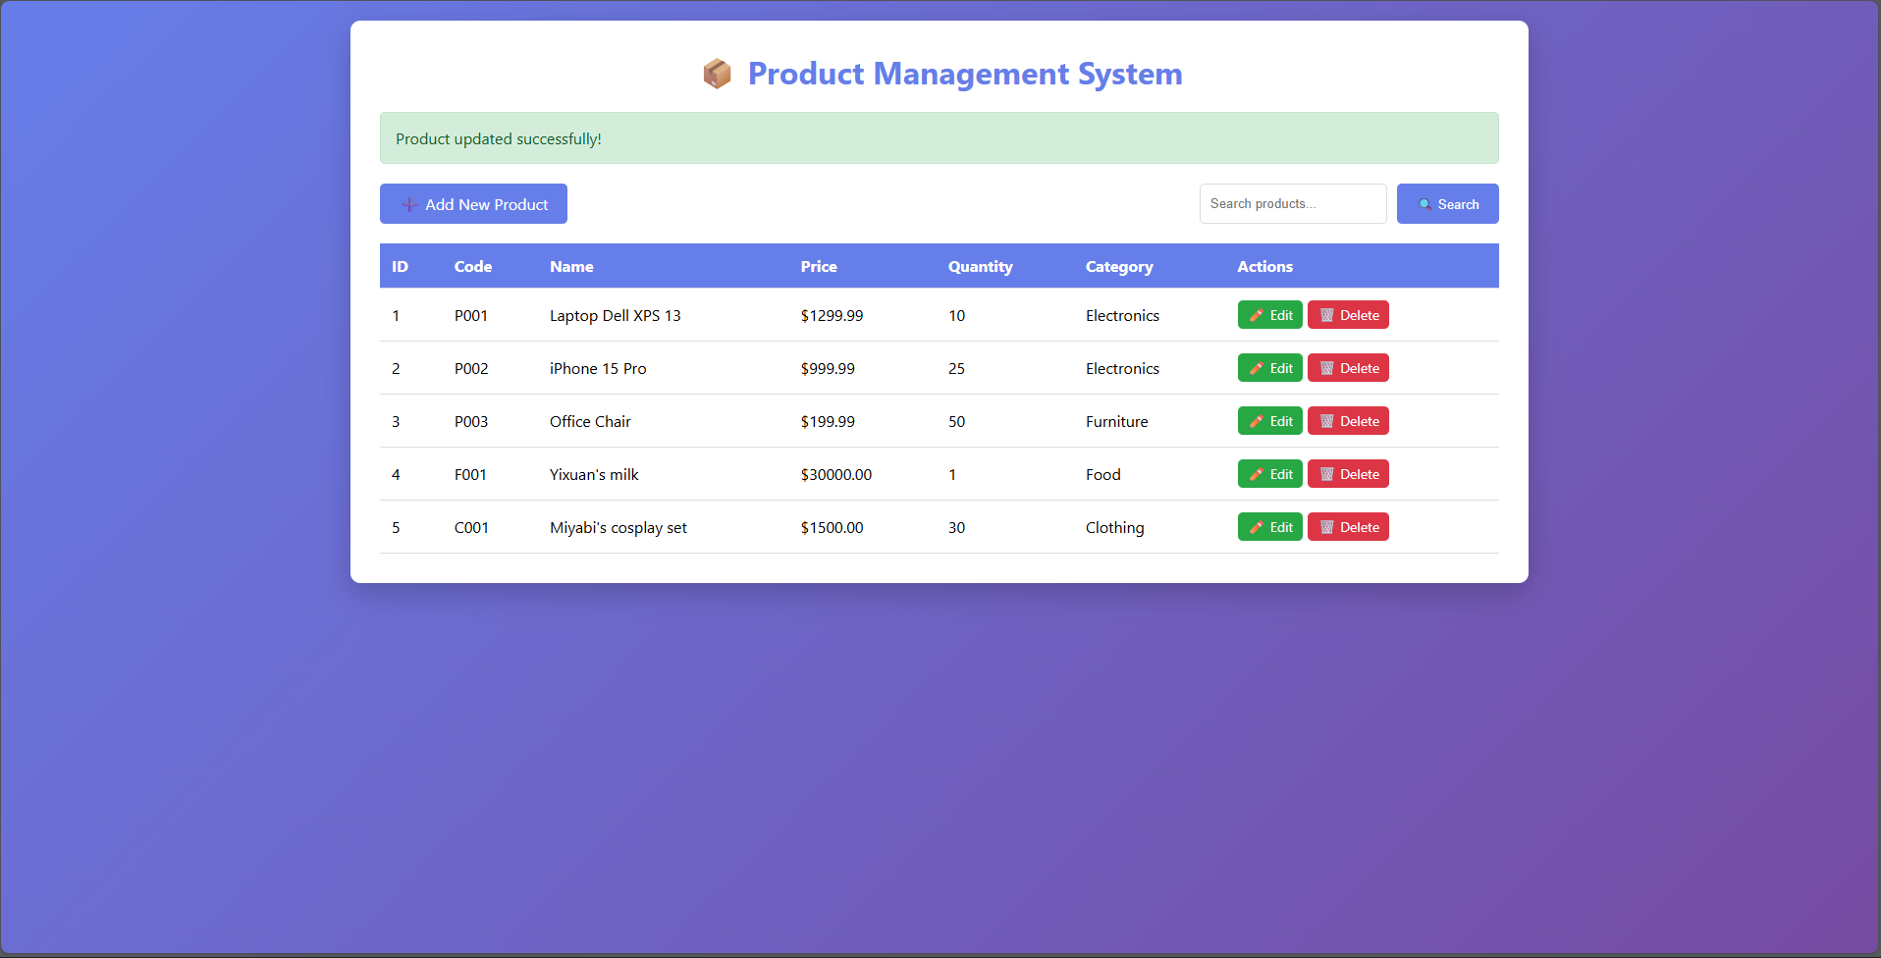
4. Delete
4.1 When user click “delete” button
-> appear delete confirmation box
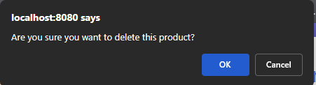
4.2 If ok -> send a GET request to the controller -> call deleteProduct(…)
- Call Service (void deleteProduct(Long id);) -> delete the object
- Redirect to products with message
