**DEVELOP AN SIMPLE STATIC WEBSITE**

## **COS10026: Computing Technology Inquiry Project**

**Name: Le Ba Tung**

**ID: 104175915**

**Introduction:**

We're glad you're here at Swin-Tech, your entryway to a world of fascinating IT career options. Finding the ideal IT career might be a difficult undertaking in this digital age when technology advances quickly. Swin-Tech steps in at this point. In navigating the ever-changing IT industry, we are your dependable partner.

We at Swin-Tech are aware that progress and innovation rely heavily on IT specialists. Whether you're a seasoned professional or just starting out in your career, we can match your talents, objectives, and career goals with the most sought-after IT employment jobs.

**Object of the report:**

The goal of this report is to talk about how this website was created. At the same time, inform users about website features, technical requirements, graphic techniques, and user experience. Through these things, you can know whether the website is truly successful and meets all the requirements of the given assignment. When all members of my team participated and created it with HTML and CSS.

This report is also documented so that readers can understand the structure of the HTML and CSS files

**Outline:**

1. Introduction:

• Website introduction

• Objective of the Report

• Outline of the Report’s Structure

2. Website Content:

• Purpose and Content of Each Page • Technical Details on HTML Markup

• Sitemap

3. Website Style:

• Presentation of the Website

• Technical Details on CSS Markup

• Screenshots Displaying Design/User Interface

4. Key Features:

• Highling Innovative Website Features

• Descriptions of Enhancements

5. Contributions:

• List and Discussion of Main Contributions

6. Conclusion:

• Summary of the Report

• Recommendations for Future Improvements

7. References:

• List of Reference Materials

8. Appendix:

• Additional Supporting Information

**Website Content:**

Website pages:

* **Home page**

The Homepage of a website plays a crucial role in making a first impression and guiding users. It creates an impression of the brand, displays important information such as products, news, or events, and encourages the user's initial action. Furthermore, the Home Page should integrate the brand and optimize page loading speed, provide contact information, and integrate social elements if necessary. Careful design and management of the Home Page are important to ensure the success of the website.

A simple Homepage’s structure is outlined in the HTML code that is given. It starts with the required document declaration and selects English as the document's language. The viewport parameters and character encoding for responsive design are specified in the <head> element. The title seen in the browser title bar is defined by the <title> tag, which also provides connections to external stylesheets for Font Awesome icons and CSS styling.

There is a <header> element with a navigation menu and a logo inside the <body> section. Links to other pages are included in the navigation menu, along with corresponding icons. The Homepage’s primary material is included in a <section> with the class "hero." This part has a text, an application link, and a nested span heading, together with video content. There's also a picture and social media connections including Font Awesome symbols.

All things considered, this HTML code serves as the basis for a webpage that includes connections to other resources for styling and iconography, a hero section, and navigation. The external resources that are cited must be accessible and well formatted in order to produce a comprehensive and aesthetically pleasing webpage. It's important to note that the code may use some improvements. For example, the Font Awesome classes should be specified appropriately, and the external resources should be made sure they are current.

* **Jobs Page:**

The "jobs" page on a website tailored for IT job listings is a central hub with far-reaching impacts. It's the primary gateway for job seekers, allowing them to discover, explore, and apply for a wide array of tech-related positions. The quality of this page directly influences user engagement and the effectiveness of the application process, crucial in attracting top talent. In addition to providing detailed job information, it serves as a branding platform for employers, shaping their image and values in the eyes of prospective hires. Its SEO optimization ensures discoverability, and data analytics gleaned from it offer valuable market insights. With a mobile-responsive design and integration with applicant tracking systems, it streamlines the entire job-seeking process. In essence, the "jobs" page is a linchpin in the tech job market, uniting job seekers and employers while wielding a significant impact on their experience and outcomes.

The format of a webpage for job descriptions is outlined in the HTML code that is given. The usual HTML declaration is used at the beginning, and English is selected as the document language. The <head> section refers to an external CSS stylesheet for styling and contains metadata, such as viewport settings and character encoding.

The webpage is broken up into pieces inside the <body> element. Two job descriptions follow the term "JOBS DESCRIPTION," which appears in the main heading. Every job description consists of a title, an overview, a range of pay, and a list of the main duties. Skills and qualifications are also provided in an organized manner. The job descriptions are accompanied by images pertaining to the occupations.

The website closes with a list of members and fast action links in the footer. At the bottom of the page are a copyright disclaimer and information about the website's connection to Swinburne University of Technology and the COS10026 course.

Semantic markup best practices are followed in the HTML code to improve accessibility and search engine optimization. Users will find it easy to read and comprehend the job descriptions as well as traverse the homepage due to its clarity and organization.

* **Apply Page:**

A website designed for applying to IT jobs is a vital gateway for both job seekers and employers in the tech industry. It plays a pivotal role in facilitating the recruitment process by offering a user-friendly interface for candidates to search for positions, create and manage their profiles, and submit resumes seamlessly. Additionally, it

provides essential details about the companies and job roles, empowering candidates to make informed decisions. The incorporation of an Applicant Tracking System streamlines the application process, making it efficient for employers to manage and evaluate applications. It also enables real-time communication between employers and candidates, fostering transparency in the hiring process. Ensuring data security is paramount, as it safeguards candidates' personal information. In essence, a well-crafted IT job application website not only attracts top talent but also enhances the overall efficiency and effectiveness of the hiring process in the IT sector.

The given HTML code creates a webpage with an application for employment. The <head> section contains the necessary document declaration and metadata, along with character encoding and external CSS linking for style. The <body> element contains the webpage's content, which is arranged with a navigation menu, page header, and an extensive job application form. Information like your work reference number, contact information, personal information, and talents are all gathered on this form. Additionally, it has a text field for extra talents and checkboxes for choosing programming abilities. The page is finished with a footer area that has fast links and a list of members. It is improved with icons that symbolize different programming languages. Semantic HTML principles are used in the code to guarantee accessibility and search engine optimization while  providing users with a complete application platform

* **About Page:**

The "About Us" web page, created using the provided HTML code, serves as an essential component of a website, offering visitors insights into the team behind the project. It plays a crucial role in providing transparency and building trust with users. The page contains detailed information about the team members, including their names, dates of birth, cities, majors, and hobbies, which can help users relate to and connect with the people responsible for the website. Additionally, the navigation menu in the header allows users to explore other sections of the website easily. Overall, this page contributes to the website's credibility and provides a personal touch, enhancing the user experience by creating a sense of connection and trust with the site's creators.

The "About Us" homepage is created using the given HTML code, which adheres to standard principles for HTML. The <head> section contains the document declaration and metadata, which includes the author's details, description, keywords, and character encoding. The primary content is contained in the <body> element and consists of a page header, a navigation menu, and team member profiles with photographs and private data. The code complies with semantic HTML and incorporates anchor links for simple navigation, accessibility, and search engine optimization. The page ends with a footer that includes a list of team members and fast links, along with a copyright notice and details on the website's partnership with COS10026, Swinburne University of Technology. This code produces an organized "About Us" page that improves user experience by providing a thorough overview of the website's development team.

* **Enhancements Page:**

The given HTML code is organized to produce a webpage that highlights improvements made to a website. Essential metadata, such as a document description, keywords, and author details, come first. The organization of the page is standard, with connections to different parts of the website located in a navigation menu. The two enhancement parts that make up the primary material are each text-described and include an appropriate image. These sections provide particulars on the upgrades made to the form fields and buttons on the website. The footer facilitates simple navigation and offers insights into the project's contributions by including a list of team members and fast action buttons. At the bottom of the page, a copyright notice guarantees that intellectual property rights are respected. All things considered, the HTML code complies with web development best practices and displays the improvements in an efficient manner that is both user-friendly and educational.

Site map:

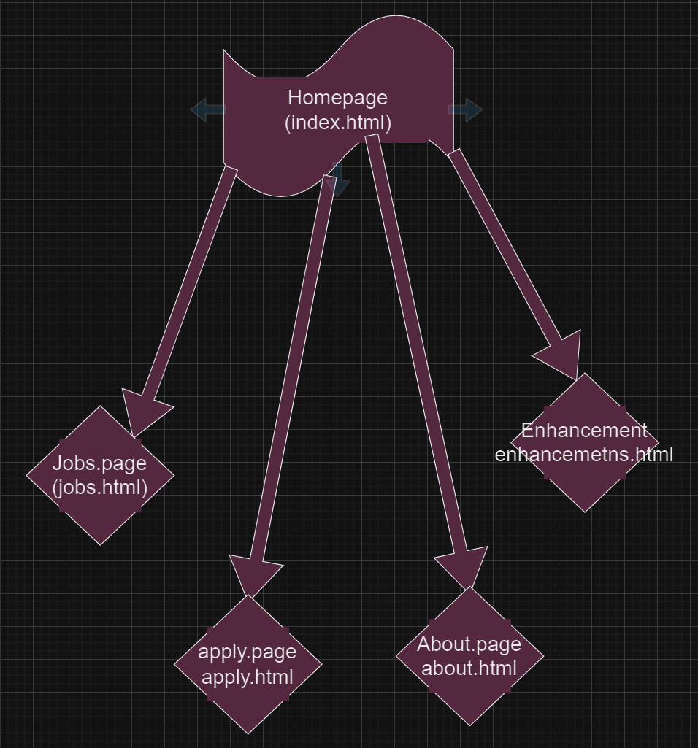

**Website Style:**

**Homepage:**

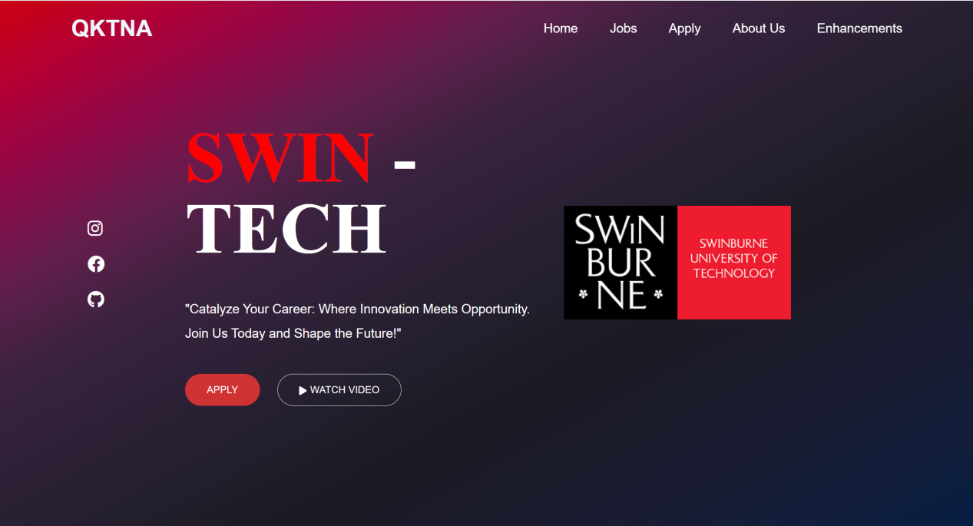

The linked HTML document's layout and visual style are defined in large part by the CSS code that is given. It improves the look of the webpage, beginning with the fixed header at the top of the viewport, by using flexbox to give it an organized layout and transparency. Specific guidelines determine how navigation links appear, including an animated underlining effect when the link is hovered over. The universal selector establishes standard styles for all components, guaranteeing a uniform appearance. The hero section features a grid structure, a gradient backdrop that is visually appealing, and button styles and fonts that are expertly designed. Specifically, the "Apply" button has a unique look and a lively hover effect. Lastly, the social media symbols that are placed squarely in the middle of the hero area are designed using a hover effect to make things more interactive. All things considered, this CSS code turns the HTML text into an interesting and eye-catching webpage.

In order to guarantee that the websites function properly across a range of devices—including tablets and phones—my colleague also employed the @media query. This allows us to reach users anywhere, regardless of the device they are using to view the webpages. For the most part, he has included basic animations to the information on the home page so that people can see how fluid the website is when they interact with it or resize the window.

**Jobs.page:**

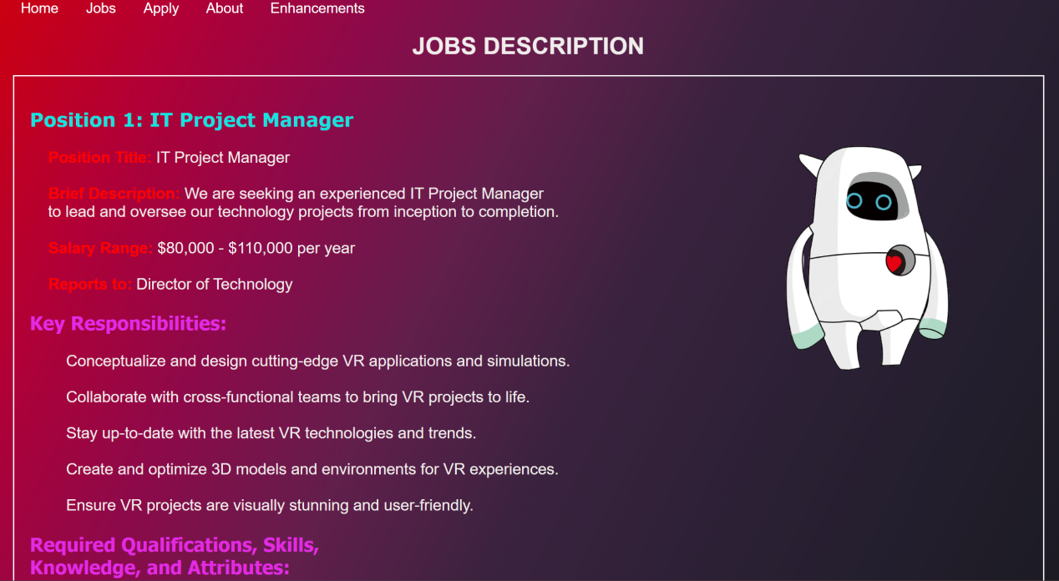

The accompanying HTML document's appearance and layout are much improved by the CSS code that is included. It gives the material a unique visual personality by adjusting the fonts, colors, and placement of different components. It specifically inserts white borders to separate content parts, changes text components for readability, and styles heads with various fonts and colors. Creative page design is made possible by the placement rules, which guarantee that pictures are positioned in predetermined ways. In addition, the code centers and styles particular text components to grab attention and create a unified, appealing appearance. A dynamic underlining effect that extends on hover is added to navigation links to improve engagement. When combined, this CSS code turns the HTML material into a visually beautiful and well-structured webpage, enhancing its aesthetic appeal and usability.

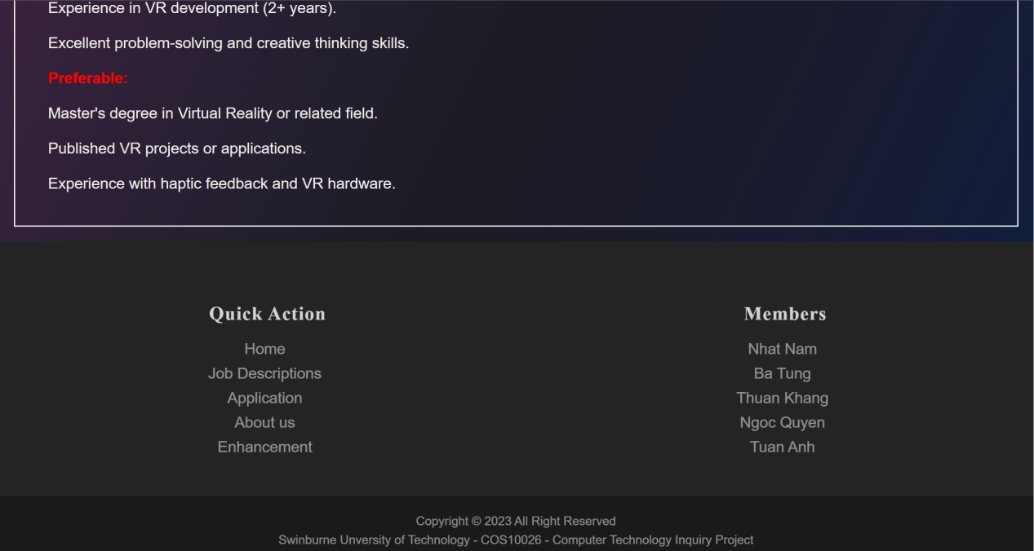

*(footer of jobs.page)*

**Apply.page:**

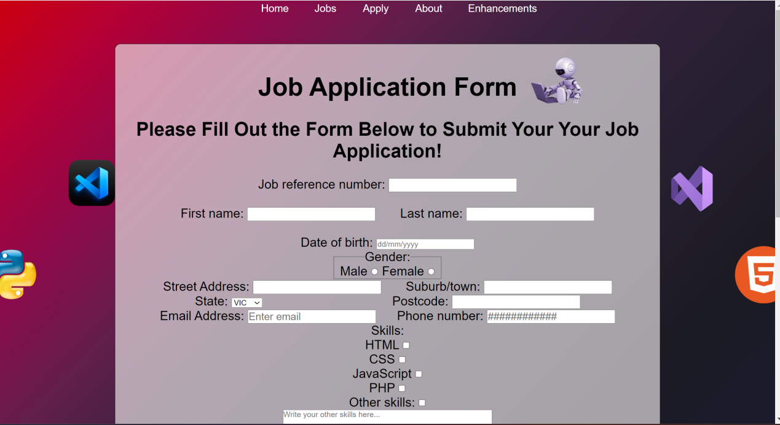

The webpage's visual design and layout are greatly influenced by the CSS styles that are applied to the HTML code. These styles have an impact on a number of page components, including buttons, form elements, and header look. To give them a bold and organized appearance, they specify font sizes, font weights, and text alignment for headers, for example. A hover effect that highlights the menu items as the user hovers over them visually enhances the navigation menu. In addition, box-shadow effects and text size variations upon hovering or clicking give buttons and form components a contemporary and engaging feel. The visual design is visually appealing and well-coordinated thanks to the background colors, gradients, and general color schemes. Lastly, these styles also govern how icons are positioned and styled on the page. In conclusion, the webpage's overall aesthetics and user experience are significantly enhanced by the CSS rules.

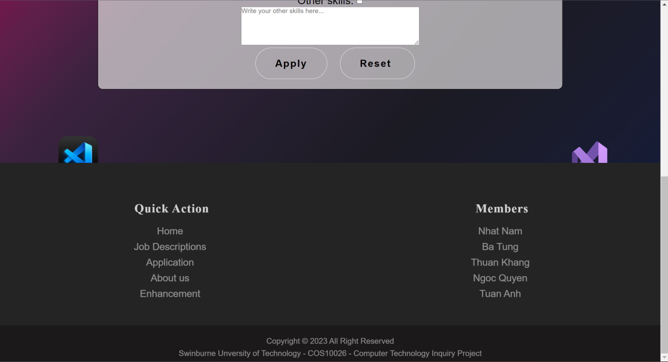

(*footer of apply.page*)

**About page:**

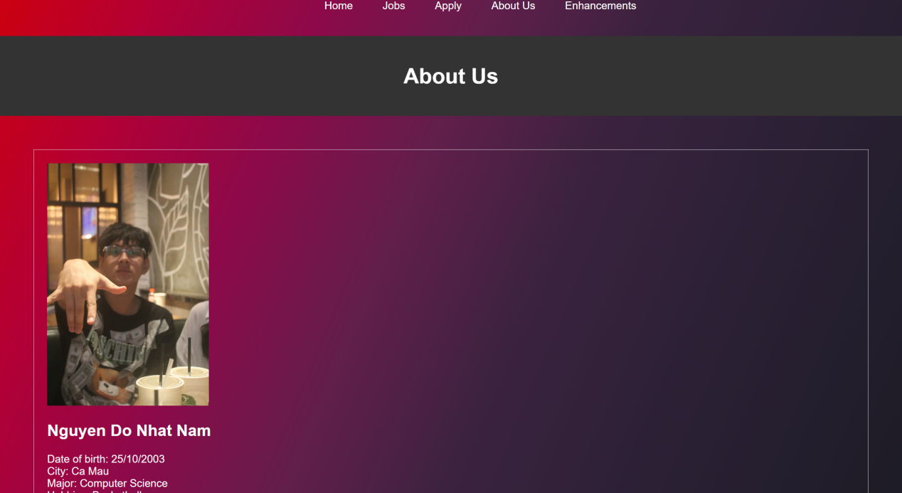

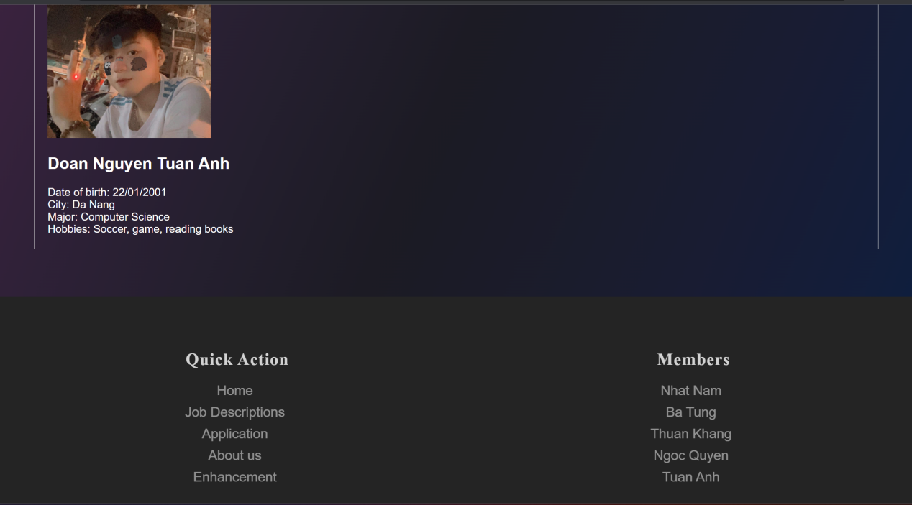

The "About Us" webpage's visual appearance and layout are mostly shaped by the CSS styles that are applied to the HTML code. The backdrop, team member sections, and navigation menu are the main areas impacted by these styles. The navigation links feature a faint underlining movement when hovered over, are centered, and are styled in white. An eye-catching image is used as the background, giving the material a visually pleasing setting. White borders and backgrounds set off the team member portions, and the photographs inside are resized to provide for a visually balanced display. Every team member's text information are also formatted for readability and coherence. When used, these CSS styles improve the webpage's readability and aesthetics, creating a visually appealing and well-organized.

**Enhancements.page:**

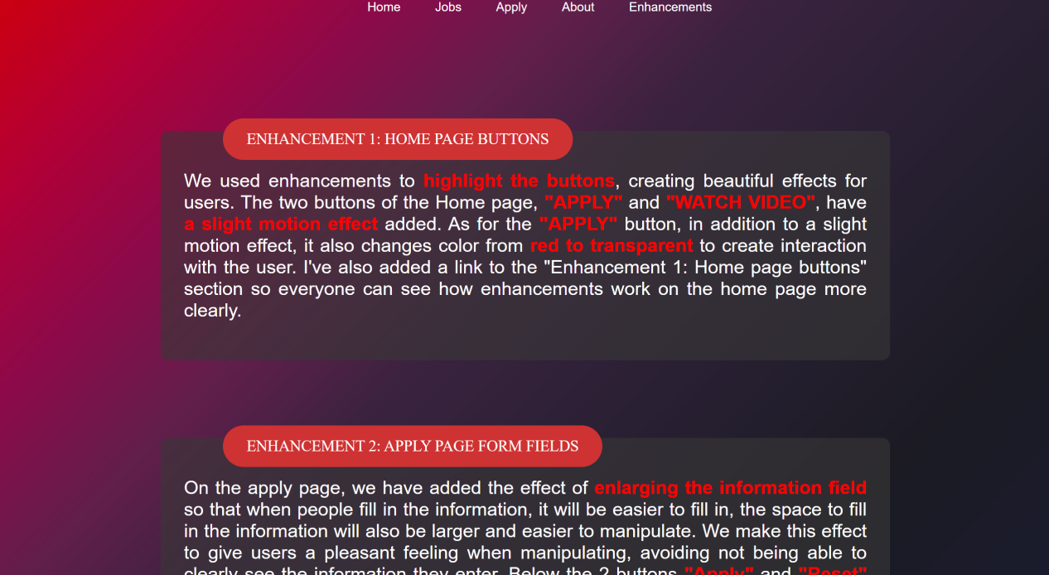

The "Swin Tech/Enhancement" webpage's responsive design and aesthetic elements are greatly influenced by the CSS code that is supplied. It establishes designs for navigation links, endowing them with a modest hover effect and a distinctive look. The minimum height and background and text colors of the body container guarantee a full-screen, aesthetically pleasing experience. The algorithm also controls the attributes and placement of robot pictures, ensuring that they are properly aligned on the page. The enhanced detail parts are made uniform by the "itemN" class, which also gives them a unique look. Enhancement names are more interactive due to their prominent style, which changes as the user hovers over them in terms of size, color, and backdrop. Users are guaranteed a pleasurable reading experience by the "enhancement-textN" class. Additionally, the media queries that are supplied address various screen sizes providing responsive modifications to different page elements so that they may be viewed at their best on a variety of devices. All things considered, the CSS code greatly enhances the webpage's aesthetics and flexibility, making it aesthetically pleasing and suitable for a variety of screen sizes and devices.

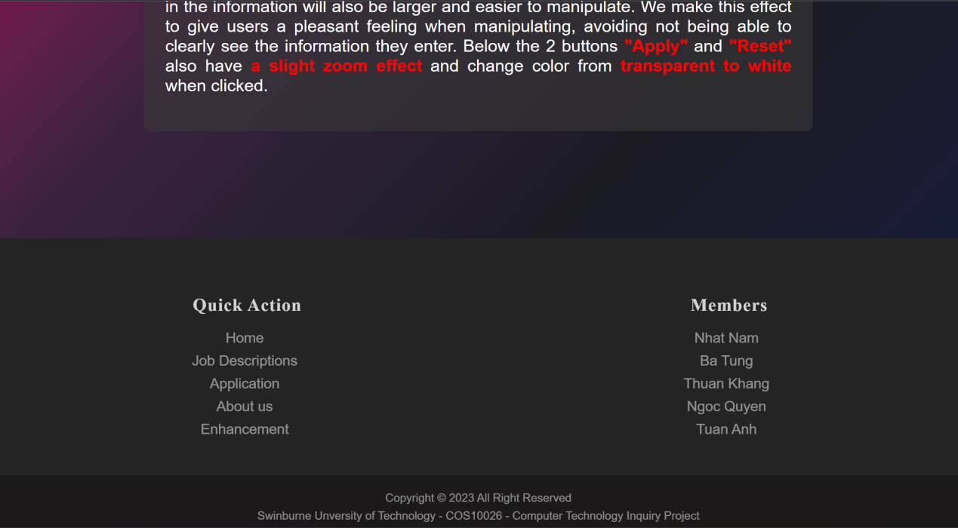

*(footer of Enhancements.page)*

**Key Features:**

Homepage: The homepage serves as the gateway to a website and typically includes a header with the site's logo and navigation menu, a hero section featuring engaging visuals and a brief introduction, prominent calls to action encouraging user interaction, testimonials to build trust, and recent news or articles to keep users informed. The footer often contains contact information, social media links, and additional navigation options.

Job Page: A dedicated job page commonly offers structured job listings with details such as job titles, locations, and application deadlines. Users can access search and filtering options to narrow down job listings according to their preferences. Clicking on job listings reveals comprehensive descriptions of each job, including responsibilities, qualifications, and application instructions. The page also provides a means for users to apply, either through an online form or by following specific application guidelines, along with links to additional information about the company's culture and benefits.

Apply Page: The apply page features an application form where users can input their personal information, upload documents like resumes and cover letters, and receive a confirmation or thank-you message upon submission. Users may also find options to check the status of their applications and frequently asked questions related to the application process.

About Page: The about page typically includes a company overview with information about the company's history, mission, and values. Users can explore profiles of key team members, often with photos and bios, and discover highlights of the company's achievements or awards. This page also offers insights into the company's work culture, values, and unique qualities, along with contact information for getting in touch with the company.

Enhancements Page: The enhancements page provides in-depth explanations of website improvements or features, often accompanied by before-and-after examples. It may incorporate media and visuals, including images, videos, or interactive elements, to showcase these enhancements. Users can often engage with interactive demos to experience the enhancements firsthand, and there's typically a section for user feedback and comments. The page may also include related links to documentation or tutorials for users to learn how to use these enhancements effectively.

**Contribution:**

In addition to creating the jobs.page website, I also support team members in finding images and contributing ideas for developing other websites.

**Conclusion:**

In summary, the HTML code that follows is organized logically and efficiently generates a webpage that highlights modifications that have been made to a website. Web development best practices are followed in the code, which includes standard features like a navigation menu and footer as well as necessary metadata. It presents the improvements in an understandable and educational manner, complete with thorough explanations and related visuals. This user-friendly strategy guarantees that users can comprehend the enhancements produced to the form fields and buttons on the website with ease. A copyright notice also shows that you are committed to respecting intellectual property rights. All things considered, this HTML code does a great job at accomplishing its goal, which makes it a useful tool for showcasing and recording online improvements.