# Exercices de révision sur la segmentation des réseaux

# Exercice 1

On veut segmenter le réseau 192.168.1.0/24 en 2 sous-réseaux.

Ecrivez d’abord l’adresse réseau et le masque en binaire du réseau **avant segmentation**.

|  |  |  |  |  |  |  |  |  |  |  |  |  |  |  |  |  |  |  |  |  |  |  |  |  |  |  |  |  |  |  |  |  |  |  |  |
| --- | --- | --- | --- | --- | --- | --- | --- | --- | --- | --- | --- | --- | --- | --- | --- | --- | --- | --- | --- | --- | --- | --- | --- | --- | --- | --- | --- | --- | --- | --- | --- | --- | --- | --- | --- |
| Adresse réseau | 192 | | | | | | | | . | 168 | | | | | | | | . | 1 | | | | | | | | . | 0 | | | | | | | |
|  |  |  |  |  |  |  |  | . |  |  |  |  |  |  |  |  | . |  |  |  |  |  |  |  |  | . |  |  |  |  |  |  |  |  |
| Masque en binaire |  |  |  |  |  |  |  |  | . |  |  |  |  |  |  |  |  | . |  |  |  |  |  |  |  |  | . |  |  |  |  |  |  |  |  |

Combien de bits faut-il emprunter à la partie hôte pour définir 2 sous-réseaux :

Complétez maintenant les tableaux ci-dessous :

**Sous-réseau 0**

|  |  |  |  |  |  |  |  |  |  |  |  |  |  |  |  |  |  |  |  |  |  |  |  |  |  |  |  |  |  |  |  |  |  |  |  |
| --- | --- | --- | --- | --- | --- | --- | --- | --- | --- | --- | --- | --- | --- | --- | --- | --- | --- | --- | --- | --- | --- | --- | --- | --- | --- | --- | --- | --- | --- | --- | --- | --- | --- | --- | --- |
| Adresse réseau |  | | | | | | | | . |  | | | | | | | | . |  | | | | | | | | . |  | | | | | | | |
|  |  |  |  |  |  |  |  | . |  |  |  |  |  |  |  |  | . |  |  |  |  |  |  |  |  | . |  |  |  |  |  |  |  |  |
| Masque en binaire |  |  |  |  |  |  |  |  | . |  |  |  |  |  |  |  |  | . |  |  |  |  |  |  |  |  | . |  |  |  |  |  |  |  |  |
|  |  | | | | | | | | | | | | | | | | | | | | | | | | | | | | | | | | | | |
|  | | | | | | | | | | | | | | | | | | | | | | | | | | | | | | | | | | | |
| Adresse 1er hôte |  | | | | | | | | . |  | | | | | | | | . |  | | | | | | | | . |  | | | | | | | |
|  |  |  |  |  |  |  |  | . |  |  |  |  |  |  |  |  | . |  |  |  |  |  |  |  |  | . |  |  |  |  |  |  |  |  |
|  | | | | | | | | | | | | | | | | | | | | | | | | | | | | | | | | | | | |
| Adresse dernier hôte |  | | | | | | | | . |  | | | | | | | | . |  | | | | | | | | . |  | | | | | | | |
|  |  |  |  |  |  |  |  | . |  |  |  |  |  |  |  |  | . |  |  |  |  |  |  |  |  | . |  |  |  |  |  |  |  |  |
|  | | | | | | | | | | | | | | | | | | | | | | | | | | | | | | | | | | | |
| Adresse de broadcast |  | | | | | | | | . |  | | | | | | | | . |  | | | | | | | | . |  | | | | | | | |
|  |  |  |  |  |  |  |  | . |  |  |  |  |  |  |  |  | . |  |  |  |  |  |  |  |  | . |  |  |  |  |  |  |  |  |

**Sous-réseau 1**

|  |  |  |  |  |  |  |  |  |  |  |  |  |  |  |  |  |  |  |  |  |  |  |  |  |  |  |  |  |  |  |  |  |  |  |  |
| --- | --- | --- | --- | --- | --- | --- | --- | --- | --- | --- | --- | --- | --- | --- | --- | --- | --- | --- | --- | --- | --- | --- | --- | --- | --- | --- | --- | --- | --- | --- | --- | --- | --- | --- | --- |
| Adresse réseau |  | | | | | | | | . |  | | | | | | | | . |  | | | | | | | | . |  | | | | | | | |
|  |  |  |  |  |  |  |  | . |  |  |  |  |  |  |  |  | . |  |  |  |  |  |  |  |  | . |  |  |  |  |  |  |  |  |
| Masque en binaire |  |  |  |  |  |  |  |  | . |  |  |  |  |  |  |  |  | . |  |  |  |  |  |  |  |  | . |  |  |  |  |  |  |  |  |
|  |  | | | | | | | | | | | | | | | | | | | | | | | | | | | | | | | | | | |
|  | | | | | | | | | | | | | | | | | | | | | | | | | | | | | | | | | | | |
| Adresse 1er hôte |  | | | | | | | | . |  | | | | | | | | . |  | | | | | | | | . |  | | | | | | | |
|  |  |  |  |  |  |  |  | . |  |  |  |  |  |  |  |  | . |  |  |  |  |  |  |  |  | . |  |  |  |  |  |  |  |  |
|  | | | | | | | | | | | | | | | | | | | | | | | | | | | | | | | | | | | |
| Adresse dernier hôte |  | | | | | | | | . |  | | | | | | | | . |  | | | | | | | | . |  | | | | | | | |
|  |  |  |  |  |  |  |  | . |  |  |  |  |  |  |  |  | . |  |  |  |  |  |  |  |  | . |  |  |  |  |  |  |  |  |
|  | | | | | | | | | | | | | | | | | | | | | | | | | | | | | | | | | | | |
| Adresse de broadcast |  | | | | | | | | . |  | | | | | | | | . |  | | | | | | | | . |  | | | | | | | |
|  |  |  |  |  |  |  |  | . |  |  |  |  |  |  |  |  | . |  |  |  |  |  |  |  |  | . |  |  |  |  |  |  |  |  |

# Exercice 2

On veut segmenter le réseau 192.168.1.0/24 en 5 sous-réseaux.

Ecrivez d’abord l’adresse réseau et le masque en binaire du réseau **avant segmentation**.

|  |  |  |  |  |  |  |  |  |  |  |  |  |  |  |  |  |  |  |  |  |  |  |  |  |  |  |  |  |  |  |  |  |  |  |  |
| --- | --- | --- | --- | --- | --- | --- | --- | --- | --- | --- | --- | --- | --- | --- | --- | --- | --- | --- | --- | --- | --- | --- | --- | --- | --- | --- | --- | --- | --- | --- | --- | --- | --- | --- | --- |
| Adresse réseau |  | | | | | | | | . |  | | | | | | | | . |  | | | | | | | | . |  | | | | | | | |
|  |  |  |  |  |  |  |  | . |  |  |  |  |  |  |  |  | . |  |  |  |  |  |  |  |  | . |  |  |  |  |  |  |  |  |
| Masque en binaire |  | | | | | | | | . |  | | | | | | | | . |  | | | | | | | | . |  | | | | | | | |
|  |  |  |  |  |  |  |  | . |  |  |  |  |  |  |  |  | . |  |  |  |  |  |  |  |  | . |  |  |  |  |  |  |  |  |

Combien de bits faut-il emprunter à la partie hôte pour définir 5 sous-réseaux :

Complétez maintenant les tableaux ci-dessous :

**Sous-réseau 0**

|  |  |  |  |  |  |  |  |  |  |  |  |  |  |  |  |  |  |  |  |  |  |  |  |  |  |  |  |  |  |  |  |  |  |  |  |
| --- | --- | --- | --- | --- | --- | --- | --- | --- | --- | --- | --- | --- | --- | --- | --- | --- | --- | --- | --- | --- | --- | --- | --- | --- | --- | --- | --- | --- | --- | --- | --- | --- | --- | --- | --- |
| Adresse réseau |  | | | | | | | | . |  | | | | | | | | . |  | | | | | | | | . |  | | | | | | | |
|  |  |  |  |  |  |  |  | . |  |  |  |  |  |  |  |  | . |  |  |  |  |  |  |  |  | . |  |  |  |  |  |  |  |  |
| Masque |  | | | | | | | | . |  | | | | | | | | . |  | |  | | | | | | . |  | | | | | | | |
|  |  |  |  |  |  |  |  | . |  |  |  |  |  |  |  |  | . |  |  |  |  |  |  |  |  | . |  |  |  |  |  |  |  |  |
| Adresse 1er hôte |  | | | | | | | | . |  | | | | | | | | . |  | |  | | | | | | . |  | | | | | | | |
|  |  |  |  |  |  |  |  | . |  |  |  |  |  |  |  |  | . |  |  |  |  |  |  |  |  | . |  |  |  |  |  |  |  |  |
| Adresse dernier hôte |  | | | | | | | | . |  | | | | | | | | . |  | |  | | | | | | . |  | | | | | | | |
|  |  |  |  |  |  |  |  | . |  |  |  |  |  |  |  |  | . |  |  |  |  |  |  |  |  | . |  |  |  |  |  |  |  |  |
| Adresse de broadcast |  | | | | | | | | . |  | | | | | | | | . |  | |  | | | | | | . |  | | | | | | | |
|  |  |  |  |  |  |  |  | . |  |  |  |  |  |  |  |  | . |  |  |  |  |  |  |  |  | . |  |  |  |  |  |  |  |  |

**Sous-réseau 1**

|  |  |  |  |  |  |  |  |  |  |  |  |  |  |  |  |  |  |  |  |  |  |  |  |  |  |  |  |  |  |  |  |  |  |  |  |
| --- | --- | --- | --- | --- | --- | --- | --- | --- | --- | --- | --- | --- | --- | --- | --- | --- | --- | --- | --- | --- | --- | --- | --- | --- | --- | --- | --- | --- | --- | --- | --- | --- | --- | --- | --- |
| Adresse réseau |  | | | | | | | | . |  | | | | | | | | . |  | | | | | | | | . |  | | | | | | | |
|  |  |  |  |  |  |  |  | . |  |  |  |  |  |  |  |  | . |  |  |  |  |  |  |  |  | . |  |  |  |  |  |  |  |  |
| Masque |  | | | | | | | | . |  | | | | | | | | . |  | | | | | | | | . |  | | | | | | | |
|  |  |  |  |  |  |  |  | . |  |  |  |  |  |  |  |  | . |  |  |  |  |  |  |  |  | . |  |  |  |  |  |  |  |  |
| Adresse 1er hôte |  | | | | | | | | . |  | | | | | | | | . |  | | | | | | | | . |  | | | | | | | |
|  |  |  |  |  |  |  |  | . |  |  |  |  |  |  |  |  | . |  |  |  |  |  |  |  |  | . |  |  |  |  |  |  |  |  |
| Adresse dernier hôte |  | | | | | | | | . |  | | | | | | | | . |  | | | | | | | | . |  | | | | | | | |
|  |  |  |  |  |  |  |  | . |  |  |  |  |  |  |  |  | . |  |  |  |  |  |  |  |  | . |  |  |  |  |  |  |  |  |
| Adresse de broadcast |  | | | | | | | | . |  | | | | | | | | . |  | | | | | | | | . |  | | | | | | | |
|  |  |  |  |  |  |  |  | . |  |  |  |  |  |  |  |  | . |  |  |  |  |  |  |  |  | . |  |  |  |  |  |  |  |  |

**Sous-réseau 2**

|  |  |  |  |  |  |  |  |  |  |  |  |  |  |  |  |  |  |  |  |  |  |  |  |  |  |  |  |  |  |  |  |  |  |  |  |
| --- | --- | --- | --- | --- | --- | --- | --- | --- | --- | --- | --- | --- | --- | --- | --- | --- | --- | --- | --- | --- | --- | --- | --- | --- | --- | --- | --- | --- | --- | --- | --- | --- | --- | --- | --- |
| Adresse réseau |  | | | | | | | | . |  | | | | | | | | . |  | | | | | | | | . |  | | | | | | | |
|  |  |  |  |  |  |  |  | . |  |  |  |  |  |  |  |  | . |  |  |  |  |  |  |  |  | . |  |  |  |  |  |  |  |  |
| Masque |  | | | | | | | | . |  | | | | | | | | . |  | | | | | | | | . |  | | | | | | | |
|  |  |  |  |  |  |  |  | . |  |  |  |  |  |  |  |  | . |  |  |  |  |  |  |  |  | . |  |  |  |  |  |  |  |  |
| Adresse 1er hôte |  | | | | | | | | . |  | | | | | | | | . |  | | | | | | | | . |  | | | | | | | |
|  |  |  |  |  |  |  |  | . |  |  |  |  |  |  |  |  | . |  |  |  |  |  |  |  |  | . |  |  |  |  |  |  |  |  |
| Adresse dernier hôte |  | | | | | | | | . |  | | | | | | | | . |  | | | | | | | | . |  | | | | | | | |
|  |  |  |  |  |  |  |  | . |  |  |  |  |  |  |  |  | . |  |  |  |  |  |  |  |  | . |  |  |  |  |  |  |  |  |
| Adresse de broadcast |  | | | | | | | | . |  | | | | | | | | . |  | | | | | | | | . |  | | | | | | | |
|  |  |  |  |  |  |  |  | . |  |  |  |  |  |  |  |  | . |  |  |  |  |  |  |  |  | . |  |  |  |  |  |  |  |  |

**Sous-réseau 3**

|  |  |  |  |  |  |  |  |  |  |  |  |  |  |  |  |  |  |  |  |  |  |  |  |  |  |  |  |  |  |  |  |  |  |  |  |
| --- | --- | --- | --- | --- | --- | --- | --- | --- | --- | --- | --- | --- | --- | --- | --- | --- | --- | --- | --- | --- | --- | --- | --- | --- | --- | --- | --- | --- | --- | --- | --- | --- | --- | --- | --- |
| Adresse réseau |  | | | | | | | | . |  | | | | | | | | . |  | | | | | | | | . |  | | | | | | | |
|  |  |  |  |  |  |  |  | . |  |  |  |  |  |  |  |  | . |  |  |  |  |  |  |  |  | . |  |  |  |  |  |  |  |  |
| Masque |  | | | | | | | | . |  | | | | | | | | . |  | | | | | | | | . |  | | | | | | | |
|  |  |  |  |  |  |  |  | . |  |  |  |  |  |  |  |  | . |  |  |  |  |  |  |  |  | . |  |  |  |  |  |  |  |  |
| Adresse 1er hôte |  | | | | | | | | . |  | | | | | | | | . |  | | | | | | | | . |  | | | | | | | |
|  |  |  |  |  |  |  |  | . |  |  |  |  |  |  |  |  | . |  |  |  |  |  |  |  |  | . |  |  |  |  |  |  |  |  |
| Adresse dernier hôte |  | | | | | | | | . |  | | | | | | | | . |  | | | | | | | | . |  | | | | | | | |
|  |  |  |  |  |  |  |  | . |  |  |  |  |  |  |  |  | . |  |  |  |  |  |  |  |  | . |  |  |  |  |  |  |  |  |
| Adresse de broadcast |  | | | | | | | | . |  | | | | | | | | . |  | | | | | | | | . |  | | | | | | | |
|  |  |  |  |  |  |  |  | . |  |  |  |  |  |  |  |  | . |  |  |  |  |  |  |  |  | . |  |  |  |  |  |  |  |  |

**Sous-réseau 4**

|  |  |  |  |  |  |  |  |  |  |  |  |  |  |  |  |  |  |  |  |  |  |  |  |  |  |  |  |  |  |  |  |  |  |  |  |
| --- | --- | --- | --- | --- | --- | --- | --- | --- | --- | --- | --- | --- | --- | --- | --- | --- | --- | --- | --- | --- | --- | --- | --- | --- | --- | --- | --- | --- | --- | --- | --- | --- | --- | --- | --- |
| Adresse réseau |  | | | | | | | | . |  | | | | | | | | . |  | | | | | | | | . |  | | | | | | | |
|  |  |  |  |  |  |  |  | . |  |  |  |  |  |  |  |  | . |  |  |  |  |  |  |  |  | . |  |  |  |  |  |  |  |  |
| Masque |  | | | | | | | | . |  | | | | | | | | . |  | | | | | | | | . |  | | | | | | | |
|  |  |  |  |  |  |  |  | . |  |  |  |  |  |  |  |  | . |  |  |  |  |  |  |  |  | . |  |  |  |  |  |  |  |  |
| Adresse 1er hôte |  | | | | | | | | . |  | | | | | | | | . |  | | | | | | | | . |  | | | | | | | |
|  |  |  |  |  |  |  |  | . |  |  |  |  |  |  |  |  | . |  |  |  |  |  |  |  |  | . |  |  |  |  |  |  |  |  |
| Adresse dernier hôte |  | | | | | | | | . |  | | | | | | | | . |  | | | | | | | | . |  | | | | | | | |
|  |  |  |  |  |  |  |  | . |  |  |  |  |  |  |  |  | . |  |  |  |  |  |  |  |  | . |  |  |  |  |  |  |  |  |
| Adresse de broadcast |  | | | | | | | | . |  | | | | | | | | . |  | | | | | | | | . |  | | | | | | | |
|  |  |  |  |  |  |  |  | . |  |  |  |  |  |  |  |  | . |  |  |  |  |  |  |  |  | . |  |  |  |  |  |  |  |  |

En déduire les informations manquantes sur le schéma suivant (adresses réseaux, hôtes et interfaces des routeurs[1])

Adresse réseau

Adresse hôte

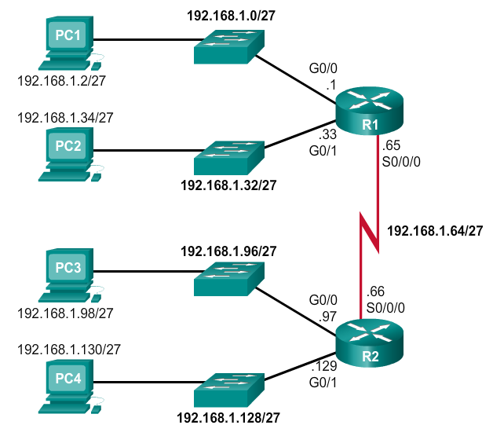

Légende

# Exercice 3 : Réseau d’entreprise

Dans les entreprises, chaque réseau est conçu pour accueillir un nombre limité d'hôtes. La segmentation en sous-réseaux de base consiste à créer suffisamment de sous-réseaux pour répondre aux besoins du réseau tout en fournissant suffisamment d'adresses d'hôte par sous-réseau.

Certains réseaux, tels que les liaisons de réseau étendu point à point, ne requièrent que deux hôtes. D'autres, comme le réseau local d'un grand bâtiment ou d'un service important, doivent accueillir des centaines d'hôtes. Les administrateurs réseau doivent développer un schéma d'adressage interréseau de façon à pouvoir accueillir le nombre maximal d'hôtes pour chaque réseau. Le nombre d'hôtes dans chaque division du réseau doit permettre un nombre plus important d'hôtes.

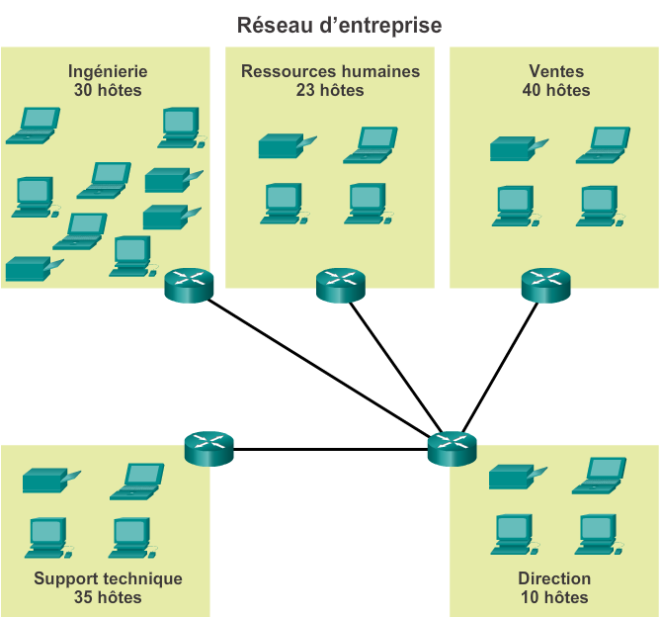

.

.

A compléter en fin d’exercice

.

.

.

.

.

.

Déterminer le nombre total d’hôtes :

Le fournisseur de services a attribué à l’entreprise l’adresse réseau 172.16.0.0/22

Le nombre d’hôtes est-il suffisant ?

Justifiez

Combien d’hôtes maximum il y a t-il par sous-réseau ?

En déduire le nombre de bits minimum nécessaires pour définir les hôtes d’un sous-réseau donné

Combien de bits reste-t-il pour les sous-réseaux ?

En déduire le nombre de sous-réseaux possibles

Est-ce suffisant ?

Justifiez-le en indiquant le nombre de sous-réseaux que l’on a besoin dans notre architecture.

Complétez le tableau ci-dessous pour chacun des sous-réseaux

|  |  |  |  |  |  |  |
| --- | --- | --- | --- | --- | --- | --- |
|  | Adresse du sous-réseau | Masque | Adresse de broadcast | Adresse du 1er hôte | Adresse du dernier hôte | Notation CIDR du sous-réseau |
| Sous-réseau 0 |  |  |  |  |  |  |
|  |  |  |  |  |  |  |
|  |  |  |  |  |  |  |
|  |  |  |  |  |  |  |
|  |  |  |  |  |  |  |
|  |  |  |  |  |  |  |
|  |  |  |  |  |  |  |
|  |  |  |  |  |  |  |
|  |  |  |  |  |  |  |
|  |  |  |  |  |  |  |

Complétez ensuite les adresses IP des réseaux et interfaces sur le schéma du réseau

1. *Les adresses IP des interfaces des routeurs sont à choisir parmi les hôtes.*