Article
Fuel consumption monitoring chart for marine voyage data: A combined deep learning and time series method
Yu-Yi Pan ¹, Mi‐Chia Ma*², Yu-Hao Chen and Heiu-Jou Shaw
Citation: To be added by editorial staff during production.
Academic Editor: Firstname Lastname
Received: date
Revised: date
Accepted: date
Published: date

Copyright: © 2023 by the authors. Submitted for possible open access publication under the terms and conditions of the Creative Commons Attribution (CC BY) license (https://creativecommons.org/licenses/by/4.0/).
¹ Affiliation 1; starorangewww@gmail.com
² Affiliation 2; mcma@ncku.edu.tw; 886-6-2757575 ext 53639
* Correspondence: mcma@ncku.edu.tw; Tel.: 886-6-2757575 ext 53639
Abstract: Fuel consumption monitoring is a crucial concern of marine vessel corporations. Fuel consumption is directly associated with energy efficiency. This paper proposes a comprehensive predictive fuel consumption model with explanatory variables and monitoring charts. Predicted values were computed using weighted mean of predicted values by the time-transformation model and the long short-term memory deep learning network. The mean absolute percentage errors were recorded in the monitoring chart for evaluation, and the maintenance warning boundary was incorporated into the monitoring points. This study employed a dataset from the voyages of three vessels belonging to anonymous Taiwanese marine vessel corporations. We observed changes in fuel consumption for the three vessels and determined the optimal schedule for vessel maintenance and inspection based on the analysis results and monitoring charts.
Keywords: monitoring charts, regression with autoregressive integrated moving average error, long short-term memory neural network, mean absolute percentage error

1. Introduction
Shipping constitutes a crucial component of the global economy. When unprecedented emergencies occur, such as global pandemics, shipping can help maintain communication between countries. Moreover, compared with other modes of transportation, shipping is highly energy efficient [1]. With the development of electronic equipment on vessels, most marine vessel corporations have established databases to collect data on navigation status, hull condition, the engine room, energy efficiency management, and cargo management. Corporations analyze these data and suggest methods for reducing fuel consumption and operating costs [2-5].
Among marine data, energy efficiency and fuel consumption are of vital concern to marine vessel corporations. Energy efficiency is an essential factor in the life cycle costs of a vessel and is closely related to fuel consumption. Changes in energy efficiency are reflected in a vessel’s fuel consumption. When fuel consumption increases, energy efficiency decreases. This study monitored fuel consumption through statistical modeling. A potential benefit of this research is to extend the life of marine vessels.
Studies have indicated that a vessel’s fuel consumption is directly or indirectly affected by internal and external factors. Internal factors, including power, vessel speed, hull design, and rusted hull, belong to the vessel status [6-8]. External factors, including ocean currents and wind speed, are natural variables [9]. Jensen et al. demonstrated that training in energy-efficient operations and crew awareness improved energy efficiency [10]. Critical operations to improve energy efficiency include periodical cleaning of the vessel’s hull and propeller.
Hull deterioration is one notable cause of increased fuel consumption. Dückert indicated that hull deterioration is an essential vessel performance lever in shipping [11]. The ISO 19030 standard [12], a practical method for hull and propeller performance monitoring, measures how much power is required to move a vessel through the water at a given speed, draft, and wind condition; it also calculates performance indicators. This standard provides guidelines to assess the condition of a hull based on collected data. Adland et al. investigated the effect of periodic hull cleaning on oil tanker energy efficiency, and they reported three results: (i) periodic hull cleaning significantly reduced daily fuel consumption; (ii) dry-docking yielded significantly greater reductions in fuel consumption than underwater hull cleaning (approximate reductions of 17% and 9%, respectively); and (iii) the hull cleaning energy efficiency effect was greater when the vessel was sailing laden rather than in the ballast condition [13].
Zayed et al. developed a model of local environmental conditions to predict vessel locations with limited information [14]. Doran revealed that reducing the accumulation of aquatic life and debris through regular hull or propeller cleaning is the most direct method to decrease fuel consumption and improve vessel performance [15]. Shaw and Lin developed the integrated vessel navigation information platform (SNIP) for energy efficiency assessment [16]. This system’s infrastructure includes the following three modules to send and read operational data: an onboard server, an onshore server, and a client interface. In addition, they constructed an indicator to monitor energy efficiency in integrated SNIP data. These verified indicators can be used as references for performance monitoring and maintenance prediction. Therefore, mass flow rates are considered fuel consumption monitoring values.
This study proposed the integration of predictive values in two predictive models for fuel consumption; furthermore, it investigated whether hull and propeller maintenance or cleaning timing should be incorporated into the predictive models of marine vessel corporations. In this paper, first, section 2 describes the construction of the predictive model for fuel consumption and provides monitoring charts. Section 3 discusses the investigation into changes in fuel consumption based on real-world monitoring charts and the differences in fuel consumption after maintenance. Finally, section 4 presents the conclusion and the discussion of limitations of monitoring charts.

2. Materials and Methods

2.1. Predictive model of fuel consumption
A time series model is suitable for analyzing longitudinal marine or shipping data [17-18]. The predictive model in this study incorporates a time transformation model (TTM) and a long short-term memory (LSTM) neural network, which are models for time series data.
The TTM is a regression model with an autoregressive integrated moving average (ARIMA) errors [19-21]. The ARIMA model focuses solely on the autoregressive relationship of the response variable and does not consider explanatory variables. The regression model with ARIMA errors improves on the ARIMA time series model and can be expressed as follows:
${y_{t}=β^{'}X}_{t}+η_{t}$，$η_{t}\sim \text{ARIMA}(p,d,q)$, $t=1,…,n,$ | (1)
where $y_{t}$ is a response variable, $X_{t}$ is an m-dimensional explanatory variables vector at time $t$, $η_{t}$ is an error term with ARIMA, $β$ is an m-dimensional parameter vector of $X_{t}$, and $β^{'}$ is the transpose of $β$. Furthermore, n is the number of voyage segments for each vessel, $p$ is the order of the autoregressive (AR) model, $d$ is the degree of differencing, and $q$ is the order of the moving average (MA) model. As a result, ARIMA ($p$,$d$,$q$) can be represented as follows:
$\left(1-\sum_{i=1}^{p}{ϕ_{i}B^{i}}\right){\left(1-B\right)}^{d}η_{t}=\left(1-\sum_{i=1}^{q}{θ_{i}B^{i}}\right)ε_{t}$ | (2)
where $ε_{t}$ is an error term with a normal distribution, $B$ is the backward shift operator ($B^{d}η_{t}=η_{t-d}$), $ϕ_{i}$ is the coefficient of the AR model, and $θ_{i}$ is the coefficient of the MA model. We employed this equation to construct the predictive model of fuel consumption. The explanatory variables include water speed, ground speed, and engine torque.
In addition to the TTM, deep learning models can be employed to predict longitudinal data. Deep learning models include LSTM and a fully convolutional network (FCN). LSTM, a type of recurrent neural network, was proposed by Hochreiter and Schmidhuber to solve the vanishing gradient problem [22]. LSTM utilizes an input gate, an output gate, a forget gate, and a memory cell to predict values based on historical information in the time $t$. LSTM can increase or decrease the number of memory cells and gates to appropriately assess data. Karim et al. proposed a LSTM neural network with FCN (LSTM–FCN) for multivariate time series data and verified their performance using 85 datasets [23].
The LSTM–FCN model comprises LSTM and FCN. The FCN part implements three layers of convolution, batch normalization, and activation to extract the features of the dependent variables. The LSTM is employed to collect time-correlated information by using a fully connected layer with a rectified linear unit (RELU) function. The RELU function is a commonly used activation function for the continuous response variable to obtain non-linear combinations of the LSTM and FCN outputs. We considered relations between the dependent variables and the pattern of time. RELU is represented by the function $f(a)=max(0,a)$, where $a$ is the input value to a neuron.
Multicollinearity often occurs in multiple regression models. Principal component analysis (PCA) is a statistical method that reduces the dimensionality of datasets and resolves multicollinearity. PCA analysis identifies uncorrelated variables, called the principal components, from a large dataset. Suppose $Σ$ is an $m×m$ variance–covariance matrix of X_t. The principal component is expressed as follows:
$$X_{t}^{*}=RX_{t},$$ | (3)
where $X_{t}^{*}$ is a new $k$-dimensional explanatory variables vector and R is a $k×m$ matrix that consists of the corresponding eigenvectors of the first $k$ largest eigenvalues of $Σ$. The k is determined if the cumulative proportion of the first $k$ largest eigenvalues is greater than 90% after sorting $m$ eigenvalues of $Σ$. That is,
$$Σ=\sum_{i=1}^{m}{{λ_{i}e}_{i}e_{i}^{'}}, R=(e_{1},…,e_{k}),$$
where $λ_{i}$ is the$i$th largest eigenvalue of $Σ$, $e_{i}$ is the eigenvector corresponding to $λ_{i}$, and $e_{i}^{'}$ is the transpose of $e_{i}$.
As a result, we use $X_{t}^{* }$ to replace $X_{t}$ in equation (1) if multicollinearity exists between explanatory variables. This study considered five characteristic variables (four explanatory variables and a response variable); a description of the variables is provided in section 3. After constructing the comprehensive predictive model, we determined the evaluation criterion for fuel consumption and the reference values based on mean absolute percentage error (MAPE).
Because TTM operates on specific assumptions, the LSTM–FCN method can be implemented when the data violate model assumptions and have a poor fit. We used the fuel consumption data for a voyage with a newly maintained hull and propeller cleaning as a model data set and separately calculated the predicted values with the TTM and LSTM–FCN methods. The fuel consumption data of a subsequent voyage with the same destination constitutes the testing data set. However, because the actual fuel consumption of a subsequent voyage may be between the values predicted by the TTM and LSTM–FCN methods, we employed the linear combination of the predicted values as a reference value. The reference value of the two integrated models, ${\hat{y}}_{t}^{I}$, is expressed as follows:
$${\hat{y}}_{t}^{I}=w{\hat{y}}_{t}^{TTM}+\left(1-w\right){\hat{y}}_{t}^{LSTM-FCN},$$ | (4)
where the reference value is entirely based on the LSTM–FCN model if $w$ is 0, and the reference value is entirely based on the TTM model if $w$ is 1.
We employed the MAPE to assess the predictive models. The MAPE is a ratio measurement of the accuracy of a prediction method and is a relative value that is not affected by units or the size of the data set. The reference value is used to monitor the actual fuel consumption of another voyage for each period with the same destination. We calculated the MAPE for each period and constructed the monitoring charts. Each period in the data analysis has 100 values for actual fuel consumption and reference values. The MAPE formula is expressed as follows:
$$\text{MAPE}=\frac{1}{100}\sum_{t=1}^{100}{\left|\frac{{\hat{y}}_{t}^{I}-y_{t}}{y_{t}}\right|}×\text{100\%},$$ | (5)
where $y_{t}$ is the true value at time $t$. If the MAPE is too large, the fuel consumption of subsequent voyages deviates from the reference value. Lewis proposed the forecasting assessment of the MAPE in Table 1 [24].
In accordance with the monitoring chart of the hull, the status of the vessel is normal when the MAPE is under 10%. Furthermore, MAPEs of 10% and 20% indicate warning boundaries and checking boundaries, respectively. When the MAPE exceeds 20%, the hull must be reviewed and maintained when docked. The figures in the data analysis present the MAPEs at weight $w$ = 0, 0.25, 0.5, 0.75, and 1, respectively. The $w$ values range from weak to strong and correspond to the degree of the reference value depending on the TTM.
Table 1. Assessment of MAPE
MAPE (%) | Assessment
<10% | Precise prediction
10%-20% | Good prediction
20%-50% | Reasonable prediction
>50% | Bad prediction

2.2. Monitoring chart of fuel consumption
The purpose of the monitoring charts is to detect changes in fuel consumption during each voyage. The monitoring chart concept originates from a statistical control chart of industrial statistics. Shewhart et al. applied a statistical control chart to improve manufactured products [25]. The control chart’s upper and lower boundaries are based on the central limit theorem. When the sample means of product measurements continually exceed the upper or lower limits, the manufacturing process is halted and problems are examined. Thus, if a vessel frequently navigates the same channel and ports, the fuel consumption should not differ greatly when some unpredictable factors are excluded on these voyages.
Suppose the actual fuel consumption is different from the reference value. In this condition, the MAPE exceeds the boundary of the monitoring chart, and the hull status must be examined. The predictive model assumes that the hull status resembles that of a new vessel after hull maintenance or propeller cleaning. In addition, the data from the first voyage segment after hull maintenance are regarded as the baseline data. After constructing the baseline model, we can compute the mass flow rates ${\hat{y}}_{t}^{I}$ of the next voyage segment as reference values. An MAPE greater than the checking boundary indicates problems with the vessel’s status. Monitoring continues until the next time of hull and propeller maintenance, which may include dry-docking or propeller cleaning. The advantages of this monitoring chart include its intuitive interpretation; furthermore, it enables observation of the degree of deviation in fuel consumption for each voyage after hull maintenance.

3. Data analysis

3.1. Data description
Anonymous marine vessel corporations collected the voyage data in Taiwan, which were obtained through integrated SNIP. Various measuring devices on vessels provided the raw datasets. The vessel data host and the network communication system sent the data to the shore data host. The shore data host downloaded the data, which were then classified into folders according to vessel number and data source. Data included the alarm monitoring system (AMS), the mass flow meters (MFM), the shaft horsepower meters, the vessel data recorders, the electronic model display and information system (ECDIS) on the bulk vessel, the draft value obtained from the pilot card, and midday reports. Finally, we employed R programming language to create dated folders, which were moved to local storage. These datasets were employed to construct the TTM and monitoring chart.
The raw data may contain errors, omissions, repetitions, and changes in the data collection process. Therefore, we employed R programming language to preprocess the raw data in the dated folders to ensure data integrity and correct identification; the valid data were then added to the “Data Processing System” database. The system records AMS, ECDIS, and MFM every 5 minutes, whereas midday reports are manually recorded by the crew once or twice per day. However, this recording method results in inconsistent time units. To rectify this problem, we labeled the earliest instance of 1-minute recorded data as 1 and then integrated the dataset such that every 5 minutes equaled one unit in each vessel.
Before constructing the TTM and LSTM–FCN models, we divided the whole voyage data to identify the similar voyage segments of each vessel by the ports of departure and arrival with latitude and longitude data. Identifying similar voyage segments enabled us to evaluate the degree of fuel consumption under similar voyage conditions. When the status of the hull is affected by ocean conditions or other variables, the fuel consumption varies during a similar segment. Therefore, the voyages of each vessel were separated into two routes: from the Asian ports to the American ports and from the American ports to the Asian ports. Figure 1 presents one voyage segment for two routes of the transoceanic voyages of three vessels. The plots on the left illustrate the journeys from the Asian port to the American port, and those on the right illustrate the journeys from the American port to the Asian port. Due to the fixed directions of ocean currents, we must consider possible anterograde and retrograde effects.
We adjusted the engine power as “engine power*” based on the influence of the trim, draft, and limits of engine power. The “mass flow rate diff” is the outlet mass flow rate of engine fuel minus the inlet mass flow rate of engine fuel in the raw data; this variable is predicted and evaluated. Values of “engine power*”, “engine torque”, “engine speed”, and “water speed” not greater than 0 may indicate an abnormal sailing state or an instrument recording error. Therefore, such values do not reflect the actual status of the vessel during sailing, so we removed these data and time points in data analysis.
In addition, because vessel fuel consumption does not remain stable during the time between the port of departure and the port of arrival, the relationship between fuel consumption and explanatory variables in two instances may vary. Therefore, this study excluded voyages with latitude data greater than 147 or less than −125. This study employed four explanatory variables of usual shipping indicators to construct a model; the fuel consumption response variable is “mass flow rate diff.” Table 2 presents the descriptive statistics of the four explanatory variables and one response variable for the voyages of three vessels.
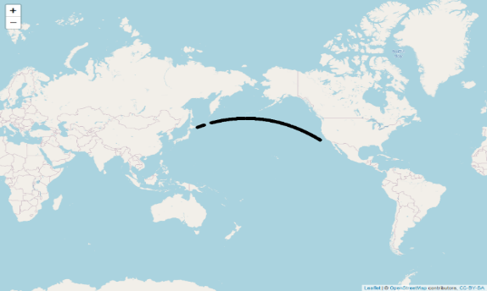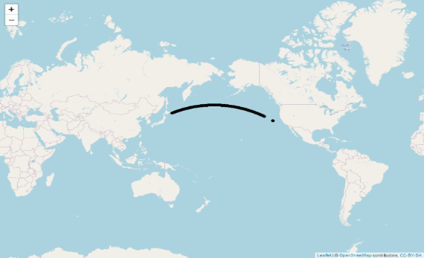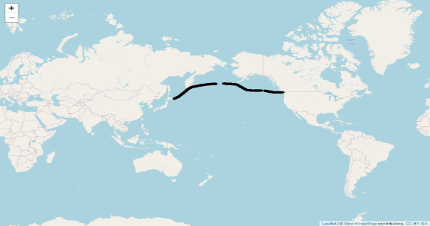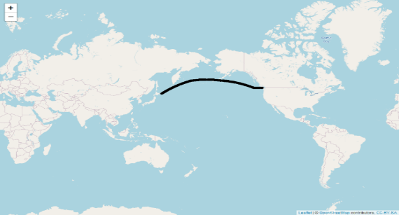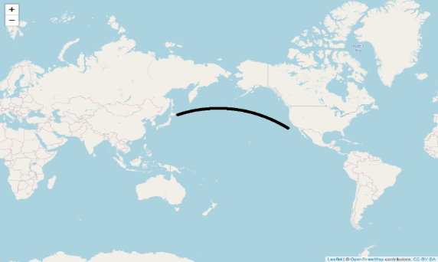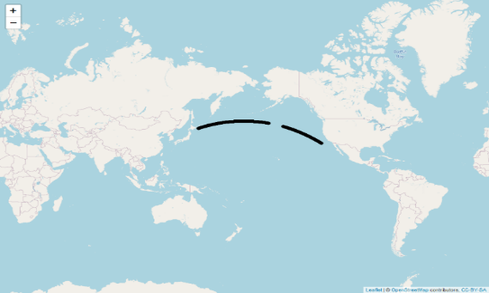
Vessel A
Vessel A
Vessel B
Vessel B
Vessel C
Vessel C
Figure 1. (Left) Voyages from Asian port to American port. (Right) Voyages from American port to Asian port. (Top) Vessel A. (Middle) Vessel B. (Bottom) Vessel C.

Vessel A had 2,363 time data points for the voyage from the Asian port to the American port and 2,651 time data points from the American port to the Asian port, as indicated in Table 2. The statistics revealed that the values for “engine torque,” “engine speed,” “engine power,*” “water speed,” and “mass flow rate diff” differed among the three vessels. The Mann–Whitney U test compares the mean or median difference between two independent groups. The dependent variable is an ordinal variable or continuous variable; therefore, it does not require a normal distribution assumption. In addition to the descriptive statistics, we investigated whether these data shared the same distribution during two-way voyages for each variable in the last column of Table 2. If the Mann–Whitney U test results indicated no differences in means or medians, we combined two-way trips into one voyage.

3.2. Figures, Tables and Schemes
Because the Mann–Whitney U test results indicated differences in the means or medians for two-way trips (i.e., less than the significant level of .05) for all variables, we constructed predictive models for separate two-way voyages (Table 2). Moreover, the results indicated correlations between “engine power,*” “engine speed,” “water speed,” and “engine torque,” which may indicate multicollinearity. We implemented PCA for four variables before fitting the model to address potential multicollinearity. We designed a program to select the number of principal components that accounted for 90% of the data variation. Because the first principal components of all datasets exceeded 90% of the data variation, we extracted the first principal component as an explanatory variable in the predictive model. Table 3 presents the hull and propeller maintenance times of the three vessels. Dry-docking and propeller cleaning are two standard procedures to improve vessel fuel consumption. During dry-docking, the vessel is removed from the water for maintenance and repair. Propeller cleaning is completed underwater; it requires more precise execution and is more convenient than dry-docking. Although dry-docking is a more comprehensive component of hull improvement than propeller cleaning, it requires more time and resources. Thus, most marine vessel corporations choose to employ propeller cleaning for vessel maintenance.

Table 2. Descriptive statistics of five variables for the voyages of three vessels
Variables | Unit | The Asia to the America |  | The America to the Asia
Vessel A |  | Mean±SD | Median | Mean±SD | Median | p-value
Time points |  | 2363 |  | 2651
Engine torque | Nm | 3775.1±268.1 | 3668.3 | 3367.6±410.5 | 3369.3 | <0.001
Engine speed | rpm | 72.0±0.66 | 72.0 | 66.7±4.6 | 65.5 | <0.001
Engine power* | kW | 28880.6±1991.7 | 28111.4 | 23245.1±4253.7 | 22633.0 | <0.001
Water speed | knot | 17.9±0.62 | 18.0 | 16.4±1.0 | 16.46 | <0.001
Mass flow rate diff | MT/hr | 5.3±0.34 | 5.2 | 4.5±0.76 | 4.3 | <0.001
Vessel B |  | Mean±SD | Median | Mean±SD | Median | p-value
Time points |  | 2510 |  | 2679
Engine torque | Nm | 2601.2±1612.4 | 3657.0 | 2127.1±397.7 | 2077.2 | <0.001
Engine speed | rpm | 55.6±23.4 | 72.7 | 52.1±4.6 | 52.0 | <0.001
Engine power* | kW | 18907.2±13262.6 | 27600.6 | 11783.0±3357.4 | 11318.3 | <0.001
Water speed | knot | 15.2±6.5 | 19.7 | 12.64±1.5 | 12.9 | <0.001
Mass flow rate diff | MT/hr | 3.5±2.4 | 5.1 | 2.28±0.60 | 2.2 | <0.001
Vessel C |  | Mean±SD | Median | Mean±SD | Median | p-value
Time points |  | 2153 |  | 2165
Engine torque | Nm | 3370.6±338.5 | 3410.5 | 2403.7±244.0 | 2422.4 | <0.001
Engine speed | rpm | 67.6±3.3 | 69.1 | 56.46±3.2 | 57.0 | <0.001
Engine power* | kW | 23908.4±3173.0 | 24393.0 | 14219.4±2125.4 | 14418.0 | <0.001
Water speed | knot | 18.6±1.2 | 19.0 | 15.74±1.1 | 15.8 | <0.001
Mass flow rate diff | MT/hr | 4.6±0.57 | 4.7 | 2.8±0.39 | 2.9 | <0.001
The voyage of Vessel A was from November 12, 2018, to January 4, 2019; the voyage of Vessel B was from March 12, 2019, to June 3, 2019; the voyage of Vessel C was from May 27, 2019, to July 1, 2019.
SD is the standard deviation; the p value is for the Mann–Whitney U test.

Table 3 The hull and propeller maintenance times of three vessels
Vessel number | Date | Item of hull and propeller maintenance
A | 2018/10/24 | Dry-docking
B | 2019/2/20 | Propeller cleaning
C | 2019/2/13 | Propeller cleaning

This study implemented data analysis of the constructed predictive models with R programming language. Figure 2 presents the monitoring charts with five weights for the three vessels in two-way voyages. Figure 3 presents actual fuel consumption trends and reference values for the LSTM–FCN model and the TTM for two-way journeys of the three vessels. We also provided the number of time points for the model data set and testing data set for the three vessels in Appendix A.
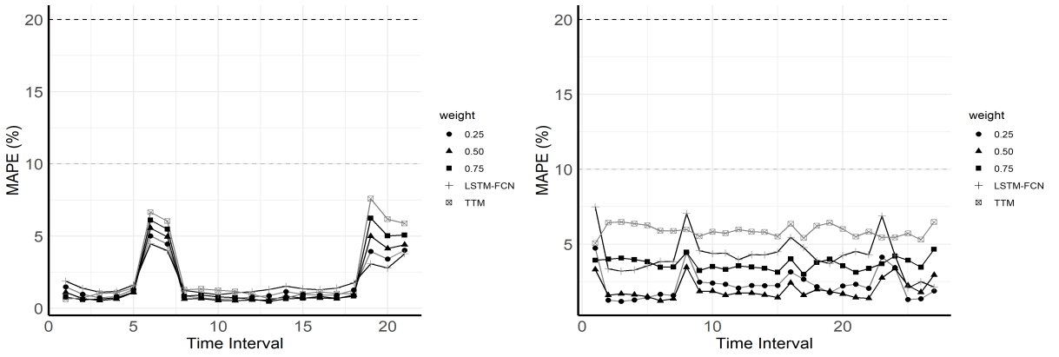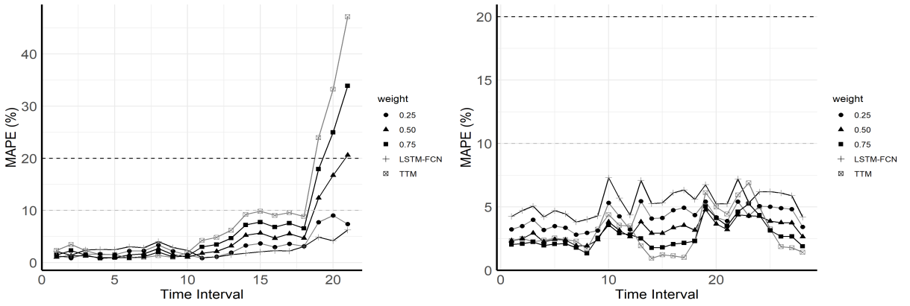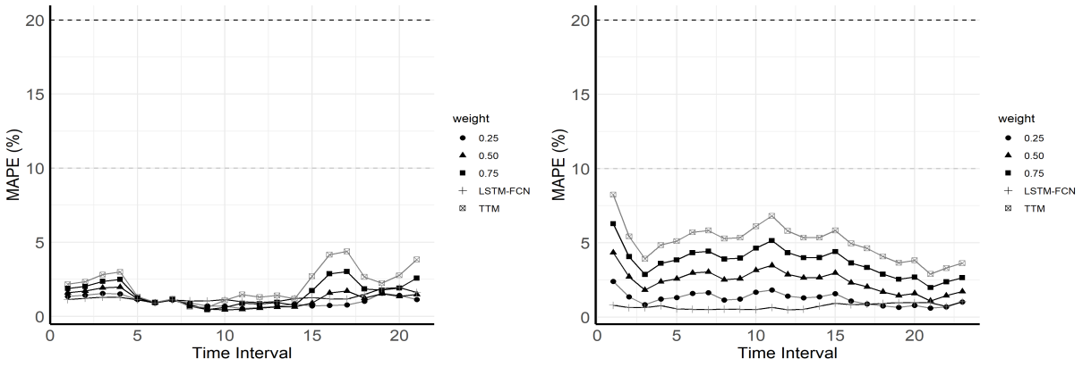
(c)
(a)
(b)
Figure 2. Monitoring charts of voyages. (Left) Voyages from Asian port to American port. (Right) Voyages from American port to Asian port.
The time series plots of the four explanatory variables, “mass flow rate diff,” and “abs vessel speed diff” (the absolute value of the difference between the speed of the vessel over the ground and the speed of the vessel over the water) are provided in Appendix B for the two-way voyages of the three vessels. The time series plots of the variables reveal correlations between “engine power,*” “engine speed,” “engine torque,” and “water speed” and “mass flow rate diff” (Figures B1 to B3 of Appendix B).
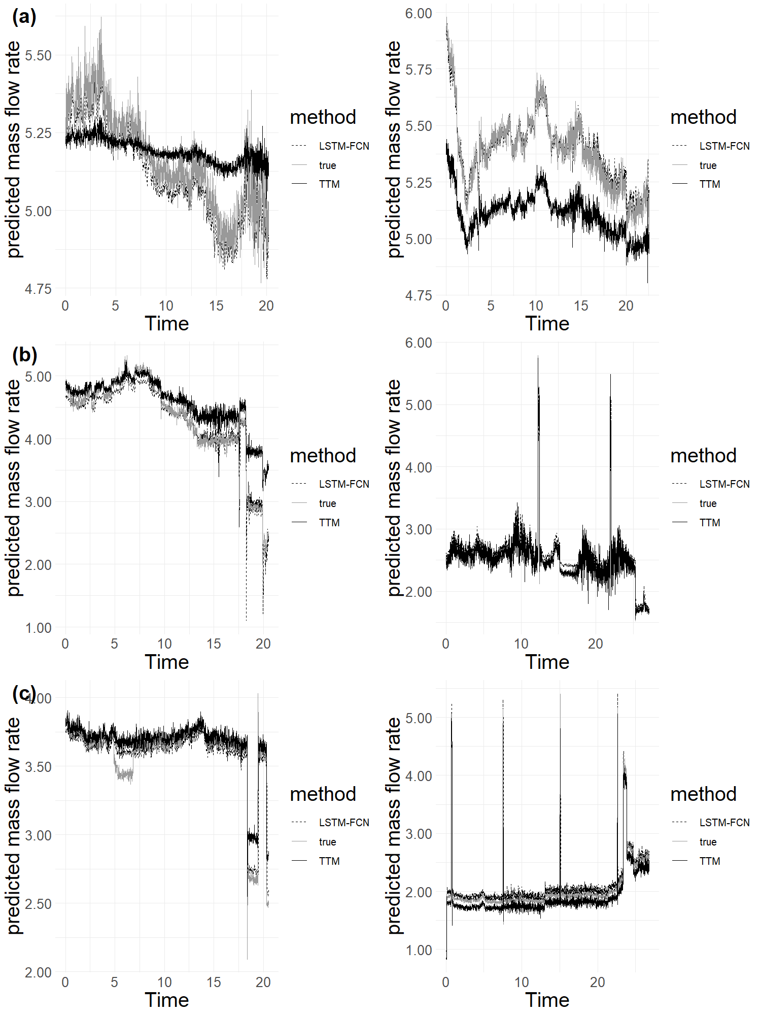
Figure 3. Time series plots of true fuel consumption and predicted values of TTM and LSTM–FCN model. (Left) Voyages from Asian port to American port. (Right) Voyages from American port to Asian port (x-axis indicates time periods; one time period includes 100 time points).
(C)
(C)

3.2.1 Vessel A
All MAPEs in the two monitoring charts of Figure 2(a) do not exceed the warning boundary. This finding demonstrates that Vessel A had regular fuel consumption during the voyage from the Asian port to the American port; the vessel also maintained a good status during the journey from the American port to the Asian port. The trends of the five weights were similar on two-way voyages. When the weight value increases, the importance of the monitoring points increases, and the MAPE value of TTM ($w=\text{1}$) is the highest for all weights of the two voyages. Figure 3(a) reveals that the predicted value of the LSTM–FCN model is closer to the actual value than that of TTM. After Vessel A was maintained by dry-docking, it could provide an excellent baseline model to predict fuel consumption during the subsequent voyage. The time series plots of five variables have two peaks, except for “abs vessel speed diff” (bottom plot of Figure B2 in Appendix B). The periods with small peaks in the MAPEs in Figure 2(a) indicate large differences between the predicted mass flow rate values of TTM and the actual values in Figure 3(a). This result demonstrates that our monitoring chart detected deviations between the reference value and the actual mass flow rates during voyages.

3.2.2 Vessel B
In the last four time periods of the left monitoring chart in Figure 2(b), the monitoring points increased sharply beyond the maintenance checking boundary from the Asian port to the American port. However, the direction of the MAPEs was stable from the American port to the Asian port for five weights. The left diagram of Figure 3(b) indicates that the true mass flow rates sharply decreased after the 17th period. Based on shipping experience, we concluded that this strange phenomenon may have resulted from human factors. The most likely explanation was that Vessel B had a smooth voyage and arrived at the port earlier than expected. Therefore, its speed slowed earlier, and the arrival time was as expected. As indicated in the upper plot of Figure B2 of Appendix B, the relevant maritime variable “abs vessel speed diff” did not fluctuate significantly. Four explanatory variables exhibited a strange fluctuation after the 17th period, and the fluctuation shape is similar.
Another noteworthy phenomenon is that the MAPE of TTM is the smallest of five weights during several periods in the right monitoring chart of Figure 2(b). Although the predicted mass flow rate values of the LSTM–FCN model have more accurate fits than those of TTM for most actual values, we must avoid overfitting. Hence, we must consider a linear combination of the predicted values of the LSTM–FCN model and the predicted values of TTM. In the lower plot of Figure B2 of Appendix B, the time series plots of five variables have two peaks except for the “abs vessel speed diff.” In those periods with peaks, the MAPE in the right diagram of Figure 2(b) and the mass flow rates in the right diagram of Figure 3(b) have peaks at corresponding periods. This finding reveals the severe ocean conditions during those periods and demonstrates that our monitoring chart detected fluctuations in the ocean conditions.

3.2.3 Vessel C
In the left monitoring chart of Figure 2(c), the Vessel C results resemble those of Vessel A. Although we can observe two changes from the fifth period to the eighth period and from the 18th period to the 21st period, the time series plots of five weights were under 10%, which indicates a normal status for Vessel C. In the right monitoring chart of Figure 2(c), the MAPE of LSTM–FCN (w=0) and other weights have four peaks. In those periods with peaks, mass flow rates and five variables have corresponding peaks in Figure B3, except for the variable “abs vessel speed diff” in Appendix B. This finding reveals the severe ocean conditions during those periods and demonstrates that the LSTM–FCN model detected fluctuations in the ocean conditions. The monitoring chart of the voyages from the American ports to the Asian ports remained under the 10% boundary. In the right monitoring chart of Figure 2(c), the MAPEs of three weights are lower than those of the LSTM–FCN model and TTM. This occurred because the actual values were between the predicted values of the TTM and the LSTM–FCN model.
The right diagram of Figure 3(c) illustrates predicted mass flow rates for the voyage from the American port to the Asian port. The TTM generated lower predicted values than the actual mass flow rates, and the LSTM–FCN model generated higher predicted values than the actual mass flow rates. Since the true mass flow rates were between the predicted values of the TTM and the LSTM–FCN model, we incorporated combined weights for the two predicted values. The weights can help balance the differences between the two methods with actual mass flow rates and thus obtain more accurate forecasts. However, because the time of this voyage was close to the time of hull and propeller maintenance, the hull likely had a good status. MAPEs were below the warning boundary. Therefore, the weighted means of two predicted values performed better than those of the TTM and the LSTM–FCN model in this voyage.

4. Conclusion and discussion
This study constructed monitoring charts to detect differences between predicted fuel consumption and reference values. The reference values were calculated by combining the TTM of the time series model and the LSTM–FCN of the deep learning method. Relevant studies have indicated that changes in fuel consumption may be associated with hull deterioration. When the hull deteriorates, fuel consumption increases. Hence, the proposed monitoring chart can also detect the degree of hull deterioration.
This study yielded several conclusions regarding the weight of the two modeling methods. Although TTM (w = 1) provided stable predictive values, it failed to effectively detect some natural variations in the reference values. Therefore, it may generate large MAPEs and trigger false alarms in the monitoring chart. The LSTM–FCN (w = 0) model was quite sensitive to data performance, and it may generate overfitting and small MAPEs. Therefore, determining the weight of the two predicted values is of crucial importance. We recommend a weight of 0.25 if insufficient information is available. Our combined model integrated the parametric model and the results of deep learning methods. Furthermore, we determined the optimal weight of predicted values by minimizing the MAPE for different voyages.
In accordance with the predictive model characteristics, the number of models depends on the number of hull and propeller maintenance times. In addition, although we assumed good hull and propeller status after maintenance, we could not determine the actual degree or quality of vessel maintenance. This limitation is a potential problem in the predictive model. Due to the small number of voyages, the suggestions for two-way voyages’ predictive models may generate contradictions in practice. Increasing the number of voyages or reducing the difference between them may be required to achieve consistent data for the same vessel. Statistical hypothesis testing methods can be implemented to detect the mean or median difference for each variable for two-way voyages before constructing predictive models. Separating the predictive models into two-way trips is not required if the mean difference for each variable is nonsignificant. We could generate multiple models after each instance of hull and propeller maintenance to improve this predictive model. Too few voyage segments and regular hull and propeller maintenance results in insufficient data to construct predictive models. The construction of accurate predictive models requires data from the same vessels over a longer period and with a fixed route.
Future studies should not solely measure the effect of hull deterioration based on the fuel mass flow rates of the main engine; other response variables require investigation. In addition, future studies should consider employing additional indicators as monitoring points to construct improved predictive models. The degree and timing of propeller cleaning may be incorporated into monitoring chart. The influence of ocean currents is another variable of concern. Because this study’s data set contained no information on ocean currents, we were unable to analyze this variable. If data on ocean currents are available in the future, we will eliminate more uncontrollable variables and thus achieve a more targeted forecast of marine vessel fuel consumption.
Author Contributions: Yu-Yi Pan: Methodology, Data Analysis, Writing - original draft. Yu-Hao Chen: Data analysis, Writing - initial draft. Mi‐Chia Ma: Conceptualization, Methodology, Funding acquisition, Supervision, Writing - review & editing. Heiu-Jou Shaw: Conceptualization, Funding acquisition, Supervision, Writing - review.
Funding: This research was funded by by the Ministry of Science and Technology, Taiwan [grant number MOST109-2218-E-006-017].
Institutional Review Board Statement: Not applicable
Data Availability Statement: No new data were created or analyzed in this study. Data sharing is not applicable to this article.
Acknowledgments: This work was supported by the Ministry of Science and Technology, Taiwan [grant number MOST109-2218-E-006-017]. In addition, we would like to thank assistant Sin-Yuan Huang in the Department of Statistics and Institute of Data Science, National Cheng Kung University, Tainan, Taiwan, for assistance in providing R programming, and thank assistant Jia-Rong Chang in the Department of Systems and Naval Mechatronic Engineering, National Cheng Kung University, Tainan, Taiwan, for providing comments of the marine domain knowledge.
Conflicts of Interest: The authors declare no conflict of interest.
Appendix A
Table A. the number of the time points for three vessels in two-way voyages
Vessel | The number of time-point  of modelling data set |  | The number of time-point  of testing data set
 | From the Asia  to the America | From the America  to the Asia | From the Asia  to the America | From the America  to the Asia
A | 2363 | 2651 | 2026 | 2261
B | 2510 | 2679 | 2259 | 2716
C | 2153 | 2165 | 2061 | 2686
Appendix B
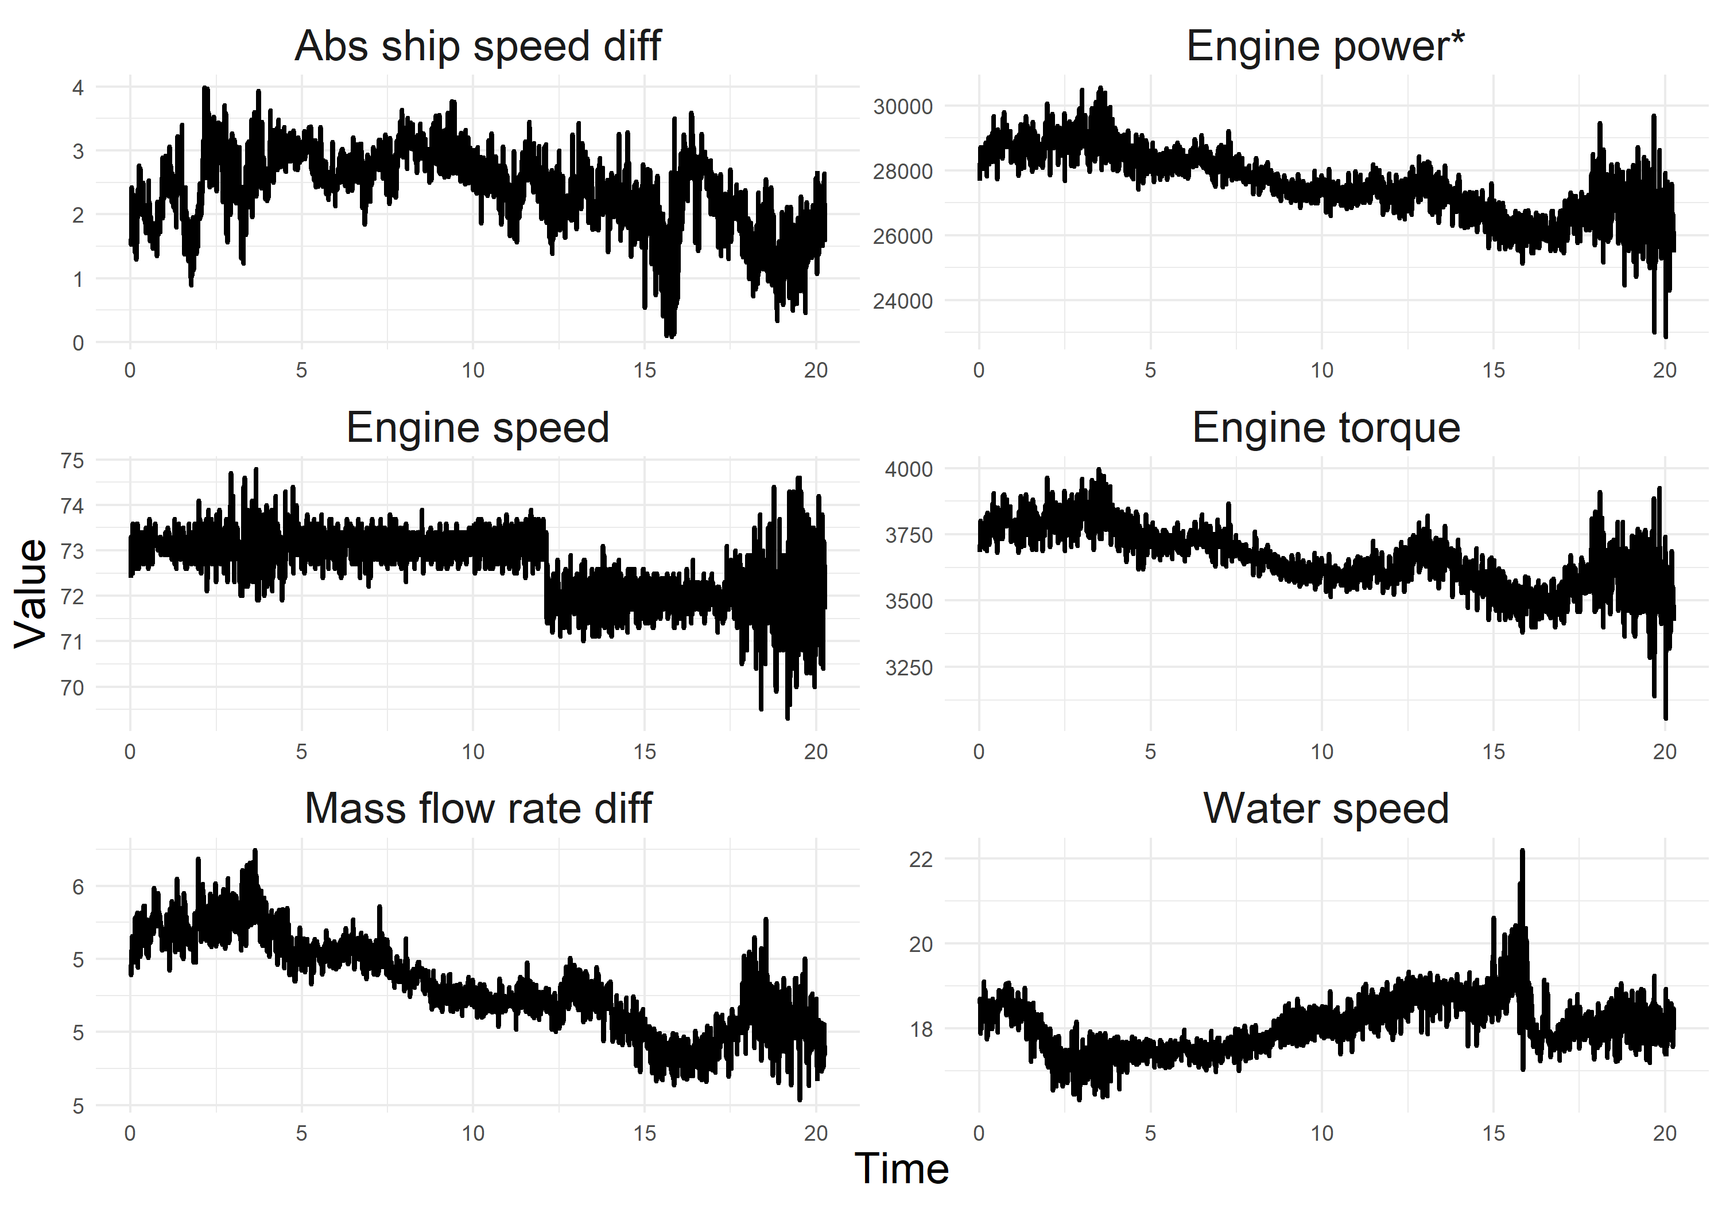
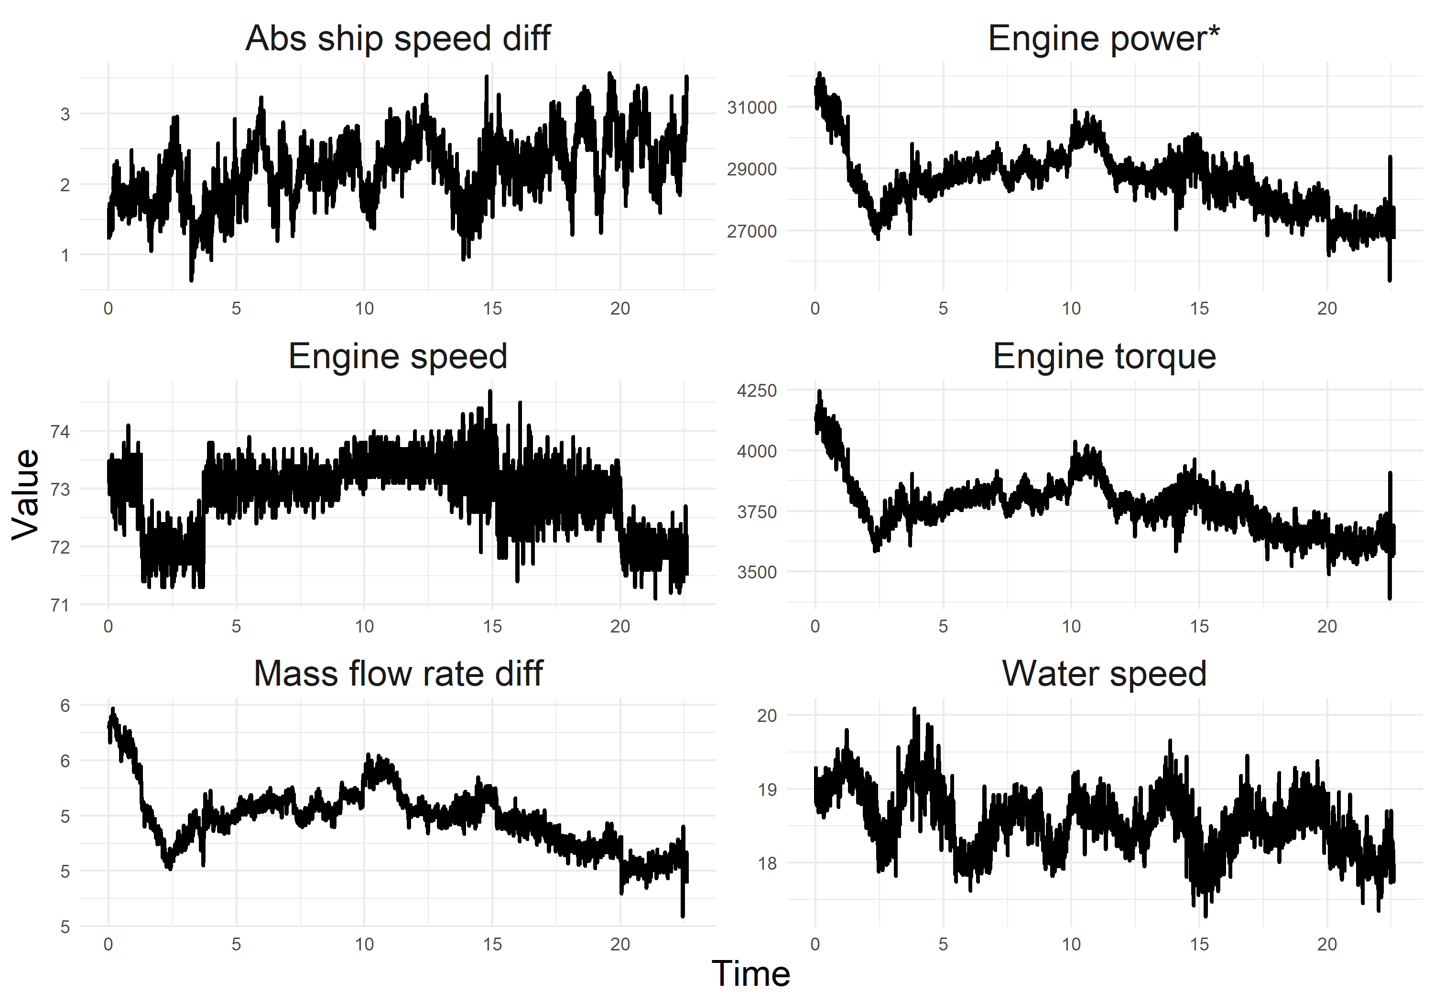
Fig. B1 The time series plots of six variables for vessel A, the upper plots are from the Asian port to the American port; the lower plots are from the American port to the Asian port. (The x axis is the time periods; one time-period includes 100 time points)
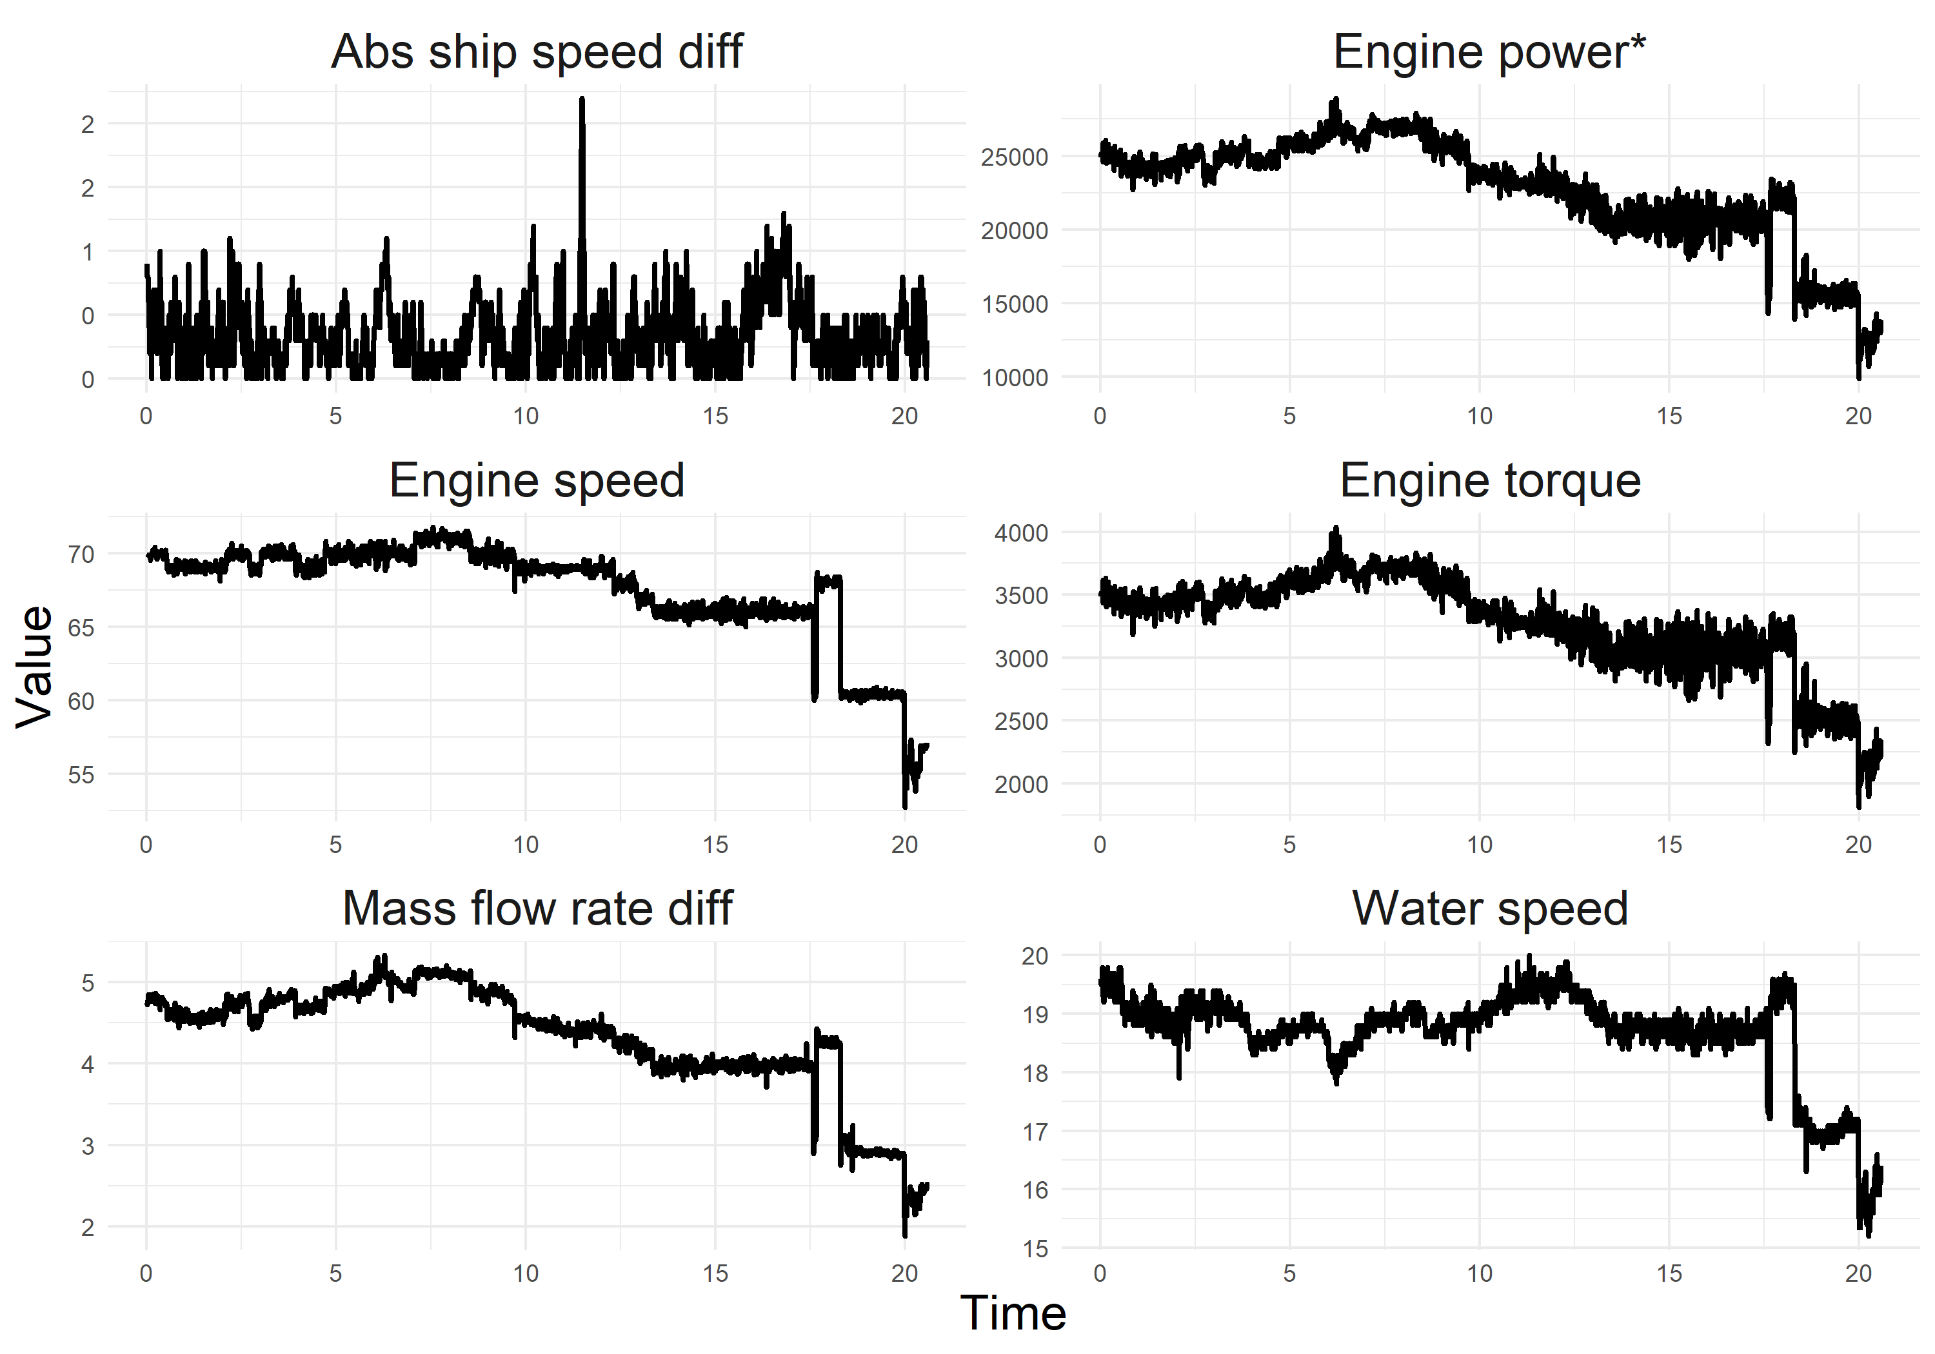
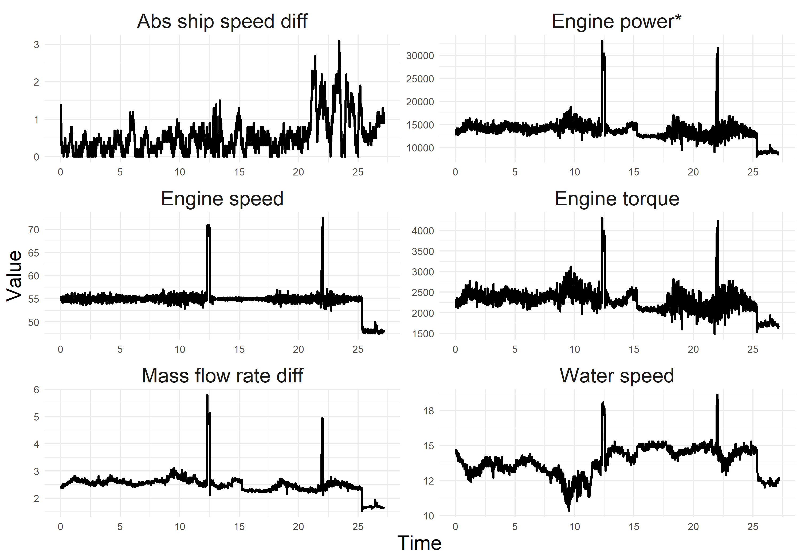
Fig. B2 The time series plots of six variables for vessel B, the upper plots are from the Asian port to the American port; the lower plots are from the American port to the Asian port. (The x axis is the time periods; one time-period includes 100 time points)
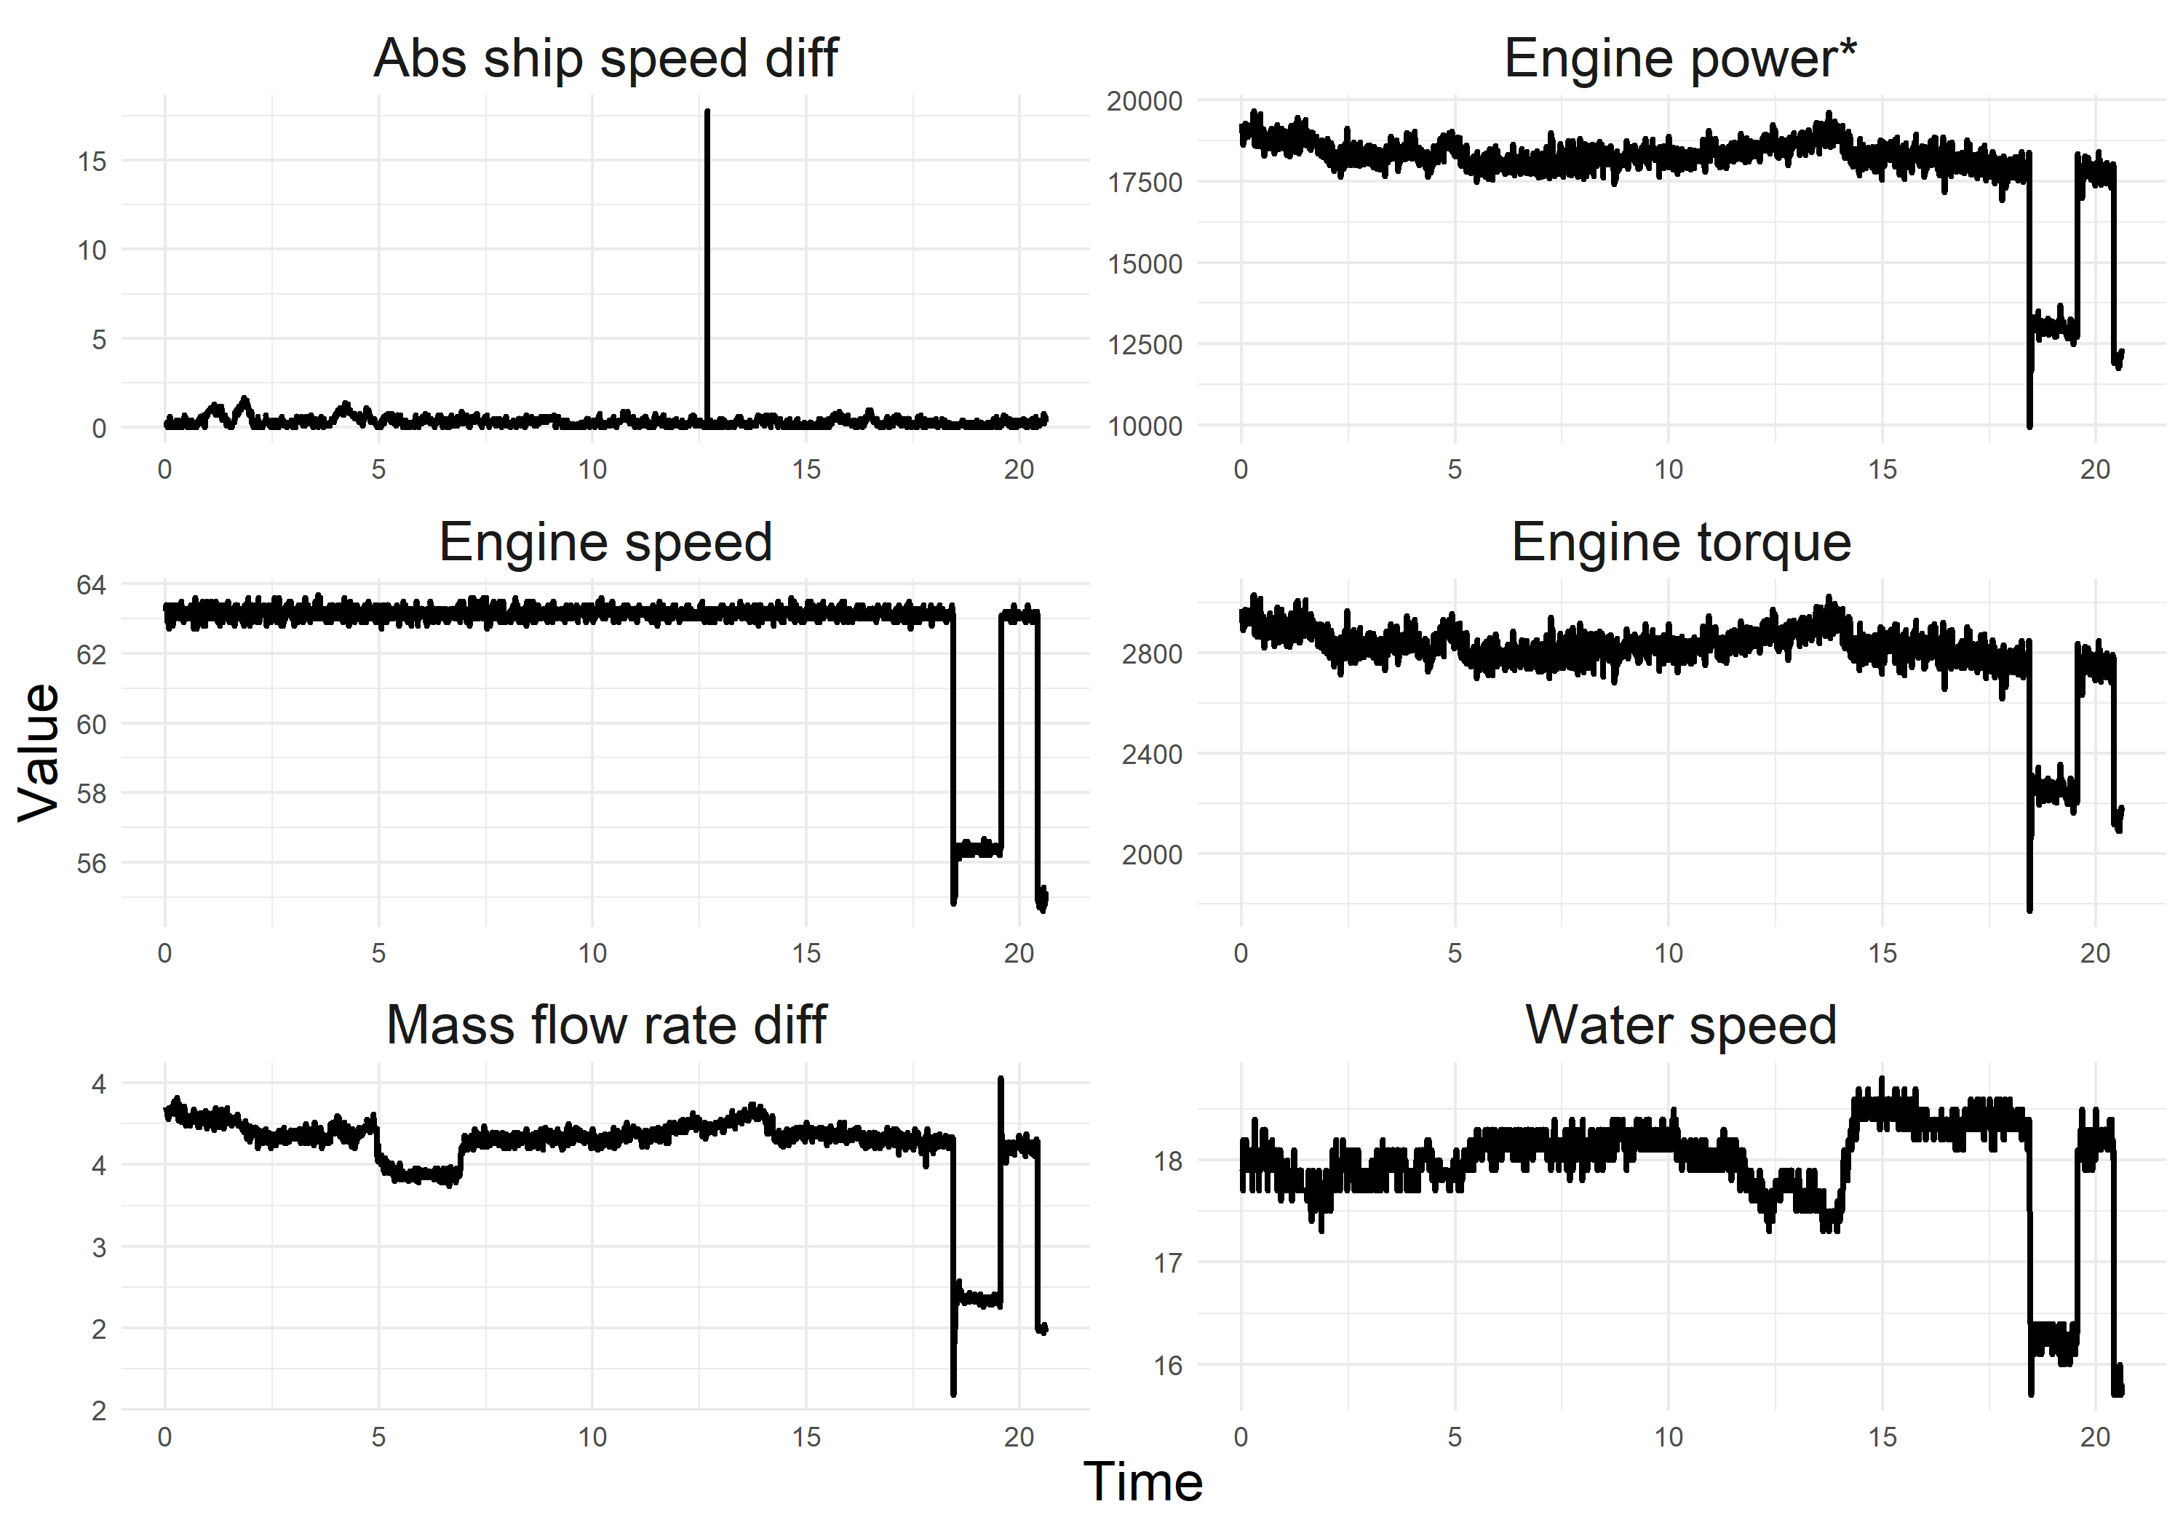
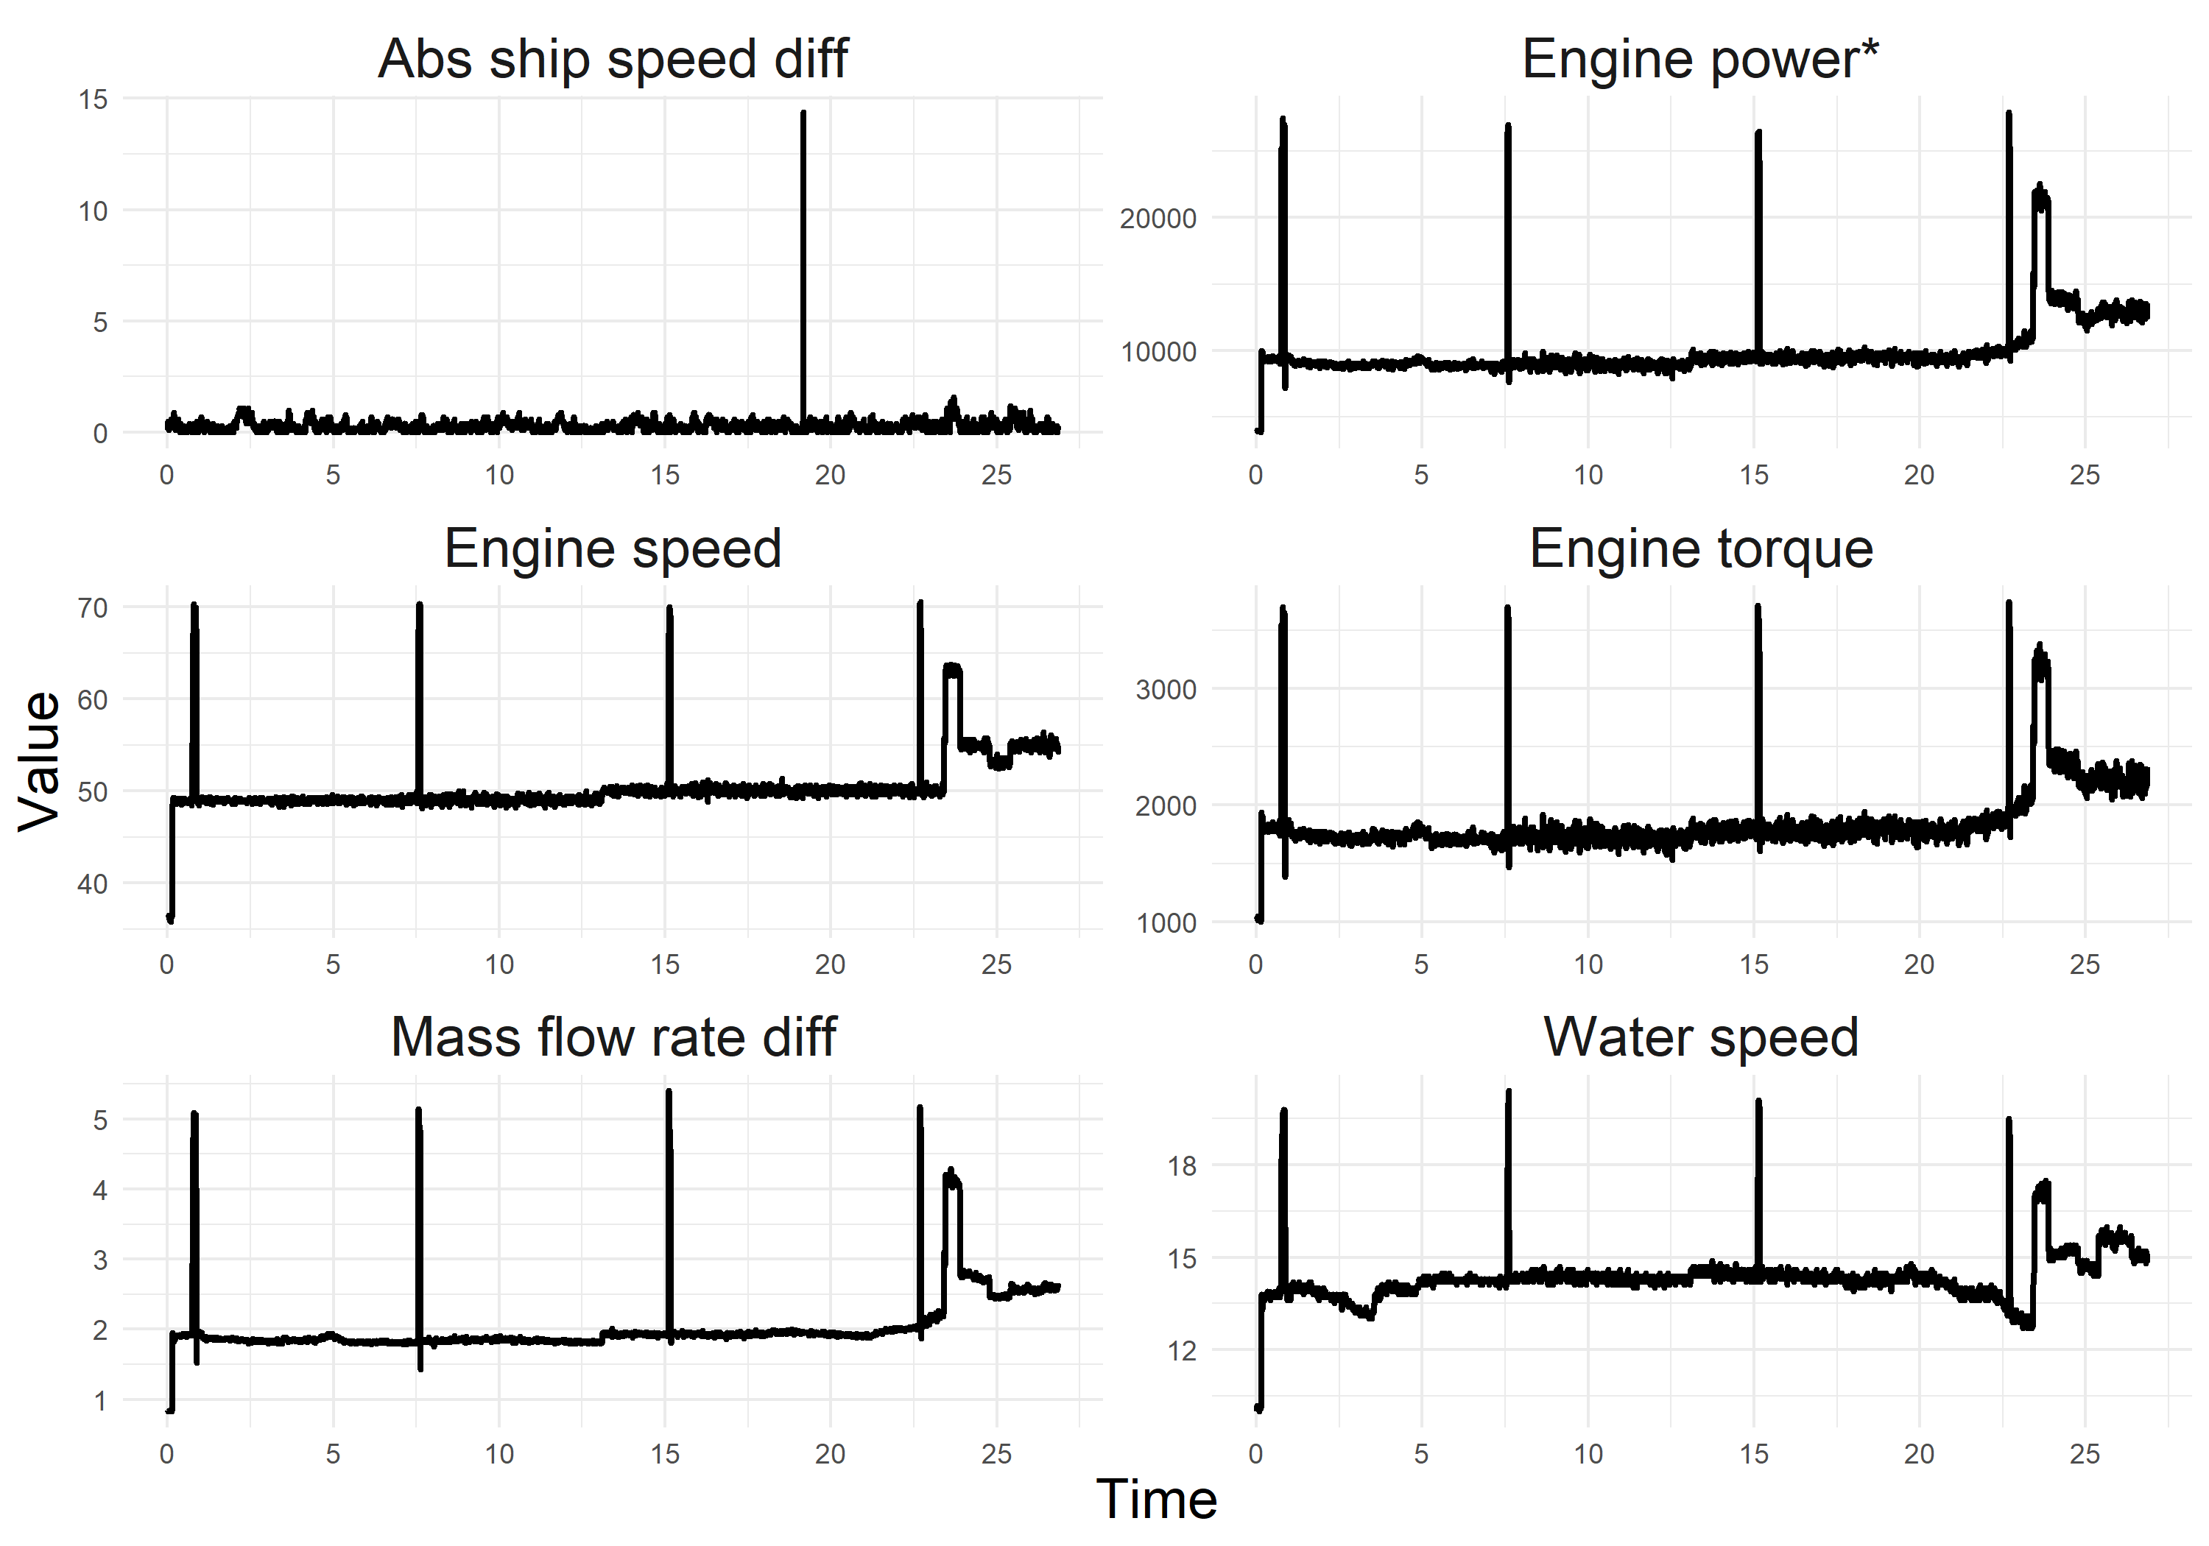
Fig. B3 The time series plots of six variables for vessel C, the upper plots are from the Asian port to the American port; the lower plots are from the American port to the Asian port. (The x axis is the time periods; one time-period includes 100 time points)

References
- Buhaug, Ø.; Corbett, J.; Endresen, Ø.; Eyring, V.; Faber, J.; Hanayama, S.; Lee, D.S.; Lee, D.; Lindstad, H.; Markowska, A.Z.; et al. Second imo ghg study 2009 2009.
- Coraddu, A.; Oneto, L.; Baldi, F.; Cipollini, F.; Atlar, M.; Savio, S. Data-driven ship digital twin for estimating the speed loss caused by the marine fouling. Ocean Engineering 2019, 186, 106063.
- Cristea, D.S.; Moga, L.M.; Neculita, M.; Prentkovskis, O.; Md Nor, K.; Mardani, A. Operational shipping intelligence through distributed cloud computing. Journal of Business Economics and Management 2017, 18, 695–725.
- Latifov, K. A critical evaluation of potential outcomes of using modern artificial intelligence and big data analysis technology in maritime industry 2019.
- Zhang, C.; Zhang, D.; Zhang, M.; Mao, W. Data-driven ship energy efficiency analysis and optimization model for route planning in ice-covered Arctic waters. Ocean Engineering 2019, 186, 106071.
- Johnson, H.; Styhre, L. Increased energy efficiency in short sea shipping through decreased time in port. Transportation Research Part A: Policy and Practice 2015, 71, 167–178.
- Tarelko, W.; Rudzki, K. Applying artificial neural networks for modelling ship speed and fuel consumption. Neural Computing and Applications 2020, 32, 17379–17395.
- Onyshchenko, S.; Melnyk, O. Efficiency of ship operation in transportation of oversized and heavy cargo by optimizing the speed mode considering the impact of weather conditions. Transport and Telecommunication Journal 2022, 23, 73–80.
- Hu, Z.; Jin, Y.; Hu, Q.; Sen, S.; Zhou, T.; Osman, M.T. Prediction of fuel consumption for enroute ship based on machine learning. IEEE Access 2019, 7, 119497–119505.
- Jensen, S.; Lützen, M.; Mikkelsen, L.L.; Rasmussen, H.B.; Pedersen, P.V.; Schamby, P. Energy-efficient operational training in a ship bridge simulator. Journal of Cleaner Production 2018, 171, 175–183.
- ECO Insight hull degradation computation method goes beyond ISO 19030 standard. https://www.stormgeo.com/products/s-suite/s-insight/articles/eco-insight-hull-degradation-computation-method-goes-beyond-iso-19030-standard/ (accessed on December 12, 2020).
- ISO, 2016a. ISO 19030-1: Vessels and marine technology measurement of changes in hull and propeller performance - part 1: General Principles, Geneva.
- Adland, R.; Cariou, P.; Jia, H.; Wolff, F.C. The energy efficiency effects of periodic ship hull cleaning. Journal of Cleaner Production 2018, 178, 1–13.
- Zayed, A.; Garbatov, Y.; Soares, C.G. Corrosion degradation of ship hull steel plates accounting for local environmental conditions. Ocean engineering 2018, 163, 299–306.
- Forces combine to bring hull efficiency into the spotlight. Available online: https://www.hullwiper.co/news/forces-combine-to-bring-hull-efficiency-into-the-spotlight/ (accessed on 12 December 2020).
- Shaw, H.J.; Lin, C.K. Marine big data analysis of ships for the energy efficiency changes of the hull and maintenance evaluation based on the ISO 19030 standard. Ocean Engineering 2021, 232, 108953.
- Kocharekar, A.; Nemade, B.V.; Patil, C.G.; Sapkale, D.D.; Salunke, S.G. Weather prediction for tourism application using arima. Weather 2019, 6.
- Suhermi, N.; Prastyo, D.D.; Ali, B.; et al. Roll motion prediction using a hybrid deep learning and ARIMA model. Procedia computer science 2018, 144, 251–258.
- Bianco, A.M.; Martinez, E.; Ben, M.G.; Yohai, V. Robust procedures for regression models with ARIMA errors. In Proceedings of the COMPSTAT: Proceedings in Computational Statistics 12th Symposium held in Barcelona, Spain, 1996. Springer, 1996, pp. 27–38.
- Kalbfleisch, J.D.; Prentice, R.L. The statistical analysis of failure time data; John Wiley & Sons, 2011.
- Hyndman, R.J.; Athanasopoulos, G. Forecasting: principles and practice; OTexts, 2018.
- Hochreiter, S.; Schmidhuber, J. Long short-term memory. Neural computation 1997, 9, 1735–1780.
- Karim, F.; Majumdar, S.; Darabi, H.; Chen, S. LSTM fully convolutional networks for time series classification. IEEE access 2017, 6, 1662–1669.
- Lewis, C.D. Industrial and business forecasting methods: A practical guide to exponential smoothing and curve fitting; Butterworth- Heinemann, 1982.
- Shewhart, W.A.; Deming, W.E. Statistical method from the viewpoint of quality control; Courier Corporation, 1986.
Disclaimer/Publisher’s Note: The statements, opinions and data contained in all publications are solely those of the individual author(s) and contributor(s) and not of MDPI and/or the editor(s). MDPI and/or the editor(s) disclaim responsibility for any injury to people or property resulting from any ideas, methods, instructions or products referred to in the content.

