June 2, 2026
Leen Emad Jarad AlHwita
22110462

Breast Cancer Survival Prediction and Subtype Analysis Using Gene Expression and Clinical Data
Bioinformatics -Spring/2026

Table of Contents
Q1) Problem Definition and Dataset Justification 4
Problem definition 4
Dataset description 5
Size of the data: 5
Features 5
Limitations 6
Dataset and analytical approach 6
Q2) Pipeline Implementation: 7
1. Data Loading 8
2. Exploratory Data Analysis (EDA) 8
3. Data Preprocessing 8
4. Feature Selection 9
5. Principal Component Analysis (PCA) 10
6. Transcriptomic Clustering 10
Grid Search Parameter Optimization 11
7. Cluster-Based Survival Prediction 12
8. Clinical Survival Prediction 13
9. Late Fusion Modeling 13
10. Explainable Artificial Intelligence (XAI) 14
Q3) Implementation Decisions: 15
1. Dataset and Multi-Modal Learning Justification 15
2. EDA 15
3. Preprocessing Decisions 16
4. Feature Selection Decisions 16
5. PCA 17
6. Clustering Decisions 18
7. Helper Functions 18
8. Cross Validation 18
9. Grid Search and Hyperparameter 19
10. Machine Learning Model Selection 20
11. Cluster-Based Survival Prediction 21
12. Clinical Survival Prediction 21
13. Late fusion 21
14. XAI 22
Q4) Performance Metrics 23
• Accuracy 23
• Precision 24
• Recall 24
• F1-score 24
• ROC-AUC 24
• Cross-validation metrics 25
Model performance comparison 26
Q5) Visualisation of Results and XAI 28
• Exploratory data visualisations 28
• PCA visualisations 30
• Clustering visualisations 31
• Model evaluation visualisations 32
• XAI Visualisations 36
Q6) Results Interpretation 38
Results in terms of their biological or clinical significance and what it means from a healthcare perspective? 38
Does the model’s performance suggest it could be useful in a real clinical or research setting? 39
What do the errors or weaknesses in the results tell you about the problem or the data ? 39
Conclusion: 39
Q7) Design Evaluation 40
Workflow Reliability 40
Effect of Preprocessing on Validity 40
Feature Selection and Transcriptomic Data Validity 40
PCA Design Evaluation 41
Model Selection and Interpretability 41
Clustering Design Evaluation 42
Clinical Prediction Design Evaluation 42
Late Fusion Design Evaluation 43
Explanation of prediction logic using XAI. 43
Suitability for Clinical or Research Use 45
Q8) Critical Reflection and Future Directions: 46
Similar work or published work 46
Critically evaluate this study compared to relevant published work 46
Ethical considerations 48
Future improvements required: 48
Clinical Readiness 49
Resources 50

Q1) Problem Definition and Dataset Justification

Problem definition

Breast cancer is a disease with diverse biology with some women diagnosed with the same type of breast cancer having very different survival times. This variation is thought to be a combination of molecular tumor properties and patient clinical characteristics. Identifying relationships between these biological and clinical patterns with respect to prognosis represents an important problem in bioinformatics and precision medicine.

The advent of new transcriptomic technologies and machine learning has led to the exploration of the potential of gene expression patterns to enhance prediction of survival and identify biologically meaningful patient subsets. Meanwhile, classic clinical parameters are still very common in the process of making decisions in healthcare and could deliver excellent prognosis.

This project seeks to explore the value of various data modalities on prediction of breast cancer survival analysis. The study investigates:
- whether transcriptomic gene expression data can be used to predict patient survival,
- whether molecular subgroup patterns derived from the transcriptomic profile are related to survival behavior.
- how the performance of the biological data compares to the performance of the clinical data, and
- and if combining biological and clinical data can enhance the predictive performance of survival.

These questions are explored using PCA and clustering methods to uncover the structure of the transcriptome and to define molecular patient subgroups. Several machine learning algorithms are then trained and tested with clinical data, cluster-specific data, and the probabilites of these 2 models combined.

The project also seeks to examine the biological and clinical significance of various computational strategies for breast cancer prognosis prediction, as well as their predictive performance.

Dataset description
Dataset link: https://www.kaggle.com/datasets/raghadalharbi/breast-cancer-gene-expression-profiles-metabric.
The dataset used in this project is from the source Molecular Taxonomy of Breast Cancer International Consortium (METABRIC) study, which is a large international research project that focuses on enhancing the understanding of breast cancer at a molecular level.
This data combines genetic sequencing and clinical information of breast cancer patients from the united kingdom and canada.
This dataset has gene expression data and clinical information, including survival times and tumor characteristics.
For this project, the data was downloaded from Kaggle where it has been processed, cleaned and published publicly for researchers and students to use.

Size of the data:
- Around 2,000 breast cancer patients (1905 samples)
- Hundreds of gene expression features making this data high-dimensional.
- Multiple clinical variables for each patient

Features
Gene Expression Features
All columns of gene expression data represent each gene with its activity level in the tumor as Continuous numerical values and these columns are consedired High-dimensional cause we have hundreds of genes.
These data provide insight into molecular tumor behavior and are commonly used in bioinformatics research for subtype discovery and disease analysis.
In this project, all gene features are considered to fully represent the biology of cancer. We will use manipulation and preprocessing techniques such as feature selection, clustering, and PCA to be able to extract valuable insights from this high dimintional data.
Clinical Features
clinical featurs in this data include: Age at diagnosis, Tumor size, Lymph node , Overall Survival Survival status, Cancer subtype through Pam50 + Claudin-low subtype column.
these clinical features are commonly associated and linked with prognosis and treatment outcomes in breast cancer studies.

Limitations
- High dimensionality, where we have many genes but fewer samples, which makes us vulnerableto the risk of overfitting.
- Missing values in some clinical variables
- The Class is imbalanced in subtype distribution
- Gene expression data has biological noise.
These limitations make predictive modeling harder and require preprocessing, validation strategies, and careful model evaluation to mitigate overfitting and enhance generalization.

Dataset and analytical approach
The METABRIC data is a good choice for this project since it contains both gene expression data and clinical data, which is crucial in researching the impact of cancer subtype on patient survival, In addition, this combination off data sources, makes this data suitable for investigating breast cancer prognosis from multiple biological and healthcare perspectives.
This project is analyzed by the following approach:
- Transcriptomic analysis allows the study of the molecular behaviour of the tumor and the expression of genes that play a role in the prognosis of survival.
- PCA visualization can be used to explore the structure of the transcriptomic data and to investigate if there are biologically meaningful patient sub group patterns within the gene expression data,
- Using clustering methods, biologically similar patient groups based on their transcriptomic profile can be investigated,
- The clinical variables give practical prognosis information that is regularly used in healthcare decision making,
- Machine learning models can identify the complex connections between patient characteristics and survival outcomes,
- AI systems in the healthcare industry can be transparent and interpretable with the help of and explainability techniques.
In addition, the comparisons of biological methods, clinical methods, cluster methods, and integrated methods will give a complete picture of the contribution from various sources of information to breast cancer survival prediction and precision medicine research.

Q2) Pipeline Implementation:
To explore breast cancer survival prediction based on gene expression and clinical patient data, a complete bioinformatics and clinical AI workflow was implemented in a well-structured and reproducible Jupyter Notebook. This involved data preprocessing, EDA, exploratory transcriptomic analysis, clustering, machine learning model development, model performance evaluation, and explainable AI techniques. The analysis process was organized into well-defined steps to increase readability, reproducibility, and understanding of the analysis process.
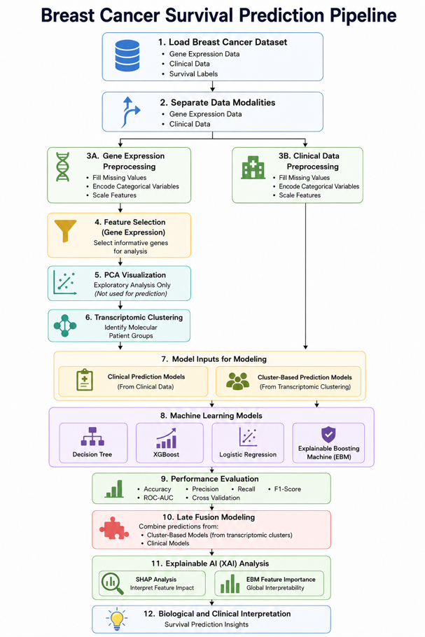

1. Data Loading
The breast cancer dataset was loaded, and the following data sources was provided:
- gene expression data,
- clinical patient information,
- molecular subtype annotations,
- and survival outcome labels.
Now we have the data as pandas dataframe

2. Exploratory Data Analysis (EDA)
The breast cancer dataset was analyzed using Exploratory Data Analysis techniques to gain insights into the structure, quality, and characteristics of the dataset before building machine-learning models. This step led us to the decision on important patterns, potential data quality problems, and pre-processing and modelling decisions.
The EDA process involved the following:
- Examining clinical and transcriptomic features to look at their distribution,
- Recognizing missing data and inconsistencies
- looking at the distribution of the class within the survival target variable,
- exploring relationships between variables,
- and visualizing patterns of transcriptomes in the dataset.
The exploratory analysis gave a better understanding of the biological heterogeneity and total structure of the data set before clustering and machine learning implementation.

3. Data Preprocessing
The preprocessing stage is crucial to this study cause it prepares the dataset for transcriptomic analysis, clustering and machine learning model development. This step was done to enhance the quality of the data, to resolve inconsistencies, and to make the data compatible with various computational techniques.
First, some of the non-informative columns that do not affect the survival outcome, were removed and the variable for survival outcome was excluded from the input features. Finally, stratified train-test 80:20 splitting was applied to the dataset to maintain the class distribution and to minimize sampling bias.
The data were divided into:
- The features of transcriptomic (gene expression)
- clinical patient attributes.

- Handling missing values:
For numerical and categorical variables missing values were dealt with separately. The missing values were imputed by median imputation for quantitative variables and most frequent category imputation for qualitative variables. No missing values were found after preprocessing using the validation checks.
- Encoding:
To make the categorical data compatible with machine learning algorithms, categorical variables were transformed into numerical format, and ordinal encoder was used.
- Scaling:
The transcriptomic and clinical features were then scaled individually with StandardScaler to help normalize the feature distribution and minimize the variance in numerical values between each feature and avoid bias.
The resulting datasets after processing were cleaned, encoded, standardized and ready for clustering, machine learning model development and performance evaluation.

4. Feature Selection
The gene expression data was reduced in dimension by applying feature selection to obtain the most informative genes for the survival prediction analysis. In order to minimize noise and improve computational efficiency, and to avoid overfitting when training machine learning models, feature selection was crucial, especially since there are many features in the gene expression dataset and a relatively low number of samples.
The relationship between gene expression features and the target variable (survival) was assessed using SelectKBest method and the ANOVA F-test scoring function. The top 150 most informative features from the original transcriptomic set were chosen based on their feature importance scores.
The gene expression data had 662 transcriptomic features prior to feature selection. SelectKBest was used to select 150 gene features and discard less informative variables.
The selected features are biologically relevant genes that are related and connected to breast cancer.
Selection of such features improves the efficiency of the model without reducing the biological information contained within transcriptomic patterns.

5. Principal Component Analysis (PCA)
As exploratory analysis and visualization tools, Principal Component Analysis (PCA) was applied to the gene expression data only, in order to assess if known biological subgroup structures were reflected in transcriptomic gene expression patterns.
After preprocessing and feature selection, the processed data was used for performing PCA analysis. The primary goal of this step was to assess if there was any discernible separation of patients by the transcriptomic profiles for each of the different PAM50 molecular subtypes.
In the PCA workflow, the following steps were carried out:
- Computing principal components for the gene expression data,
- checking cumulative explained variance
- and visualizing patient distributions in lower dimensional space.
Cumulative explained variance plot was used to assess the contribution of the PCA components towards the transcriptomic explained variance. The biological variation of the data set was highly retained in the selected components, where about 85% of the total variance was retained, which means that a large proportion of the biological variation of the data set was kept during the visualization.
This was followed by scatter plots of the first two PCs with colours assigned to them according to:
- Molecular subtypes labels (PAM50),
- and the survival status of the patient.
To assess alignment of transcriptomic patterns with known biological breast cancer subtypes, a PCA visualization of the subtypes was used. To examine if there was a discernible difference in the transcriptomes of survival groups, the survival-based visualization was used.
Only exploratory biological analysis and visualization were used with PCA. No PCA components were used as features to train the machine learning model.

6. Transcriptomic Clustering
The processed gene expression data was subjected to clustering analysis, which clustered the patients based on their transcriptomic profiles.
After the preprocessing and feature selection, the selected gene expression features were clustered using K-Means algorithm. Several values of k were calculated with the following:
- Elbow Method,
- Silhouette Analysis.
The Elbow plot was used to observe how the inertia changed when different cluster numbers were used and the Silhouette score was used to examine the separation of the clusters and the similarity of the samples in the clusters.
Using the results of these analyses, 3 transcriptomic clusters were chosen as the final clustering model.
The K-Means model was fitted to the gene expression data. To analyze the cluster distribution, the number of patients in each cluster was then examined.
Survival rates were computed for every cluster after the clustering stage as a way to compare the behavior of survival between transcriptomic patient groups. A survival proportion plot was created to show any differences in survival rates between the clusters.
The identified clusters were also cross tabulated and plotted as stacked bar with known PAM50 molecular subtype labels. This analysis was performed to examine the relationship between transcriptomic clusters and biological breast cancer subtype patterns.

Grid Search Parameter Optimization
Hyperparameters of all the machine learning models were optimized using Grid Search. It was decided to create separate parameter grids for every algorithm and systematically test different combinations of parameters to find the optimal model configurations for each algorithm, depending on the cross-validation performance.
Decision Tree Parameters
- maximum tree depth,
- Minimum number of samples needed to split,
- The minimum number of leaf samples required to be taken from each leaf,
- pruning strength (ccp_alpha),
- and splitting measures (gini and entropy).
XGBoost Parameters
- number of estimators,
- maximum tree depth,
- learning rate,
- subsampling ratio,
- L1 regularization (reg_alpha),
- Regularization on the L2 norm and regularization on the L2 norm on the parameters (reg_lambda).
Logistic Regression Parameters
- regularization strength (C),
- solver type,
- class weighting options,
- and max iterations.
Explainable Boosting Machine (EBM) Parameters
- learning rate,
- number of boosting rounds,
- maximum number of leaves,
- maximum number of bins,
- and interaction settings.

7. Cluster-Based Survival Prediction
First, the transcriptomic clusters were generated, and then, separate survival prediction models were created for each group of clusters based on the gene expression features selected.
Each transcriptomic cluster was processed in the workflow separately. For every cluster:
- Subsequently, the training and testing sets were split depending on the clusters they belonged to.
- Class balance within each cluster group was evaluated.
Within each of the four clusters the following four machine learning models were trained separately:
- Decision Tree,
- XGBoost,
- Logistic Regression,
- Explainable Boosting Machine (EBM).
Helper functions were used throughout the workflow to:
- train models,
- perform hyperparameter tuning (Grid Search),
- evaluate model performance,
- generate prediction probabilities,
- and visualize results across all clusters and models in a consistent manner.
To ensure that the survival class distribution present in the model data is distributed across multiple splits and assure reliability of the model, the model was trained with Stratified K-Fold Cross Validation (5 folds) during its training. All machine learning models were also tested using Grid Search hyperparameter tuning, which systematically tested various combinations of parameters and selected the best performing set of parameters in the model based on the cross validation performance.
The workflow produced for each cluster model:
- classification predictions,
- probability outputs,
- confusion matrices,
- Performance metrics such as Accuracy, Precision, Recall, F1-score, ROC-AUC and cross validation scores.
The prediction probabilities from the cluster-based models were also saved to be used in the late fusion part of the workflow.
Thirdly, the resulting values of all cluster-specific models were put in a single table for comparison between clusters and machine learning models.

8. Clinical Survival Prediction
Preparation of clinical dataset was followed by construction of survival prediction models based on the clinical features alone. The purpose of this step was to confirm if the clinical variables already available could be used for accurate determination of patient survival status and to compare the performance of it to the late fusion and cluster based models.
During model training:
Stratified K-Fold Cross Validation with five folds was used to maintain the distribution of the survival class within each split of the data.
For all machine learning models, hyperparameter tuning using Grid Search was carried out to find the best parameter combinations by training them using cross validation.
Four machine learning models were trained and tested:
- Decision Tree,
- XGBoost,
- Logistic Regression,
- Explainable Boosting Machine (EBM).
Helper functions were used throughout the workflow to:
- Train models,
- Perform Grid Search optimization.
- Evaluate model performance.
- Generate prediction probabilities.
- Visualize confusion matrices.
- Build learning curves in a standardized manner for all models.
The workflow created for each model was:
- classification predictions,
- probability outputs,
- confusion matrices,
- learning curves,
- It includes various accuracy, precision, recall, f1-score, roc-auc and cross validation scores for evaluation.
All clinical models were combined in one result table and then compared and evaluated based on the performance of the different machine learning algorithms.

9. Late Fusion Modeling
The same workflow used in the previous prediction stages was impmented in the same way during late fusion modelling. Clinical prediction probabilities and cluster based transcriptomic prediction probabilities were merged together to form meta level clinical and transcriptomic prediction probabilities, and then training of decision tree, XGboost, logistic regression, and explainable boosting machine (EBM) meta-models was performed. Five-fold Stratified Cross Validation and Grid Search hyperparameter tuning were performed during training, and helper functions were employed for training, evaluation of models, model visualization, ROC analysis and model learning curve generation.

10. Explainable Artificial Intelligence (XAI)
Explainability analysis was conducted only for the top performing models which passed the previous evaluation stage. This was done to concentrate on the models that most closely matched the final prediction workflow.
Best model selection for XAI:
Based on the comparative analysis of the models, only the models showing the best performance were selected for the explainability analysis.

- Late-fusion XGBoost SHAP analysis:
Selected XGBoost model was converted to a SHAP explainer. The SHAP values were computed from the test set (late-fusion).
- SHAP summary plot:
To see how each of the late-fusion input feature affects the output of the selected model, a SHAP summary plot was created.
- SHAP bar plot:
The mean absolute SHAP value for each input feature of the late-fusion model was plotted in a SHAP bar plot.
- Late-fusion EBM feature importance:
The output was extracted from the last fusion EBM model for the global explanation. The feature names along with their importance scores were stored in a dataframe.
- Late-fusion EBM importance visualisation:
The feature importance dataframe from the late fusion EBM was sorted in a descending order and plotted as a horizontal bar plot.
- Clinical EBM feature importance:
The selected clinical EBM model was used to obtain the global explanation output. The clinical features' names and importance levels were saved in a dataframe.
- Visualisation of the importance of clinical EBM:
The feature importance dataframe of clinical EBM was sorted in descending order and the result was plotted as a horizontal bar graph.

Q3) Implementation Decisions:

Dataset and Multi-Modal Learning Justification
For this study, the breast cancer data that was chosen met all the requirements and contained both the gene expression data for the transcribed genes as well as clinical patient information. These two data sources were combined to examine the analysis of survival prediction from a biological and clinical view. The different modalities (transcriptomic data, clinical variables) reflect the different behaviors of the molecules and the patients' healthcare information. Both modalities allowed for a more robust survival prediction framework and allowed for comparison of biological, clinical, and integrated prediction approaches.

EDA
Prior to using machine learning techniques, exploratory data analysis (EDA) was carried out to better understand the structure and the characteristics of the breast cancer dataset. Because of the combination of transcriptomic and clinical data, it was important to explore the data-set early to look for potential data quality problems that might impact the clustering and performance of the survival prediction.
EDA assisted in evaluating the data quality, evaluating the distribution of survival classes and molecular subtypes, and detecting if meaningful biological and clinical patterns existed within the data. This also aided future decisions in preprocessing and modeling the gene expression data, for instance highlighting missing values, possible imbalance and variability within the data.
By conducting EDA before the development of the models, it was possible to make sure that the subsequent machine learning and clustering analysis would be based on the information and problem that was clearly understood throught EDA.

Preprocessing Decisions
In this stage, preprocessing steps were done in order to prepare the data for the models and ensure its consistency.
Imputation methods were implemented to deal with missing values as machine learning models cannot use the missing data directly. The imputation method for numerical variables was based on the median to minimize the impact of outliers and for categorical variables, the most common variable method was used to maintain the dominant class patterns.
In the dataset, there were several categorical feature columns, and for these, Ordinal Encoding was used to convert them into a numerical format suitable for machine learning models. OrdinalEncoder also provided consistency in the transformation of training and testing data, including the unknown categories which could be present in the testing data.
To normalize the distributions of the features and avoid having variables with high numerical range which may cause bias during training, feature scaling was done using StandardScaler.
To avoid data leakage and information from the testing data influencing the training of the model, the train-test split was conducted prior to performing any transformations.

Feature Selection Decisions
The method SelectKBest was used for the feature selection of the transcriptomic gene expression data with the scoring function ANOVA F-test. This step was necessary because gene expression data sets typically have a large number of features, many of which may not be well correlated with patient survival outcomes.
The choice of SelectKBest as the supervised feature selection method was made because it is simple and effective, using a ranking basis on the relation between the features and the target variable. This was relevant to the present study since the primary aim was to define gene expression features that were most closely related to breast cancer survival outcome.
The 150 genes that were selected were a compromise between the number of informative genes in the expression and the fact that the data was very high dimensional. This decision is informed by previous studies that demonstrate that gene expression data typically have significantly more genes than number of patients, leading to greater redundancy, noise and risk of overfitting. Thus, the technique of feature selection is frequently employed in gene expression analysis in order to eliminate irrelevant or redundant genes and to enhance the generalisation of the model, the computational efficiency, and interpretability. A set of 150 genes was chosen for this project, which was a manageable number of genes with sufficient molecular information to enable clustering and prediction of survival espiciall with low number of samples (1905).
The principal aim of this work was to determine if transcriptomic patterns can be used to predict breast cancer survival, so it was essential to remove all of the irrelevant or weakly informative genes, with a view to concentrating on the most relevant biological patterns for the survival behaviour.
If all gene features were used directly, then there would be increases in:
- computational complexity.
- model training time.
- noise in the data set.
- risk of overfitting, particularly when transcriptomic data is high-dimensional with respect to the number of samples.
Each gene feature was compared to the survival target variable using the ANOVA F-test. Features that were more informative for prediction and had more differences in absolute survival value between the survival groups were considered more informative.
The top 150 gene features were identified based on these scores and kept for further clustering and machine learning analysis. This enabled the workflow to retain the most relevant transcriptomic information without adding unnecessary complexity or reducing the efficiency of the models.

PCA
Principal Component Analysis (PCA) was used as an exploratory analysis technique to better understand the structure of the transcriptomic gene expression data before clustering and survival prediction.
The primary aim of exploring the use of PCA in this study was to determine if there were obvious correlations in patient features of:
- PAM50 molecular subtype labels,
- Survival outcomes.
The amount of transcriptomic variance captured by principal components was measured using explained variance analysis. This made it possible to check if the low dimensional representation contained any meaningful biological information from the original gene expression data set.
Scatter plots were then created to visualize the distribution of patients in the transcriptomic feature space, using PCA. The analysis explored the possibility of the existence of biologically meaningful separation patterns between the various patient groups by colouring the plots with molecular subtype and survival labels.
This step was crucial as it gave insight into the biological heterogeneity of the data, and it was important to infer if there might be useful information in the transcriptomic patterns related to the structure of breast cancer and survival behavior.
Only for exploratory analysis and visualization, PCA was employed. The PCA components were not used as input features for these clustering and machine learning models.

Clustering Decisions
The processed transcriptomic gene expression data were clustered to examine whether the patients could be divided into biologically similar groups, or clusters, based on their gene expression.
Breast cancer is heterogeneous and molecular characteristics and survival behaviour may be different amongst similar clinical diagnosis patients. Origenated by clustering, this biological variability was analyzed without applying survival labels in the process of clustering.
K-Means clustering was chosen due to its ability to effectively cluster samples with similar feature patterns in high-dimensional data sets like transcriptomic data, which is an unsupervised learning technique. The algorithm classified patients into groups according to similarity of the patients' gene expression features.
To choose the final number of clusters, different cluster structures were evaluated using the Elbow Method and Silhouette Analysis. The Elbow Method was used to analyze the changes in clustering inertia at varying values of k, and the Silhouette score was used to determine how well the patients fit into the clusters in which they were classified compared to other clusters.
Patients were clustered into the optimal number of clusters and the resulting distributions of patient subgroups into the clusters were analyzed. The survival rates and the PAM50 subtype compositions were then analysed in each cluster to assess if the transcriptomic clusters exhibited biological and clinical differences.
Clustering was an integral part of the workflow as it enabled the study of whether the project could find differences in the survival prediction behaviors, and if there were differences in the survival prediction behaviors, whether those differences could be captured more effectively in a cluster-specific models.

Helper Functions
To structure, clarify and optimize the code and workflow, helper functions were used throughout the code. They enabled repetitive tasks like model training, evaluation, visualization, and hyperparameter tuning to be consistently repeated across models and datasets and deduplicated code to improve the reproduction of the analysis.

Cross Validation
To ensure a more reliable evaluation of model performance during training, Stratified K-Fold Cross Validation with 5 folds was used. The models were evaluated not only on a single train-validation split, but on five different splits of the data, and thus trained and validated many times using different subsets of data, helping to better understand the models and assess their stability.
The stratified approach was chosen since the project aimed to predict whether a person survives or not so maintaining the class distribution throughout the folds was crucial not to skew the evaluation results. This ensured that the similar class distribution of survivors per class were represented in training and validation.
For this project, it was crucial to use cross validation, as transcriptomic datasets can be high dimensional and prone to overfitting. Conducting the evaluation on multiple folds gave more consistent evaluation of model generalization and minimized the chance that the evaluation was a random choice of data split.

Grid Search and Hyperparameter
Grid Search was employed to exhaustively examine different sets of hyperparameters for each model to find the set that yields the optimal result during training. This strategy facilitated optimization of model performance without being at the risk of overfitting or underfitting the models.
The hyperparameters used in the models were selected according to the characteristics of the tasks of transcriptomic survival and clinical survival predictions.

Model | Parameter | Why It Was Tuned
Decision Tree | max_depth | Controls how deep the tree can grow. This tuning helped to balance the learning of complex survival patterns and to avoid overfitting.
 | min_samples_split | Determines the minimum number of samples to split a node. This reduced over-splitting and helped to generalize better.
 | min_samples_leaf | Controls the minimum number of samples allowed in leaf nodes. This minimised very small groups of leaf and the noise that could be present.
 | ccp_alpha | For tree pruning to reduce the model’s complexity, helps avoid overfitting by removing branches that are not very informative.
 | criterion | Specifies the type of split (Gini impurity or entropy). Testing both helped to determine the best splitting strategy.
XGBoost | n_estimators | Regulates the number of boosting trees to use in training. This impacted learning strength and complexity in this model.
 | max_depth | Adjusts and limits the complexity of the tree in boosting. The deeper the tree, the more complex the relationships, and the shallower the depths, the better the generalization.
 | learning_rate | Sets the strength of each boosting step for the model. The lower the value, the more stable the learning.
 | subsample | Determines the percentage of training data to use for each tree. This is to avoid overfitting and robustness.
 | reg_alpha | Uses L1 regularisation to suppress the model complexity.
 | reg_lambda | Implements L2 regularisation to improve the generalisation of the model and limit overfitting.
Logistic Regression | C | Controls regularization strength. This helped to give a balance to controlling for model flexibility and overfitting.
 | solver | Sets the optimization algorithm for training. liblinear was suitable for binary classification and regularization support.
 | class_weight | Supports a balance of survival classes with an adjustment of the importance of the minority classes.
 | max_iter | Sets a maximum number of iterations to perform in training to avoid overfitting the model.
EBM | learning_rate | Determines the learning rate for the boosting process when learning.
 | max_rounds | Sets the number of boosting iterations in learning survival patterns.
 | max_leaves | The boosting structure is modeled with controls, which help to reduce overfitting.
 | max_bins | Determines how continuous features are broken into bins and impact learning and interpretability.
 | interactions | Regulates the number of pairwise feature interactions learned by the model whilst preserving the interpretability.

Machine Learning Model Selection
The four machine learning models have been used to compare different learning strategies for breast cancer survival prediction using both transcriptomic and clinical data include:
First, Decision Trees, which is easy-to-understand, easy-to-interpret and it is one of the learning models that can learn and represent complex non-linear relationships in a straightforward manner. Due to their transparent nature, they are ideal for use in any healthcare prediction tasks.
Second, XGBoost is one of the most popular ensemble boosting models used for prediction purposes. XGBoost is particularly useful in high dimensional dataset prediction, such as the transcriptomic gene expression prediction.
Third, Logistic Regression is a very efficient statistical classifier that was included in this study as a baseline classifier due to its high efficiency, effectiveness, and transparency.
Finally, Explainable Boosting Machines (EBMs) were included since they can be easily interpreted and yet they still offer very competitive performance when predicting breast cancer survivability.
This helped in ensuring that the workflow had a chance of comparing different predictive models' performances and interpretability.

Cluster-Based Survival Prediction
Transcriptomic patient clusters were generated and then used to train survival prediction models individually to examine if there was a different survival prediction pattern for each patient molecular type.
This approach was suitable for the research question as the central research question was to not only predict breast cancer survival but also to examine if the survival behavior is influenced by the transcriptomic structure of breast cancer. Breast cancer is biologicly heterogeneous; there are differences in how patients will respond, depending on their molecular nature. Training individual models in each cluster enabled the workflow to identify the survival patterns of each transcriptomic subset instead of the entire population of patients.
Additionally, cluster-specific prediction models helped to reduce biological variability within each cluster, making it easier for machine learning models to learn more specific relationships between the gene expression patterns and survival outcomes within each cluster. This allowed for the analysis to be more consistent with a precision medicine framework and allow for various patient subgroups to be treated with different predictive modeling approaches.
Each cluster model generated predictions of probability that were saved to use later on in late fusion.

Clinical Survival Prediction
The prediction models of clinical survival were developed separately and compared to determine the ability of the traditional patient clinical information to predict the survival outcome of breast cancer without the use of transcriptomic gene expression data.
This method was a significant one as clinical variables like tumor features, patient information, and treatment-related variables are frequently employed in actual medical decision making and have been shown to possess prognostic significance. The study was able to compare the predictive power of clinical data against transcriptomic sub-group prediction approaches by building separate clinical model.
The overall goal of the research was to examine the impact of various data modalities on survival prediction, with an independent clinical prediction stage helping to satisfy that goal. The process involved evaluating clinical and transcriptomic models independently of each other, which would enable a future assessment of whether the integration of both types of information by late fusion would enhance predictive accuracy.
Clinical model prediction probabilities were saved and as an additional set of input features to the late fusion model along with the transcriptomic cluster prediction probabilities.

Late fusion
Late fusion was used as a means to leverage the advantages of both the transcriptomic and the clinical survival prediction models by integrating them into a unified scheme.
It was highly appropriate for the purpose of the study, as the survival of patients diagnosed with breast cancer depends on:
the way the tumor behaves at the molecular level, based on transcriptomic gene expression data,
and specific features of the patients themselves, which can be obtained through clinical data.
Thus, excluding either the transcriptomic or the clinical data could result in missing crucial information about the patients, their tumors, and survival risk factors. However, combining the two approaches enabled the creation of an even better model.
Furthermore, creating distinct prediction models for clinical and transcriptomic data helped achieve another objective of the study, which included studying the predictive power of both approaches and determining whether integrating the data sources improves survival prediction accuracy.
Late fusion entailed the use of probabilistic prediction results rather than integration of the datasets directly. Thus, the prediction probabilities for clinical data and the transcriptomic clusters were used as inputs in the meta-models.
It provided an opportunity for individual modalities to independently learn their specific prediction rules before combining their results. While the transcriptomic clusters' models were designed for predicting the survival behavior of their particular subgroups, the models for clinical predictors considered more conventional patient prognosis factors.
This last step in our approach thus served both the primary purpose of merging biological and clinical insights into one framework and the secondary purpose of comparing individual predictions generated by various types of input.

XAI
Explainable Artificial Intelligence is used in this project due to the nature of the task being breast cancer survival prediction, a clinically sensitive task. In this context, only reporting on model performance metrics, such as accuracy, f1_score, and roc_auc is not sufficient.
Additionally, the process should illustrate how the trained models are leveraging the input variables to make predictions, particularly given the ultimate goal of the workflow is related to clinical decision support and prediction of survival outcomes.
For this project, a number of models were trained and compared, but only the best performing models were used for XAI. This meant that the models that were most relevant to the end pipeline got more attention in the interpretation stage. In the final workflow, clinical prediction models and late-fusion models were involved, so it was necessary to provide explainability to gain insight into the inputs that were driving the selected models following training.
The chosen model is late fusion XGBoost since it showed a powerful performance which is not necessarily direct transparent in its decision-making process. Each input feature could be analyzed to see its contribution to the model output with SHAP. It proved to be helpful for the late-fusion stage as it shows which features the model relied on from the previous models probability as its inputs. This was helpful in the case of the late-fusion stage, as the model depended on the probability output from the previous models as the input features, and was able to demonstrate how these feature values were important in the prediction process.
Additionally, the feature importance was computed using EBM, as EBM is an interpretable model that allows to explain its contribution on a global level. In the clinical model, this allowed for the identification of most important clinical variables used by the chosen model. It was used in the late-fusion model to elucidate the impact of the saved probability outputs that were fed to the last prediction stage.
The use of XAI thus facilitated reliability and interpretability of the workflow. It enabled the project to extend beyond performance based scores and give a better understanding of how the model behaved. Understandable, reviewable, and not using a black-box system is important for any clinical AI pipeline, as is the survival prediction model.

Q4) Performance Metrics
In this project, we are dealing with a binary classification problem which was to predict the patient survival status of the patients, with the different sources of information being: clinical data and cluster-specific data of the transcriptomic clusters, and combined predictions from all of these data sources using late fusion. Several classification metrics were employed to measure the performance of the models fairly, including accuracy, precision, recall, F1-score, ROC-AUC and cross-validation scores.
Employing multiple metrics was significant since breast cancer survival prediction is a clinical issue in which using a single metric may be misleading. Especially, survival datasets might have class-imbalanced which was a challenge we faced during cluster prediction as cluster 1 & 2 had a noticeble class imbalnace, where one class of survival outcome is more prevalent than the other. In this case, a model can get a very high accuracy just by predicting the most common class, but do a very poor job with the minority class. As such, ROC-AUC and F1-score were used as the main comparsion metrices, as they were deemed to be more informative than accuracy.

Accuracy
Accuracy is the percentage of all predictions that are correct. Provides a general idea of model performance, and is easy to interpret. In this project, accuracy was not chosen as the primary assessment criterion as it can be misleading if the classes are imbalanced. A model can have high accuracy if it most of the time predicts the class which most of the patients belong to, even when it fails to predict the class of the minority of patients. Thus, the accuracy was not taken as a major criterion for the model quality, but was recognized as a secondary criterion.
Accuracy is calculated as: TP+TN/TP+TN+FP+FN

Precision
Precision is the percentage of patients who were correctly classified as being in the positive survival class. This is helpful in clinical practice as it reveals the fidelity of the model in assigning the patient to a particular outcome group. A high precision means that the model makes fewer false positive predictions. The use of precision in this project was useful to assess the trustworthiness of those positive predictions of the model.

Precision is calculated as: TP/TP+FP

Recall
Recall is a measurement of the number of correct positive predictions that were accurately identified by the model. For prediction tasks in healthcare, it is particularly important that clinically relevant and important cases are not missed, as it can be a serious issue. If the model was with low recall score, then it fails to identify patients with a high risk and it will not be useful for a clinical decision-support system. Hence, the recall was added to see whether the models were able to capture the relevant survival class effectively.
Recall calculated as : TP/TP+FN

F1-score
F1 score is a single metric that indicates a combo between precision and recall. It is particularly valuable when the data set is imbalanced (when there are more false positives than false negatives or vice versa). F1-score was chosen as an optimisation metric during model training as a way to balance between precision and recall when optimising model parameters. This was significant in the case of predicting breast cancer survival, where the overall number of correct predictions was not the only important thing, but the number of false negative predictions and false positive predictions was also important. These errors are important in a clinical prediction question because the model should be able to reliably detect the survival-related patterns of errors, not just the easy or majority class.
A second advantage of using F1-score as an evaluation metric was its ability to provide a better understanding of a model's usefulness than accuracy, particularly when one class of survival events was more predictable than the other. The models were designed to make balanced and clinically meaningful predictions across survival classes, by basing their predictions on F1, which was used as the metric for training, and reported in the results.
F1 calculated as : 2* (Precision*Recall/ Precision+Recall)

ROC-AUC
In this project, the second major performance metric used was ROC-AUC. ROC-AUC is a measure of the ability of the model to differentiate between the two classes of survival outcomes at various decision thresholds. It's important because of the fact that it is not dependent on a single classification threshold, unlike accuracy or F1-score. The closer the ROC-AUC value is to 1.0, the better the classification into survival outcome groups. A value of 0.5 means random classification.
The aim of this project was to classify patients as well as to evaluate the ability to distinguish between survival outcomes using different data sources, making ROC-AUC well suited for this project. The comparison of these with ROC-AUC allowed for a consistent comparison of discrimination ability across all modelling approaches, since this project compared clinical models, cluster-specific models, and late-fusion models.

Cross-validation metrics
Cross validation scores were also reported to provide assessment of the stability and generalisability of each model, in addition to test set performance. Stratified cross-validation was performed while training the model to retain the class distribution across each fold. This was crucial, as the survival target was skewed and stratification minimized the risk of creating validation folds that were not representative of both the survival groups.
Test ROC-AUC and cross-validation ROC-AUC were compared to determine the stability of a model or whether it might be unreliable. Models that showed very large differences between their test set scores and their cross-validation scores were handled with caution while models that showed similar test and cross-validation scores were considered to be more trustworthy.

Model performance comparison
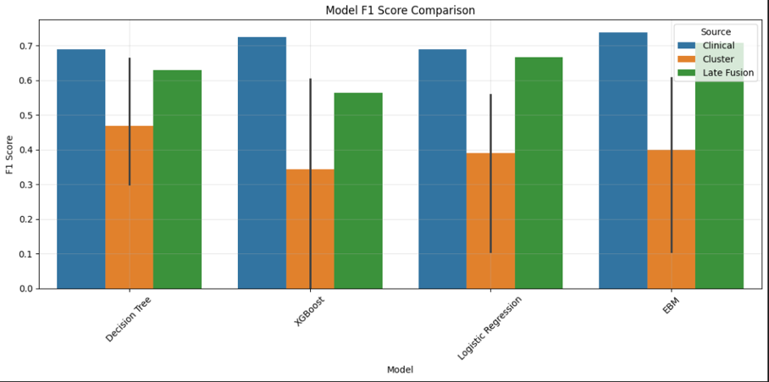
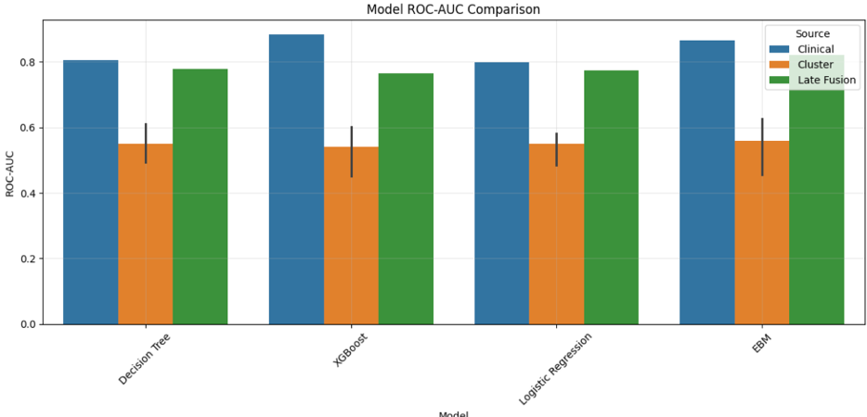
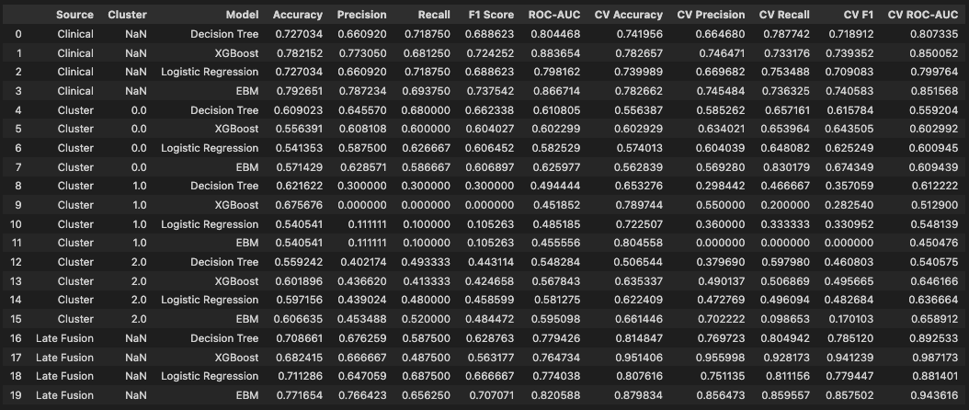

The Clinical EBM model was the best overall and most reliable model. It had the best test ROC-AUC value of 0.867, test cross validation ROC-AUC of 0.852 and it had an F1 score of 0.738. The small difference between its test and cross-validation ROC-AUC scores suggests that the model was stable and generalised well, rather than performing well only on one specific train-test split. The Clinical EBM also had high precision and recall, and was able to make balanced predictions among the survival classes.
The clinical models performed better than the transcriptomic cluster-based models and the late-fusion models in general. The Cluster 0 EBM had a test ROC-AUC of 0.626 and a cross validation ROC-AUC of 0.609, the best of the clusters. This indicates that the cluster-based transcriptomic models contained some survival-related signals, but it was less strong than the signal in the clinical models. F1-scores were very low or even not calculable for some cluster models, particularly ones in Cluster 1, indicating that class imbalance and the smaller size of the clusters had impacted model trustworthiness. Hence, the performance of the models was interpreted with caution.
Whether combining prediction probabilities from clinical and transcriptomic was better for survival prediction, late fusion models were applied to test this. The Late Fusion EBM model was the best late fusion model with a test ROC-AUC of 0.821 and an F1-score of 0.707. This yielded a similar result to the cluster-specific models, but was not as strong as the best Clinical EBM model. Furthermore, the values of the cross validation ROC-AUC values were higher than those of the test ROC-AUC values, particularly for the Late Fusion EBM, which had a CV ROC-AUC of 0.944. This gap highlights the need to be cautious of the fusion results, and that the held-out test performance is the more accurate one.
Overall, ROC-AUC was the most suitable primary measure for this project since it was a measure of the ability of each model to distinguish between survival classes at various cut points. In addition, the F1 score was relevant as it was employed as an optimisation criterion during training and was used to evaluate the precision/recall balance. For accuracy, it was reported but taken with a grain of salt, as it can give a false sense of performance in unbalanced clinical datasets. As well as Recall in the presence of class imbalance. The accuracy was reported and analyzed with caution, since it can overestimate the performance in imbalanced clinical data sets.
These results clearly indicated that using clinical features can be really efficient, as it has shown the best performance, yet there is a crucial aspect that we should not neglect, which is that the number of samples in this data is relatively low, leading to low number of clusters per cluster, especially compared to healthcare settings. On the other hand, this does not contradict the findings of this study, as many previous studies have shown that clinical data can produce valuable insights when it comes to breast cancer.

Q5) Visualisation of Results and XAI
Different visualisations were employed to get an understanding of the structure of the dataset, to explore the transcriptomic patterns, to assess the behaviour of the models, and to assist in interpretation of the survival prediction results. These visualisations were: class distribution plots, molecular subtype plots, PCA projections, PCA scatter, clustering evaluation plots, confusion matrices, ROC curves, learning curves and explainable AI output.

Exploratory data visualisations
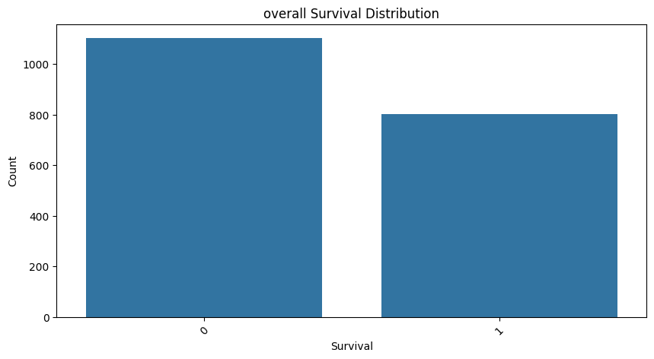

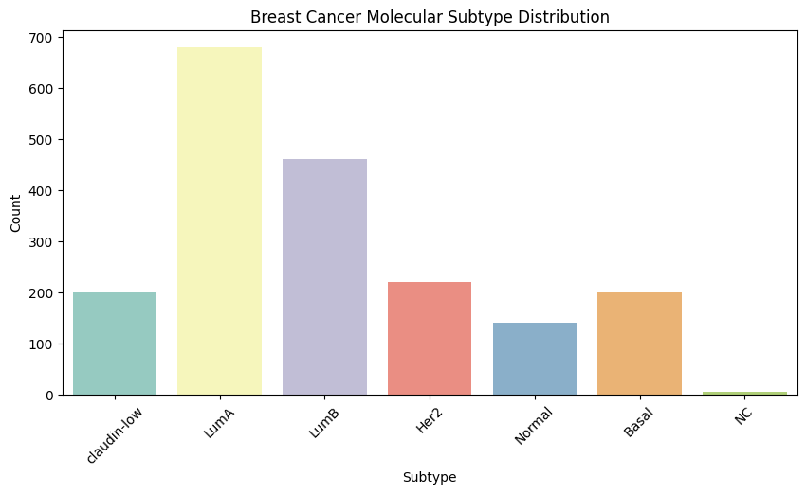
The overall survival distribution plot revealed an uneven distribution of data between the two survival groups. There was one class which had more samples than the other, thus indicating that it is important to use the evaluation metrics other than accuracy like F1 score and ROC AUC. Although this imbalance is not sever so it didn’t require any resampling or balancing.

The distribution of molecular subtypes indicated that the dataset included an imbalanced number of breast cancer subtypes. Luminal A and Luminal B were the most frequent subtypes, whereas some, like NC and Normal-like, had very small numbers of cases. This is evidence of the biological heterogeneity of the METABRIC dataset and indicates that the dataset comprises of several different molecular breast cancer patterns, not just one single type of patient population.

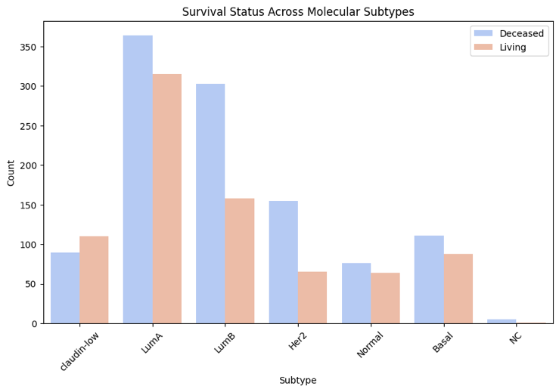
The survival status across molecular subtypes plot indicated that the survival rates were not the same for each molecular subtype. There was a greater percentage of deceased patients in some subtypes and greater percentage of living patients in others. This reflects the biological theory that breast cancer subtypes are associated with prognosis and that there is a potential for differential survival behaviour based on molecular subtyping.
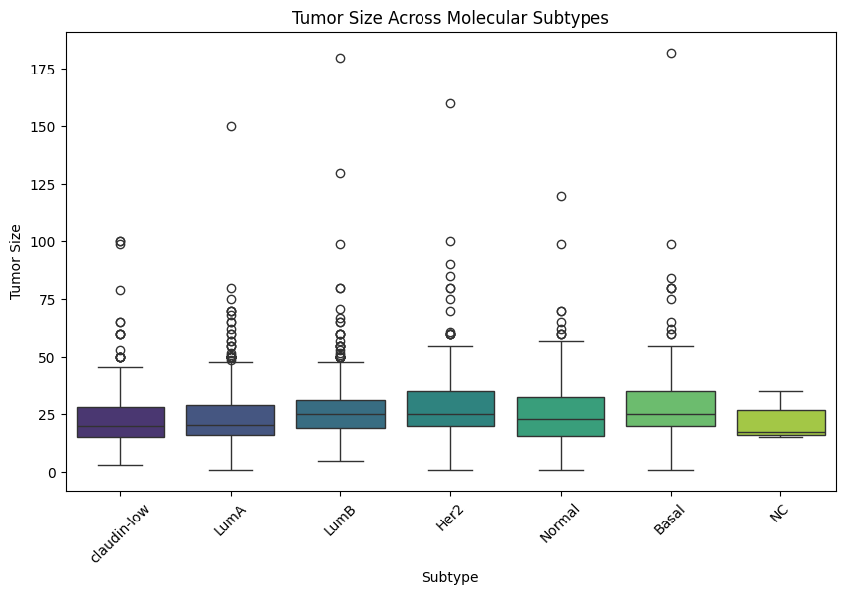

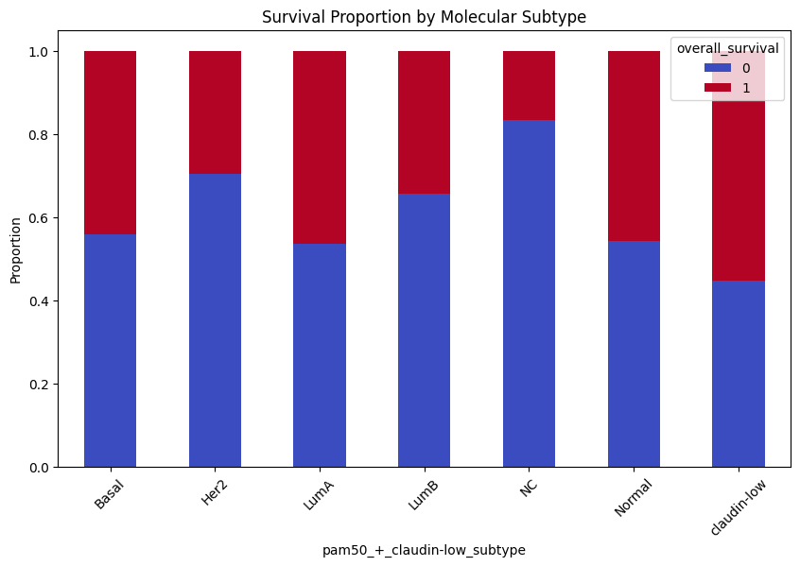
The boxplot of tumour size revealed differences in tumour size by molecular subtypes and had a few outliers. This means that clinical features are not the same for each of the molecular subsets and that some clinical features may contain valuable prognostic information. This also helps explaining the good performance of the clinical models as clinical characteristics like tumour size are directly related with disease severity and patient outcome.

The plot of survival proportion according to molecular subtype offered a better comparison between prognosis patterns in the PAM50 and Claudin-low groups as it presented the relative proportion of each survival category in each molecular subtype instead of just the number of samples. This was necessary because the number of patients differed considerably among some of the subtypes. As shown in this graph, there was an inequality in terms of survival pattern across all subtypes since survival proportion was not the same for every molecular subtype, implying that the patient's subtype is associated with their prognosis. In other words, some subtypes tended to have a greater proportion of deaths, while others had a comparatively high number of survivors. The use of molecular subtype information seems biologically meaningful since molecular phenotype was associated with survival behavior.

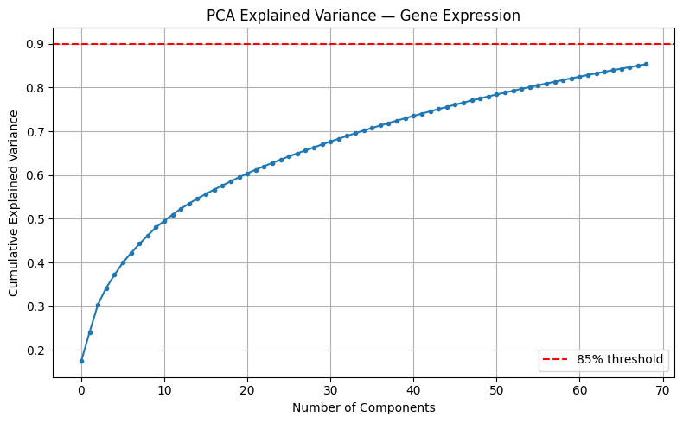
PCA visualisations

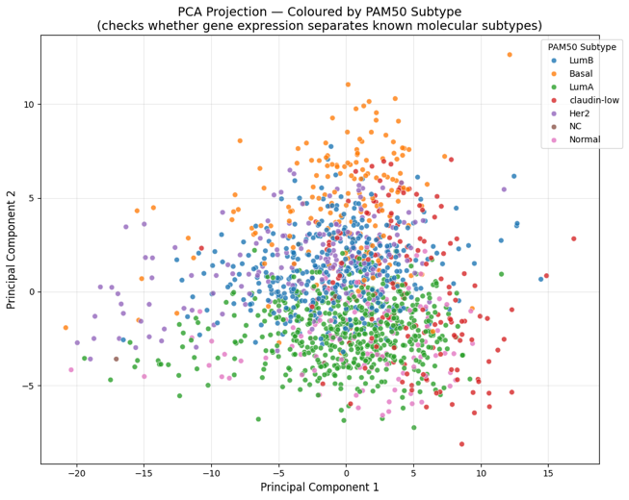
The structure of the selected gene expression features was explored using Principal Component Analysis. The cumulative explained variance plot revealed that many principal components would be needed to capture most of the variance of the transcriptomic data. This stems from the fact that gene expression data is highly dimensional, in that isometric data is not contained in the first one or two dimensions, but rather in many.

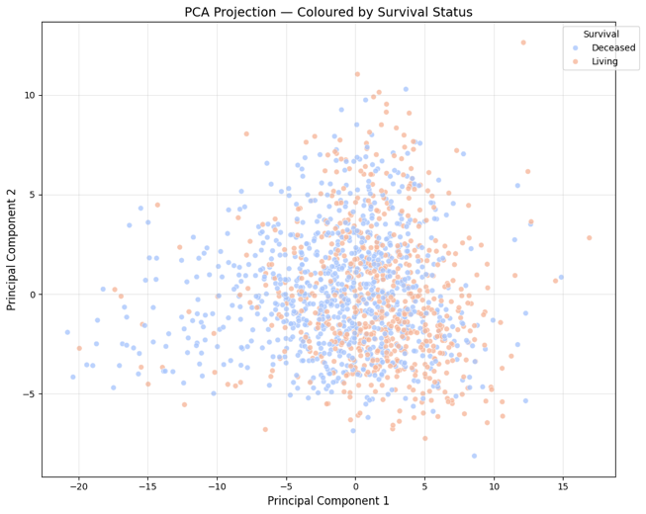
Partial separation between some molecular subtypes was observed while also a significant overlap was seen in the PCA projection by PAM50 subtype. This suggests that there is also structure in gene expression data which corresponds to biological subtypes, but is not well separated in the first two principal components. As such, PCA was used as an exploratory biological interpretation but not as an input to the machine learning models.

The PCA+survival projection colored by survival status had significant overlap between the two groups (living and deceased). This indicates that it is difficult to distinguish between live and dead cells with just the first two principal components from the expression data. This is consistent with the later model results that cluster-based models did not perform as well in predicting survival as the clinical models.

Clustering visualisations
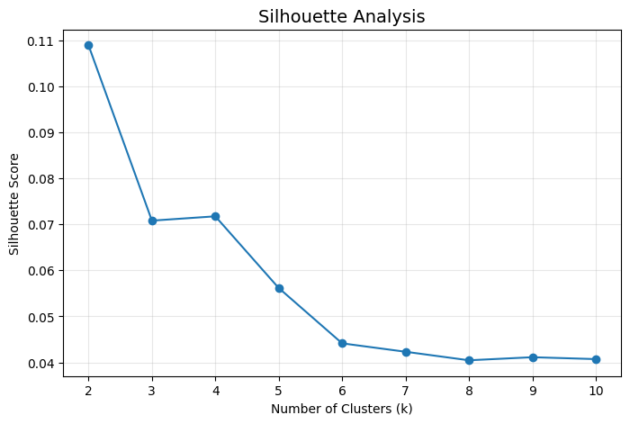
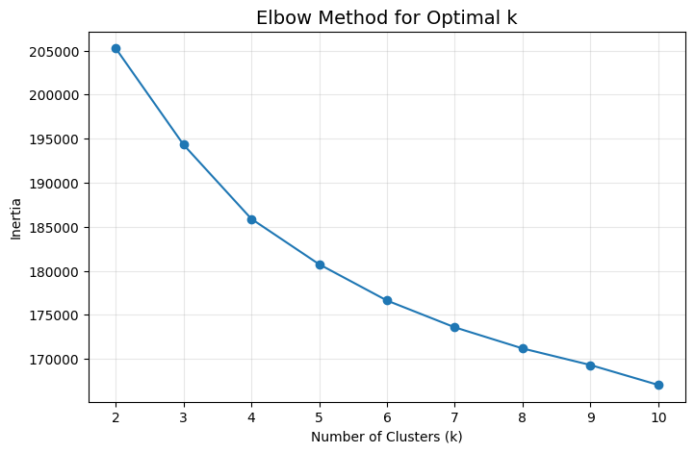

The elbow method and silhouette analysis were used to support the choice of the number of transcriptomic clusters. The elbow plot indicated a decrease in inertia as cluster number increased and the silhouette plot was used to further evaluate cluster separation. These plots were used to identify that 3 clusters is the best choice for K-Means clustering.

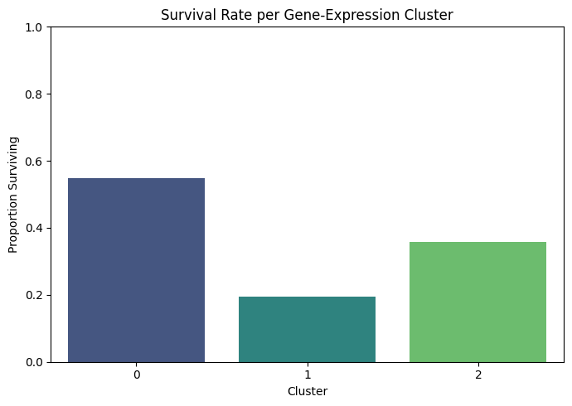

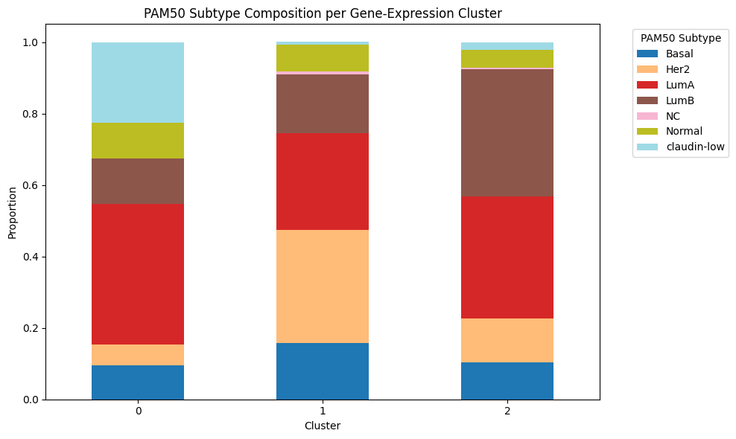
We found that the three ‘transcriptomic clusters' had survival proportions that were not the same, as shown in the survival rate per gene-expression cluster plot. Cluster 0: highest proportion of survival, Cluster 1: lowest proportion of survival, and Cluster 2: intermediate. This indicates there were some biological differences in the unsupervised transcriptomic clusters that were related to survival. The later prediction results indicated, however, that the cluster differences were not enough to yield cluster-specific, high-performing survival prediction models espicially that this plot also indicates sever class imbalance espicially cluster 1.

The subtype composition of clusters of genes with similar expression patterns by subtype is displayed in the PAM50 subtype composition per cluster plot, where the gene-expression clusters were different mixes of breast cancer molecular subtypes. This indicates some biological significance of the clusters as they were not a random mix of patients. Each cluster, however, did contain several PAM50 clusters, contributing to the limited ability to predict survival based on clusters. The clusters identified were transcriptomic similar, but not entirely concordant with survival outcome groups.

Model evaluation visualisations
The number of correct and incorrect predictions of each model was presented in the form of a confusion matrix. These plots enabled not only to observe the number of correct predictions, but also the type of errors which the models made. This was key since false positives and false negatives in a clinical prediction have different meanings and cannot be judged from accuracy.

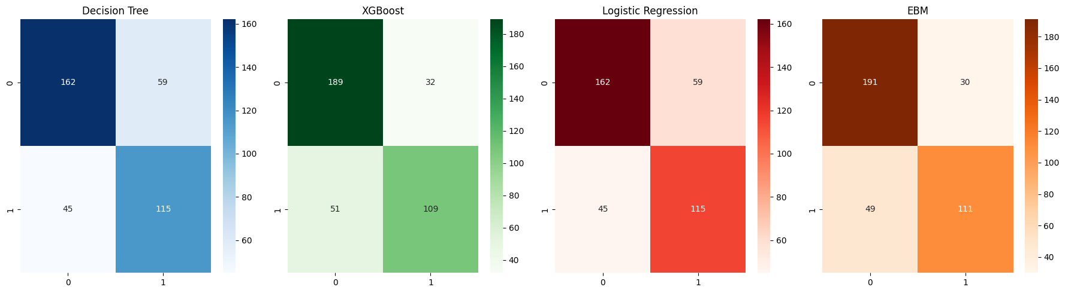
The confusion matrices for the clinical models were better separating between the two survival classes than the cluster based models. This is consistent with the numerical results, with the Clinical EBM performing best and with the highest level of confidence. Both clinical models performed better than clinical clustering alone in classification of both survival outcomes, thus reinforcing the notion that clinical variables provided more useful prognostic information than clinical clustering alone.
Cluster 0 :
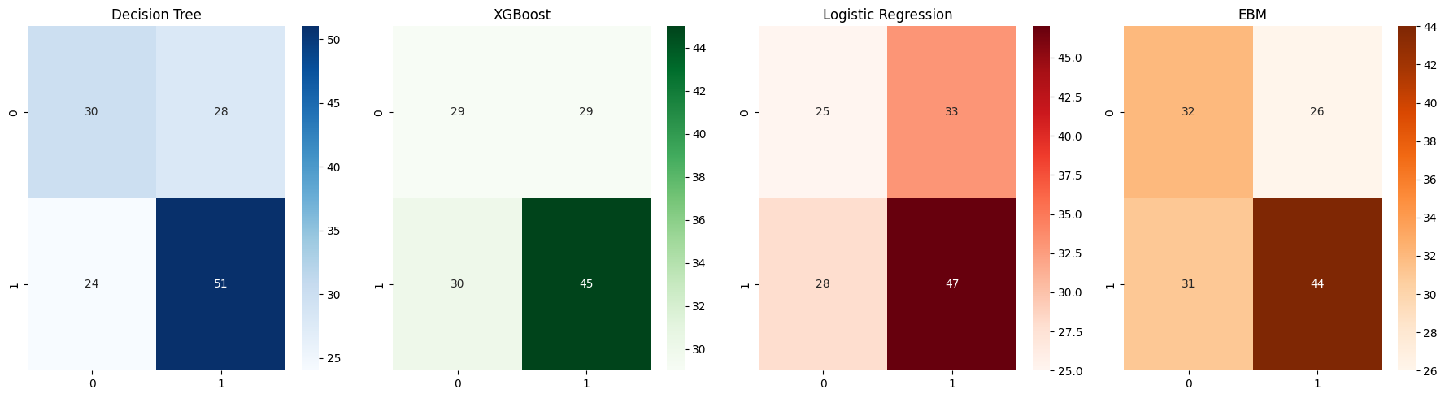
Cluster 1:
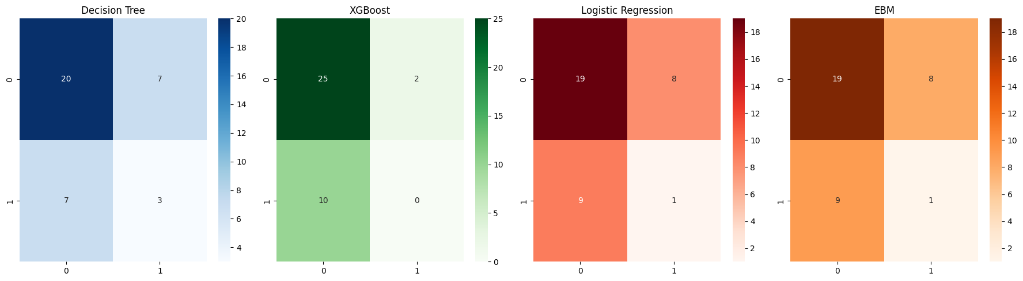
Cluster 2:
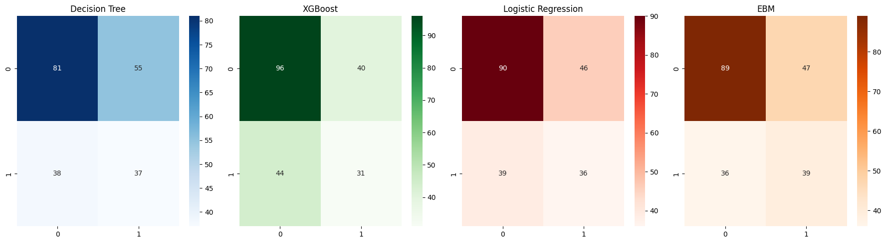
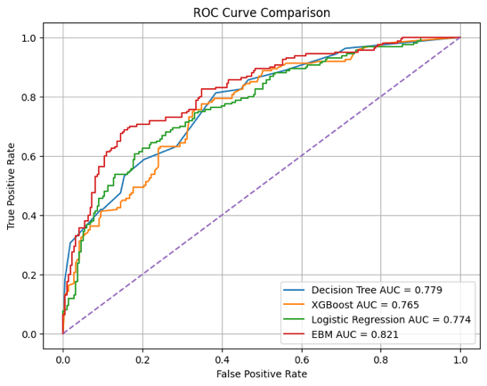
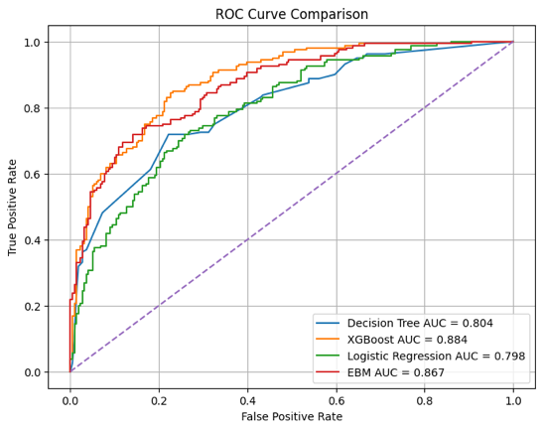
The cluster-specific confusion matrices revealed poorer and less consistent classification. In particular, the Cluster 1 exhibited a degenerate behavior, with almost all cases predicted as belonging to one of the classes. The result is due to the small size of samples and class imbalance of the cluster. The cluster-specific results were thus interpreted with some caution, as model weakness may be partly responsible for the poor performance, but this may be partially due to the fact that the clusters were not well balanced.

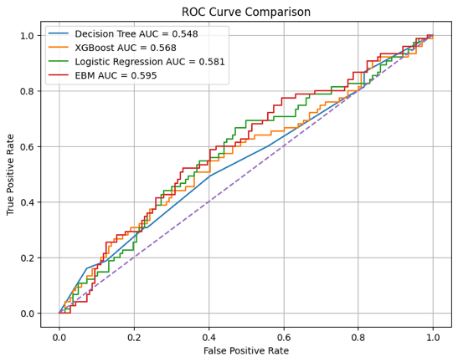
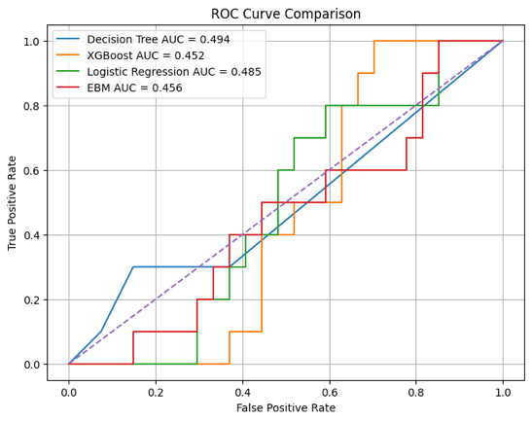
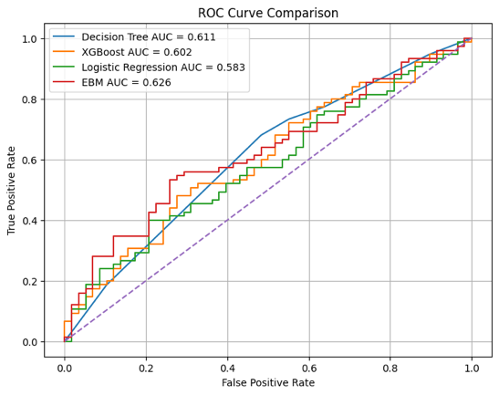
Late Fusion
Clinical
Cluster 1
Cluster 2
Cluster 0

Ability to classify survival classes at various classification thresholds were compared using ROC curves. The Clinical ROC curves displayed the highest discrimination; the Clinical EBM and Clinical XGBoost had high ROC-AUC values which also proves its better performance. The cluster-based ROC curves were more towards the random classifier line, indicating lower discriminatory power. The late-fusion ROC curves did not yield the best performance, but were moderate.

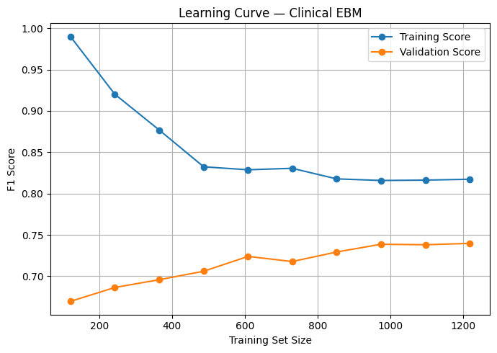
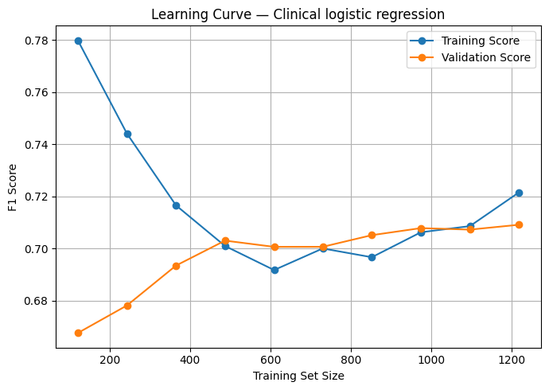
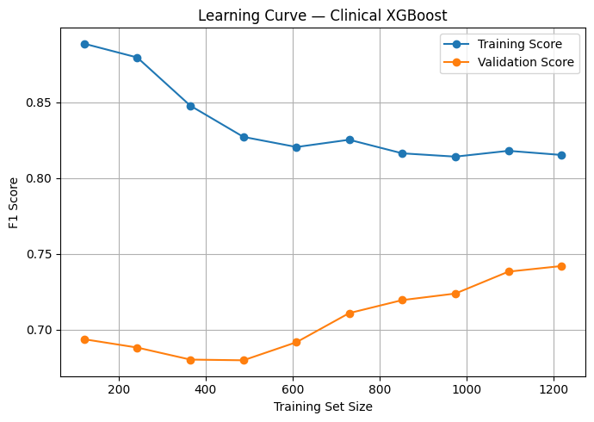
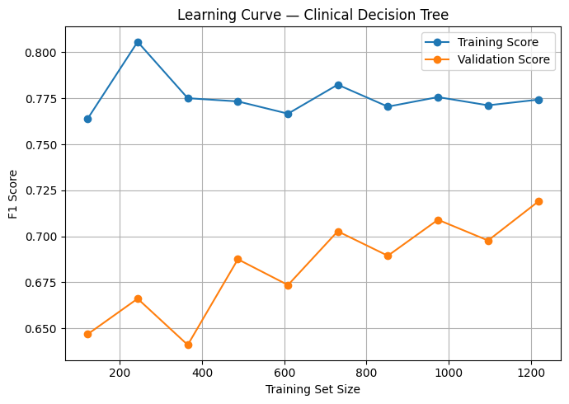

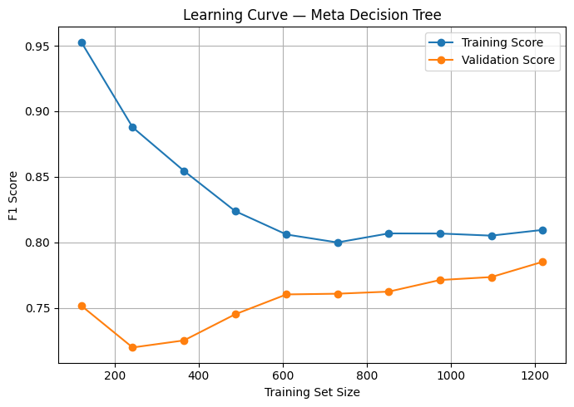
The stability of the models and potential overfitting were assessed with learning curves. In the clinical models, the training and validation F1-scores converged with the increasing number of training samples indicating that the models became more stable with more training data. The Clinical XGBoost had good training results but there was a little overfitting as the difference between the training curve and validation curve was high. Logistic Regression exhibited a relatively minimal difference between the training and validation accuracy, indicating less variability but also less flexibility in learning, The clinical EBM learning curve showed acceptable behaviour as botth lines were moving in the sme diriction and getting closer.
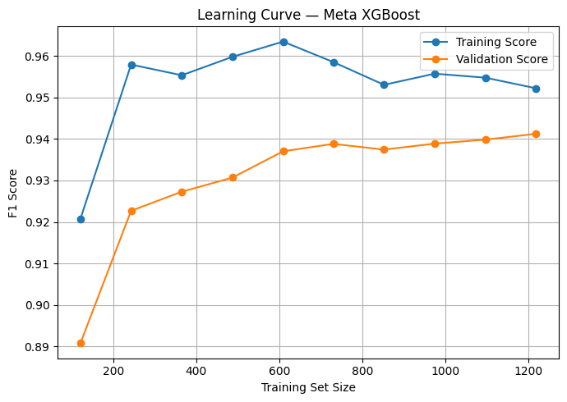
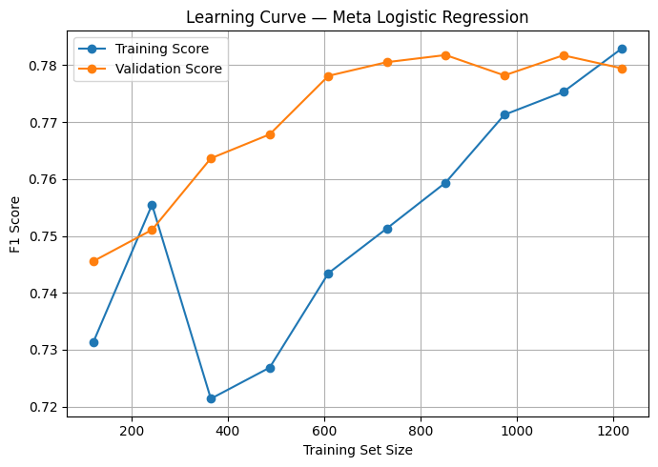
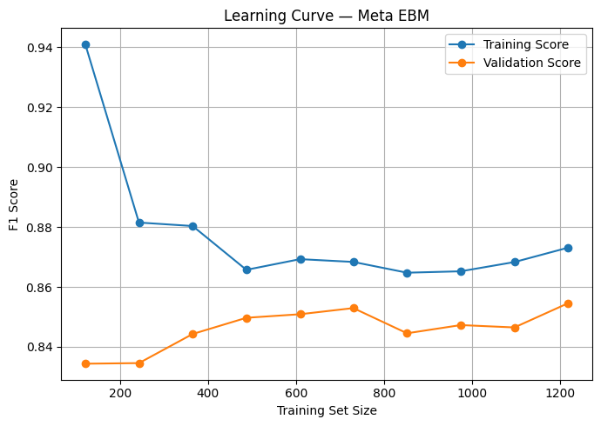

For the late-fusion models, the learning curves indicated that the meta-models obtained good validation F1-scores with XGBoost and EBM models. However, the best clinical model didn't perform better than late fusion test ROC-AUC. This results in a relative (but not absolute) improvement of the fusion models in cross-validation, while the results on the held-out test set are more conservative. Thus, care was taken to interpret late-fusion results, and the more reliable estimate was taken to be the test-set performance.

XAI Visualisations
Explainable Artificial Intelligence was used to efficiently gain insights into the learned models' survival predictions. Since the project used classical machine learning models on tabular clinical and transcriptomic data, SHAP and EBM feature importance were suitable explainability methods.
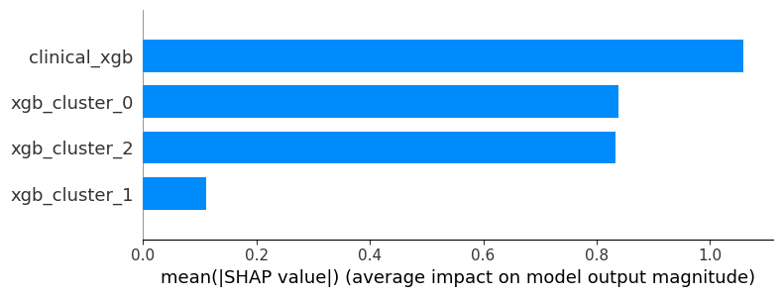
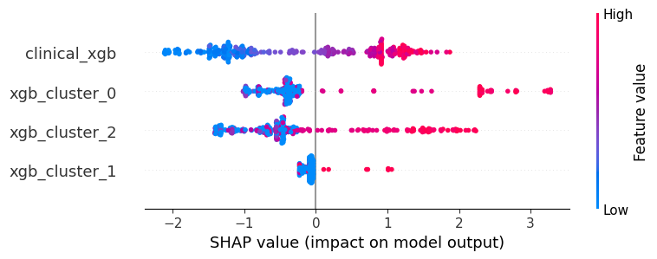
SHAP summary and bar plots for the late-fusion XGBoost

The SHAP summary and bar plots for the late-fusion XGBoost model indicated that the clinical prediction feature was the most influential one for the model output. The contribution of the transcriptomic cluster prediction was also significant, but less. The influence of Cluster 0 and Cluster 2 was greater than Cluster 1; and Cluster 1 had the lowest influence. This is consistent with the model performance results, which was unstable and weak for Cluster 1.
Additionally, the importance of clinical prediction values was observed in the SHAP plot and was found to have a strong positive effect on the output of the late-fusion model. This indicates that most of the clinical prediction signal was utilized in the prediction of the final survival of the late fusion model. The cluster based transcriptomic predictions provided some additional information but were less impactful and more variable.
EBM Late fusion
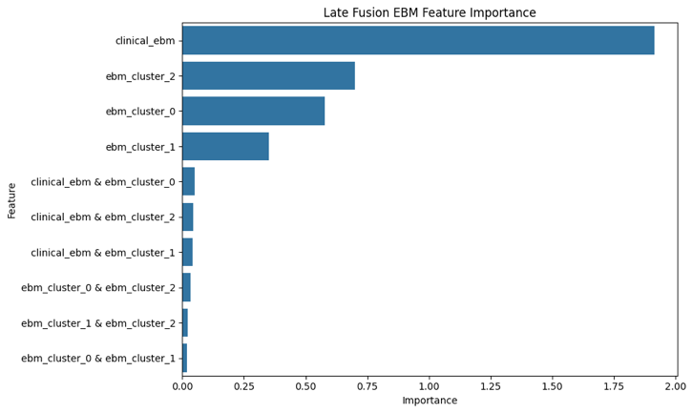

This was confirmed by the feature importance plot Late Fusion EBM. The clinical EBM prediction was clearly the most important, whereas the EBM cluster prediction features had lower importance. The interaction terms between clinical and cluster predictions had negligible importance values indicating that the model was not trained on strong interactions between clinical and transcriptomic predictions.
Clinical EBM
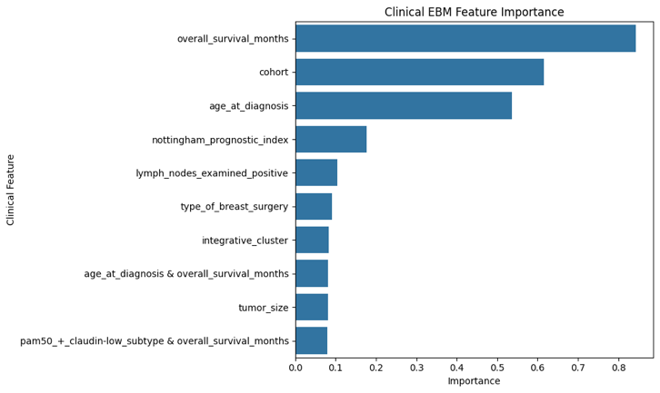

A small number of clinical features (overall_survival_months, cohort, age_at_diagnosis)were found to be having the most impact on survival prediction using the Clinical EBM feature importance plot. This indicates that important clinical variables were the most important factors to drive the best clinical model, and that other variables were not equally important. This is suitable in the context of breast cancer prognosis in which other factors such as patient and tumour characteristics may have a significant impact on survival.

Q6) Results Interpretation

Results in terms of their biological or clinical significance and what it means from a healthcare perspective?
This project demonstrates that clinical information plays a greater role in determining the survival of a breast cancer patient than does the transcriptomic expression of genes alone. The Clinical EBM model had the highest and the most consistent ROC-AUC and F1 scores ROC-AUC = 0.867, cross-validation ROC-AUC = 0.852 and, F1 score= 0.738 . This means that for this survival prediction task, the clinical variables conveyed the most direct information to the prediction task. This is a biologically and clinically reasonable approach as clinical factors like tumour characteristics, patient condition, subtype-related information and disease burden are closely related to patient outcomes.
The cluster-based models had poorer performance than the clinical models. This is not to say that transcriptomic data was not relevant. The PCA plots, molecular subtype distribution and clustering results demonstrated a biological structure in gene expression data, which could be indicative of differences between breast cancer molecular subtypes. However, the PCA survival plot showed the distribution of patients living and dead overlapped, indicating that survival status was not clearly distinguishable with the leading transcriptomic components. This is the reason why the gene-expression-based models were less effective at predicting survival than were the clinical models.
The cluster-based analysis revealed that there were different proportions of survival for the transcriptomic clusters, which indicated some biological differences between the unsupervised gene-expression clusters with relevance to survival. In addition, Clustering results revealed meaningful insights as there were various proportions of survival and different compositions of the PAM50 subtypes. It implies that the clustering step was able to capture some biological patterns from the transcriptomic data. However, the prediction models for the clusters were not very successful. This means that the clusters were biologically meaningful, but not enough to stand alone as survival prediction groups. The reason is that, K-Means clustering is performed based on the transcriptomic similarity, rather than directly on the survival outcome of the patient. Thus, the clusters can be molecularly similar but not clearly delineate survival classes.
Cluster 1 was particularly weak and yielded a model behaviour that was unstable or degenerate. This is probably because the number of samples collected was low and their class imbalance was high in that sub-group. The result is significant because it indicates that subgroup modelling can be misleading if the sample size within a cluster is too small or if one survival class is much larger than the other. Thus, weak cluster performance is not just a modelling failure, but also a sign that the structure of the clusters in the transcriptomic space is not necessarily a reliable predictor for survival.
To assess the ability of combining clinical and transcriptomic prediction probabilities to enhance survival predictions, the late-fusion models were tested. Late-fusion results were moderate, but failed to outperform the best clinical model. This indicated that the additional predictive value of the transcriptomic cluster predictions over the clinical model was limited. This interpretation has been confirmed by the XAI results as the clinical prediction feature had the largest effect on the final model output, with the cluster-based transcriptomic predictions having less effect.

Does the model’s performance suggest it could be useful in a real clinical or research setting?
From a clinical perspective, the model performance would indicate that a research-level survival prediction model could be of value from the Clinical EBM model, particularly as it had good model performance and was interpretable. But it would not be suitable for clinical decision making until it was validated further. The model was only tested on the held-out part of the METABRIC data set and there was no external validation cohort. The model would have to be evaluated on separate datasets, screened for bias, and validated in other patient populations to be used in patient-level decisions in the real clinical setting.

What do the errors or weaknesses in the results tell you about the problem or the data ?
Putting it into clinical or research practice, the results indicated that the pipeline would be better suited for exploratory research than as a primary clinical decision support system. The Clinical EBM exhibited good performance and interpretability, which is desirable for discovering patterns related to survival in the METABRIC dataset. The model is at present not ready to inform real patient decisions as it was only tested on a held-out METABRIC test set and not on an external independent test set. The limitations of the model, particularly the limited performance on the cluster level and the imbalance among some subgroups, highlight the challenges associated with predicting survival in small sample sizes and when molecular patterns do not clearly dichotomize survival.

Conclusion:
In summary, the amounts of clinical data were the most effective predictor of survival, and transcriptomic data were able to offer valuable biological information, but with less direct predictive effect. The main advantage of the transcriptomic analysis was to gain insight into molecular heterogeneity, while the clinical models were more effective in predicting the survival outcome. This result corroborates the result that clinical and transcriptomic information are different types of information: clinical information is more predictive, transcriptomics more useful for understanding biological variation.

Q7) Design Evaluation

Workflow Reliability
The developed workflow is considered reliable as a research-based bioinformatics and clinical AI pipeline as it was developed through a complete end-to-end analytical process. The process consisted of loading the data, cleaning the data, preprocessing, splitting the data, selecting the most important transcriptomic features, exploratory data analysis, visualisation using PCA, clustering using K-Means, training the model, hyperparameter tuning, validating the model, testing the model, comparing the performance of the model, and interpreting the model using explainable AI. This structure helped to increase the reliability of the work since every stage had a purpose and the results of each stage were utilized appropriately during the next stage.
A held-out train-test split was used to test the models on data not utilized when training them. This allowed the reported test performance to be more realistic. During training and hyperparameter tuning, stratified cross validation was performed. Stratification was important because the survival target was not perfectly balanced and keeping a similar class distribution for each fold minimised the risk of one fold having an unrepresentative survival distribution. This enhanced the fairness and stability of the model comparison in clinical models, cluster-specific models, and late-fusion models.
On the other hand, there was some unrelibel parts of the workflow. The clinical models were more reliable as they were trained on the whole training set and had relatively stable test and cross validation results. The cluster specific models were less reliable as they were subdivided into smaller groups for model training. This decreased the sample size for each model as well as increased sensitivity to class imbalance and randomness. Thus, the clinical model results can be more confidently interpreted than the cluster-specific model results.

Effect of Preprocessing on Validity
The preprocessing steps ensured the results were valid and trust worthy because of the consistent and reliable manner in which the data was prepared. The data was imputed for missing values, categorical clinical variables were encoded and numerical variables were scaled prior to modelling. The steps were required because machine learning models are unable to directly process missing values and non-numerical data.
Scaling was also important due to the fact that the values of transcriptomic and clinical features may differ. By standardising the features, the aim was to eliminate and equalize variables that had a larger numerical range when compared to the rest of the variables. The separation of clinical and transcriptomic features also increased the validity of the comparison by having each data source evaluated independently.

Feature Selection and Transcriptomic Data Validity
Transcriptomic workflow design was largely dominated by the choice of feature selection. Gene expression datasets are high-dimensional, with a large number of gene expression features compared to the number of patient samples. Without selection all gene expression features would be more prone to learning noise than survival patterns, leading to overfitting and less trust of the results.
Important and relevant transcriptomic features were selected by a method called SelectKBest with ANOVA F-test based on their correlation with the target of survival. This decreased the dimensionality of gene expression data and improved model training. It also facilitated the analysis to be more focused on genes with a stronger statistical association with the survival status. This design decision helped to validate the transcriptomic models, as it minimized noise and complexity of the calculations.
This feature selection technique is also not without its drawbacks, however ANOVA F-test treats each gene separately and fails to account for the presence of complex interactions between genes. The biology of breast cancer is more likely determined by gene networks and pathways than by individual genes, and biologically meaningful features may have been excluded if they were not strongly associated with the target individually. Future work may be enhanced by implementing the use of pathway-based feature selection, embedded model-based feature selection or biological knowledge databases to select features in a more biologically relevant manner.
In addition, this is a supervised feature selection method, and thus needs to be used carefully to prevent data leakage. As future research, it needs to be investigated whether feature selection can be fully integrated into the cross-validation pipeline and find out when is better to apply feature selection whether before data splitting or after data splitting (outside cross-validation). This would lead to a more robust and clinically valid evaluation.

PCA Design Evaluation
PCA was only employed for exploratory visualisation and was not a part of the final machine learning models. This was an appropriate design choice because PCA reduced the gene expression data into two-dimensional plots which could be visually inspected without altering the features used in the training of the models. PAM50 scores were used to color the PCA projection, revealing some structure based on the subtypes, showing consistency with the hypotheses that the gene expression data had meaningful biological information. The PCA projection by survival status, however, revealed significant overlap between living and deceased subject patients and this was also one of the reasons for the transcriptomic model not outperforming the clinical models. Which made the study more reliable and helped answer the objectives as it showed that there is a connection between subtypes of breast cancer and gene expressions, but no relationship between them and survival status, which was evidence of why the cluster-based models performed poorly.
PCA has its limitations where, it is based on the directions that account for the maximum variance and not the directions that are most predictive and informative of survival. Hence, a lack of separation of the survivors in the first two components is not evidence that there is no survival patterns in gene expression. This simply demonstrates that there was no strong evidence for survival in the dominant low-dimensional variance structure. For this reason, PCA was used appropriately as an exploratory tool for biological visualisation, and not as the final prediction method.

Model Selection and Interpretability
Model selection strategy enhances comparison and interpretation due to testing of different types of models. Logistic regression was employed as a simple baseline model, the decision tree was used to create a non-linear model that was transparent, XGBoost was used to build a robust ensemble model, EBM was used to build an ensemble model that balances predictive performance and model transparency. This improved and enhanced the relibility of the design because it allowed comparison between simple, interpretable, non-linear, ensemble, and explainable models.
This was appropriate for a clinical AI project as performance only is not enough in healtcare. A model should be understandable and explainable. The Clinical EBM was particularly suited for its performance, and in addition the fact that it also enables feature importance interpretation which would be more relevant to clinical research than a black-box model.
However, the model complexity can influence its reliability. For instance, both XGBoost and EBM have an ability to recognize non-linear relationships and learn them but they may also suffer from overfitting in case the sample size is relatively small and the tuning process is not conducted properly. The use of grid search and cross-validation mitigated this challenge, yet the analysis of learning curves revealed certain inconsistencies between training and validation phases. Therefore, more complex models should be cautiously assessed and validated externally to increase trustworthiness of this study.

Clustering Design Evaluation
To explore the possibility of grouping the patients according to transcriptomic similarity, K-Means clustering algorithm was applied. This design approach was made to meet the biological goal of the project as breast cancer is a heterogeneous disease and patients with similar gene expression patterns may represent biologically meaningful subgroups. Which raised the workflow efficiency as this step aligns with the objective of understanding whether molecular subgroup patterns derived from the transcriptomic profile are related to survival behavior. Importantly, clustering was done without any survival label which prevent the clusters from being directly forced to match the prediction target.
The clustering results were helpful as the clusters had different proportions of survival and different compositions of PAM50 subtypes. This indicates that there was some biological structure in the transcriptomic data captured during the clustering stage.
But it also had its strong disadvantages. K-Means assumes the clusters are close to spherical and are separated by distance, which may not be exactly the same as the complexity of gene expression data. Transcriptomic data can overlap in molecular patterns and patient characteristics in subtypes can overlap. in addition, after partitioning the data into clusters, the size of the subgroups decreased. This issue was particularly problematic for Cluster 1, where the class imbalance and small sample sizes resulted in unstable and poor model performance. Future studies could be done to compare k-means with other clustering techniques like hiararchical clustering, gaussian mixture models, or consensus clustering.

Clinical Prediction Design Evaluation
A critical step in the workflow was the clinical survival prediction stage, which determined the discriminative ability of clinical patient level variables in predicting survival, independent from gene expression data. This design was appropriate as clinical factors like tumour size, cancer type, patient characteristics and disease-related variables are directly linked with prognosis in breast cancer. The clinical workflow was trained independently and it was possible to evaluate the predictive power of the clinical data compared to the transcriptomic and cluster information.
The clinical prediction results helped to make the project more reliable as it served as a baseline to compare to. Overall the Clinical EBM model performed best, with the clinical variables providing the strongest survival prediction performance in this dataset. This is not a contradiction to the bioinformatics goal of this project, because this study demonstrates that clinical information can sometimes be even more predictive of survival than gene expression features. It was also used to assess the added value of transcriptomic data and late fusion above and beyond the standard clinical data.

Late Fusion Design Evaluation

To assess whether a combination of clinical and transcriptomic prediction probabilities would improve survival prediction, late fusion was tested. This design was suitable as clinical and gene expression data were different kinds of patient data. Clinical variables are used to describe patient and tumour level features and transcriptomic features describe molecular tumour behaviour. The two sources can be combined, as they bring complementary information, which in theory should be better to predict and show better performance.

The approach of deriving prediction probabilities instead of actually combining all raw features was a sensible one, as the individual modalities were modelled first where clinical models learned clinical survival pattern and cluster specific models learned transcriptomic subgroup pattern. Meta-models were then merged with these predictions, this simplified the fusion strategy as compared to direct feature-level fusion.

However, the late-fusion results indicated that the best clinical model outperformed fusion. This implies that the additional predictive information from the transcriptomic cluster predictions was not sufficient. This was validated by the XAI results where the clinical prediction feature was dominating the late-fusion model. A few late-fusion models even performed worse in cross-validation than in testing, which may indicate overfitting or model instability. In preparation for deployment, the fusion pipeline should be further validated, calibrated, and tested on other cohorts.

Explanation of prediction logic using XAI.
The interpretability of the workflow was strengthened by using SHAP and EBM feature importance. These methods enabled the interpretation of the effect of various features or prediction sources on the model output. This is crucial in clinical AI applications as patients need to know how and why a clinical model generates a prediction, particularly in applications where the clinical model predicts patient survival, so adding this step raised the transparency and the reliability of the workflow and made it more suitable for healthcare settings.
The results of the XAI indicated that the most important feature was the clinical prediction in the late-fusion models. This finding confirmed the numerical performance results (evaluation metrics) and gave a better understanding of the model behaviour. While clinical models did perform better, the XAI analysis revealed that the model still mainly used the clinical signal even when both the clinical and transcriptomic signals were used. This added to the interpretation and credibility of the result.
In addition, the importance of the features in the Clinical EBM was also small in number, with only a few clinical features having the highest influence on the model predictions. This is helpful because it indicates that the model was not using all of the variables equally, but instead it was using a smaller number of variables that had a more signifecant effect on the model. This is consistent with clinical reasoning, where important characteristics of the tumour and the patient can impact prognosis.
Overall Workflow Evaluation
In general, the workflow was found to be effective as a research pipeline, with its steps being complete and structured from preprocessing to feature selection, PCA visualization, clustering, model training, validation, testing, performance comparison, and to the interpretability of the AI.
Stratified train-test splitting and cross-validation enhanced the validity of the evaluation by maintaining the distribution of the class of survival, while avoiding the overreliance on a single data split.
The workflow also examined various modelling approaches, such as clinical modelling, transcriptomic cluster-based approach, and the late-fusion approach, which strengthened the final conclusions, as the performance of each data source was evaluated separately and fairly.
The interpretability of the workflow also was a strength. Model behaviour was also explained using SHAP and EBM which is crucial in a clinical AI task that the model predictions are not to be used as black boxes. The XAI results confirmed the results in the performance section, as the clinical prediction features had the greatest impact on the outputs of the final model. This boost in confidence in the clinical variables predicting survival best in this dataset and allowed a clustering process based on transcriptomics to be helpful but not as strongly predictive.
But a few aspects of the workflow were not ideal. The biggest drawback was the absence of external validation, since the models were tested only on a test set of the METABRIC cohort, and not in a completely independent cohort. The results do not yet demonstrate that the model would generalise to other hospitals, patient groups, or data collection environments. The model would need to be externally validated before it could be relied upon for clinical use.
Another challenge was the class imbalance, particularly in the models for the clusters. The overall dataset imbalance was not markedly severe, but splitting patients into transcriptomic clusters resulted in the number of samples on each cluster becoming unbalanced and a reduced number of samples per cluster in some clusters. This led to a reduction in the F1-score, ROC-AUC, and reliability of the models created for each cluster, particularly for Cluster 1, where models exhibited weak and unstable behavior. This illustrates that a reliable prediction may only be obtained through enough samples and balanced outcomes of survival within a subgroup modelling.
Another limitation of the late-fusion strategy was the relatively simple probability-level fusion approach that it implemented. While this enabled clinical and transcriptomic models to be linked together, this approach might not have been sufficient to fully account for the complex interactions between clinical variables and gene expression patterns. The results of feature importance of the EBM model revealed that the importance of interaction terms was low, indicating that the fusion model was mainly driven by the clinical prediction probabilites and not using the transcriptomic clusters as much to obtain complementary information.

Suitability for Clinical or Research Use
The workflow is broadly acceptable for research applications due to the fact that it offers a repeatable and meaningful comparison between the clinical, transcriptomic, cluster-based and late-fusion survival prediction approaches. It facilitates the understanding of the contribution of each data source to the prediction of the survival from breast cancer and offers meaningful biological and clinical information.
However, the pipeline is not yet ready for clinical use. Prior to deployment, it would require external validation in an independent population with breast cancer, addressing the issue of class imbalance, calibration of the model, fairness testing and prospective testing in real-world clinical data.

Q8) Critical Reflection and Future Directions:

Similar work or published work
Study reference:
Aich, A., Hewage, S. and Murshed, M.M. (2025). Copula Based Fusion of Clinical and Genomic Machine Learning Risk Scores for Breast Cancer Risk Stratification. [online] arXiv.org. Available at: https://arxiv.org/abs/2511.17605? .
In the study by Aich et al. (2025), breast cancer prognosis was explored in the METABRIC cohort with the aim to see if clinical and genomic machine learning risk scores could be integrated to enhance risk stratification in patients. They were trying to predict the likelihood of death from cancer in 5 years, which is cancer-specific mortality. This makes the study very similar to this project, as all of its analysis is based on METABRIC data which is the same data I used, compares clinical data with gene-expression data, and is based on prediction of survival.
They were going to develop individual machine learning models using two data views: a clinical view which contains variables such as demographic, tumour, treatment, and pathological, and a genomic view which includes gene-expression features. They trained various models including Random Forest and XGBoost, and compared their predictive performance by ROC AUC, which evaluates the accuracy of classification. They have trained models like Random Forest and XGBoost using 5-fold cross validation and compared their predictive performance by ROC AUC,. They first derived clinical and genomic risk scores individually, then used a copula-based fusion method to model the association between both risk scores, and determine patients with particularly high risk.
The primary result was that the clinical model outperformed the genomic model with the best clinical model having an AUC of 0.783 compared to the best genomic model with an AUC of 0.681. The genomic model performed moderately well illustrating that there was useful but less powerful prognostic information in the gene-expression data available. Their fusion analysis also showed that patients with both high clinical and high genomic risk had the worst survival, suggesting that combining both sources can improve risk stratification even when clinical data is the stronger standalone predictor.

Critically evaluate this study compared to relevant published work
The results of this project were compared to a recent machine learning-based study of clinical and genomic variables to predict survival-related outcomes in the breast cancer cohort METABRIC by Aich et al (2025). They studied the prediction of 5-year cancer-specific mortality and compared clinical risk scores to genomiqc risk scores based on gene expression data. This is important for this project because both studies were based on METABRIC data, incorporated machine learning methods, compared clinical and molecular predictors, and explored the potential for combining the two data sources to boost prediction of prognosis for breast cancer.
The results of this project align with those by Aich et al. demonstrating that clinical data can be a more powerful predictor of survival than genomic and transcriptomic data are alone. The best clinical model had an AUC of 0.783 and the best genomic model had an AUC of 0.681. Likewise, in this project, the Clinical EBM exhibited the highest performance with ROC-AUC 0.867 score, indicating that the performance of the developed clinical EBM is even better than the study of Aich et al , while the transcriptomic cluster-based models had lower performance. This strengthens the notion that clinical variables could be more directly related to survival outcomes, as they reflect tumour burden, clinical status at the time of the procedure, disease stage, and other clinical factors which are already strongly correlated with prognosis.
However, This comparison also illustrates that the transcriptomic results should not be thought of as meaningless. Despite being inferior to clinical models, Aich et al. concluded that genomic models were still better than random prediction. This is similar to this project, which found gene expression and transcriptomic clustering were capable of revealing biological structure in PCA when it comes to molecular subtype patterns, but failed to outperform the clinical model in terms of direct survival prediction. Both studies indicate that gene-expression data contain biologically informative information, but this information might be less compelling or less direct than clinical information to predict survival.
One major distinguishing factor between the two studies is the method by which the clinical and genomic information were merged. Using a copula-based fusion method, Aich et al modeled the dependencies of the clinical risk score and genomic risk score to determine that the worst survival was for patients with both high clinical and high genomic risk. The late-fusion models in this study, in contrast, did not outperform the best Clinical EBM model, and this project implemented a simpler late-fusion technique of prediction probabilities. This means that the fusion method is a matter of choice. Simple probability-level fusion might not fully reflect the relationship between clinical and transcriptomic data and more sophisticated fusions may be more capable of defining high-risk populations.
The Clinical EBM in this project performed better, with an ROC-AUC greater than that of the clinical model reported by Aich et al. This should be taken with a pinch of salt, however, rather than as an endorsement of this project's creation of a better clinical model. Both studies applied different models, preprocessing and validation design. Aich et al. made prediction of 5-year cancer-specific mortality; this project made prediction of overall survival status. Hence there is some similarity in direction but not in value. The main comparison is not in the exact ROC-AUC value, but in the fact that both clinical and genomic/transcriptomic variables predicted only a little less well.
Overall, the comparison with Aich et al. confirms the reliability of this project at the research level as the major pattern in the results is congruent with a similar study based on METABRIC, which found that clinical variables yielded better survival prediction than genomic and transcriptomic variables alone. This agreement indicates that this finding is not specific to this workflow, but is indicative of a larger trend in the prognosis modelling of breast cancer. The project is also viable as the Clinical EBM performed consistently well on the held-out test set and also cross-validated and XAI results established that the clinical prediction signals were the primary factors in the Clinical EBM output.
But a comparison also reveals that the pipeline is not completely effective for actual clinical decision making as of yet. This conducted study used a simpler probability level late fusion that did not improve or outperform the clinical model, whereas Aich et al. applied a more sophisticated copula based late fusion model. it does not mean that the workflow is reliable in comparing data modalities and finding out which one is the best predictor to the model, but it is not yet enough to prove the model would generalize to new patients or enhance the clinical decisions. The project, therefore may be consedired as good exploratory research pipeline, but the results of this project would require more external validation, calibration, and more comprehensive multimodal fusion before it could be considered clinically trustworthy and ready.

Ethical considerations
As clinical and transcriptomic data were used from real breast cancer patients, patient privacy is a key ethical issue. The METABRIC dataset has been publicly released as "processed", however there is still sensitive biomedical information in the dataset, such as survival data, tumour data, treatment related data and gene expression data. therefore it is very important that the data is dealt with responsibly, without an attempt to identify individual patients. In real healthcare settings, additional safeguards would be needed, including secure data storage, controlled access, anonymisation and adherence to health data protection laws.
Bias and fairness are also very crucial, since the model was trained on a particular population of patients. METABRIC is a valuable dataset however, it may not be representative of all breast cancer patients from varying ethnic groups, hospitals, countries, treatment systems or socioeconomic groups. Its performance may be reduced for other populations, or it may be unfair to these groups when applied to them. The risk of this is that it may lead to inaccurate calculations of risk in some patients, which may be particularly damaging in survival prediction. The model would have to be sub-grouped for age, tumour stage, molecular subtype and other clinical parameters before it's used in clinical practice.
The second ethical problem is the interpretability and tendency to over rely on model predictions. survival prediction models should not be used as black-boxes, particularly when their results may impact clinical decision. In this project, the importance of SHAP and EBM is in the transparency factor it adds to the study. While the model might show great performance it should not be used in place of clinician judgment as there are other factors that influence a patient's survival such as treatment response, comorbidities, patient preference, and healthcare access. Because of this the used pipeline is ethically acceptable for research and analysis, but is not an appropriate pipeline for direct clinical decision making without external validation, calibration, fairness testing, and clinical review.

Future improvements required:
The main future improvement would be to validate the pipeline on an independent breast cancer cohort. Validation in an external sample is required to ascertain if the Clinical EBM and other models would transfer to other hospitals, populations and data collection environments, especially since the size of the used data is relatively small compared to unprocessed and real healthcare datasets.
Further enhancement would include the application of more powerful multimodal fusion techniques. The simple late-fusion strategy in this project did not achieve a better performance than the best clinical model, methods like advanced stacking, survival-specific ensemble models, or copula-based fusion could be tested in future work to better describe the relationship between clinical and transcriptomic risk factors.
Lastly, Biologically motivated feature selection, including pathway analysis, gene set enrichment and known breast cancer gene sets, could also potentially enhance the transcriptomic component of the workflow. This would render the chosen genes more biologically relevant and facilitate the understanding of molecular patterns associated with survival.

Clinical Readiness
If I was asked, will this pipeline be ready for actual patient decisions, I'd say I think not yet. The Clinical EBM model performed well and was interpretable, and the workflow was effective for extracting patterns that were related to survival from the METABRIC dataset. The model, however, has only been tested in one patient set and not tested on an independent patient set outside of that group.
So, I would not say it is a research level decision support prototype and could be used as a baseline for further research. As it would require external validation and calibration testing, fairness assessment across patient subgroups, more straightforward clinical interpretation of significant features, and prospective testing in “real world” clinical settings before it could support real decisions. It can aid in research and hypothesis building until then, but should not be the basis for making treatment decisions or making judgements about patient risk until then.

Resources
- Le, P., Gong, X., Ung, L., Yang, H., Keenan, B.P., Zhang, L. and He, T. (2024). A robust ensemble feature selection approach to prioritize genes associated with survival outcome in high-dimensional gene expression data. Frontiers in Systems Biology, [online] 4. doi:https://doi.org/10.3389/fsysb.2024.1355595.
- Aich, A., Hewage, S. and Murshed, M.M. (2025). Copula Based Fusion of Clinical and Genomic Machine Learning Risk Scores for Breast Cancer Risk Stratification. [online] arXiv.org. Available at: https://arxiv.org/abs/2511.17605? .
- GeeksforGeeks (2020). Evaluation Metrics in Machine Learning. [online] GeeksforGeeks. Available at: https://www.geeksforgeeks.org/machine-learning/metrics-for-machine-learning-model/.

