**Pyung Lee**

**CHE 2216**

**HW 2**

1)

* A) 110101 🡪 53
* B) 0.001010 🡪 0.15625
* C) 511 🡪 111111111
* D) 0.01171875 🡪 0.00000011

2) It is impossible to get to that precision of 10^-21. Even if we shifted all 64 bits to the mantissa, we would get a would only get a precision of 10^-19.

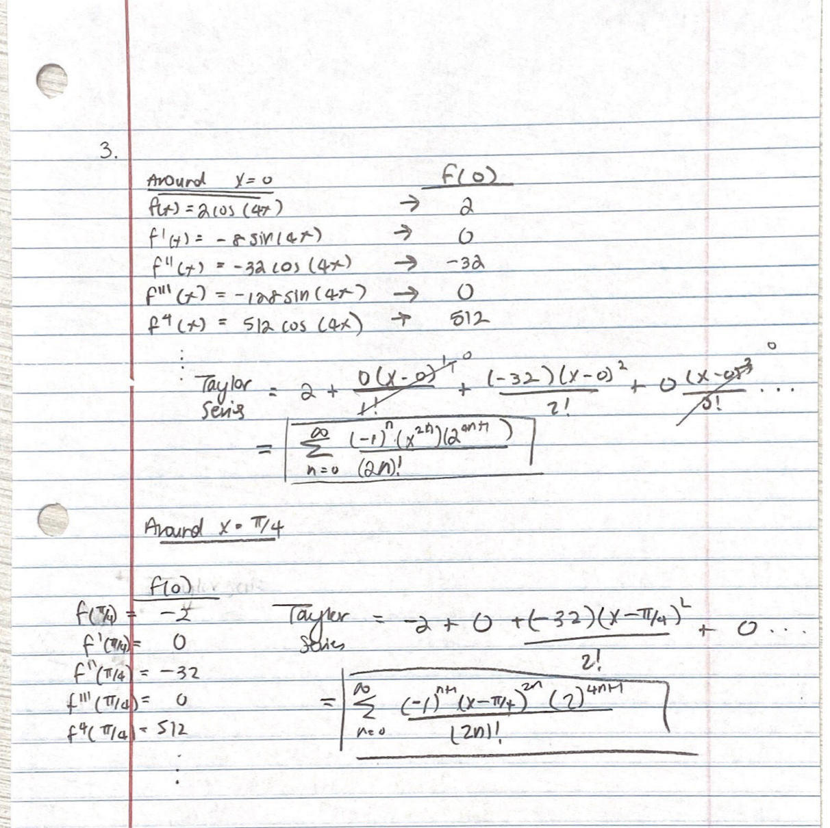3) a)

d)

|  |  |  |  |
| --- | --- | --- | --- |
|  | X = 0.1 | X = 0.2 | X = 0.8 |
| Around 0 | 4 | 5 | 9 |
| Around Pi/4 | 8 | 8 | 2 |

6)

a)

|  |  |  |
| --- | --- | --- |
|  | Absolute Error | Relative Error |
| T = 200 | 2.64 | 0.04 |
| T = 1200 | 22.4296 | 0.12 |

b)   
ans = delA + delB*T + delC*(T^2) + delD*(T^3) + delE*(T^4) + (0+B+(2*C*T)+(3*D*T^2)+(4*E*T^3));

Using this equation to find the error of the heat capacity – to find the constant that contributes to the most error, find the constant that has the largest error. If we omit the terms relating to the error in temperature, and focus on the highlighted terms, the second term has the largest value regardless of low or high temperature. So, out of the five constants, B is the constant that is most important to determining the temperature in lower and higher ranges.