
BDS23114 Data Analytics
Week 10 Assignment
From Clusters to Product:
Building and Deploying a Clustering Model in a Web App
Short Report
Lee Wen Xin
BIT_B2201F-2505004

1. Dataset & Problem Framing

Dataset: UCI Online Retail (Chen, 2015) — 541,909 transaction line items, UK-based online gift retailer, Dec 2010–Dec 2011.
Source: https://archive.ics.uci.edu/dataset/352/online+retail
License: Creative Commons Attribution 4.0 International (CC BY 4.0) — sharing and adaptation permitted with attribution.
The raw data is transactional (one row per line item), not customer-level. The business question guiding this analysis is: what natural customer segments exist in the transaction history, and what should be done differently for each one? This required first aggregating transactions into a customer-level feature table — 4,338 customers, 8 features, above the assignment's 200-observation / 3-feature minimum.

2. Preprocessing & Feature Engineering

Rows with missing CustomerID (~135,080, 25% of the raw data) were dropped, since a transaction with no customer identity cannot be attributed to any customer-level cluster.
Cancelled invoices (InvoiceNo starting with 'C') were flagged rather than discarded, so that return behaviour could be kept as a feature instead of being treated as noise.
Rows with non-positive UnitPrice that were not cancellations were removed as data-entry errors.
Eight features were engineered per customer: Recency, Frequency, Monetary, AvgUnitPrice, DistinctProducts, TotalItems, AvgBasketValue, and ReturnRate.

3. EDA & Method Justification

Feature distributions were extremely right-skewed (skewness ranging from ~6 to ~50 across features), visible in the raw histograms below.
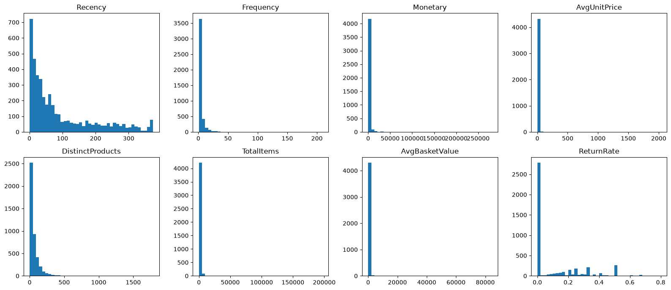
Figure 1. Raw feature distributions (right-skewed, motivating a log-transform).
A scatter of log(Frequency) vs log(Monetary) shows uneven customer density — a dense mass of casual buyers, and a much sparser, spread-out region of high-frequency buyers — which rules out K-Means (it assumes roughly equal-sized, spherical clusters).
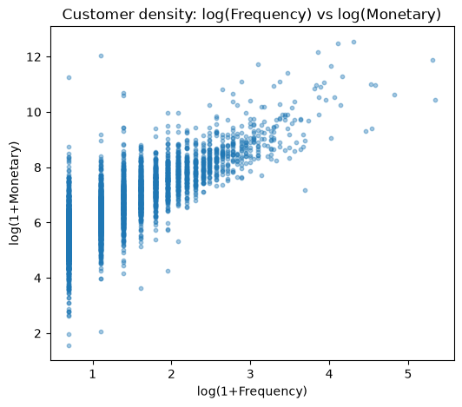
Figure 2. Density/shape check motivating a density-based method over K-Means.
A correlation heatmap was also produced (Figure 3): Monetary and TotalItems correlate at 0.92, and Frequency/DistinctProducts at 0.69 — both features were retained since they carry distinct business meaning (total spend vs. product breadth), but the redundancy is noted as a possible target for feature selection in future work.
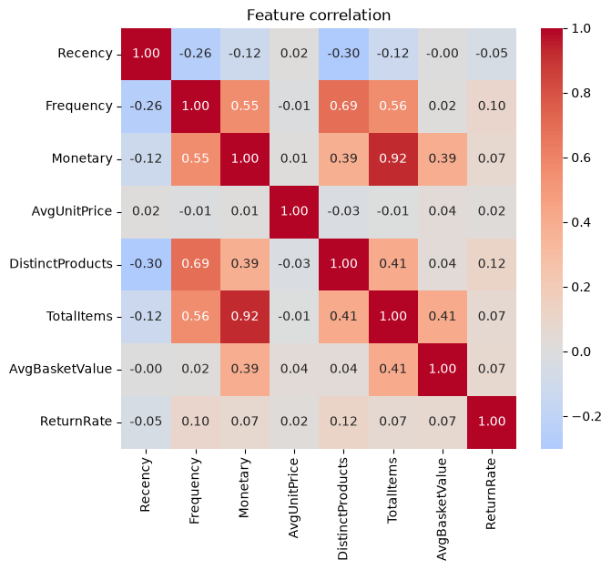
Figure 3. Feature correlation heatmap.
Given the skew, six heavily right-skewed features (Frequency, Monetary, AvgUnitPrice, DistinctProducts, TotalItems, AvgBasketValue) were log1p-transformed, then all features were scaled with RobustScaler (median/IQR-based), which limits the influence of the remaining large-spender outliers.
HDBSCAN was selected as the clustering method because it adapts to variable density, does not require the number of clusters to be specified in advance, and natively flags outliers instead of forcing every customer into a cluster. K-Means, GMM, and PCA-driven pipelines were excluded per the assignment brief and were, in any case, a poor fit for this uneven-density data. UMAP (not PCA) was used purely for 2D visualization and never drove cluster assignment.

4. Hyperparameter Tuning

A grid search was run over min_cluster_size and min_samples. The single best silhouette score on its own came from a configuration that flagged 54% of customers as noise — statistically strong, but not usable for a real segmentation product. A business constraint (noise ratio ≤ 35%) was applied before re-ranking by silhouette score.
A finer follow-up grid search confirmed that this dataset naturally supports only two well-separated clusters at an acceptable noise level — attempts to force three or more clusters always pushed the noise ratio above 55%. Rather than artificially splitting the data to hit a target cluster count, the model was left at two clusters, and this trade-off is reported transparently rather than hidden.
Final model: HDBSCAN(min_cluster_size=25, min_samples=5, metric="euclidean")

5. Evaluation Results

Metric | Value
Silhouette Score | 0.311
Davies–Bouldin Index | 0.832
Calinski–Harabasz Index | 80.0
Number of clusters | 2
Noise points | 1,486 (34.3%)
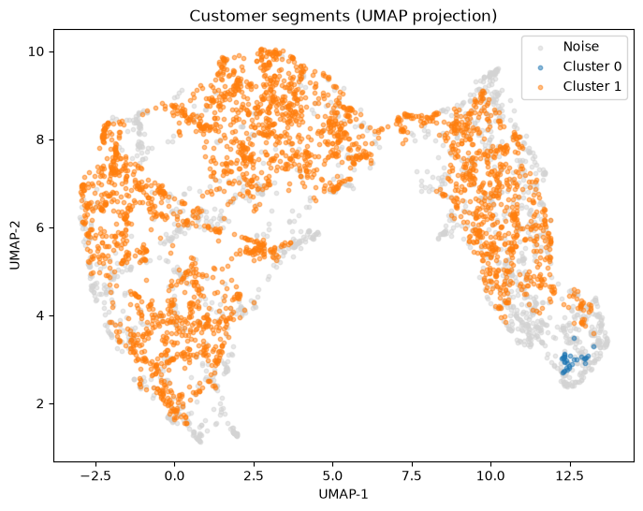
Figure 4. UMAP projection of customer segments, colored by HDBSCAN cluster.
Note: the UMAP projection shows two macro-level 'islands' that the HDBSCAN cluster assignment (computed in the original 8-dimensional feature space) does not cleanly align with. This is reported as an honest finding rather than smoothed over — see Limitations.

6. Cluster Interpretation

Cluster | Name | Recency | Freq. | Monetary | Return rate | Size
0 | At-risk, high-return sleepers | 247 days | 1 | £326 | 50% | 30
1 | Core active customers | 40 days | 2 | £660 | 0% | 2,822
-1 (noise) | Heterogeneous / edge | 81 days | 2 | £721 | 9.7% | 1,486
Cluster 1 is the stable core of the customer base: recent, low-return, repeat buyers, and the group most worth protecting with loyalty incentives. Cluster 0 is small (30 customers) but high-signal — a 50% return rate on a single order placed roughly eight months ago is a clear churn / product-fit warning worth investigating manually. The noise group (34.3%) is not bad data: its metrics sit in the moderate range across every dimension, meaning these customers genuinely don't match either archetype tightly. In a real deployment this group would need a secondary or manual-review process rather than automated targeting.

7. Web App Walkthrough

A Streamlit app loads the persisted pipeline (RobustScaler, fitted HDBSCAN model, and UMAP reducer) at startup and does not retrain anything. The left panel displays the existing customer base in UMAP space, colored by cluster. The right panel lets the user enter a new or hypothetical customer's RFM and behavioural values; on submission, the app applies the saved log-transform and scaler, calls hdbscan.approximate_predict() for a live cluster assignment with a membership-strength confidence score, and plots the new point on the existing UMAP map.
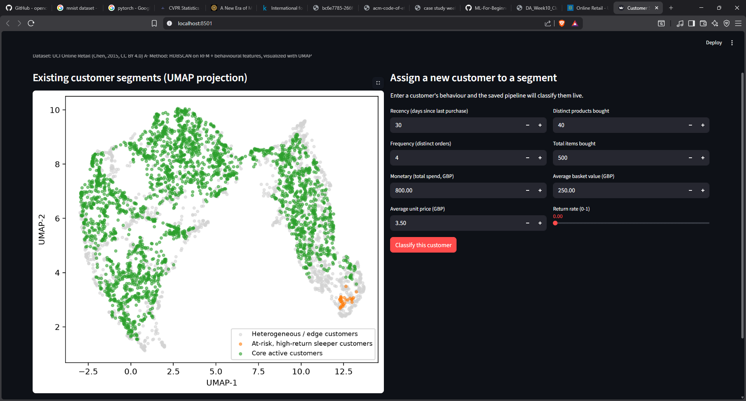
Figure 5. Streamlit app — cluster map (left) and live classification form (right).
Run locally: python -m streamlit run app.py

8. Limitations

HDBSCAN's noise category covers 34.3% of customers. This is documented as a modeling and business finding rather than hidden; these customers would need a secondary or manual-review process in a real deployment.
The UMAP visualization shows two macro-level customer groupings that the cluster assignment does not align with — flagged as a direction for future work (e.g. sub-clustering within each UMAP region) rather than smoothed over.
The dataset covers a single UK retailer over roughly one year; the discovered segments may not generalize to other markets or seasons without re-fitting.

