Predictive Modeling of FIFA World Cup Match Outcomes
A Machine Learning Approach Using Historical International Match Data
BDS23114 Data Analytics | May 2026 Semester
Author: Lee Wen Xin | Student ID: BIT-B2201F-2505004| Lecturer: Dr. Ng Choon Ching

1. Introduction and Objectives
Football results appear unpredictable, yet over thousands of matches clear patterns emerge. This project applies the full data-analytics lifecycle to historical international football data with two goals: to predict the outcome of a match (Win, Draw, or Loss from the home team’s perspective), and — more importantly — to explain why one team beats another. Rather than treating the final score as the input, the project derives measurable pre-match indicators of team strength and uses interpretable models to quantify how each contributes to the result.
Research questions: (1) Can match outcomes be predicted more accurately than a naive baseline? (2) Which factors explain a win, and how much does each contribute? (3) Do these factors generalise to World Cup matches, including the 2022 tournament?

2. Dataset Description and Source
The primary dataset is International Football Results (1872–2026), obtained from Kaggle as a continuously updated snapshot. It contains 49,490 international matches with the columns: date, home team, away team, home goals, away goals, and a flag indicating whether the home team played at its own stadium. This exceeds the minimum requirement of 500 rows and 8 columns once the engineered features are added. Three supporting files (World Cup matches 1930–2018, tournament summaries, and the 2022 fixture list) provide additional context and a live prediction target.
Outcome balance: home wins 49.0% (24,253), away wins 28.3% (13,981), and draws 22.7% (11,255). The home team wins more often, which sets the baseline any model must beat.

3. Methodology

3.1 Data Cleaning and Preparation
The date column was converted to a datetime type and the records sorted chronologically — an essential step, because all engineered features must use only information available before each match. Exact duplicate fixtures (identical date, teams, and score) were removed. Extreme scorelines such as 31–0 were inspected and retained, as they are genuine historical results rather than data-entry errors; the modelling uses smoothed strength features that are robust to isolated blow-outs. The target variable was derived by comparing home and away goals and encoded as Win, Draw, or Loss.

3.2 Exploratory Data Analysis
Descriptive statistics show a mean of 2.94 total goals per match (median 3, standard deviation 2.10). Crucially, the home win rate is 50.7% when a team actually plays at its own stadium but only 44.2% at a neutral venue — the first quantitative evidence that home advantage is real but modest. Figure 1 shows the overall outcome distribution.
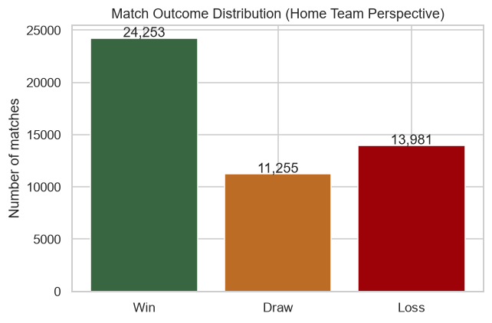
Figure 1. Distribution of match outcomes from the home team’s perspective.
Two further views complete the EDA picture before feature engineering begins. Figure 2 shows the distribution of goals: both home goals and total goals per match are right-skewed, with most matches settling in the 1–4 goal range and a long tail of high-scoring outliers — consistent with the 31–0-style blow-outs discussed above being genuine rather than data-entry errors.
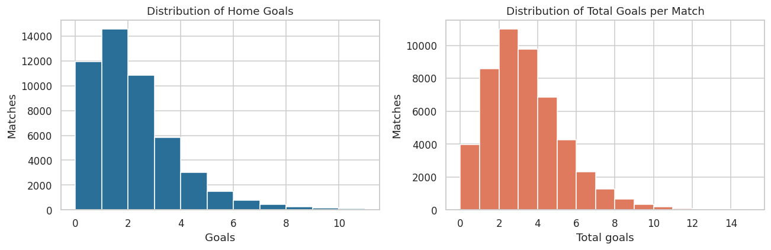
Figure 2. Distribution of home goals and total goals per match — both right-skewed.
Figure 3 steps back to tournament level: total goals scored and matches played at each FIFA World Cup from 1930 to 2018 have both trended upward, reflecting the tournament's expansion (from 13 teams in 1930 to 32 by 1998) rather than a change in how attacking the sport itself has become. This motivates treating Exp_Diff (matches played) as a genuine strength signal rather than noise.
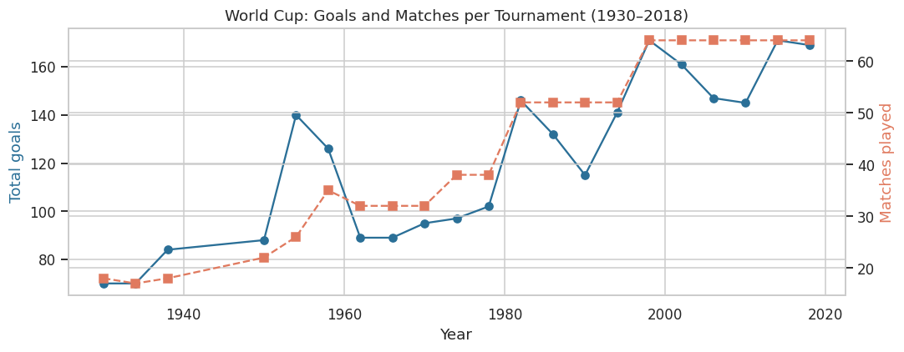
Figure 3. World Cup goals and matches played per tournament, 1930–2018 — both track tournament expansion.
A correlation analysis (Figure 4) was used both to understand relationships and to support feature selection. The engineered Elo-difference feature shows by far the strongest correlation with the result, confirming team strength as the leading signal.
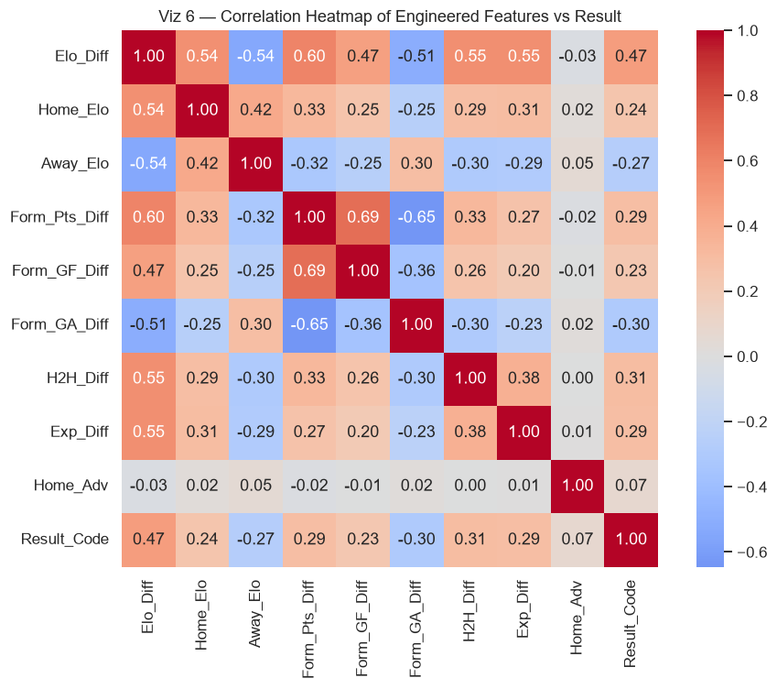
Figure 4. Correlation heatmap of engineered features against the match result.

3.3 Feature Engineering — Turning Outcomes into Explanations
This stage is the core of the project and the basis for explaining why teams win. Raw columns only record what happened; the following pre-match features were derived to capture each team’s strength before kick-off, all computed chronologically and time-shifted to prevent data leakage:
- Elo rating (Home_Elo, Away_Elo, Elo_Diff): a running skill score updated after every match, weighted by the goal margin. The pre-match Elo difference is the single clearest measure of relative strength.
- Recent form (Form_Pts_Diff, Form_GF_Diff, Form_GA_Diff): the difference in average points, goals scored, and goals conceded over each team’s previous five matches.
- Head-to-head (H2H_Diff): the home team’s historical win rate against this specific opponent.
- Home advantage (Home_Adv) and experience (Exp_Diff): playing at one’s own stadium, and the number of matches played to date.
Figure 5 illustrates why these features work: teams that go on to win enter the match with a clearly higher Elo than their opponent, while losses cluster below zero.
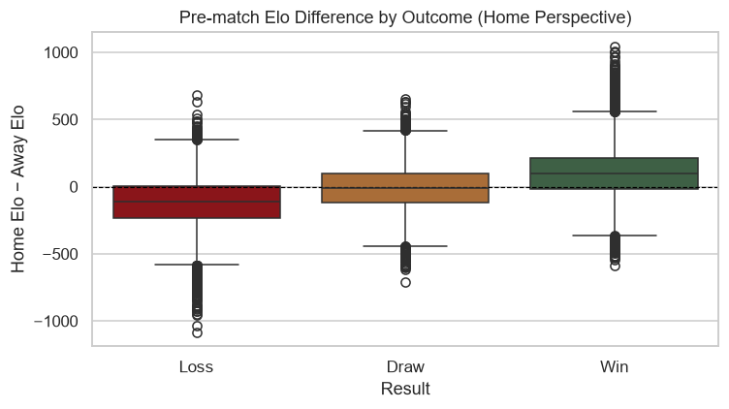
Figure 5. Pre-match Elo difference by outcome — winners start stronger.

3.4 Modelling Approach
Because the data is time-ordered, a chronological 80/20 split was used (first 80% of matches for training, most recent 20% for testing) rather than a random split. A random split would let the model train on future matches and test on past ones, leaking information and inflating the score. Three models were compared: Logistic Regression (transparent coefficients), Random Forest (tuned with GridSearchCV over a time-series cross-validation), and Gradient Boosting. The baseline to beat is always predicting the most common class, Win (47.6%).

4. Results and Evaluation

4.1 Model Performance
All three models clearly beat the baseline, reaching just under 60% accuracy on the held-out test set (Table 1). Accuracy and macro-F1 are close across all three models; Random Forest and Gradient Boosting are tied on macro-averaged F1 (0.446), just ahead of Logistic Regression (0.440). Random Forest is selected as the best model: beyond the tie-breaking F1 score, it also directly exposes feature importances, which this report relies on in Section 4.2 to explain why teams win.
Table 1. Test-set performance of the three models versus the baseline.
Model | Accuracy | Precision | Recall | F1 (macro)
Baseline (predict Win) | 0.476 | – | – | –
Logistic Regression | 0.597 | 0.543 | 0.498 | 0.440
Random Forest | 0.596 | 0.500 | 0.498 | 0.446
Gradient Boosting | 0.592 | 0.480 | 0.496 | 0.446

Figure 6 compares accuracy against the baseline, and Figure 7 shows the confusion matrix of the best model.
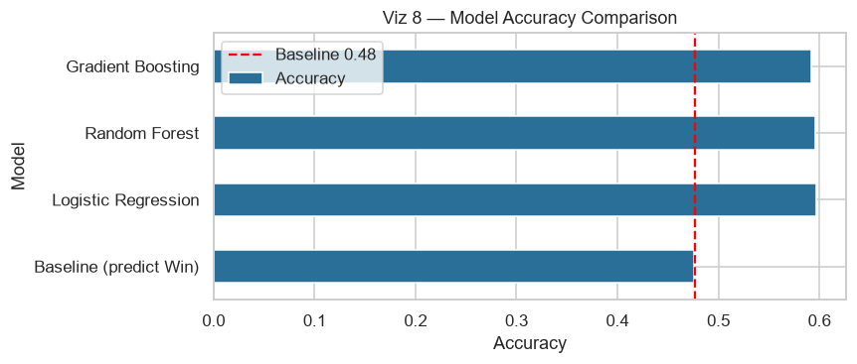
Figure 6. Model accuracy compared with the baseline (red line).
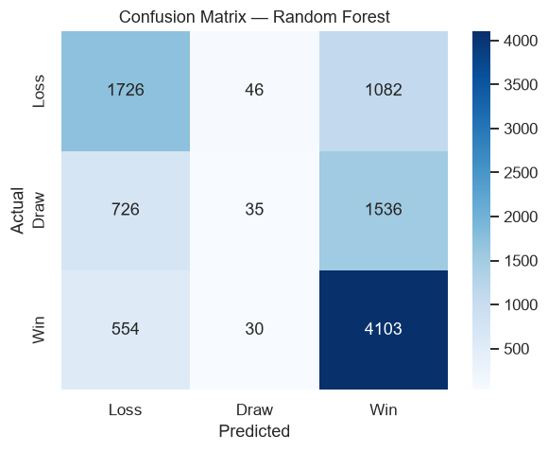
Figure 7. Confusion matrix of the best model (Random Forest).
The confusion matrix confirms a known difficulty: wins and losses are predicted reasonably well, but draws are frequently misclassified — draws are inherently close to random and are the main source of error.
Table 2 breaks this down by class for Random Forest and shows the difficulty precisely: Win and Loss are recovered reasonably well (recall 0.88 and 0.60), but Draw recall is only 0.02 — the model correctly identifies roughly 35 of the 2,297 draws in the test set, and effectively predicts “not a draw” almost every time. This is a class-imbalance effect: draws are the minority and hardest-to-separate class, so a classifier optimising for overall accuracy learns that rarely predicting Draw is the lower-risk strategy. Macro-F1 (0.446) rather than accuracy (0.596) is therefore the more honest headline metric for this task, since accuracy alone hides this collapse.
Table 2. Per-class precision, recall, and F1-score for the Random Forest model (test set).
Class | Precision | Recall | F1-score
Win | 0.61 | 0.88 | 0.72
Loss | 0.57 | 0.60 | 0.59
Draw | 0.32 | 0.02 | 0.03
Three remedies were identified for future iterations, in order of expected impact: (1) class-weighted training (class_weight="balanced" in scikit-learn), which penalises misclassifying the minority class more heavily; (2) resampling the training set (e.g. SMOTE oversampling of draws, or undersampling Win/Loss); and (3) an ordinal reframing of the target (Loss < Draw < Win), which respects the natural ordering between outcomes instead of treating the three classes as unrelated categories. None of these were applied in the current model so that the reported metrics reflect an untuned baseline; trying (1) first would be the cheapest next step, since it requires no resampling and no change to the feature set.

4.2 Why Teams Win
The central question is answered three ways. Random Forest feature importance (Figure 8) shows the Elo strength gap dominates all other factors. Logistic Regression coefficients (Figure 9) add direction: a larger Elo difference, home advantage, and stronger attacking form raise win probability, while a higher opponent rating and more goals recently conceded lower it. A model-agnostic permutation test confirmed the same ranking, with Elo difference far ahead of every other feature.
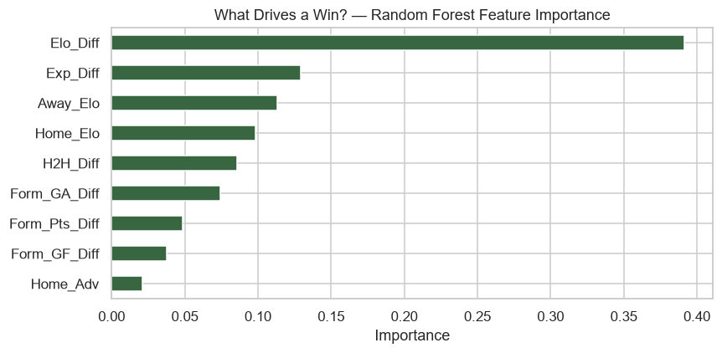
Figure 8. Random Forest feature importance — the strength gap dominates.
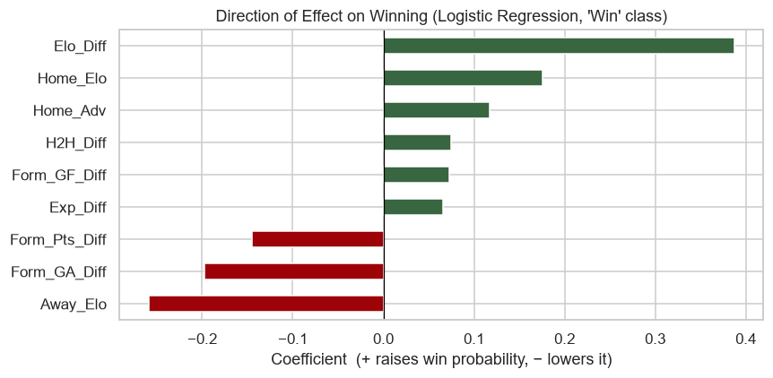
Figure 9. Logistic Regression coefficients — direction of each effect on winning.
Interpretation. Three findings stand out. First, relative team strength (Elo difference) is overwhelmingly the most important factor — football is largely a contest of accumulated quality. Second, defence matters more than attack: a lower recent goals-conceded average raises win probability more than a higher goals-scored average. Third, home advantage is real but small, consistent with the EDA finding, and is easily outweighed by a large strength gap.

4.3 Application: 2022 World Cup
As a live demonstration, the trained Random Forest was applied to the 2022 group-stage fixtures, which carry no scores in the source data. Table 3 shows a sample of the output. One caveat applies: because the underlying dataset is a continuously-updated snapshot running through July 2026, each team's Elo and recent-form values reflect their current strength rather than their strength at the actual time of the 2022 tournament. This means the exercise demonstrates that the pipeline runs end-to-end on unseen fixtures — it is not a true retrospective forecast of the 2022 tournament, since a real pre-2022 forecast would need Elo and form computed only from matches before November 2022. A faithful backtest is listed under Future Work.
Table 3. Sample Random Forest predictions for 2022 World Cup group-stage fixtures.
Home Team | Away Team | Prediction | Home win prob.
Argentina | Saudi Arabia | Home win | 0.825
Qatar | Ecuador | Away win | 0.135
Germany | Japan | Home win | 0.488
Morocco | Croatia | Home win | 0.480

4.4 Live Application: 2026 World Cup Semifinal
Section 4.3 showed the pipeline running end-to-end, but flagged that predicting 2022 fixtures with a 2026-dated snapshot is not a genuine forecast. This section closes that gap with a true out-of-sample test: on 12 July 2026, the France v Spain 2026 FIFA World Cup semifinal (kick-off 14 July, AT&T Stadium, Dallas) was a confirmed fixture with an unknown outcome. Feeding it through the trained Random Forest below is therefore a real, verifiable prediction — not a retrospective one — since neither team's result was known at the time of writing.
Table 4. Pre-match indicators for France v Spain, as of the 2 July 2026 data snapshot.
Metric | France | Spain | Source
Elo rating | 2087.0 | 2127.9 | model.py, trained on full snapshot
Last 5 results | W W W W W | W D W W W | chronological, most recent last
Head-to-head (38 meetings) | 13 wins | 18 wins (7 draws) | historical, all competitions
The model gives Spain the edge (Table 5): a narrow 41-point Elo advantage and a stronger head-to-head record (18 wins to 13 across 38 meetings) outweigh France's marginally better recent form. Because a World Cup knockout match cannot end in a draw, the 25.7% draw probability is also redistributed proportionally between the two teams to give an approximate advancement probability.
Table 5. Model output for France v Spain, with a simple draw-redistributed advancement estimate.
Outcome | Raw model probability | P(advances)¹
France win | 32.6% | 43.9%
Draw (n/a in knockout) | 25.7% | —
Spain win | 41.6% | 56.1%
¹ Redistributes P(Draw) between Win and Loss in proportion to their relative odds; a naive approximation, not a calibrated knockout-match model.
Limitation carried over honestly: the underlying snapshot is dated 2 July 2026, so Elo and form here do not yet reflect the Round of 16 and Quarter-final results played between 4–11 July. This makes the prediction slightly stale rather than leaked — the opposite failure mode from Section 4.3, and one that resolves itself automatically as the dataset is refreshed. The France v Spain result, once known, will be added as a worked accuracy check in the final submission.

5. Insights and Recommendations
- For analysts and pundits: Rank teams by a properly updated Elo rating before a tournament. It captures most of what predicts results and is far simpler than tracking dozens of separate statistics.
- For team management: Prioritise defensive consistency. The data shows reducing goals conceded yields a larger gain in win probability than increasing goals scored, so clean-sheet form is the higher-value target going into major tournaments.
- For organisers and hosts: Do not over-rely on host-nation advantage. Home advantage is genuine but modest and will not overturn a large strength gap, so it should not drive major planning or expectations.

6. Limitations and Future Work
- Draws are hard to predict. The models under-predict draws, a well-known challenge in football modelling; an ordered model (Loss < Draw < Win) or a goals-based Poisson model may help.
- No squad-level data. Injuries, line-ups, and red cards are absent from the dataset and would likely improve accuracy.
- Elo cold start. Newer national teams begin at the default rating of 1500, slightly mis-rating their earliest matches.
- Future extensions include player-level features (e.g. FIFA ratings or market values), tournament-importance weighting, and an interactive dashboard that displays per-match feature contributions — directly extending the project’s “explain why” goal.
- A faithful 2022 backtest: rebuild Elo and form using only matches before November 2022, so Section 4.3’s predictions reflect pre-tournament strength rather than strength inflated by four subsequent years of results.

7. References
Kaggle. International Football Results from 1872 (martj42), continuously updated — snapshot used covers matches through July 2026. https://www.kaggle.com/datasets/martj42/international-football-results-from-1872-to-2017
Elo, A. E. (1978). The Rating of Chessplayers, Past and Present. Arco Publishing.
Pedregosa, F. et al. (2011). Scikit-learn: Machine Learning in Python. Journal of Machine Learning Research, 12, 2825–2830.

