University of Neuchâtel
Faculty of Science
Master in Biodiversity Conservation

Micromammals and mountain habitats
Effects of land use, local habitat structures and climatic gradients on species abundance
Master's Thesis
Presented by
Milan Peterschmitt
Supervisor: Prof. Sergio Rasmann
Academic year: 2025–2026
Neuchâtel, 2026
Abstract
Mountain agricultural landscapes are composed of grasslands, wetlands, forest, edges, aquatic structures and other local microhabitats that may influence micromammal communities in different ways. This thesis examines how land-use typologies, local habitat structures and climatic gradients are associated with the abundance of small mammals in Swiss mountain landscapes. The analysis was based on capture data collected by Faune Concept over the last ten years in the Swiss Alps, with 2684 conserved records, 504 sampling stations and 11 species. For each species, the most frequent typologies, structures and typology x structure combinations were first described. Their statistical association with abundance was then tested using negative binomial models. Climatic covariates (BIO1, BIO2, BIO5, BIO12 and PCA1) were introduced separately to assess the robustness of habitat effects.
The results show that habitat associations are strongly species-specific. Wetlands and aquatic structures were positively associated with Microtus agrestis, Microtus arvalis and Neomys fodiens, but negatively associated with Clethrionomys glareolus and Chionomys nivalis. Forest habitats and forest edges were especially important for Clethrionomys glareolus, while Sorex araneus showed a negative association with forest habitats. Most robust effects remained significant after climatic adjustment, suggesting that the observed patterns were not only due to climatic variables.
Overall, the study highlights the importance of maintaining heterogeneous mountain landscapes, where wetlands, aquatic structures and forest edges provide complementary ecological contexts for different species.
Keywords: micromammals; mountain agriculture; land use; habitat structures; wetlands; forest edges.
Table of Contents
1. Introduction 1
2. Literature review 3
2.1. Land use, forest habitats, and edge structures 4
2.2. Open, wetland, and aquatic habitats 4
2.3. Influence of climate 5
3. Materials and Methods 6
3.1. Study area 6
3.2. Data used and unit of analysis 6
3.3. Dataset structure 8
3.4. Climatic variables used 8
3.5. Data harmonization and hierarchical analysis 9
3.5.1. Harmonization of the different categories 9
3.5.2. A second targeted hierarchical pass 10
3.6. Statistical analyses 10
4. Results 12
4.1. Apodemus alpicola 12
4.2. Apodemus flavicollis 12
4.3. Apodemus sylvaticus 13
4.4. Chionomys nivalis 13
4.5. Clethrionomys glareolus 14
4.6. Microtus agrestis 14
4.7. Microtus arvalis 15
4.8. Microtus lavernedii 15
4.9. Neomys fodiens 16
4.10. Sorex antinorii 17
4.11. Sorex araneus 17
4.12. General synthesis 18
5. Discussion 21
5.1. Contrast between wetlands, forests, and grasslands 21
5.2. The contribution of local structures 22
5.3. What does the second hierarchical pass teach us? 23
5.4. Species with no robust signal: no effect or no statistical power? 24
5.5. Limitations of the analysis 24
5.6. Ecological and management implications 25
5.7. A review of the assumptions made in the introduction 25
6. Conclusion 27
Bibliography 28
Appendix 31
List of Figures
Figure 1. Swiss cantons included in the micromammal surveys 6
Figure 2. Sampling coverage and total abundance by species 7
Figure 3. Extract of the worked dataset used for subsequent analyses 8
Figure 4. Effect sizes of significant habitat associations 18
Figure 5. Species-specific responses to harmonized habitat categories 19
Figure 6. Robustness of significant habitat effects after climatic adjustment 20
List of Tables
Table 1. Harmonized typology and structure categories used in the analysis 9
Table 2. Summary of the second hierarchical pass 24
Table 3. Climate-adjusted robustness of significant effects 34

1. Introduction
The biodiversity in the world is facing a major decline during the last decades, mainly linked to land use change due to human activity (IPBES,2019; WWF France, 2024). According to the WWF and his report “living planet”, over the past fifty years, there has been an average decline of 73% in the size of 34,836 wild animal populations across 5,495 species (WWF France,2024). Changes in land uses are one of the main reasons of the reorganization of the communities of small mammals, because they modify simultaneously the structure of the vegetation, the availability of resources, the exposition to predators and the connectivity of habitats (Paniccia and al., 2022; Torre et al., 2024).
Micromammals form a relevant group to study the connexions between habitats and abondance, due to their quick life cycle, their strong dependency to the microstructures, to the variation of the vegetation cover and climate. (Čepelka & Dokulilová, 2025). They occupy a key position in the terrestrial ecosystems, contributing to the food web, soil tillage, dispersing of seeds and controlling invertebrate populations (Kauer et al., 2025). In mountain agricultural landscapes, effects of land use on micromammals are not uniform (Kratschmer and al., 2024). Species do not only react to bigger categories of soil utilisation, but also to fine structures such as forest edges, hedges, small patch of forest, ponds or drystone walls (Schlinkert and al., 2016). Studies conducted in Europe show that permanent or semi natural habitats, wooden structures generally support more abundant or mor diversified communities than a simplified landscape (Broughton and al., 2014.) On the opposite, forest species and those from open environment or humid do not meet the same environmental standards, so that only one category of soil usage can favour some species and disadvantages some others, regarding their needs in terms of humidity, opening or closing environments (Balčiauskas et al., 2017).
Mountain landscapes are characterised by a wide variety of permanent meadow, hedges, edges, forests, humid areas, offering a wide range of micro-habitats crucial for numerous species (Marshall & Moonen, 2002). This is important to assess what uses of soil and what structures fine associated explain the abundance of micromammals in a landscape if we want to see them thrive (Dorigo et al., 2021). We should in this case think in terms of general typologies and ecological categories finer (Torre and al., 2024).
In this view, the objective of this study is to identify the types of typologies, local structures and the combinations between typologies and structure that are associated with the abundance of micromammals species listed, while verifying if those effects persist when we consider the climatic gradients available in our data. To do that, we will analyse data from catches made the 10 last years in the Swiss Alps. Furthermore, in this study, we’ll try to answer to the following assumptions: The first assumption is that wetlands and aquatic habitats are positively associated with the abundance of species associated with wetland environments, although these same habitats are not necessarily favourable to all species. The second hypothesis is that forest related habitats are positively associated with the abundance of species associated with forest environment, while certain species typically found in more open areas may be less abundant there. The third hypothesis is that the associations between typologies, local structures, and abundance remain detectable even after accounting for the climatic covariates BIO1, BIO2, BIO5, BIO12, and PCA1, suggesting that the observed effects do not solely reflect a regional climatic gradient.

2. Literature review
The micromammals are frequently used as biological indicators (Čepelka & Dokulilová, 2025). This is due to the composition of their communities that vary strongly with the structure of the habitats and the management of the environment, which allows to connect precisely the biodiversity observed to the characteristics of the studied area (Shilereyo and al., 2023). In agricultural landscapes, communities tend to simplify when the land use surfaces increase and that the natural areas decrease (Heroldová and al., 2007). On the opposite, micromammal communities become more variated when they are imbedded into diversified cultures, prairies, hedges, small woods and non-cultivated areas, which increase the diversity of resources and refuges for micromammals (Paniccia and al., 2022). For instance, a study centered around small forest patches, showed that the composition of the micro-habitats was able to explain an important part of the variations of abondance of Apodemus agrarius et Apodemus sylvaticus (Dorigo et al., 2021), which underline that micromammals interact with different level of spatial organisation and not only to a single dominant environment. This ecological sensibility can be explained by the fact that micromammals need precise combinations of humidity, vegetation cover and spatial continuity (Torre et al., 2022). Hence, small differences of local structures can product measurables changes in terms of abundance of specific richness (Benedek et al., 2021). For a problematic centered on the use of soil, it means that it is methodologically relevant not to limit to broad ecological categories, but to integrate too the fine ecological structures that influence the living conditions for many micromammals species (Dorigo et al., 2021).

2.1. Land use, forest habitats, and edge structures
Forest environments regularly host species and communities distinct to those present in open lands (Heroldová et al., 2007). Many studies show that wood patches, hedges and edges play a structuring role in the distribution of small mammals in the European agricultural landscapes (Schlinkert et al., 2016). Studies on hedges and forest edges show that small mammal specialist in forest tend to favour the wooden components connected to the forest matrix (Kratschmer et al., 2024.) However, changes of those environmental contexts can lead to changes in communities (Schlinkert et al., 2016). For example, land abandonment or the progressive closing of open spaces changes the species-specific richness in communities, with a decrease of certain species linked to grassland or forest edges, benefiting species more adapted to more advanced forest steps (Balčiauskas et al., 2017).

2.2. Open, wetland, and aquatic habitats
Open grassy areas, vegetated margins and permanent, uncultivated habitats play a major role for several voles (Broughton and al., 2014). They furnish a stable cover, a continuous of food availability and usable refuges during the unfavourable agricultural period (Heroldová and al., 2007). Hence, higher abundance of voles was shown in stable grassy margins and habitats than inside the disturbed agricultural areas (Rodríguez-Pastor and al., 2016; Kauer et al., 2025). This confirms the importance of structures that acts as refuges for the population of micromammals. Microtus agrestis populations have been shown to decrease when the untouched grass areas were destroyed (CITE). Humid habitats represent a special case, because they gather a combination of humid soil, dense vegetation and a high number of invertebrates (Greenwood and al., 2002;). This type of habitat can accommodate rare species, which are missing in dryer habitats (van der Putten and al., 2025). Neomys fodiens is the best example, because its presence is highly connected to humid zones, rivers, streams, wetlands and sites with low and dense vegetation, whereas dry and open spaces are less favourable for this species (Van der Putten et al., 2025). Hence, maintaining a diversity of humid and open habitats seems important to have a diversified community of micromammals.

2.3. Influence of climate
One of a key aspect of the ecological analysis of micromammals consists of distinguish what is part of the effect of habitats, and what is part of the climate effects (Torre and al., 2024). Because temperature, temperature range and precipitation influence vegetation, food resources, and population dynamics (Deitloff and al., 2010), climatic factors will likely affect micromammals populations (CITE). In this regard, studies conducted in agroecosystems in north-est of Spain show that the different uses of soil explain often more the variance than the climate at small scale, but that an important part of the community structure is shared between climate and use of soil (Torre and al., 2024). For example, studies on Clethrionomys glareolus shows that hotter years and episodes of extreme rains can reduce the abundance of the species, which confirm that the climate variables should be considered as important co-variables explanatory, without, however, downplaying the importance of the structure of habitats (Huerta-Schliemann and al., 2025.)

3. Materials and Methods

3.1. Study area
The study was conducted in diverse regions and mountain agricultural landscapes of Switzerland, distributed along an altitudinal gradient with different alpine bioclimatic zones. The trapping area for animals goes from 450m to 2300m.
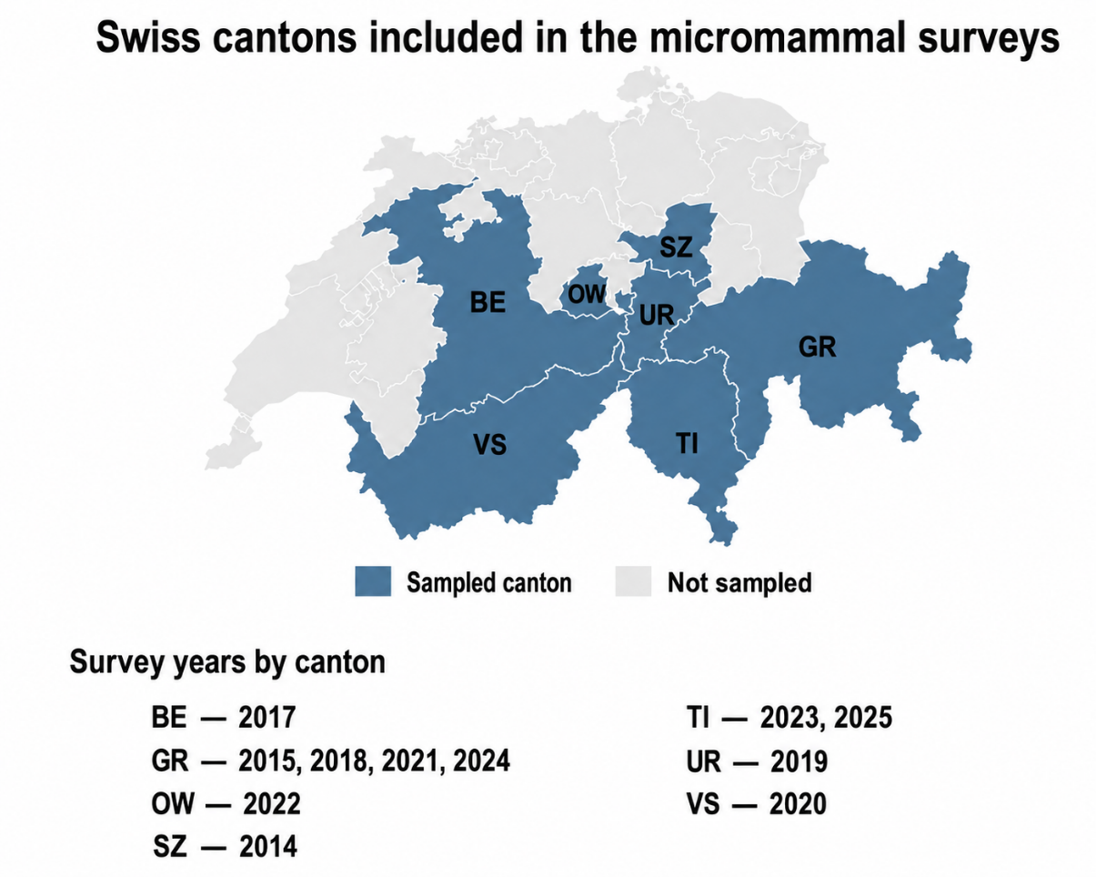
Figure 1. Swiss cantons included in the micromammal surveys

3.2. Data used and unit of analysis
The data analysed in this master’s thesis were collected during field surveys conducted by Faune Concept. Faune Concept is a community of 5 ecology firms dedicated to the study of wildlife, in particular the mammals.
Gathered over the past ten years in several regions of the Swiss Alps, the data were not collected specifically for this project but were made available as part of a collaboration with the firm.
The data are the property of Faune Concept. Their use has been authorized for the purposes of this academic work. Field collection, initial identification of individuals are the responsibility of Faune Concept. The original dataset with all captures came in form of an Excel file, which listed all the captures of micromammals and the descriptives variables associated with the different stations. After sorting the data, the dataset consisted of 2684 lines (captures), corresponding to 504 stations and 11 micromammal species. Sampling coverage differed substantially among species, both in terms of occupied stations and total abundance (Figure 2).
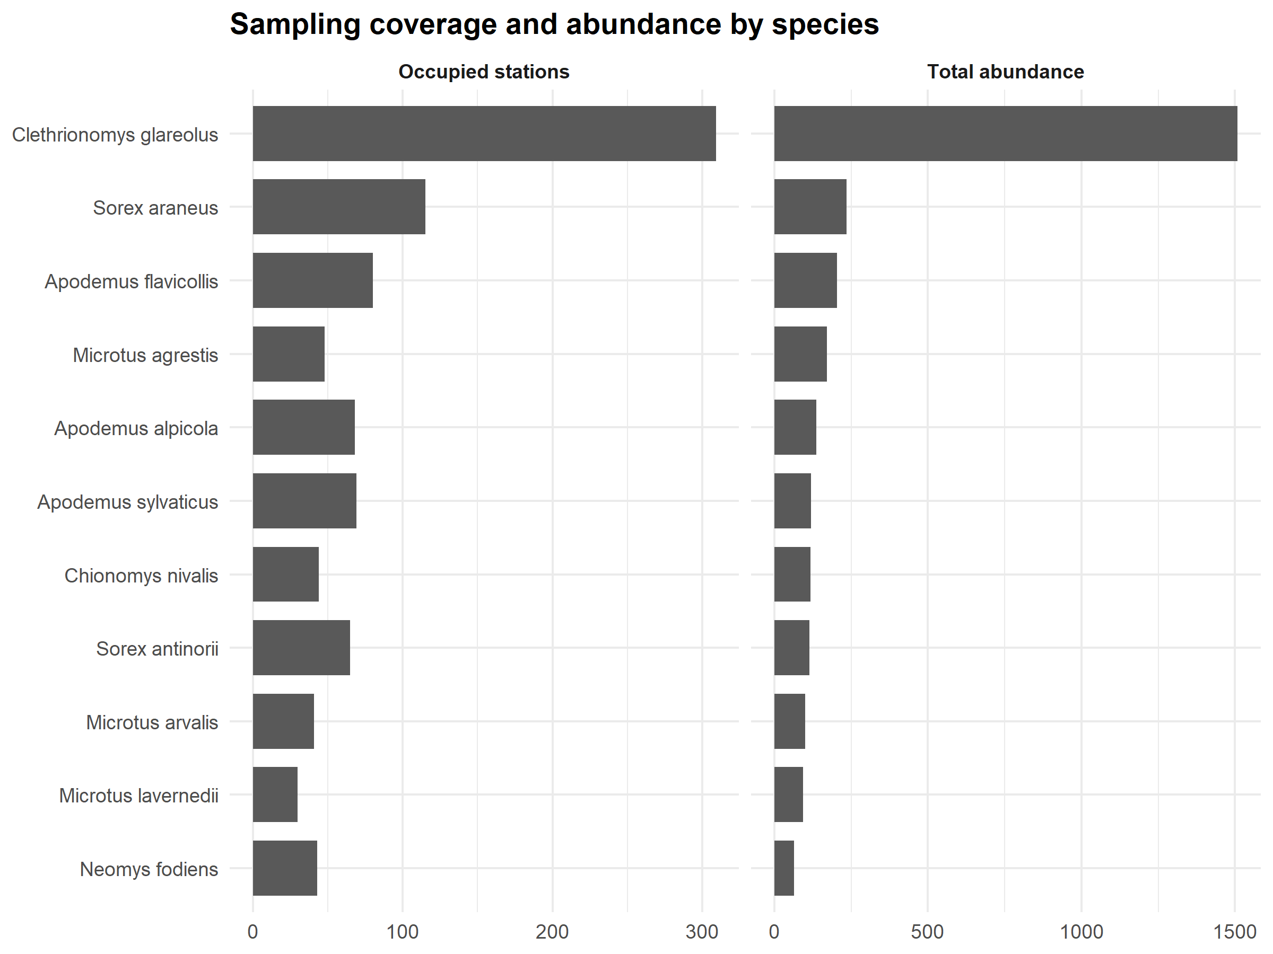
Figure 2. Sampling coverage and total abundance by species. The figure shows the number of occupied stations and the total abundance recorded for each species.

The typology describes the dominant environment surrounding the station at one hectare scale, and the structure describes the structural elements observed at the precise emplacement of the capture. A maximum of 2 structures per station could be indicated. The variables Structure 1 and structure 2 were considered as interchangeable and non-exclusive. A station could contribute to 2 structures simultaneously.
Some cells of the listing were empty regarding the typology and structure. They were therefore filed manually, based on the available data of the site map.geo.admin.ch The following filters were used to determine in which type of environment and structure the stations were located:
- Standard land area statistics
- Wetland sites
- Raised bogs
- Flat bogs
- Dry grassland zones
- IFN forest diversity
- Land use areas
- Natural habitat map – Base
- Soils: Crop typology

3.3. Dataset structure
The final dataset for subsequent analyses was formatted into a new Excel file (Figure 3), in which, each line of the dataset corresponds to an observation of an individual captured, while columns represent: 1) the species observed, 2) the GPS coordinates of the location, 3) the type of dominant environment (typology), and 4) the main structures of the habitat (structure). Such information allows us to connect every observation with a specific ecological context and to analyse the relationship between the presence of a species and the characteristics of the habitat.
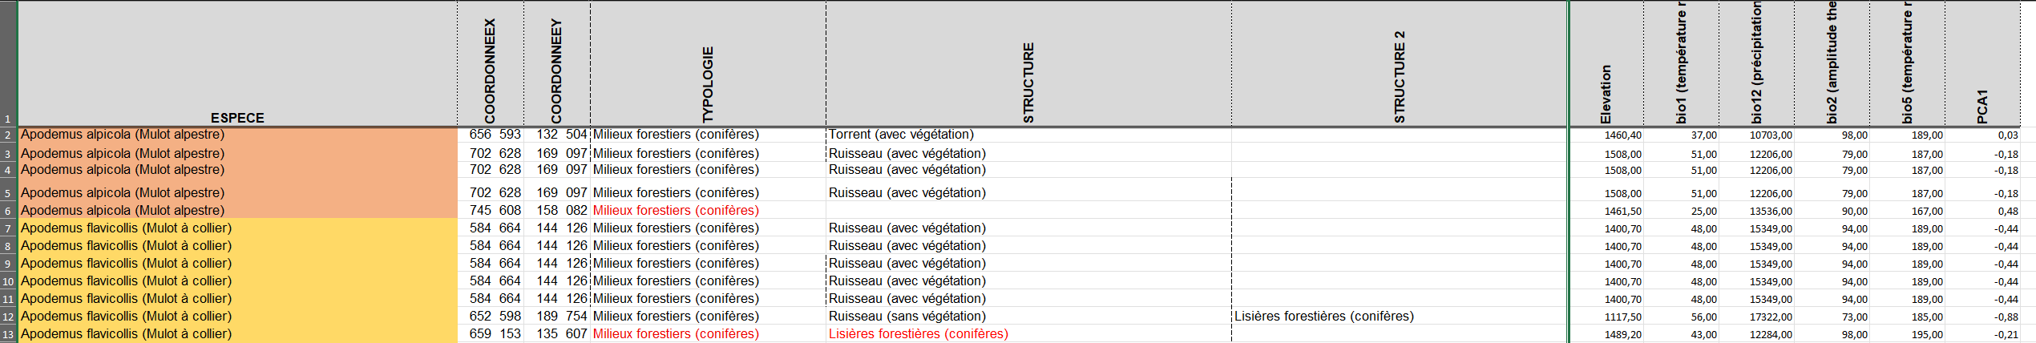
Figure 3. Extract of the worked dataset used for subsequent analyses. The figure shows how the cells were filed in the excel field file.

3.4. Climatic variables used
In this study, climatic variables were used to assess the robustness of the relationships observed between habitat characteristics (typology and structure) and species abundance. This approach aims to distinguish the contributions of local ecological conditions and climatic gradients. A result that remains significant after climatic adjustment is interpreted as reflecting a relationship strongly linked to the typology and structure, whereas a result that disappears after adjustment suggests that the observed association may be largely driven by the climatical conditions rather than by habitat characteristics.
Hence, the adjusted analyses integrated five climatic variables separately: bio1 (mean annual temperature), bio2 (mean diurnal temperature range), bio5 (maximum temperature of the warmest month), bio12 (annual precipitation), and PCA1 (the first principal axis of a principal component analysis summarizing the main multivariate climatic variables). The climate variables used in this study were retrieved from the Worldclim2 database, developed by Fick and Hijans (2017).

3.5. Data harmonization and hierarchical analysis

3.5.1. Harmonization of the different categories
A preliminary harmonization step was put in place to avoid directly comparing categories with different levels of precision (Table 1). The objective was to build a level of analysis consistent between stations, and to conserve more precise categories for complementary analyses. Hence, some categories were transformed as follows:
Variable | Harmonized category | Fine categories
Structure | Forest edges | Forest edges (coniferous); Forest edges (deciduous); Forest edges (mixed)
Structure | Built anthropogenic habitats | Built anthropogenic habitats
Structure | Aquatic habitats with vegetation | Stream (with vegetation); Torrent (with vegetation)
Structure | Aquatic habitats without vegetation | Stream (without vegetation); Torrent (without vegetation)
Structure | Rocky habitats | Anthropogenic rocky habitats; Natural rocky habitats
Structure | Semi-open woody structures | Scrub / shrub formations; Linear tree structures in agricultural landscapes
Typology | Forest habitats | Forest habitats (coniferous); Forest habitats(deciduous);Forest habitats (mixed); Open / disturbed forest habitats (deciduous)
Typology | Wetlands | Wetlands (lowland marshes); Wetlands (raised bogs); Wetlands (wet meadows)
Typology | Grasslands | Grasslands
Table 1. Harmonized typology and structure categories used in the analysis
As a complement, a second variable was created by merging “Aquatic habitats with vegetation” and “Aquatic habitats without vegetation” in a more general category: “Aquatic habitats”. The variable was not replaced at the main level of analysis but has allowed to assess whether certain results were associated with a general aquatic structure or a more specific aquatic type.

3.5.2. A second targeted hierarchical pass
After the first harmonized analyse, a second hierarchical pass was done for the typologies and structures that had a visible effect after climatic adjustment. The goal was to test the detailed subcategories inside a broad, statistically significant category. Hence, for example, when a more general category such as “Wetlands” or “Forest habitats” was standing out in the harmonized analyses, the detailed subcategories were tested. The same logic was applied to the structures. However, this second pass was not conducted for the combinations of typology and structure together, because they were more numerous and more fragile from a statistical point of view.

3.6. Statistical analyses
All analyses were made using R, version 4.4.3, And RStudio, version 2026.01.2+418. Data preparation, analyses, table, and figure generation utilized the following packages: readxl, dplyr, tidyr, stringr, tibble, MASS, writexl, ggplot2, forcats, sf, rnaturalearth, and rnaturalearthdata.
At each level of analysis (Typologie ; Structure ; Typologie x structure), the three habitats categories most frequently occupied by the species were selected. Each category was then tested separately: sites where it was present were compared to all sites where it was absent. Abundances were analysed using generalized linear models with a negative binomial distribution and a logarithmic link function. When this model could not be used, a Poisson model was used.
For each association between a species and a category, an unadjusted model was first estimated. Five additional models were then constructed by separately adding one of the following climate variables: BIO1, BIO2, BIO5, BIO12, or PCA1. These variables were never included simultaneously in the same model.
Statistical significance was assessed using Wald tests. Model coefficients were transformed to obtain rate ratios (RR) and their 95% Wald confidence intervals (CI), which indicates the uncertainty surrounding each RR estimate. A RR greater than 1 indicated a higher model-estimated abundance at sites containing the tested category, and an RR below 1 indicated a lower estimated abundance. Final significance was determined using Benjamini-Hochberg adjusted p-values (qBH). An association was considered significant when qBH <0.05. All analyses were conducted separately for each species. Within each species, each selected habitat category was tested independently. The results were then divided into four categories. An effect was considered as robust if it was significant in the unadjusted model and remained significant after at least one climate adjustment. It was classified as limited to the raw model if it was significant only before adjustment. On the opposite, an effect was considered to be visible after adjustment if it became significant only after the introduction of a climate variable. All other cases were considered as “no effect detected.”

4. Results
For all results detailed below, Table 3 (Appendix) summarizes all statistically significant effects, while Figures 4, 5 and 6 illustrate effect sizes, species-specific responses and robustness after climatic adjustment.

4.1. Apodemus alpicola
With Apodemus alpicola, the three most frequent typologies are the grassland (51 stations, total abundance is 104), the forest habitats (12 stations, total abundance is 22) and the wetlands (5 stations, total abundance is 9). The 3 most frequent structures are the aquatic environment with vegetation (22 stations, total abundance is 50), the semi-open woody structures (17 sites, total abundance is 29) and forest edges (14 sites, total abundance is 34). The three most common combinations are Grasslands x Semi-open woody structures (17 sites, total abundance is 29), Grasslands x Aquatic habitats with vegetation (16 sites, total abundance is 42), and Grasslands x Forest edges (12 sites, total abundance is 30). From a statistical point of view, only the combination Grassland x aquatic environment with vegetation is significant. The model indicates an RR of 2.17 (95% CI: 1.06–4.46; qBH = 0.0395), which means that the observed abundance of the species is more than twice as high at sites with this combination. However, no robust effect was detected for the site types considered in isolation or for the structures alone. This effect persists after climate adjustment, indicating a relationship independent of the variables BIO1, BIO2, BIO5, BIO12, and PCA1.

4.2. Apodemus flavicollis
The three most used typologies for Apodemus flavicollis are Grasslands (50 sites, total abundance is 137), Wetlands (17 sites, total abundance is 31), and Forested habitats (12 sites, total abundance is 35). The three most common structures are Forest Edges (28 sites, total abundance is 69), Aquatic Environments with Vegetation (26 sites total abundance is 70), and Semi-open Woody Structures (17 sites total abundance is 44). The three most frequent combinations are Grasslands x Aquatic habitats with vegetation (18 stations, total abundance is 44), Grasslands x Forest edges (17 stations total abundance is 48), and Grasslands x Rocky habitats (14 stations total abundance is 34). No robust effect was detected in the raw model for this species. The most frequent categories therefore remain mainly descriptive. However, the adjusted analyses show a negative association with Wetlands after adjustment for BIO1 and PCA1 (RR = 0.39; 95% CI: 0.20–0.76; qBH = 0.0179). This result should be interpreted as a visible effect after climatic adjustment rather than as a robust raw-model effect. It suggests that the relationship between A. flavicollis and wetlands may be partly revealed when climatic variation is considered.

4.3. Apodemus sylvaticus
The three most present typologies for Apodemus sylvaticus are Grasslands (47 sites, total abundance is 81), Wetlands (11 sites, total abundance is 26), and Forests (11 sites, total abundance is 13). The most common structures are Aquatic Environments with Vegetation (26 stations, total abundance is 42), Forest Edges (20 stations, total abundance is 31), and Semi-open Woody Structures (17 stations, total abundance is 29). The most frequent combinations are Grasslands × Aquatic habitats with vegetation (18 stations, total abundance is 32), Grasslands × Rocky habitats (13 stations, total abundance is 25), and Grasslands × Forest edges (13 stations, total abundance is 22). No robust effects were found. For A. sylvaticus, the results remain descriptives.

4.4. Chionomys nivalis
The three most common typologies are Grasslands (36 sites, total abundance is 101), Forest habitats (4 sites, total abundance is 11), and Wetlands (3 sites, total abundance is 5). The three most observed structures are Rocky habitats (18 stations, total abundance is 47), Semi-open woody structures (10 stations, total abundance is 25), and Aquatic habitats with vegetation (9 stations, total abundance is 22). The three most frequent combinations are Grasslands x Rocky habitats (15 stations, total abundance is 40), Grasslands x Semi-open woody structures (10 stations, total abundance is 25), and Grasslands x Aquatic habitats with vegetation (7 stations, total abundance is 17). Wetlands emerged as negatively associated with the species abundance in the harmonized analysis, with an RR = 0.18 (95% CI: 0.05–0.63; qBH = 0.0216). The effect remains detectable after adjustment for BIO2 and BIO12, indicating that this association is not entirely explained by these climatic variables. The second hierarchical level within wetlands did not allow for the identification of any specific fine subcategory responsible for this effect.

4.5. Clethrionomys glareolus
The three most present typologies are Grasslands (211 sites, total abundance is 949), Wetlands (44 sites, total abundance is 203), and Forested areas (40 sites, total abundance is 246). The three most identified structures are Forest Edges (108 sites, total abundance is 591), Aquatic Environments with Vegetation (82 sites, total abundance is 457), and Semi-open Woody Structures (74 sites, total abundance is 301). The three most frequent combinations are Grasslands x Forest edges (78 stations, total abundance is 402), Grasslands x Semi-open woody structures (64 stations, total abundance is 261), and Grasslands x Aquatic habitats with vegetation (56 stations, total abundance is 326). Wetlands are negatively associated with abundance (RR = 0.63; 95% CI: 0.45–0.88; qBH = 0.0103), whereas forest habitats are positively associated (RR = 1.90; 95% CI: 1.23–2.93; qBH = 0.0076). Forest edges are also positively associated with abundance (RR = 1.68; 95% CI: 1.26–2.23; qBH = 0.00061). The combination of Grasslands × Forest Edges is also positive (RR = 1.47; 95% CI: 1.06–2.03; qBH = 0.0257). All these results hold after adjustment for bio1, bio2, bio5, bio12, and PCA1, indicating a relationship independent of those variables. The second hierarchical pass did not allow for the identification of specific subcategories for forest habitats or forest edge. The interpretation must therefore remain at the level of the broad categories “Forest Habitats” and “Forest Edges.”

4.6. Microtus agrestis
The three most observed typologies are Wetlands (30 sites, total abundance is 104), Grasslands (16 sites, total abundance is 62), and Forested areas (2 sites, total abundance is 5). The three most common structures are Aquatic habitats without vegetation (20 stations, total abundance is 75), Forest edges (16 stations, total abundance is 47), and Semi-open woody structures (8 stations, total abundance is 36). The three most frequent combinations are Wetlands x Aquatic environments without vegetation (13 stations, total abundance is 46), Wetlands x Forest edges (9 stations, total abundance is 30), and Grasslands x Aquatic environments without vegetation (7 stations, total abundance iss 29). Wetlands are strongly and positively associated with the species abundance (RR = 6.27; 95% CI: 2.54–15.51; qBH < 0.001), and grasslands are negatively associated (RR = 0.27; 95% CI: 0.12–0.62; qBH = 0.0067). Aquatic habitats without vegetation are positively associated with abundance (RR = 3.96; 95% CI: 1.40–11.20; qBH = 0.0094). At the combined level, Wetlands x Aquatic environments without vegetation are strongly positive (RR = 5.61; 95% CI: 1.15–27.41; qBH = 0.0329), and the complementary analysis at the global level also confirms a positive effect of Wetlands x Aquatic habitats (RR = 4.97; 95% CI: 1.31–18.9; qBH = 0.0307). All these results hold after climate adjustment, indicating that the observed habitat associations are not explained only by BIO1, BIO2, BIO5, BIO12, or PCA1. The second hierarchical analysis did not identify any subcategories of wetlands.

4.7. Microtus arvalis
The three most common typologies are Grasslands (26 sites, total abundance is 56), Wetlands (14 sites, total abundance is 43), and Forests (1 site, total abundance is 1). The three most identified structures are Aquatic Environments without Vegetation (16 stations, total abundance is 43), Semi-open Woody Structures (11 stations, total abundance is 22), and Forest edges (9 stations, total abundance is 21). The three most frequent combinations are Grasslands x Aquatic habitats without vegetation (10 stations, total abundance is 20), Grasslands x Semi-open woody structures (8 stations, total abundance is 14), and Grasslands x Forest edges (7 stations, total abundance is 18). Wetlands are positively associated with the species abundance (RR = 3.05; 95% CI: 1.18–7.90; qBH = 0.0263), and Aquatic habitats without vegetation also show a robust positive effect (RR = 3.83; 95% CI: 1.42–10.32; qBH = 0.0128). These results hold after adjustment for all tested climatic variables, indicating an independent relationship of the variables BIO1, BIO2, BIO5, BIO12, and PCA1.
The second hierarchical analysis of the structures suggests that the two fine subcategories, Stream (without vegetation) and Torrent (without vegetation), both become visible after adjustment with bio1, bio2, bio5, bio12 and PCA1.
These results indicate a clear association with wetlands and aquatic environments without vegetation.

4.8. Microtus lavernedii
The three most identified typologies are Grasslands (21 sites, total abundance is 69), Wetlands (7 sites, total abundance is 22), and Forested habitats (2 sites, total abundance is 2). The three most comon structures are Forest edges (11 stations, total abundance is 42), Semi-open Woody Structures (6 stations, total abundance is 26), and Aquatic habitats without Vegetation (5 stations, total abundance is 10). The three most frequent combinations are Grasslands x Forest edges (8 stations, total abundance is 36), Grasslands x Semi-open woody structures (4 stations, total abundance is 13), and Grasslands x Rocky habitats (3 stations, total abundance is 20). At the harmonized level, Mictodus lavernedii does not show a robust effect in the raw model. However, several effects become visible after climatic adjustment. Forest edges are positively associated with abundance after adjustment for BIO2 (RR = 4.70; 95% CI: 1.56–14.18; qBH = 0.0365). The combination Grasslands × Forest edges is also positively associated with abundance after adjustment for BIO2 and BIO12 (RR = 7.77; 95% CI: 2.30–26.19; qBH = 0.0057 in the BIO2-adjusted model). On the opposite, Aquatic habitats show a negative association after adjustment for BIO2 and BIO12 (RR = 0.25; 95% CI: 0.08–0.75; qBH = 0.0470 in the BIO2-adjusted model). These effects should therefore be interpreted as visible after adjustment rather than as robust raw-model effects. The second hierarchical pass details some of the results: among the fine subcategories of Forest Eeges, Forest edges (coniferous) is showing a robust effect

4.9. Neomys fodiens
The three most common typologies are Grasslands (24 sites; total abundance = 34), Wetlands (16 sites, total abundance is 24), and Forest habitats (2 sites, total abundance is 4). The three most observed structures are Forest Edges (18 stations, total abundance is 26), Aquatic Environments without Vegetation (17 stations, total abundance is 27), and Aquatic Environments with Vegetation (10 stations, total abundance is 19). The three mostpresent combinations are Wetlands x Aquatic Habitat (9 stations, total abundance is 14), Grasslands x Aquatic environments without vegetation (9 stations, total abundance is 14), and Wetlands x Forest edges (9 stations, total abundance is 12). Wetlands were positively associated with abundance (RR = 2.36; 95% CI: 1.11–5.06; qBH = 0.0431). Aquatic environments without vegetation also show a robust positive effect (RR = 3.60; 95% CI: 1.70–7.63; qBH = 0.0011). At the combined level, Wetlands x Forests edges is positively associated with abundance (RR = 3.45; 95% CI: 1.12–10.69; qBH = 0.0464). With the dominant humid–aquatic gradient, this combination represents another relevant result. Further analysis at the overall aquatic level shows that the association is even broader: the Aquatic Habitat category too is positively associated with abundance (RR = 3.56; 95% CI: 1.80–7.04; qBH = 0.00034), and the combination of Wetlands x Aquatic Habitat also is seen as robust (RR = 3.61; 95% CI: 1.40–9.30; qBH = 0.0113). On the opposite, semi-open woody structures seem to be negatively associated with abundance (RR = 0.32; 95% CI: 0.12–0.86; qBH = 0.0300). The second hierarchical analysis did not identify a single distinct subcategory with wetlands or aquatic environments without vegetation. These effects persisted after climate adjustment, indicating a relationship independent of the variables BIO1, BIO2, BIO5, BIO12, and PCA1.

4.10. Sorex antinorii
The three most common habitat types are Grasslands (37 sites; total abundance = 63), Wetlands (15 sites; total abundance = 27), and Forests (11 sites; total abundance = 19). The three most common structures are Aquatic habitats with vegetation (21 stations; total abundance = 40), Forest edges (18 stations; total abundance = 35), and Rocky habitats (13 stations; total abundance = 30). The three most observed combinations are Grasslands × Forest edges (14 stations; total abundance = 30), Grasslands × Aquatic habitats with vegetation (13 stations; total abundance = 22), and Grasslands × Rocky habitats (9 stations; total abundance = 17). No robust effects were detected for this species. The results therefore remain descriptive.

4.11. Sorex araneus
The three most observed habitat types are Grasslands (75 sites; total abundance = 161), Wetlands (31 sites; total abundance = 64), and Forested areas (7 sites; total abundance = 8). The three most common structures are Forest edges (32 stations; total abundance = 60), Aquatic Environments without Vegetation (26 stations; total abundance = 58), and Aquatic Environments with Vegetation (25 stations; total abundance = 61). The three most frequent combinations are Grasslands x Forest edges (20 stations; total abundance = 40), Grasslands x Aquatic environments with vegetation (17 stations; total abundance = 46), and Grasslands x Aquatic environments without vegetation (17 stations; total abundance = 41). Forest habitats are negatively associated with abundance (RR = 0.34; 95% CI: 0.14–0.86; qBH = 0.0262), with the association remaining significant after adjustment for BIO1, BIO2, BIO5, BIO12, and PCA1. The second hierarchical analysis within forest habitats did not identify any specific subcategory responsible for this association. At the combination level, Grasslands x Semi-open woody structures is also negatively associated with abundance (RR = 0.46; 95% CI: 0.26–0.84; qBH = 0.0191).

4.12. General synthesis
Overall, the results show that habitat associations are strongly species-specific. Wetlands were generally positively associated with the abundance of M.agrestis, M. arvalis and N. fodiens, but negatively associated with C. nivalis and C. glareolus. Forest-related categories showed contrasting effects, with positive associations for C. glareolus and negative associations for S. araneus. Aquatic habitats, especially aquatic habitats without vegetation, are mainly associated with M. agrestis, M. arvalis and N. fodiens. Several significant effects also appeared for the combined typology x structure level, including Grasslands x Aquatic habitats with vegetation in A. alpicola, Grasslands x Forest edges in C. glareolus and M. lavernedii, and Wetlands x Aquatic habitats or Wetlands x Forest edges in N. fodiens and M. agrestis.

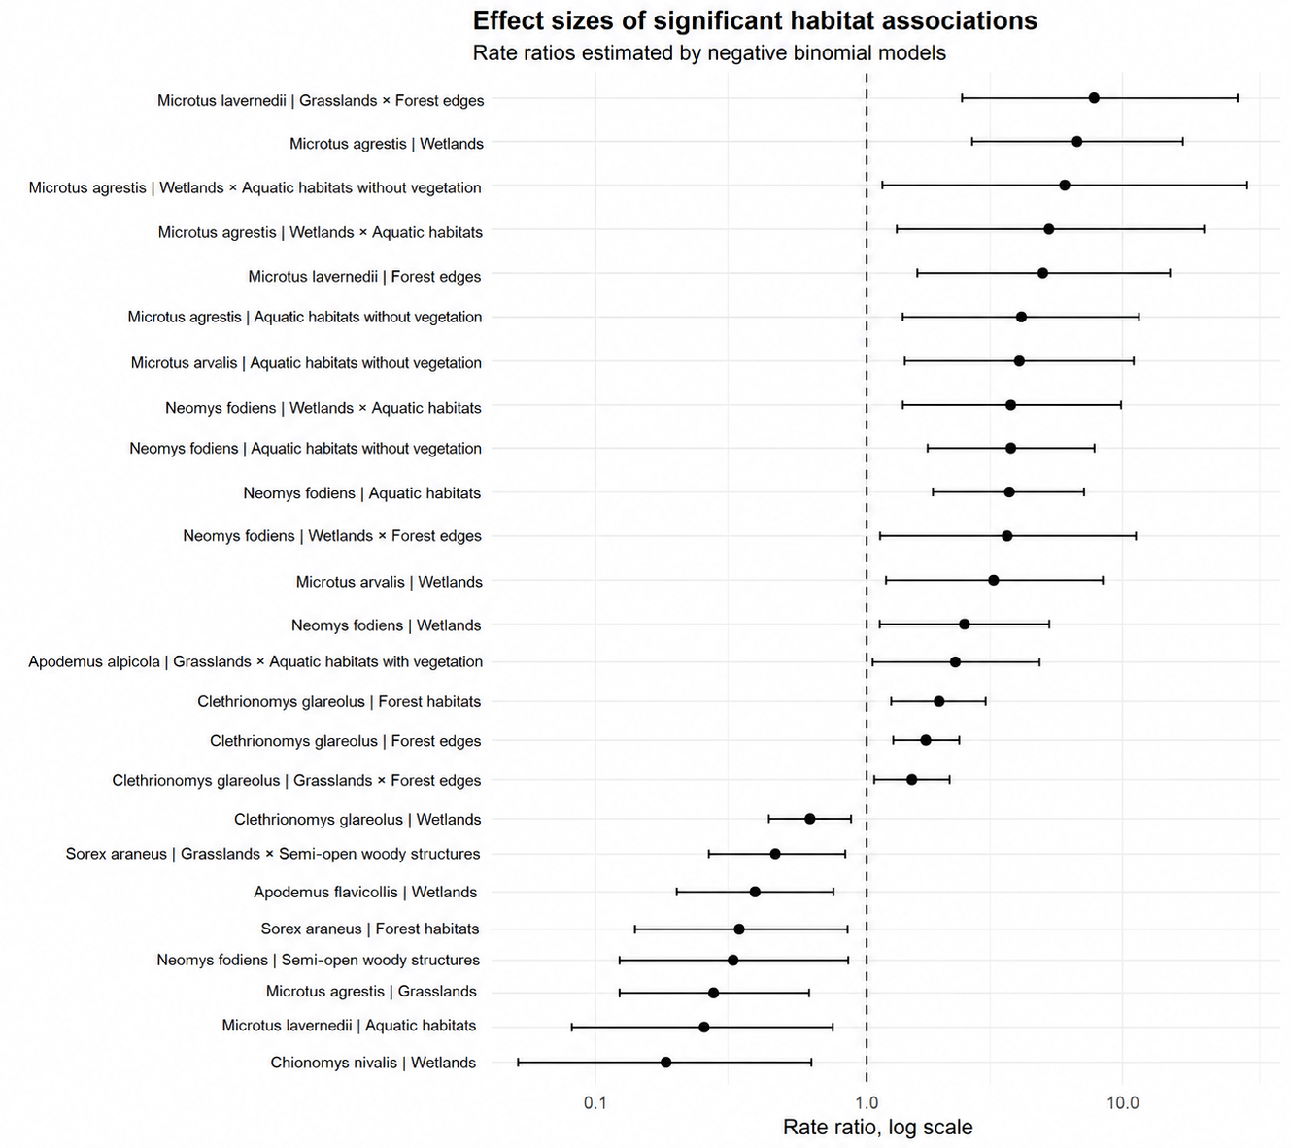
Figure 4. Effect sizes of significant habitat associations. Points represent rate ratios estimated by negative binomial models, and horizontal bars represent 95% confidence intervals. The dashed vertical line indicates no effect.

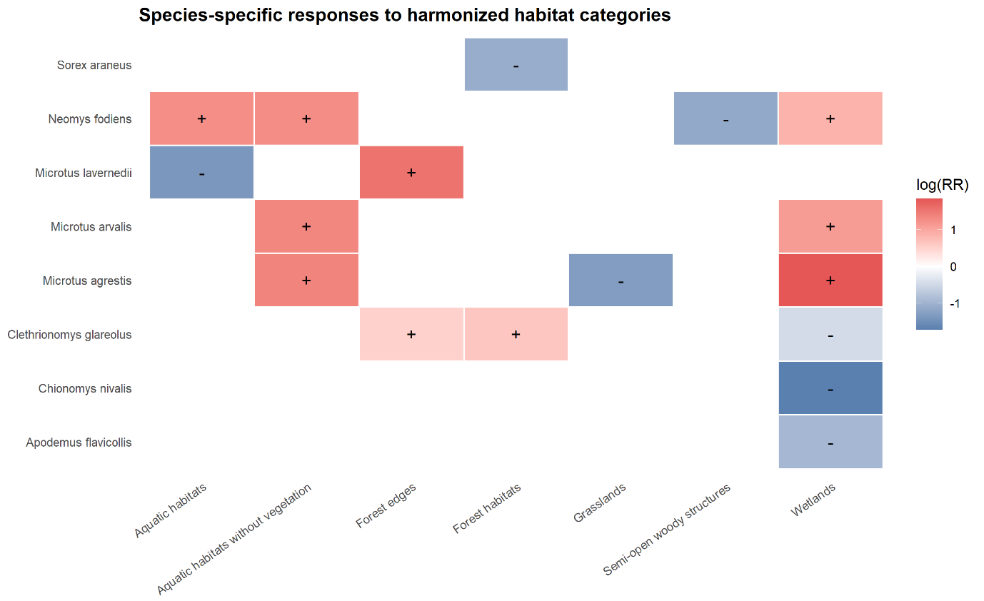
Figure 5. Species-specific responses to harmonized habitat categories. Positive and negative significant associations between species abundance and harmonized habitat categories.

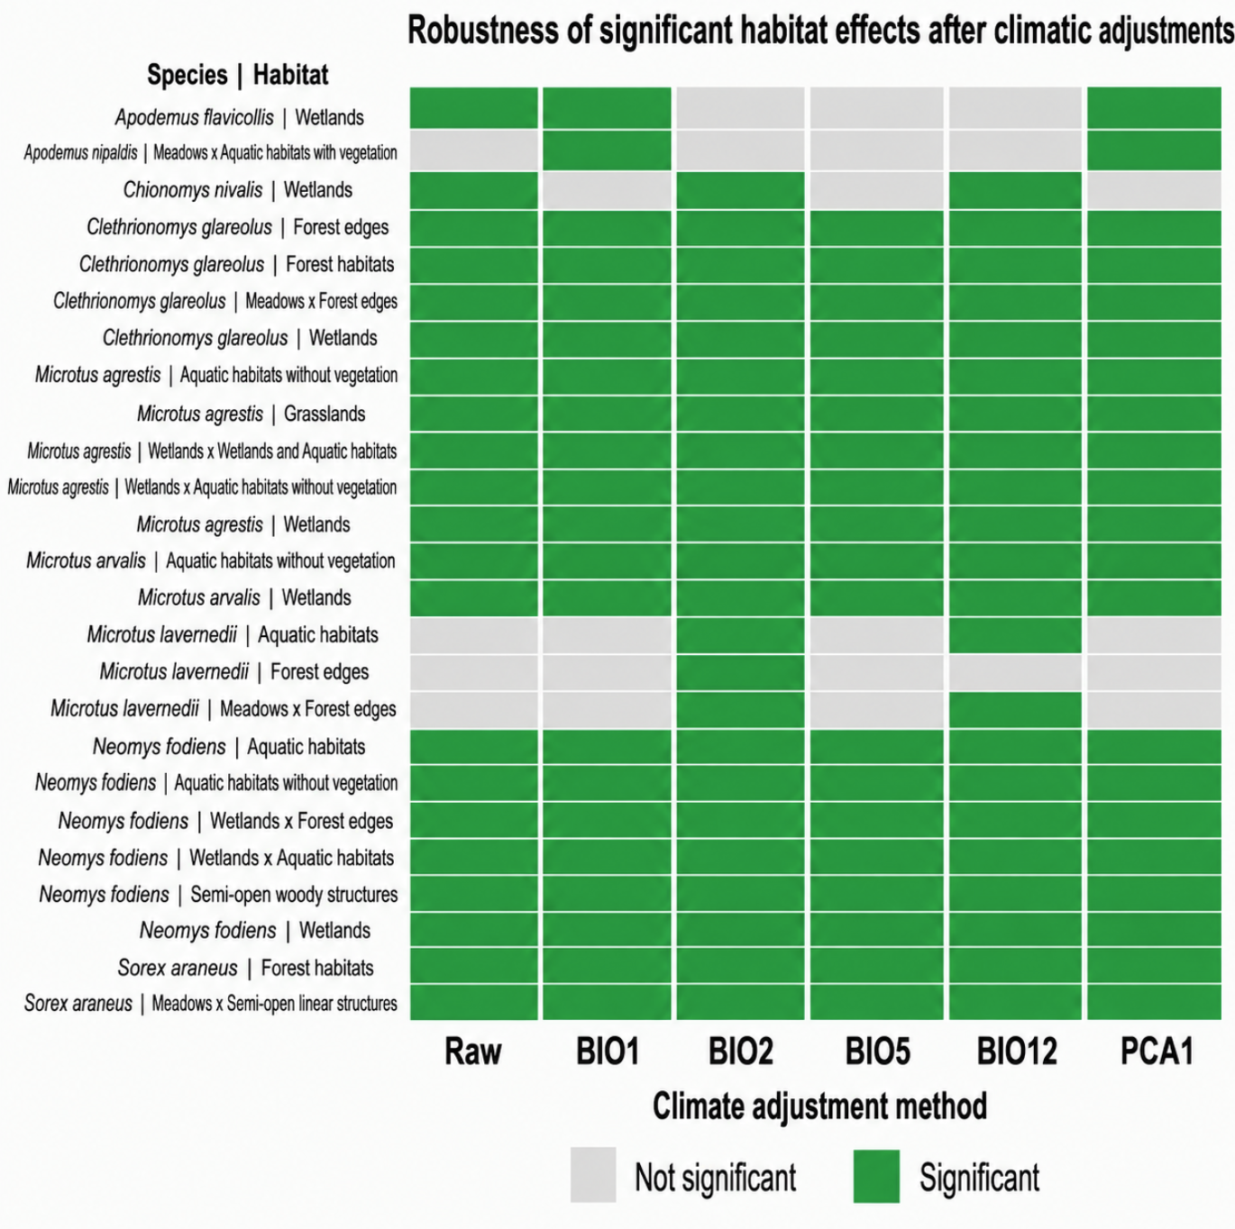
Figure 6. Robustness of significant habitat effects after climatic adjustment. Each row represents a significant habitat effect. Filled cells indicate that the effect remained significant in the raw model or after adjustment for the corresponding climatic variable. Climatic covariates were introduced separately.

5. Discussion
The results show a differentiated answer from micromammals regarding the composition of the mountain agricultural environment. Overall, three main points emerge from our analyses. The first one is the importance of wetlands, that appear to be favourable for some species but disadvantageous for others. The second is the importance of aquatic habitats, especially for aquatic habitats without vegetation, that stand out for multiple species. A third important point is that several significant effects are not linked to typologies or structures considered separately, but to their combination. This is particularly relevant because it shows that some species respond too to local ecological configurations rather than broad habitat categories alone. In this study, combinations such as Grasslands x Aquatic habitats with vegetation, Grasslands x Forest edges, Wetlands x Aquatic habitats, or Wetlands x Forest edges provide additional ecological information and help identify more precise habitat contexts associated with abundance.

5.1. Contrast between wetlands, forests, and grasslands
The most notable result is the character non unanimous of the wetlands. They are associated positively with the abundance of M. agrestis, M. arvalis and N. fodiens, but negatively with C. nivalis and C. glareolus. Hence, the wetlands can’t be considered as globally favourable or unfavourable to all small mammals. Indeed, they favour some species and disadvantage some others.
With M. agrestis and M. arvalis, the results showing a positive association for abundance with wetlands. This interpretation is strengthened, in the case of M. agrestis, by the negative effect on abundance of grassland and by the combinations that highlights the preferences for the aquatic elements (wetlands and aquatic habitats). This suggests that the species is not simply favoured by open habitats, but rather by open habitats that include a wetland or aquatic component. Hence, grassland alone does not appear to provide the same ecological suitability as wetland contexts associated with aquatic structures.
In the N. fodiens, the positive effect of wetlands is also observed. The results are not limited to the wetlands and continue with the aquatic structures and with the combinations between wetlands and aquatic structures. The results show that this species depends on wet environments and needs to be close to the water.
On the opposite, the negative associations between wetlands and the abundance of C. glareolus and C. nivalis suggest that these environments represent less favourable contexts for these species. With those species, this result is particularly convincing because we observed a positive effect of forest habitats and forest edges, and a negative effect on abundance of wetlands. This result shows an opposition between wetlands and related forest habitat.

5.2. The contribution of local structures
The results also show that local structures provide in multiple case valuable ecological information. The typology is not always the only reason explaining the abundance of micromammals species. The locally structure plays an important role too. This point is well illustrated by A. alpicola. For this species, no robust effects were detected when typologies or structures were considered separately, whereas the combination of Grasslands x Aquatic habitats with vegetation was positively associated with abundance. This suggests that the species may respond to a mixed ecological configuration, combining an open grassland environment with a locally vegetated aquatic structure. The result supports the relevance of analysing typology and structure combinations, because some habitat associations only become visible at this combined level. In M. arvalis, the second hierarchical pass suggests that both streams without vegetation and torrents without vegetation may contribute to the broader effect detected for aquatic habitats without vegetation. However, these fine-level effects appear after climatic adjustment. They shouldn’t be interpreted as strong evidence. In N. fodiens, the positive association with Wetlands x Forest edges shows that the species is not only linked to strictly aquatic structures. Transitional zones between wetlands and forest habitats may also provide favourable conditions.
For C. glareolus, forest edges stand out as a robust element, consistent with the positive effects observed for forest habitats. This finding suggests that the species responds positively not only to presence of a forest environment in the broad sense, but also to the presence of transition area between forest and more open habitats. Forest edges can be favourable for a species with an affinity for forest habitats. The positive association with the combination Grasslands x Forest edges further strengthens this interpretation. It indicates that forest edges may increase the ecological value of grassland dominated environment for C. glareolus. Thus, the favourable result is not restricted to forest habitats in the strict sense but also concerns forest edges within open agricultural landscapes.
For M. agrestis, M. arvalis and N. fodiens, a structure is the one of aquatic environment without vegetation. For Microtus agrestis and Microtus arvalis, this structure reflects a strong affinity for humid environment, combining wetlands and aquatic elements. For N. fodiens, the ecological context is clearly aquatic, with a higher abundance in wetlands and aquatic environment, and we can observe an affinity for forest edges.

5.3. What does the second hierarchical pass teach us?
The second hierarchical pass tries to respond to the following question: When a broader harmonized category statistically stands out in the first analysis, is the category related to a particular subcategory? The results obtained show that, in most cases, the answer is negative (Table 2). This shows that the harmonized level corresponds to the level at which the statistical result is the most clearly detectable. For M. lavernedii, the main analysis did not reveal a very clear robust effect at the harmonized level. The second pass on the structures show that the effect associated with forest edges is in fact more specifically made by coniferous forest edges. This result shows that the second pass can sometimes provide more ecological precision. A weaker effect also emerges for M. arvalis after climatic adjustment, indicating that the second hierarchical level may still provide complementary ecological information.
Species | Analysis level | Parent category | Fine categories with detected effect | Summary
Apodemus flavicollis (Yellow-necked mouse) | Typology  second pass | Wetlands | None | No fine-level effect detected
Chionomys nivalis | Typology  second pass | Wetlands | None | No fine-level effect detected
Clethrionomys glareolus | Structure second pass | Forest edges | None | No fine-level effect detected
Clethrionomys glareolus | Typology  second pass | Forest habitats | None | No fine-level effect detected
Clethrionomys glareolus | Typology  second pass | Wetlands | None | No fine-level effect detected
Microtus agrestis | Structure second pass | Aquatic habitats without vegetation | None | No fine-level effect detected
Microtus agrestis | Typology  second pass | Wetlands | None | No fine-level effect detected
Microtus arvalis | Structure second pass | Aquatic habitats without vegetation | Stream (without vegetation); Torrent (without vegetation) | Fine-level effect visible only after adjustment
Microtus arvalis | Typology  second pass | Wetlands | None | No fine-level effect detected
Microtus lavernedii | Structure second pass | Forest edges | Forest edges (coniferous) | At least one robust fine-level effect
Neomys fodiens | Structure second pass | Aquatic habitats without vegetation | None | No fine-level effect detected
Sorex araneus | Typology  second pass | Forest habitats | None | No fine-level effect detected
Table 2. Summary of the second hierarchical pass

5.4. Species with no robust signal: no effect or no statistical power?
Several species, such as A. sylvaticus and S. antinorii, do not show any robust statistical effect. A. flavicollis only shows a weak result after climatic adjustment. This absence of result should not be necessarily interpreted as an absence of relation to the environment. It can reflect a statistical power insufficient to detect some differences regarding the typologies or structures. This can come from an insufficient amount of data. A. flavicollis shows an intermediate situation. No robust effect is detected in the raw model, which means that the most frequently occupied habitats remain mainly descriptive. However, wetlands show a negative association after adjustment for BIO1 and PCA1. This result should not be interpreted as a robust habitat effect, because it appears only after climatic adjustment. It suggests that part of the preferred habitat may be linked to climatic gradients.

5.5. Limitations of the analysis
Several limitations should be considered in the interpretation of these results. The first one concerns the scarcity of some species or some categories. When numbers become low, especially at the detailed level, the statistical power reduces. This explains why several strong statistically significant results at the harmonized level doesn’t hold in the second hierarchical level. Furthermore, as mentioned earlier, some cells in the Excel document remained empty, so I had to enter them manually based on data from the map.geo.admin.ch website and aerial photos, which Increased the risk of error compared to being on-site with experts. The final point, which is also related to the empty cells that had to be entered manually, concerns the temporary discrepancy between the year the small mammals were captured and the year the satellite images were taken. Some captures date back ten years, while the satellite images are more recent. The situation may have changed between those two points in time, but I have no way of knowing.

5.6. Ecological and management implications
Several ecological implications stand out. On one side, the results suggest that the mountain landscapes should not be considered as homogenous from the point of view of the micromammals. Some components of the landscape, in particular the wetlands, forest edges and aquatic structures, play a more important roe than other in the organisation of the abundances. On the other side, the varying responses among species show that no single management measure can be considered universally beneficial for the entire community. For example, promoting the intensification of wetlands could advantage some species, such as M.agrestis, M. arvalis and N. fodiens, but could disadvantage to other species, such as C. glareolus or C. rivalis. Similarly, the conservation or maintenance of forest edges appears particularly important for certain species related to forest habitats, but it is not the best solution for the entire species community. Hence, these results therefore support a management approach based on landscape heterogeneity.

5.7. A review of the assumptions made in the introduction
The results make it possible to respond to the three hypotheses formulated in the introduction. Overall, the hypotheses are supported, but not in a uniform way across all species.
The first hypothesis supposed that the wetlands or the aquatic environments, favour particularly the species related to humidity and aquatic environments and are not necessarily favourable to all species. Globally, this hypothesis has been confirmed. The results obtained for M. agrestis, M. arvalis and N. fodiens point in that direction: for those species, wetlands, aquatic structures without vegetation and some combinations between humid typologies and aquatic structures are associated to higher abundance. The case of N. fodiens is particularly convincing, because many statistically significant results related to abundance were associated with humid and aquatic contexts. Wetlands are negatively associated with abundance in C. glareolus and C. nivalis. In addition, A. flavicollis shows a weaker negative effect after climatic adjustment. These results indicate that wet and aquatic environments do not act as universally favourable habitats.
The second hypothesis is that the forest habitats and forest edges must advantage forest species and disadvantage some others. The results are as expected, but only partially so. For C. glareolus, the results are statistically significant and clear: the forest habitats such as forest edges are positively associated to abundance, and this effect remains unchanged after climate adjustment. The positive combination between grassland and forest edges strengthens even more this interpretation. M. lavernedii provides an interesting result too. Forest edges and the combination Grasslands x Forest edges become significant only after climatic adjustment, and the second hierarchical pass suggests that this response is mainly connected to coniferous forest edges. This result supports the hypothesis only partly, because the result is not robust in the raw model, but it still suggests a possible affinity for structured forest-edge habitats. The second hypothesis is therefore supported for C. glareolus and partly for M. lavernedii, but not for all species. This hypothesis must also be nuanced by the result obtained for S. araneus. In this species, forest habitats are negatively associated with abundance, and this effect remains significant after climatic adjustment. Hence, forest related categories do not have a uniformly positive effect through the community. The hypothesis is strongly supported for C. glareolus, partly supported for M. lavernedii, but not supported for all species.
The third hypothesis said that the associations between habitat variables and abundance would remain detectable after considering BIO1, BIO2, BIO5, BIO12 and PCA1. Overall, this hypothesis is well supported by our results. Many statistically significant results in the analyses stay unchanged after adjustment. This is the case for the wetland for some species, or the forest habitats and forest edges for C. glareolus, or even aquatic structures without vegetation for M. agrestis, M. arvalis and N. fodiens. However, the interpretation should remain cautious for effects that are visible only after adjustment, such as those observed in A. flavicollis and M. lavernedii. These effects are informative, but they are weaker than effects that are already significant in the raw model and remain significant after adjustment.

6. Conclusion
This study shows that the mountain environment does not influences the abundance of small mammals homogenously, but the different facets of the mountain habitat greatly influence the presence or absence of different species. The results highlight the important role of several compositions of the landscapes, particularly the wetlands, aquatic structures, forest habitats and forest edges. However, these factors don’t affect the entire community in the same way. Firstly, wetlands and aquatic structures seem particularly favourable to several species, in particular M. agrestis, M. arvalis and N. fodiens. On the opposite, they are less favourable, even unfavourable to other species such as C. glareolus or C. nivalis. Then, forest habitats and forest edges are important for some species in particular for C. glareolus, and more cautiously for M. lavernedii for the coniferous forest edges. Finally, several results persist after the adjustment of climatical variables, which means that the relations observed are not explained only by a climatic gradient, but also due to the specific influence of local typologies and structures. However, effects that appeared only after climatic adjustment should be interpreted more cautiously, as they are less robust than effects already significant in the raw models. The results also show that some ecological relationship become visible only when typologies and local structures are considered together, as showed by combinations such as Grasslands x Aquatic habitats with vegetation for Apodemus alpicola. Other combinations, such as Grasslands x Forest edges, Wetlands x Aquatic habitats and Wetlands x Forest edges, also show that local ecological configurations can provide information that is not visible when typologies or structures are analysed separately.
This master thesis suggest that the results do not point a single habitat type or structure that should be favoured everywhere, but rather the importance of having diversified landscape. Wetlands, aquatic structures and forest edges appear to be important components for maintaining a diversity of favourable ecological contexts. However, the contrasted responses observed among species show that no single management recommendation can be considered universally positive for the whole micromammal community.
This study supports the idea that the biodiversity of small mammals in the mountains is influenced by the agricultural environment, but through relationships that depend on the combination of habitat type, local structure, and climatic conditions. This complexity reminds us that a deep comprehension of micromammals requires thinking on multiple levels simultaneously. In this perspective, preserving heterogeneous mountain agricultural landscapes appears essential for maintaining the species and functional diversity of these communities over the long term.

Bibliography
Aschwanden, J., Holzgang, O., & Jenni, L. (2007). Importance of ecological compensation areas for small mammals in intensively farmed areas. Wildlife Biology, 13(2), 150–158. https://doi.org/10.2981/0909-6396(2007)13[150:IOECAF]2.0.CO;2
Balčiauskas, L., Čepukienė, A., & Balčiauskienė, L. (2017). Small mammal community response to early meadow–forest succession. Forest Ecosystems, 4, 11. https://doi.org/10.1186/s40663-017-0099-6
Benedek, A. M., Sîrbu, I., & Lazăr, A. (2021). Responses of small mammals to habitat characteristics in Southern Carpathian forests. Scientific Reports, 11, 12031. https://doi.org/10.1038/s41598-021-91488-6
Boyce, M. S., MacKenzie, D. I., Bryan F. J. Manly, Haroldson, M. A., & Moody, D. (2001). Negative Binomial Models for Abundance Estimation of Multiple Closed Populations. The Journal of Wildlife Management, 65(3), 498–509. https://doi.org/10.2307/3803103
Broughton, R. K., Shore, R. F., Heard, M. S., Amy, S. R., Meek, W. R., Redhead, J. W., Turk, A., & Pywell, R. F. (2014). Agri-environment scheme enhances small mammal diversity and abundance at the farm-scale. Agriculture, Ecosystems & Environment, 192, 122–129. https://doi.org/10.1016/j.agee.2014.04.009
Čepelka, L., & Dokulilová, M. (2025). Ecological roles and forest management implications of small terrestrial mammals in temperate and boreal forests—A review. Forests, 16(6), 994. https://doi.org/10.3390/f16060994
Chirichella, R., Ricci, E., Armanini, M., Gobbi, M., Mustoni, A., & Apollonio, M. (2022). Small mammals in a mountain ecosystem: The effect of topographic, micrometeorological, and biological correlates on their community structure. Community Ecology, 23(3), 289–299. https://doi.org/10.1007/s42974-022-00104-8
de la Huerta-Schliemann, L., Vilella, M., Freixas, L., & Torre, I. (2025). Effects of climate and land use on the population dynamics of the bank vole (Clethrionomys glareolus) in the southernmost part of its range. Animals, 15(6), 839. https://doi.org/10.3390/ani15060839
Deitloff, J., Falconer, C. M., & Vucetich, J. A. (2010). Correlating small mammal abundance to climatic variation over twenty years. Journal of Mammalogy, 91(1), 193–199. https://doi.org/10.1644/08-MAMM-A-267R.1
Dorigo, L., Boscutti, F., & Sigura, M. (2021). Landscape and microhabitat features determine small mammal abundance in forest patches in agricultural landscapes. PeerJ, 9, e12306. https://doi.org/10.7717/peerj.12306
Fick, S. E., & Hijmans, R. J. (2017). WorldClim 2: New 1-km spatial resolution climate surfaces for global land areas. International Journal of Climatology, 37(12), 4302–4315.
Glueck, D. H., Mandel, J., Karimpour-Fard, A., Hunter, L., & Muller, K. E. (2008). Exact calculations of average power for the Benjamini-Hochberg procedure. The international journal of biostatistics, 4(1), 11. https://doi.org/10.2202/1557-4679.1103
Godó, L., Valkó, O., Borza, S., & Deák, B. (2022). A global review on the role of small rodents and lagomorphs (clade Glires) in seed dispersal and plant establishment. Global Ecology and Conservation, 33, e01982. https://doi.org/10.1016/j.gecco.2021.e01982
Greenwood, A., Churchfield, S., & Hickey, C. (2002). Geographical distribution and habitat occurrence of the water shrew (Neomys fodiens) in the Weald of South-East England. Mammal Review, 32(1), 40–50. https://doi.org/10.1046/j.1365-2907.2002.00099.x
Heroldová, M., Bryja, J., Zejda, J., & Tkadlec, E. (2007). Structure and diversity of small mammal communities in agriculture landscape. Agriculture, Ecosystems & Environment, 120(2–4), 206–210. https://doi.org/10.1016/j.agee.2006.09.007
Hilbe, J. M. (2011). Negative binomial regression (2nd ed.). Cambridge University Press.
Kauer, L., Imholt, C., Jacob, J., & Kuehn, R. (2025). Assessing the effects of land-use intensity on small mammal community composition and genetic variation in Myodes glareolus and Microtus arvalis across grassland and forest habitats. Landscape Ecology, 40, 1. https://doi.org/10.1007/s10980-024-02021-9
Kratschmer, S., Hauer, J., Zaller, J. G., Dürr, A., & Weninger, T. (2024). Hedgerow structural diversity is key to promoting biodiversity and ecosystem services: A systematic review of Central European studies. Basic and Applied Ecology, 78, 28–38. https://doi.org/10.1016/j.baae.2024.04.010
Marshall, E. J. P., & Moonen, A. C. (2002). Field margins in northern Europe: Their functions and interactions with agriculture. Agriculture, Ecosystems & Environment, 89(1–2), 5–21. https://doi.org/10.1016/S0167-8809(01)00315-2
Paniccia, C., Carranza, M. L., Frate, L., Di Febbraro, M., Rocchini, D., & Loy, A. (2022). Distribution and functional traits of small mammals across the Mediterranean area: Landscape composition and structure definitively matter. Ecological Indicators, 135, 108550. https://doi.org/10.1016/j.ecolind.2022.108550
Renwick, A. R., & Lambin, X. (2011). Abundance thresholds and the underlying ecological processes: Field voles Microtus agrestis in a fragmented landscape. Agriculture, Ecosystems & Environment, 144(1), 364–369. https://doi.org/10.1016/j.agee.2011.10.006
Rodríguez-Pastor, R., Luque-Larena, J. J., Lambin, X., & Mougeot, F. (2016). “Living on the edge”: The role of field margins for common vole (Microtus arvalis) populations in recently colonised Mediterranean farmland. Agriculture, Ecosystems & Environment, 231, 206–217. https://doi.org/10.1016/j.agee.2016.06.041
Schlinkert, H., Ludwig, M., Batáry, P., Holzschuh, A., Kovács-Hostyánszki, A., Tscharntke, T., & Fischer, C. (2016). Forest specialist and generalist small mammals in forest edges and hedges. Wildlife Biology, 22(3), 86–94. https://doi.org/10.2981/wlb.00176
Shilereyo, M. T., Magige, F. J., Ogutu, J. O., & Røskaft, E. (2023). Small-mammal abundance and species diversity: Land use and seasonal influences in the Serengeti Ecosystem, Tanzania. Frontiers in Conservation Science, 4, 981424. https://doi.org/10.3389/fcosc.2023.981424
Torre, I., Jaime-González, C., & Díaz, M. (2022). Habitat suitability for small mammals in Mediterranean landscapes: How and why shrubs matter. Sustainability, 14(3), 1562. https://doi.org/10.3390/su14031562
Torre, I., Requejo, A., Arrizabalaga, A., & Baucells, J. (2024). Disentangling the effects of climate and land uses on small mammals in agroecosystems of NE Spain. Diversity, 16(6), 343. https://doi.org/10.3390/d16060343
van der Putten, T. A. W., Verhees, J. J. F., Koma, Z., van Hoof, P. H., Heijkers, D., de Boer, W. F., Esser, H. J., Hoogerwerf, G., & Lemmers, P. (2025). Insights into the fine-scale habitat use of Eurasian water shrew (Neomys fodiens) using radio tracking and LiDAR. Journal of Mammalogy, 106(3), 549–560. https://doi.org/10.1093/jmammal/gyae146
WWF France. (2024). Rapport Planète Vivante 2024. https://www.wwf.fr/sites/default/files/doc-2024-10/Rapport%20Planete%20Vivante%202024%20-%20WWF%20France.pdf

Appendix

Species | Analysis level | Category | Conclusion | Raw | BIO1 | BIO2 | BIO5 | BIO12 | PCA1
Apodemus alpicola (Alpine field mouse) | Typology × structure | Grasslands × Aquatic habitats with vegetation | Robust effect | Yes; RR=2.17; qBH=0.0395 | Yes; RR=2.10; qBH=0.0395 | Yes; RR=2.17; qBH=0.0395 | Yes; RR=2.13; qBH=0.0395 | Yes; RR=2.27; qBH=0.0395 | Yes; RR=2.24; qBH=0.0395
Apodemus flavicollis (Yellow-necked mouse) | Typology | Wetlands | Visible after adjustment | No | Yes; RR=0.39; qBH=0.0179 | No | No | No | Yes; RR=0.39; qBH=0.0179
Chionomys nivalis (Snow vole) | Typology | Wetlands | Robust effect | Yes; RR=0.18; qBH=0.0216 | No | Yes; RR=0.17; qBH=0.0216 | No | Yes; RR=0.19; qBH=0.0283 | No
Clethrionomys glareolus (Bank vole) | Structure | Forest edges | Robust effect | Yes; RR=1.68; qBH=<0.001 | Yes; RR=1.65; qBH=<0.001 | Yes; RR=1.72; qBH=<0.001 | Yes; RR=1.65; qBH=<0.001 | Yes; RR=1.70; qBH=<0.001 | Yes; RR=1.65; qBH=<0.001
Clethrionomys glareolus (Bank vole) | Structure, overall aquatic level | Forest edges | Robust effect | Yes; RR=1.68; qBH=<0.001 | Yes; RR=1.65; qBH=<0.001 | Yes; RR=1.72; qBH=<0.001 | Yes; RR=1.65; qBH=<0.001 | Yes; RR=1.70; qBH=<0.001 | Yes; RR=1.65; qBH=<0.001
Clethrionomys glareolus (Bank vole) | Typology | Forest habitats | Robust effect | Yes; RR=1.90; qBH=0.0076 | Yes; RR=1.85; qBH=0.0076 | Yes; RR=1.87; qBH=0.0076 | Yes; RR=1.79; qBH=0.0089 | Yes; RR=1.87; qBH=0.0076 | Yes; RR=1.84; qBH=0.0076
Clethrionomys glareolus (Bank vole) | Typology | Wetlands | Robust effect | Yes; RR=0.63; qBH=0.0103 | Yes; RR=0.57; qBH=0.0032 | Yes; RR=0.65; qBH=0.0147 | Yes; RR=0.58; qBH=0.0032 | Yes; RR=0.66; qBH=0.0212 | Yes; RR=0.57; qBH=0.0032
Clethrionomys glareolus (Bank vole) | Typology × structure | Grasslands × Forest edges | Robust effect | Yes; RR=1.47; qBH=0.0257 | Yes; RR=1.47; qBH=0.0257 | Yes; RR=1.46; qBH=0.0257 | Yes; RR=1.47; qBH=0.0257 | Yes; RR=1.44; qBH=0.0264 | Yes; RR=1.48; qBH=0.0257
Clethrionomys glareolus (Bank vole) | Typology × structure, overall aquatic level | Grasslands × Forest edges | Robust effect | Yes; RR=1.47; qBH=0.0257 | Yes; RR=1.47; qBH=0.0257 | Yes; RR=1.46; qBH=0.0257 | Yes; RR=1.47; qBH=0.0257 | Yes; RR=1.44; qBH=0.0264 | Yes; RR=1.48; qBH=0.0257
Microtus agrestis (Field vole) | Structure | Aquatic habitats without vegetation | Robust effect | Yes; RR=3.96; qBH=0.0094 | Yes; RR=4.55; qBH=0.0031 | Yes; RR=4.36; qBH=0.0074 | Yes; RR=4.58; qBH=0.0031 | Yes; RR=3.58; qBH=0.0075 | Yes; RR=4.47; qBH=0.0031
Microtus agrestis (Field vole) | Typology | Wetlands | Robust effect | Yes; RR=6.27; qBH=<0.001 | Yes; RR=4.58; qBH=<0.001 | Yes; RR=5.81; qBH=<0.001 | Yes; RR=4.89; qBH=<0.001 | Yes; RR=6.23; qBH=<0.001 | Yes; RR=5.10; qBH=<0.001
Microtus agrestis (Field vole) | Typology | Grasslands | Robust effect | Yes; RR=0.27; qBH=0.0067 | Yes; RR=0.37; qBH=0.0145 | Yes; RR=0.29; qBH=0.0072 | Yes; RR=0.35; qBH=0.0113 | Yes; RR=0.28; qBH=0.0059 | Yes; RR=0.34; qBH=0.0105
Microtus agrestis (Field vole) | Typology × structure | Wetlands × Aquatic habitats without vegetation | Robust effect | Yes; RR=5.61; qBH=0.0329 | Yes; RR=4.66; qBH=0.0318 | Yes; RR=6.19; qBH=0.0318 | Yes; RR=5.51; qBH=0.0318 | Yes; RR=4.33; qBH=0.0329 | Yes; RR=4.96; qBH=0.0318
Microtus agrestis (Field vole) | Typology × structure, overall aquatic level | Wetlands × Aquatic habitats | Robust effect | Yes; RR=4.97; qBH=0.0307 | Yes; RR=3.54; qBH=0.0319 | Yes; RR=5.58; qBH=0.0307 | Yes; RR=4.23; qBH=0.0307 | Yes; RR=3.51; qBH=0.0319 | Yes; RR=3.72; qBH=0.0307
Microtus arvalis (Common vole) | Structure | Aquatic habitats without vegetation | Robust effect | Yes; RR=3.83; qBH=0.0128 | Yes; RR=3.57; qBH=0.0128 | Yes; RR=3.59; qBH=0.0128 | Yes; RR=3.53; qBH=0.0128 | Yes; RR=3.52; qBH=0.0128 | Yes; RR=3.63; qBH=0.0128
Microtus arvalis (Common vole) | Typology | Wetlands | Robust effect | Yes; RR=3.05; qBH=0.0263 | Yes; RR=4.10; qBH=0.0078 | Yes; RR=3.83; qBH=0.0078 | Yes; RR=4.61; qBH=0.0052 | Yes; RR=2.74; qBH=0.0465 | Yes; RR=4.86; qBH=0.0052
Microtus lavernedii (Lavernede's vole) | Structure | Forest edges | Visible after adjustment | No | No | Yes; RR=4.70; qBH=0.0365 | No | No | No
Microtus lavernedii (Lavernede's vole) | Structure, overall aquatic level | Forest edges | Visible after adjustment | No | No | Yes; RR=4.70; qBH=0.0365 | No | No | No
Microtus lavernedii (Lavernede's vole) | Structure, overall aquatic level | Aquatic habitats | Visible after adjustment | No | No | Yes; RR=0.25; qBH=0.0470 | No | Yes; RR=0.26; qBH=0.0470 | No
Microtus lavernedii (Lavernede's vole) | Typology × structure | Grasslands × Forest edges | Visible after adjustment | No | No | Yes; RR=7.77; qBH=0.0057 | No | Yes; RR=6.01; qBH=0.0097 | No
Microtus lavernedii (Lavernede's vole) | Typology × structure, overall aquatic level | Grasslands × Forest edges | Visible after adjustment | No | No | Yes; RR=7.77; qBH=0.0057 | No | Yes; RR=6.01; qBH=0.0097 | No
Neomys fodiens (Eurasian water shrew) | Structure | Aquatic habitats without vegetation | Robust effect | Yes; RR=3.60; qBH=0.0011 | Yes; RR=3.57; qBH=0.0011 | Yes; RR=3.42; qBH=0.0012 | Yes; RR=3.59; qBH=0.0011 | Yes; RR=3.59; qBH=0.0011 | Yes; RR=3.58; qBH=0.0011
Neomys fodiens (Eurasian water shrew) | Structure, overall aquatic level | Aquatic habitats | Robust effect | Yes; RR=3.56; qBH=<0.001 | Yes; RR=3.53; qBH=<0.001 | Yes; RR=3.57; qBH=<0.001 | Yes; RR=3.57; qBH=<0.001 | Yes; RR=3.50; qBH=<0.001 | Yes; RR=3.56; qBH=<0.001
Neomys fodiens (Eurasian water shrew) | Structure, overall aquatic level | Semi-open woody structures | Robust effect | Yes; RR=0.32; qBH=0.0300 | Yes; RR=0.33; qBH=0.0300 | Yes; RR=0.32; qBH=0.0300 | Yes; RR=0.32; qBH=0.0300 | Yes; RR=0.33; qBH=0.0300 | Yes; RR=0.33; qBH=0.0300
Neomys fodiens (Eurasian water shrew) | Typology | Wetlands | Robust effect | Yes; RR=2.36; qBH=0.0431 | Yes; RR=2.32; qBH=0.0449 | Yes; RR=2.50; qBH=0.0431 | Yes; RR=2.52; qBH=0.0431 | Yes; RR=2.28; qBH=0.0449 | Yes; RR=2.43; qBH=0.0431
Neomys fodiens (Eurasian water shrew) | Typology × structure | Wetlands × Forest edges | Robust effect | Yes; RR=3.45; qBH=0.0464 | Yes; RR=3.32; qBH=0.0464 | Yes; RR=3.14; qBH=0.0464 | Yes; RR=3.46; qBH=0.0464 | Yes; RR=3.27; qBH=0.0464 | Yes; RR=3.44; qBH=0.0464
Neomys fodiens (Eurasian water shrew) | Typology × structure, overall aquatic level | Wetlands × Aquatic habitats | Robust effect | Yes; RR=3.61; qBH=0.0113 | Yes; RR=3.56; qBH=0.0113 | Yes; RR=4.30; qBH=0.0113 | Yes; RR=4.00; qBH=0.0113 | Yes; RR=3.51; qBH=0.0113 | Yes; RR=3.79; qBH=0.0113
Sorex araneus (Common shrew) | Typology | Forest habitats | Robust effect | Yes; RR=0.34; qBH=0.0262 | Yes; RR=0.33; qBH=0.0262 | Yes; RR=0.35; qBH=0.0262 | Yes; RR=0.35; qBH=0.0262 | Yes; RR=0.34; qBH=0.0262 | Yes; RR=0.32; qBH=0.0262
Sorex araneus (Common shrew) | Typology × structure, overall aquatic level | Grasslands × Semi-open woody structures | Robust effect | Yes; RR=0.46; qBH=0.0191 | Yes; RR=0.47; qBH=0.0191 | Yes; RR=0.47; qBH=0.0191 | Yes; RR=0.43; qBH=0.0191 | Yes; RR=0.52; qBH=0.0291 | Yes; RR=0.48; qBH=0.0191
Table 3. Climate-adjusted robustness of significant effects

Declaration on generative AI
During the preparation of this thesis, I used ChatGPT (OpenAI) to assist with R coding, including code development, debugging, and clarification of programming procedures. All statistical analyses and figures were performed in R. I reviewed and verified all AI-assisted content and take full responsibility for the final content of this thesis.
The data supporting the results and the code are archived on GitHub (https://github.com/LEF-UNINE/Peterschmitt_Milan_MSc_thesis_2026).

