Computational Workflow for COSMO-RS Solvent Screening of Peptide and Protein Solutes, with Application to Hen Egg-White Lysozyme
Manuscript Methods & Supporting Information (working draft)

1. Workflow Overview
Candidate-solvent screening for the biomolecular solutes proceeds through a fixed four-stage pipeline, two stages of which adapt to molecular size:
- Structure preparation and protonation (pH-dependent charge assignment with PROPKA).
- Geometry pre-optimization (size-tiered: all-electron DFT for small solutes, GFN-FF for protein-scale).
- DFT-COSMO single point yielding a screening-charge surface (.cosmo / σ-profile) per solute.
- COSMO-RS analysis (COSMOtherm) over the candidate-solvent set, ranking solvents by solute–solvent affinity.
Four solutes were treated — bombesin, vancomycin (two conformers), and hen egg-white lysozyme. The last (1963 atoms, net charge +11) is by far the largest and the methodologically limiting case, requiring the basis-set and convergence strategy detailed in Sections 4–5. The three smaller solutes were treated at full def2-TZVPD throughout.
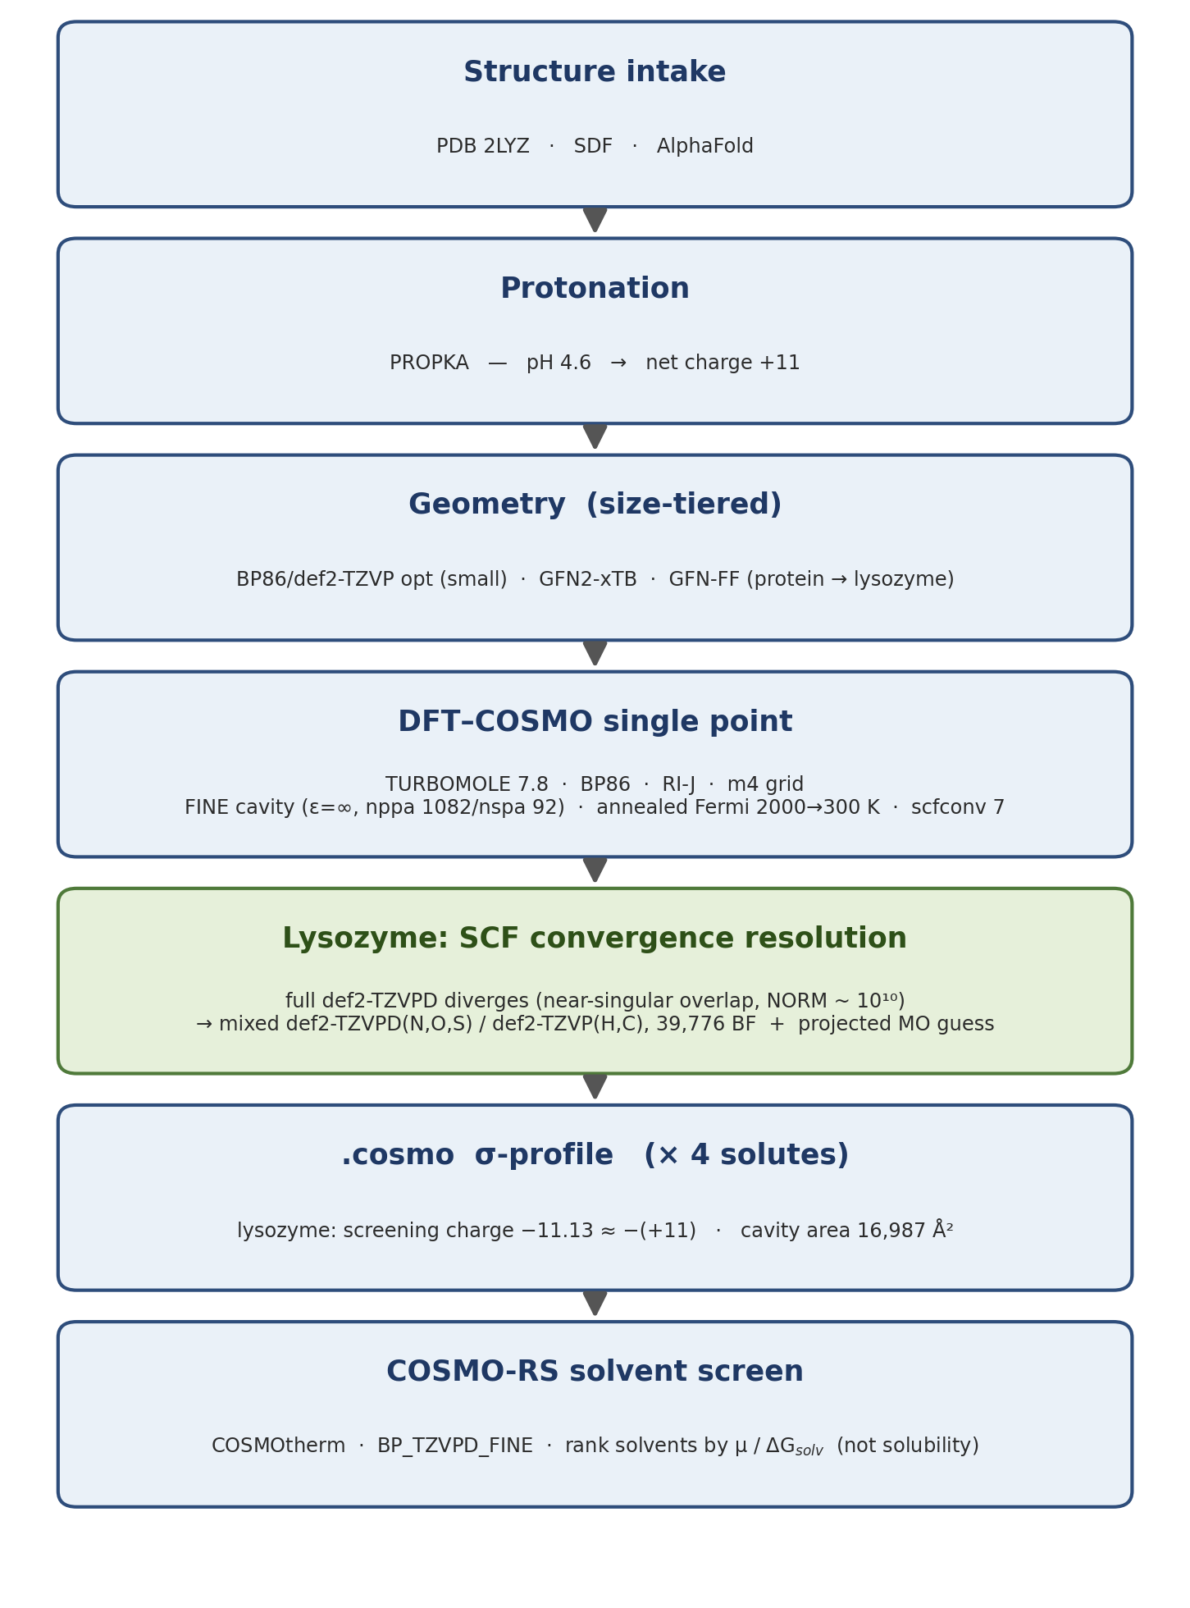
Scheme 1. End-to-end workflow from structure intake to COSMO-RS solvent ranking. Stages adapt to molecular size; the lysozyme-specific SCF-convergence resolution (mixed def2-TZVPD / def2-TZVP basis) is highlighted in green.

2. Structure Preparation and Protonation
Starting coordinates for hen egg-white lysozyme (HEWL; 129 residues, C₆₁₃H₉₆₂N₁₉₃O₁₈₅S₁₀; 1963 atoms) were taken from Protein Data Bank entry 2LYZ. Protonation states were assigned with PROPKA at pH 4.6, giving a net molecular charge of +11 (7620 electrons); OpenBabel was used as a protonation fallback for non-standard residues (e.g. the vancomycin glycopeptide).
Geometry pre-optimization (size-tiered). Because all-electron DFT geometry optimization is feasible only for the smaller solutes, the optimization method was chosen by size: small molecules at BP86/def2-TZVP with COSMO (the standard COSMO-RS preparation), intermediate systems with GFN2-xTB, and protein-scale lysozyme with the GFN-FF force field as implemented in xtb. GFN-FF preserves the experimental fold at a cost where DFT optimization is intractable, consistent with current practice for quantum-chemical treatment of proteins. Each geometry was screened for unphysical close contacts before the single point (lysozyme: minimum non-bonded interatomic distance > 0.9 Å).

3. COSMO Single-Point Calculations
Screening charges were obtained from single-point COSMO calculations in TURBOMOLE 7.8 using the BP86 exchange–correlation functional, the resolution-of-the-identity approximation for the Coulomb term (RI-J), an m4 integration grid, and the conductor-like screening model (COSMO) in the conductor limit (ε = ∞) with the refined (“FINE”) cavity construction (nppa = 1082, nspa = 92; solvent radius r_{solv} = 1.30 Å), consistent with the BP-TZVPD-FINE parameterization used for the subsequent COSMO-RS analysis. The SCF was converged to 10⁻⁷ Eh (scfconv 7). For the highly charged protein, orbital occupations were treated with Fermi smearing on an annealed electronic-temperature schedule (2000 K → 300 K, scaled by 0.95 per SCF cycle) to stabilize the near-degenerate frontier-orbital manifold.

4. Basis Set for Lysozyme
Standard def2-TZVPD could not be converged for lysozyme (Section 5). The production calculation therefore employed a mixed basis: def2-TZVPD on the electronegative heteroatoms (N, O, S) and def2-TZVP on H and C. This retains the diffuse augmentation on the atoms that dominate the COSMO screening surface while removing it from the atoms responsible for the basis-set linear dependence, giving 39,776 basis functions (versus 46,340 for full def2-TZVPD). Converged molecular orbitals from a BP86/def2-TZVP COSMO calculation were projected onto the mixed basis (the use facility of TURBOMOLE’s define) to provide the SCF start vectors.

5. SCF Convergence: Problem and Strategy (Supporting Information)

5.1 The convergence failure and its diagnosis
The full def2-TZVPD SCF for lysozyme diverged catastrophically — density-change norms of order 10¹⁰ and total-energy excursions reaching +1.7×10⁵ Eh — under both constant-temperature (300 K) and annealed (2000→300 K) Fermi-smearing schedules. The instability was traced to near-linear-dependence of the diffuse-augmented def2-TZVPD basis on the densely packed folded protein, i.e. a near-singular atomic-orbital overlap matrix, which the SCF module used (ridft) does not project out.
A controlled test isolated the cause. Starting from one and the same converged density, the SCF converged smoothly in the non-augmented def2-TZVP basis but detonated on the first cycle once the diffuse functions were added: cycle 1 reproduced the def2-TZVP energy exactly (−52,426.6 Eh) and cycle 2 jumped to a density-change norm of ≈10¹⁰. A high-quality projected initial guess therefore could not cure the divergence, confirming that the problem is basis-set conditioning rather than the starting orbitals.

5.2 Resolution by graded basis trimming
Diffuse functions were removed progressively from the atoms contributing most to the linear dependence and least to the COSMO surface. Removing them from hydrogen alone reduced but did not eliminate the instability; additionally removing them from the carbon framework — numerous, dense, and largely nonpolar — restored clean convergence while preserving diffuse augmentation on N, O, and S. The full sequence of attempts is summarized in Table S1.
# | Basis / Fermi schedule | Basis fns | Outcome | Key diagnostic
1 | def2-TZVPD; constant 300 K Fermi | 46,340 | Diverged | +2×10⁵ Eh blow-up; Fermi bracket lost
2 | def2-TZVPD; annealed Fermi (2000→300 K) | 46,340 | Diverged | NORM[dD]≈10¹⁰; E→+1.7×10⁵ Eh by cycle 10
3 | def2-TZVP; annealed Fermi | 36,863 | Converged | −52,426.6 Eh; well-conditioned — reference + MO guess
4 | def2-TZVPD; projected guess from #3 | 46,340 | Diverged | cycle 1 = −52,426.6 Eh; cycle 2 NORM≈10¹⁰ → basis, not guess
5 | Mixed: def2-TZVP(H) / def2-TZVPD(C,N,O,S) | 43,454 | Oscillated | NORM≈10⁷; E swings ±2×10³ Eh
6 | Mixed: def2-TZVP(H,C) / def2-TZVPD(N,O,S) | 39,776 | Converged | −52,426.73 Eh; clean — production
Table S1. SCF convergence attempts for lysozyme (1963 atoms, charge +11) at the BP86 / FINE-COSMO level with annealed Fermi smearing. Diffuse (def2-TZVPD) functions on the dense H/C framework render the AO overlap near-singular; retaining them only on N/O/S yields a well-conditioned, convergent calculation (row 6, production).

5.3 Final converged result and validation
The production calculation — mixed def2-TZVP(H,C)/def2-TZVPD(N,O,S), annealed Fermi smearing, projected start vectors — converged cleanly (ridft reported normal termination). The total energy is −52,426.7266 Eh (−52,426.7106 Eh including the outlying-charge correction). The resulting COSMO surface comprises 20,985 segments over a cavity area of 16,987 Å² and volume 1.039×10⁵ Å³. The total screening charge is −11.13, balancing the +11 molecular charge to within the outlying charge handled by the correction — confirming a physically valid σ-profile suitable for COSMO-RS.

6. COSMO-RS Solvent Screening
The screening-charge surfaces of all four solutes and of the candidate solvents were combined in COSMOtherm using the BP_TZVPD_FINE parameterization. All .cosmo inputs — the solutes and the solvent database (COSMObase) — were used at the matching BP-TZVPD-FINE level, so that every compound entering the calculation shares one consistent quantum-chemical level. The candidate-solvent set comprised water, methanol, ethanol, 1-butanol, 1-octanol, ethylene glycol, glycerol, 1,4-dioxane, tetrahydrofuran, n-heptane, and n-hexane, with multiple conformers per flexible solvent.
Choice of observable. Absolute solubility is not a well-defined COSMO-RS property for a folded protein: the solid-dissolution model requires the solute’s fusion thermodynamics (melting point and heat of fusion, hence ΔG_fus), which do not exist for lysozyme. A solubility calculation consequently returns degenerate values (log₁₀ x → +∞ for solvents with which the solute is miscible and −∞ for the alkanes). Solvent affinity was therefore assessed from the solute’s chemical potential / solvation free energy (µ, ΔG_solv) at infinite dilution, and from partition coefficients between solvent pairs — finite, rankable measures. The qualitative split observed in the degenerate solubility output (polar solvents favourable, aliphatic alkanes unfavourable) is itself consistent with the expected behaviour of a polar, charged solute and confirms the σ-profile is active.
Interpretation and consistency. Relative solvent rankings derived from µ / ΔG_solv are expected to be robust to the quantum-chemical level. Absolute solvation magnitudes for lysozyme should be interpreted with the mixed-basis approximation in mind (Section 4); the three smaller solutes, at full def2-TZVPD, carry no such caveat.

7. Discussion
This workflow reflects the established picture that conventional large-basis DFT is impractical for whole proteins. Schmitz et al. (2020) show that protein structures are best treated with efficient semiempirical (GFN2-xTB) or composite methods, noting that HF and DFT “cannot be applied with reasonably large atomic orbital basis sets” at this scale; correspondingly, whole-structure COSMO-RS on proteins is typically restricted to ≲ 1000 atoms. The convergence collapse of def2-TZVPD for large, dense systems is documented, and a mixed basis that strips diffuse functions from hydrogen is a known remedy. Our graded extension of that strategy — removing diffuse functions from carbon as well — was necessary at 1963 atoms and produces a def2-TZVPD-class σ-profile, with diffuse augmentation retained on the electronegative atoms (N, O, S) that govern the screening surface. Combined with the observable choice in Section 6, the workflow yields physically meaningful, internally consistent solvent rankings for a protein-scale solute that lies beyond the usual range of whole-structure COSMO-RS.

References
[1] A. Klamt, G. Schüürmann, J. Chem. Soc., Perkin Trans. 2 1993, 799 (COSMO).
[2] A. Klamt, J. Phys. Chem. 1995, 99, 2224 (COSMO-RS).
[3] F. Eckert, A. Klamt, AIChE J. 2002, 48, 369 (COSMOtherm).
[4] F. Weigend, R. Ahlrichs, Phys. Chem. Chem. Phys. 2005, 7, 3297 (def2 basis sets).
[5] D. Rappoport, F. Furche, J. Chem. Phys. 2010, 133, 134105 (def2-TZVPD diffuse functions).
[6] S. Spicher, S. Grimme, Angew. Chem. Int. Ed. 2020, 59, 15665 (GFN-FF).
[7] C. Bannwarth, S. Ehlert, S. Grimme, J. Chem. Theory Comput. 2019, 15, 1652 (GFN2-xTB).
[8] S. Schmitz, J. Seibert, K. Ostermeir, A. Hansen, A. H. Göller, S. Grimme, J. Phys. Chem. B 2020, 124, 3636 (QM peptide/protein structures).
[9] M. H. M. Olsson, C. R. Søndergaard, M. Rostkowski, J. H. Jensen, J. Chem. Theory Comput. 2011, 7, 525 (PROPKA).
[10] S. G. Balasubramani et al., J. Chem. Phys. 2020, 152, 184107 (TURBOMOLE).
Note: verify reference formatting and details against the target journal’s style before submission.

