**Merge the weather data and commodity data**

We collected the weather data and commodity data with the help of red.csv function.



We have selected the desired column and formatted date by using ymd function.

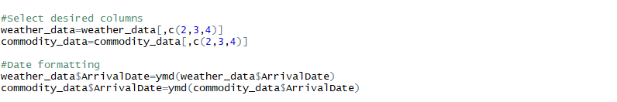

Datatype of RA (Rainfall) column is in the form of character we change it into factor type.



We merged the data (weather data and commodity data) with the help of join function of plyr package.



We exported the file with the help of write.csv.

