Week 1: Data Structures And Algorithms

Exercise 2: E-commerce Platform Search Function
Sol.:
Big O Notation:
The Big O notation describes the upper bound of an algorithm's running time or space requirement in terms of input size n . It helps to evaluate and compare the efficiency of algorithms, especially for large data by providing the time or space required for running an algorithm with respect to the input size n.
For example:
- O(1) – Constant time (fastest)
- O(n) – Linear time (time grows with input size)
- O(log n) – Logarithmic time (fast for large n)
- O(n²) – Quadratic time (slow for large n)
Where n is the input size.

Best, Average, and Worst-Case Scenarios
- Best-case: The best case describes the lowest time/space required by the algorithm.
For example: The desired element is found immediately in an array (e.g., first element).
- Average-case: The average case describes the expected time/space used for a typical input.
For example: The desired element is found somewhere in the middle of the array.
- Worst-case: The worst case describes the highest time/space required by the algorithm.
For example: The desired element is not found or is the last element in the array.

Code:-
import java.util.Arrays;
import java.util.Comparator;
class Product {
int productId;
String productName;
String category;
public Product(int productId, String productName, String category) {
this.productId = productId;
this.productName = productName;
this.category = category;
}

public String toString() {
return productId + " - " + productName + " (" + category + ")";
}
}

public class Main {
public static void main(String[] args) {
Product[] products = {
new Product(1, "Laptop", "Electronics"),
new Product(2, "Smartphone", "Electronics"),
new Product(3, "Tablet", "Electronics"),
new Product(4, "Smartwatch", "Electronics"),
new Product(5, "Bluetooth Speaker", "Electronics"),
new Product(6, "Wireless Mouse", "Accessories"),
};

Product[] sortedProducts = products.clone();
Arrays.sort(sortedProducts, Comparator.comparing(p -> p.productName.toLowerCase()));

Product result1 = linearSearch(products, "Wireless Mouse");
System.out.println("Linear Search Result: " + result1);

Product result2 = binarySearch(sortedProducts, "Wireless Mouse");
System.out.println("Binary Search Result: " + result2);
}

public static Product linearSearch(Product[] products, String name) {
for (Product p : products) {
if (p.productName.equalsIgnoreCase(name)) {
return p;
}
}
return null;
}

public static Product binarySearch(Product[] products, String name) {
int left = 0, right = products.length - 1;
name = name.toLowerCase();
while (left <= right) {
int mid = (left + right) / 2;
String midName = products[mid].productName.toLowerCase();
if (midName.equals(name)) return products[mid];
if (midName.compareTo(name) < 0) left = mid + 1;
else right = mid - 1;
}
return null;
}
}

- Output
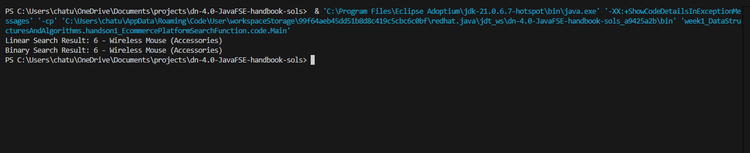

- Time Complexity comparison
- Linear Search
- Best Case - O(1)
- Average Case - O(n)
- Worst Case - O(n)
- Binary Search
- Best Case - O(1)
- Average Case - O(log n)
- Worst Case - O(log n)

- Which is better for platform
- Linear Search is straightforward and doesn’t require the data to be sorted. Its time complexity is:
  - Best case: O(1)
  - Average and worst case: O(n)
- Binary Search requires the data to be sorted but performs much faster searches:
  - Best case: O(1)
  - Average and worst case: O(log n)
Since my product list is small, linear search is simple and efficient enough. However, if my platform grows and I have thousands or millions of products, binary search would be better because it significantly reduces search time, despite the initial sorting cost.

