Week 1: Data Structures And Algorithms

Exercise 7: Financial Forecasting
Sol.:
Recursion is a programming technique where a function calls itself to solve smaller instances of the same problem. Instead of trying to solve the entire problem at once, recursion breaks it down into simpler, more manageable pieces until it reaches a basic case that is easy to solve (called the base case).
This approach can simplify problems that have repetitive structures, such as:
- Calculating factorials
- Traversing tree structures
- Computing Fibonacci numbers

Code:
public class FinancialForecast {
public static double futureValue(double initialPrice, double growthRate, int years) {
if (years == 0) {
return initialPrice;
}
return futureValue(initialPrice, growthRate, years - 1) * (1 + growthRate);
}

public static void main(String[] args) {
double initialPrice = 500.0;
double growthRate = 0.05;
int years = 5;

for (int year = 1; year <= years; year++) {
double result = futureValue(initialPrice, growthRate, year);
System.out.println("Future value after " + years + " years:" + result);
}
}
}

- Output
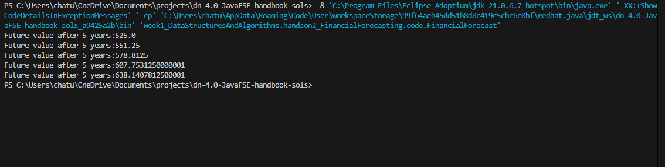

→ Analysis:
- Time Complexity
The time complexity of this recursive method is O(n), where n is the number of years. This is because the method calls itself once per year until it reaches the base case. It makes one recursive call per year, so it scales linearly.
- Optimization
Although this recursive method is straightforward, it can become inefficient if the same subproblems are recalculated multiple times (not in this example, but common in recursive algorithms). To optimize such cases, we can use memoization (caching results of subproblems) or convert the recursion into an iterative solution to avoid the overhead of recursive calls.

