网站风格 https://rechargerecycling.com/ 明媚风格，强调绿色环保
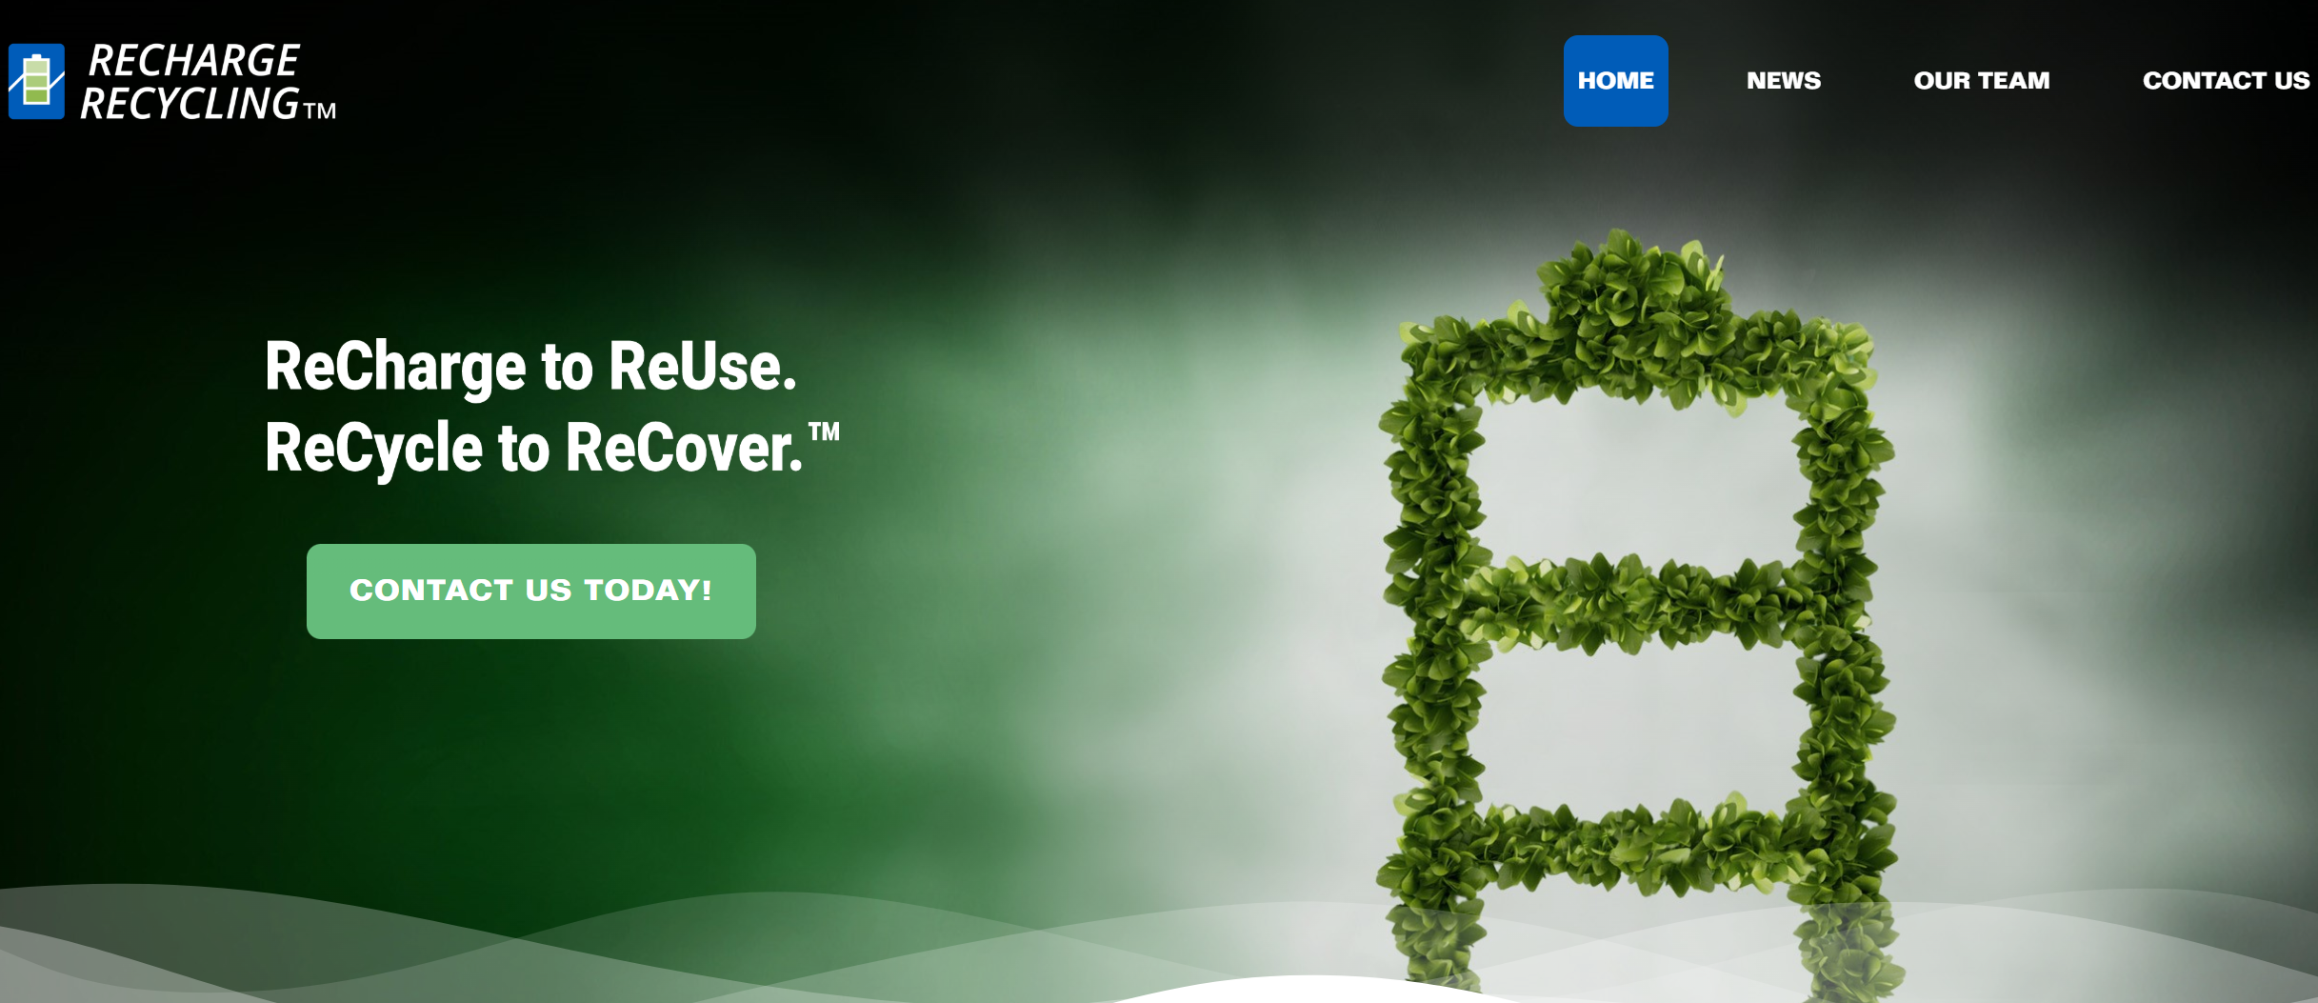
开场动画相似，我们的要有四个电池，电量不一样，一个太阳在上方，给电量最低的电池充电（电量增长）

暂时不做中文版本

英文版本 EN Edition

仿照以上网页，左上角商标
下方的话
Balance Your Battery with Solar Power
Maximize Your Mileage and Battery Life with Clean Energy
右边绿树是否可改为动画？

保留Contact US TODAY按键
Contact us 内容

Hi Solancing. My name is...
First name*
Last name*

I work for...*Company Name

I need help with...*Project description

Please contact me at...*Email address

For more information on our privacy practices and how we are committed to protecting and respecting your privacy, please review our Privacy Policy.

右上角选项
HOME TECHNOLOGY SOLUTIONS OUR STORY Contact US

