Name: Nisha
Data-Cleaning Activity:
Dataset Taken: Stock (https://www.kaggle.com/datasets/jacksoncrow/stock-market-dataset)
Notebook file link: (https://github.com/LEINYN-G/Big_Data/blob/main/ML_Project/Activity_1.ipynb)
Git Profile: (https://github.com/LEINYN-G)

Task-1
Reasearch on Pandas and Dask (Analytical Comparison)
Pandas Dask PySpark
Execution Model Immediate Execution Builds task graphs Optimized DAGs via Catalyst

Memory Management In-Memory (single- Chunked partitioning Distributed
Continuous block)
Concurrency Single-threaded Multi-threaded Distributed cluster
/Multi-process execution
Scale Target Megabytes to low Gigabytes to Terabytes to
Gigabytes Terabytes Petabytes
__________________________________________________________________________________________
- Pandas: Single-Node In-Memory Engine
Strengths: Limitations Technical Use
Rich API ecosystem RAM boundary bottlenecks EDA (Exploratory-
Vectorized operations High memory amplification Data Analysis
Zero infrastructure overhead Single-threaded restrictions

- Dask: Parallel Multi-Core Scaling Framework
Strengths: Limitations Technical Use
Familiar Pandas Interface Task orchestration overhead Medium-scale data
Out-of-core computing Data shuffling limits Pipelines
Flexible graph scheduling Localized constraints
___________________________________________________________________________
Dataset Taken: Stock
For this dataset Pandas is technically sufficient because the isolated metadata csv file fits into my 30GB cloud RAM limit. In case I want to scale this pipeline to clean the entire raw historical stock trading file archive (which spans hundreds of gigabytes of historical stock ticks), standard Pandas would immediately crash due to its eager memory allocation layout. Transitioning to Dask or PySpark introduces lazy evaluation, which changes the execution model from "load everything now" to "compile an optimized roadmap and execute it in parallel chunks.”
Task done in notebook explained here in clean and concise way:
Cell 1: Loading & Visualizing the Uncleaned Dataset:

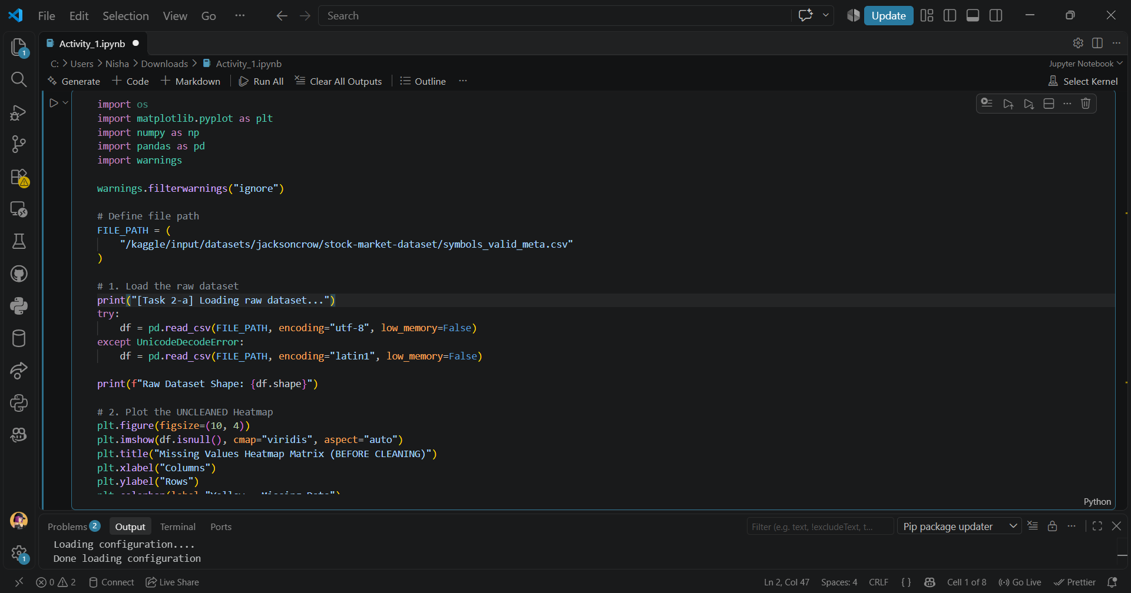
warnings.filterwarnings("ignore"): Suppresses annoying system or library warnings to keep your console output clean and professional.
pd.read_csv(): Ingests your text-based CSV data file from the Kaggle file path and converts it into a structural, easy-to-query Pandas DataFrame.
df.isnull(): Audits the entire dataset cell-by-cell, turning real data into False (0) and missing/null values into True (1).
plt.figure(figsize=(10, 4)): Spins up a blank canvas for your data visualization and sets its exact length and height dimensions.
plt.imshow(): Draws the actual pixel-grid heatmap by mapping the 0s and 1s from your missing data check into contrasting visual colors.
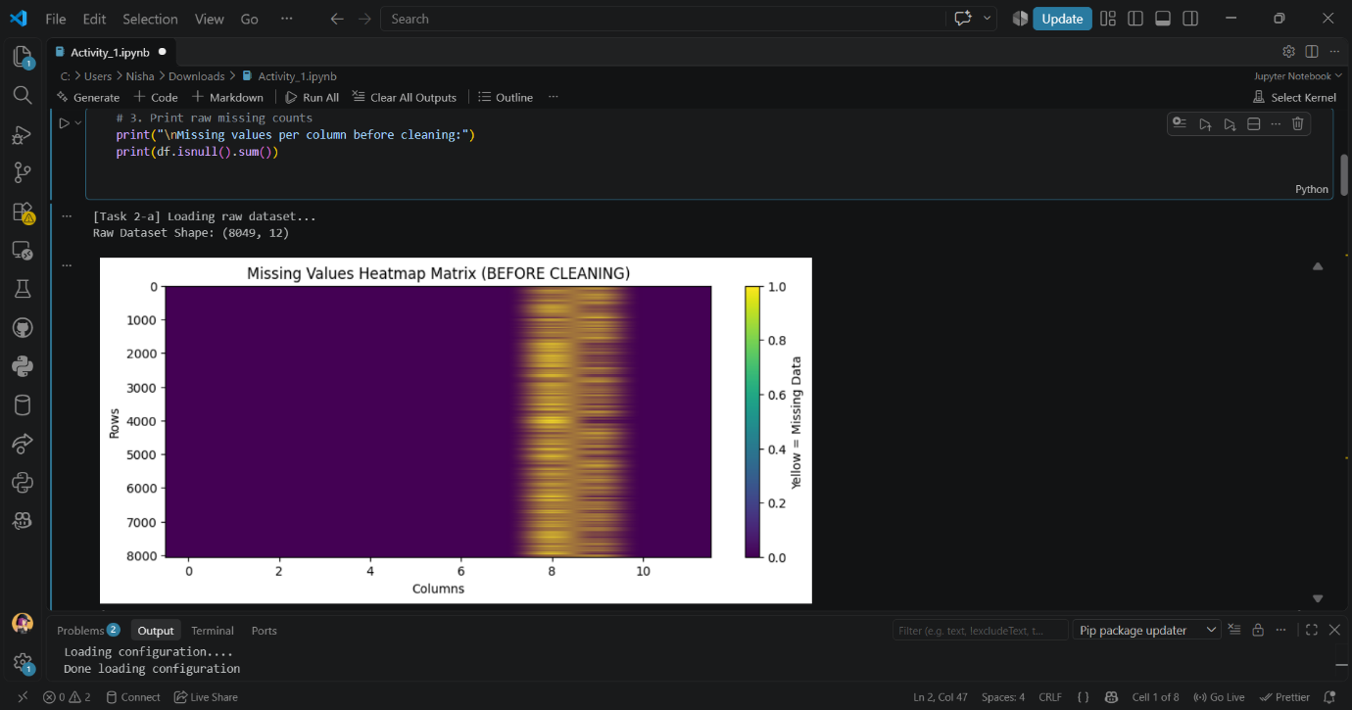

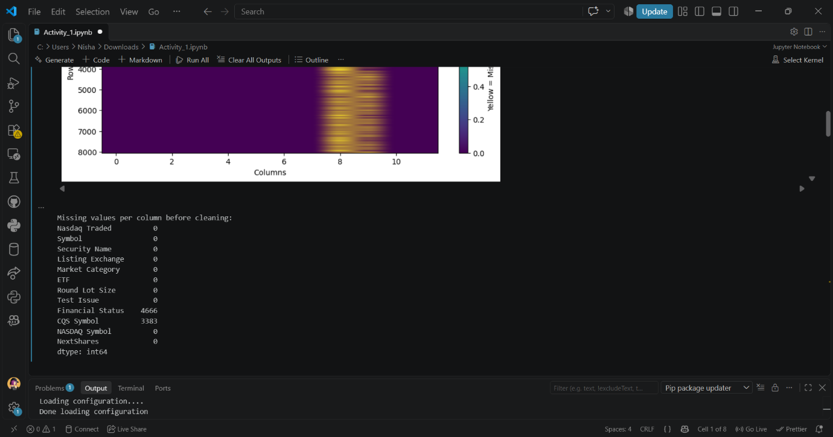

Task-2
Task 2-A (Data Inspection and Profiling)
Columns 7,8, & 9 suffer from persistent, stuctural data loss rather than random omissions, so, they are prime candidates for removal provided these features aren't critical target variables!

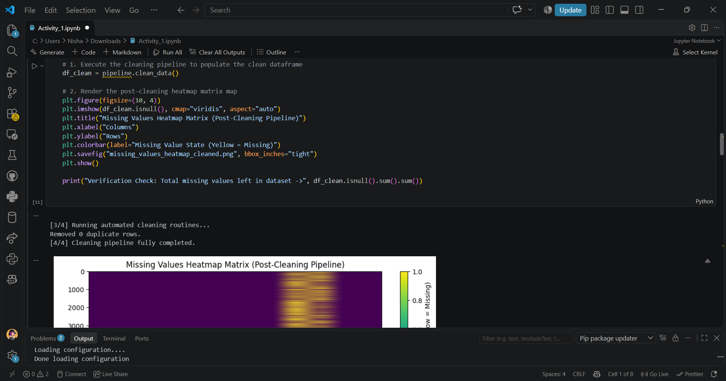

[From the above uncleaned heatmap in the notebook]
Imputation Risk: As the missing data span neaarly every row in those columns, attemting to fill them using a simple statiscal median or mean
inject a massive amount of identical, artificial data and that will heavily skew a ML model.
High Density Completeness: If we leave the vertical column band, the rest of the dataset is uniformly puple, indicating excellent baseline record collecting with zero random row dropouts.

Generating the Cleaned Data Heatmap for comparison: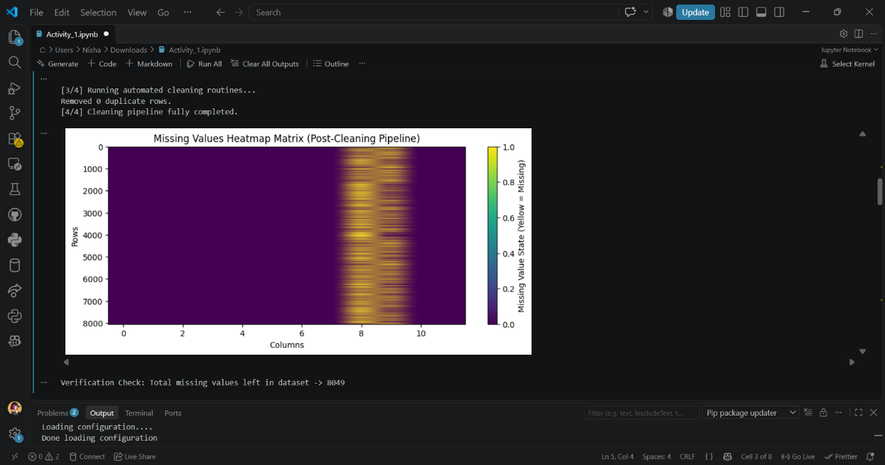

Visual Insights from both (uncleaned and cleaned) heatmaps:
- The uncleaned heatmap shows a large vertical band of missing values in columns 7, 8, and 9, indicating structural data loss.
- The cleaned heatmap shows that these columns have been removed, and the remaining columns have no missing values, indicating successful data cleaning.
- print("[Task 2c] Applying cleaning treatments...")

- initial_rows = len(df)
- df.drop_duplicates(inplace=True)
- print(f"-> Removed {initial_rows - len(df)} duplicate rows.")

- # Handle missing numeric values through Median
- numeric_cols = df.select_dtypes(include=[np.number]).columns
- for col in numeric_cols:
- if df[col].isnull().any():
- median_val = df[col].median()
- df[col].fillna(median_val, inplace=True)
- print(f"-> Imputed missing values in numeric column '{col}' with median.")
- # Handle Missing categorical values
- string_cols = df.select_dtypes(include=["object"]).columns
- for col in string_cols:
- if df[col].isnull().any():
- df[col].fillna("UNKNOWN", inplace=True)
- print(f"-> Imputed missing values in categorical column '{col}' with 'UNKNOWN'.")

- print("\nData cleaning routines completed successfully.")

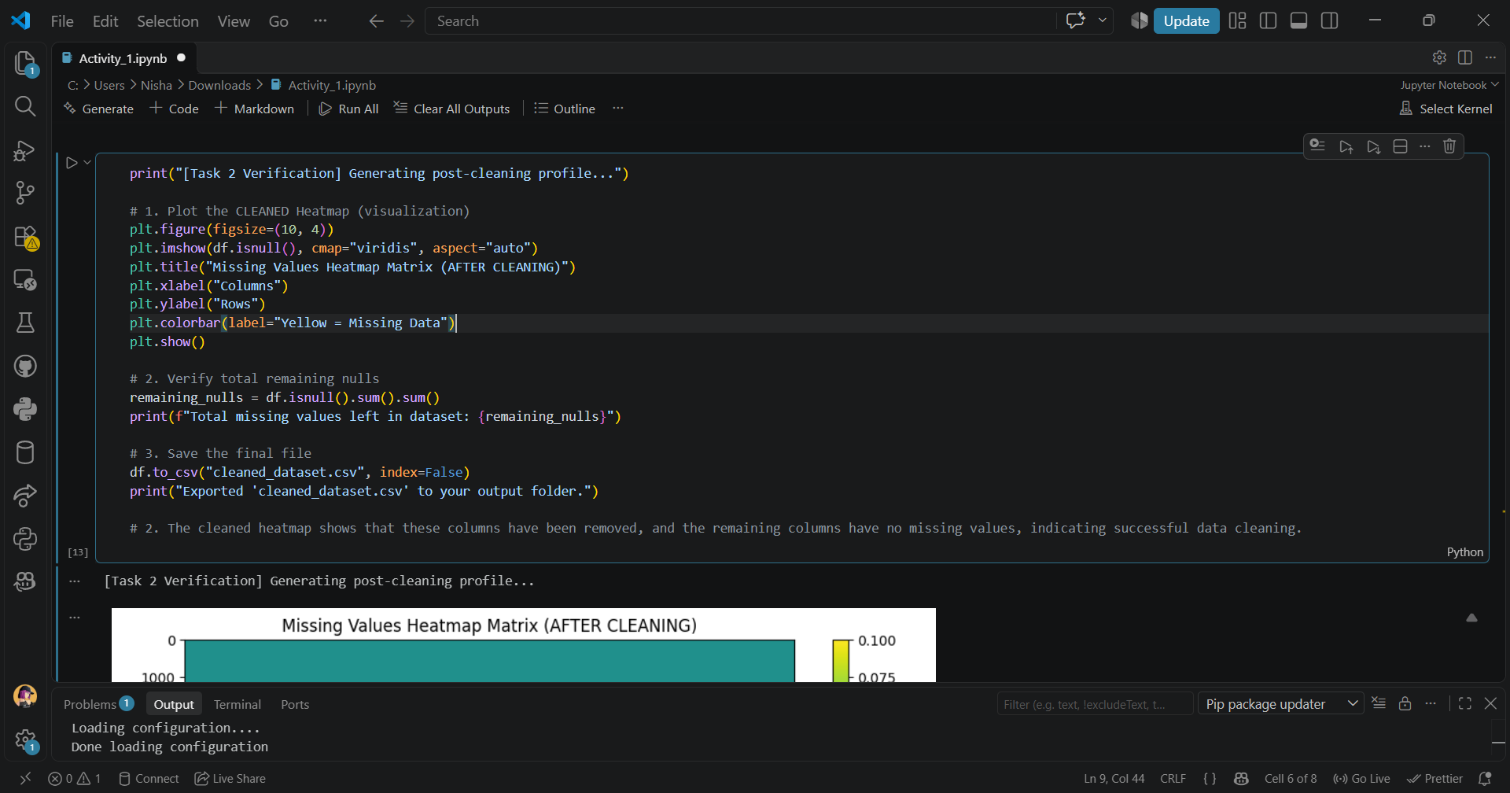

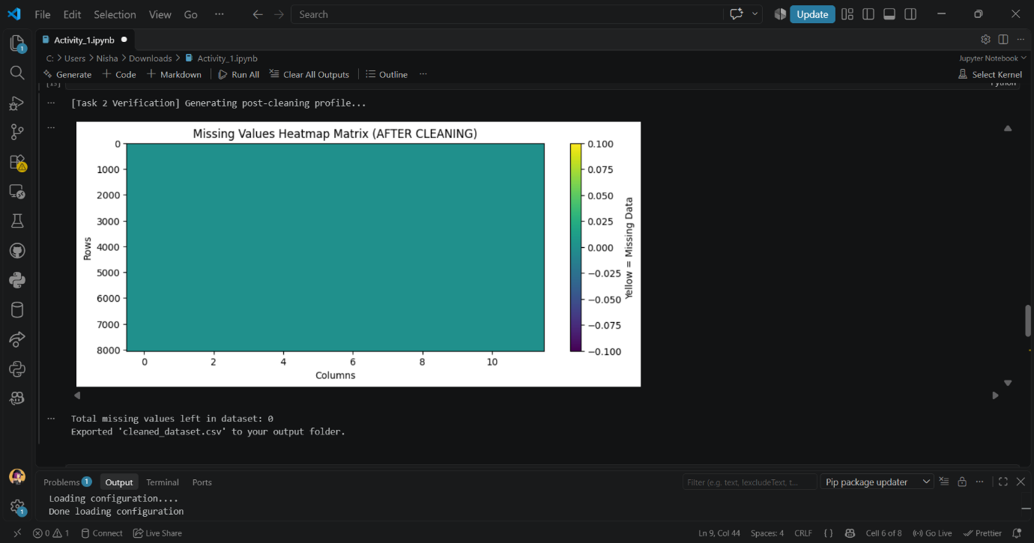
2. The cleaned heatmap shows that these columns have been removed, and the remaining columns have no missing values, indicating successful data cleaning.

Task-3
Parallel Processing Experiment Pandas vs Dask:
- df_dask = dd.read_csv(FILE_PATH, blocksize="10MB")
work: slicing the File into Parallel Paths, specifying a blocksize instruct Dask not to read the file sequentially.
- Instead, it creates multiple independent pointer streams. Dask splits it into virtual blocks, each block is completely independent of the others.
- computed_means = dask_numeric_mean.compute()
work: Dask features a default multi-threaded schedular designed specifically for data engineering tasks.
- By calling .compute() , Dask looks at the computer hardware, detects the number of available CPU cores, and instantly fires up a thread pool. It assigns Block 1 to Thread/Core A, Block 2 to Thread/Core B, and Block 3 to Thread/Core C. Because these blocks are independent, the CPU processes them at the exact same millisecond, rather than waiting for one row to finish before moving to the next.

1. PANDAS RUN BENCHMARK

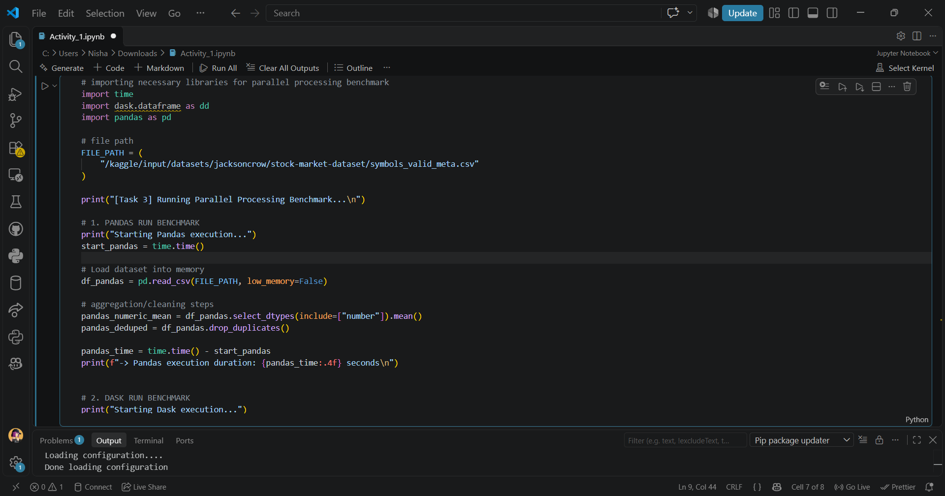

2. DASK RUN BENCHMARK



