**Space Game**

**A 3D Space Battle Simulation for the TRS-80 Model 100**

**By**

**Lloyd Johnson**

**Running on CloudT**

Navigate to the wiki for the CloudT Web Emulator using the following URL: <http://bitchin100.com/wiki/index.php?title=CloudT_Web_Emulator>. This link has a good description of the emulator from which can be gleaned the method for loading a program. You can figure it out from this page (I did it once) *or* you can follow my instructions. I recommend the latter. My instructions follow:

1. Navigate to [www.bitchin100.com/CloudT](http://www.bitchin100.com/CloudT) (this URL is also found on the wiki).
2. You should see the following display.
   1. Paste the text from the program listing (SPGGAM.ba.txt) into the white box as shown in the display below.
   2. Click the “Add Plain Text” button.

1. After clicking the “Add Plain Text” button, a window will pop up as shown below:

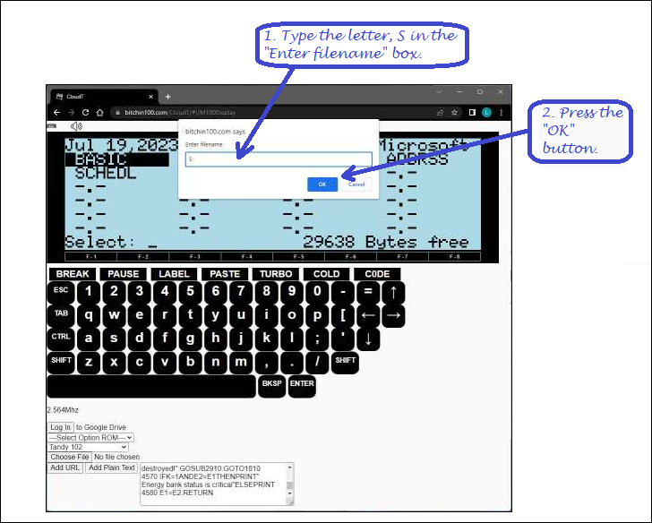

1. In the “Enter filename” box shown above, type a name. The single letter, S is sufficient. Next, click the OK button.
2. Make sure BASIC is highlighted.   If it is, click on Enter.   If not, use arrow keys (or buttons) to highlight it, then click on Enter. See below…

1. Once in BASIC, click on the BASIC screen so you are focused (It’s easy to lose focus). Type CLOAD then press Enter.   (If you want, you can type CLOAD “S” assuming that was what you named the file.)

1. After the program successfully loads, there will be an “OK” response. At this point you should type, RUN and press the “ENTER” key as shown below. Then it will be game time.

1. Gametime!

