WOMEN’S WELFARE ON THE BASIS OF SENTIMENTAL ANALYSIS
Submitted in partial fulfillment of the requirements for the award of
Bachelor of Engineering degree in Computer Science and Engineering

By

Mohammad Abdul Ghani Faiz ( Reg.No – 39110627)
Penmetsa Naga Sai Goutam Varma ( Reg.No – 39110763 )



DEPARTMENT OF COMPUTER SCIENCE AND ENGINEERING

SCHOOL OF COMPUTING

SATHYABAMA

INSTITUTE OF SCIENCE AND TECHNOLOGY

(DEEMED TO BE UNIVERSITY)
Accredited with Grade “A” by NAAC
JEPPIAAR NAGAR, RAJIV GANDHISALAI,
CHENNAI - 600119

NOVEMBER - 2022

SATHYABAMA
INSTITUTE OF SCIENCE AND TECHNOLOGY

(DEEMED TO BE UNIVERSITY)
Accredited with ―A‖ grade by NAAC
Jeppiaar Nagar, Rajiv Gandhi Salai, Chennai – 600 119
www.sathyabama.ac.in

DEPARTMENT OF COMPUTER SCIENCE AND ENGINEERING

BONAFIDE CERTIFICATE

This is to certify that this Project Report is the bonafide work of Mohammad Abdul Ghani Faiz ( Reg.No – 39110627) and Penmetsa Naga Sai Goutam Varma ( Reg.No – 39110763 ) who carried out the Project Phase-1 entitled “ANALYSIS OF WOMEN SAFETY USING MACHINE LEARNING ON TWEETS” under my supervision from June 2022 to November 2022.

Internal Guide
Dr Christy A

Head of the Department
Dr. L. LAKSHMANAN, M.E., Ph.D.

Submitted for Viva voce Examination held on

InternalExaminer ExternalExaminer

DECLARATION

I, Mohammad Abdul Ghani Faiz(39110627) , hereby declare that the Project Phase-1 Report entitled ”ANALYSIS OF WOMEN SAFETY USING MACHINE LEARNING ON TWEETS” done by me under the guidance of Dr. Christy. A is submitted in partial fulfillment of the requirements for the award of Bachelor of Engineering degree in Computer Science and Engineering.

DATE: 26-10-2022 Md Abdul Ghani Faiz

PLACE:Chennai SIGNATURE OF THECANDIDATE
ACKNOWLEDGEMENT

I am pleased to acknowledge my sincere thanks to Board of Management of SATHYABAMA for their kind encouragement in doing this project and for completing it successfully. I am grateful to them.
I convey my thanks to Dr. T.Sasikala M.E., Ph. D, Dean, School of Computing, Dr. L. Lakshmanan M.E., Ph.D., Head of the Department of Computer Science and Engineering for providing me necessary support and details at the right time during the progressive reviews.
I would like to express my sincere and deep sense of gratitude to my Project Guide Dr.Christy.A for his valuable guidance, suggestions and constant encouragement paved way for the successful completion of my phase-1 project work.
I wish to express my thanks to all Teaching and Non-teaching staff members of the Department of Computer Science and Engineering who were helpful in many ways for the completion of the project.

ABSTRACT

Women and girls have been experiencing a lot of violence and harassment in public
places in various cities starting form stalking. Girl’s safety has become major problem. This Project basically focuses on the role of social media in promoting the safety of women in Indian cities with special reference to role of social media websites including twitter platform, Facebook and Instagram. Twitter and other Twitter handles which include hash tag messages that are widely spread across the globe serve as a platform for women to express their views. The extraction of data from twitter is done by twitter API. The data extracted will be cleaned by removing noisy data. Preprocessing will be performed on it. Sentimental Analysis is performed on the collected data. Classifiers such as Naive Bayes and Support Vector Machine (SVM) are used to classify data into polarities

Chapter No | TITLE |  | Page No.
 | ABSTRACT |  | v
 | LIST OF FIGURES |  | vii
1 | INTRODUCTION |  | 1-2
1 | 1.1 Objectives |  | 2
1 | 1.2 Scope of the study |  | 2
2 | LITERATURE SURVEY |  | 3-6
2 | 2.1 Inferences from Literature Survey |  | 5
 | 2.2 Open problems in Existing System |  | 5-6
3 | REQUIREMENTS ANALYSIS |  | 7-9
 | 3.1 | Feasibility Studies/Risk Analysis of the Project | 7
 | 3.2 | Software Requirements Specification Document | 8-9
4 | DESCRIPTION OF PROPOSED SYSTEM |  | 10-21
 | 4.1 | Selected Methodology or process model | 10
 | 4.2 | Architecture / Overall Design of Proposed System | 13-18
 | 4.3 | Description of Software for Implementation and Testing plan of the Proposed Model/System | 18-21
 | 4.4 | Project Management Plan | 21
5 | REFERENCES |  | 22

LIST OF FIGURES

FIGURE NO | NAME OF THE FIGURE | PAGE NO
4.1.2.1 | SUPPORT VECTOR MACHINE LEARNING | 12
4.2 | ARCHITECTURE | 13
4.2.1.1 | USE CASE DIAGRAM | 16
4.2.2.1 | ACTIVITY DIAGRAM | 17
4.2.3.1 | SEQUENCE DIAGRAM | 18

CHAPTER 1

INTRODUCTION
Sentimental Analysis is a thought or judgment prompted by an opinion. So it is also called opinion mining. It studies people’s sentiment towards entities. From user’s perspective people are able to post their own content through various social media such as micro-blogs and social media sites. Many social media platforms provide release their Application Programming Interface (API) prompting data collection and analysis for developers such as Twitter. Hence, Sentiment analysis have strong fundament with the support of online data. R and Python are widely used programming languages. Sentiment analysis refers to identifying as well as classifying the sentiments that are expressed in the text source. Tweets are often useful in generating a vast amount of sentiment data upon analysis. These data are useful in understanding the opinion of the people about a variety of topics. Therefore we need to develop an Automated Machine Learning Sentiment Analysis Model in order to calculate the sentiments on women safety in 5 cities. Due to the presence of non-useful characters (collectively termed as the noise) along with useful data, it becomes difficult to implement models on them. So the noisy data is cleaned and preprocessing is performed on it. Sentiment analysis models focus on polarity (positive, negative, neutral) but also on feelings and emotions (angry, happy, sad), urgency (urgent, not urgent) and even intentions (interested v. not interested). Depending on the polarity obtained from each tweet from different metropolitan cities such as Mumbai, Delhi, Chennai, Pune and Kolkata the tweets are collected. Depending on the polarity obtained from each tweet from different metropolitan cities such as Mumbai, Delhi, Chennai, Pune and Kolkata the tweets are collected.

1.1 Objectives
The objectives of this project are:
- The objective of sentiment analysis is to evaluate the person's opinion in certain cases
- To teach the machine to analyze the various grammatical nuances.
- To implement an algorithm for automatic classification of text into positive or negative.
- Graphical representation of the sentiment in form of Pie-Chart or Bar Diagram.

1.2 Scope Of The Study
Sentiment analysis has been an important tool for brands looking to learn more about how society is addressing women issues. It is a relatively simplistic form of analytics that helps governments find key areas of weakness (negative sentiments) and strengths (positive sentiments). Moving forward, sentiment analysis is finding a place in other organizations. During Brexit and the 2016 US election, these data to were used to measure emotions and attempt to predict the outcome of these events. This has led to non- brand organizations turning to sentiment analysis for their own needs. Additionally, the insights gained from these tools are becoming much deeper, as a result of emerging social media platforms and features. The supervised classification algorithm Support Vector Machine is used in determining the sentiment. The classifier is initially trained on the twitter data and testing is performed on it. The data obtained is represented through bar diagram including the metropolitan cities and their safe and unsafe measure. Machine Learning algorithm is used in predicting the sentiment of a tweet.

CHAPTER 2

LITERATURE SURVEY

This problem statement has been extensively studied over the past years by researchers and automotive companies in a bid to create a solution, and all their solutions vary from analyzing various patterns of distractive habits to analyzing health vitals of the driver.

2.1 REVIEWS OF LITERATURE SURVEY:

Title : Various forms of violence and threats against the woman by making use of most popular and powerful social media data.
Author S. Rammorthy, R. Poorvadevi
Year:2019
S. Rammorthy, R. Poorvadevi [1] proposed various forms of violence and threats against the woman by making use of most popular and powerful social media data. The number of likes, tweets, comments, blogs and posts on the particular incident against woman were used for this. The data associated with the human beliefs on the particular incident namely positive, negative and neutral state of human mind set. The data collected from multiple social networking sites considered for the analysis. This data is then converted into sentimental feelings like anger, disgust, positive, negative, and sadness. These sentimental feelings are then analyzed and accordingly based on the rate of sentiment guidelines provided. Sentimental analysis is also represented in a graphical format.

Title : Twitter is indeed used extensively for political deliberation
Author: Madhura Shridokar, Sayali, Ashela Ingole, Pragati Mishra
Year:2020
Madhura Shridokar, Sayali, Ashela Ingole, Pragati Mishra[3] proposed Twitter is indeed used extensively for political deliberation. Social media has provided end users a powerful platform to voice their opinions. Opinion of people matters a lot to analyze how the propagation of information impacts the lives in a large-scale network like Twitter. Due to their important role in politics, there has been a big interest in predicting an election outcome. Proposed that the mere number of messages mentioning a party reflects the election result and twitter data was used to predict outcome of election by using sentiment analysis

Title : The emotional state of users based on the tweets
Author: Abdullaha Alaseedi, Mohammed Zubair Khan
Year:2019
Abdullaha Alaseedi, Mohammed Zubair Khan [2] proposed to examine the emotional state of users based on the tweets. The hash tagged and emoticon data set where unbiased tweets were used for training classifier. A number of document level sentiment analysis approaches and sentence-level sentiment analysis approaches are also expressed. Various sentiment-analysis approaches used for Twitter are described including supervised, unsupervised, lexicon, and hybrid approached. Feature extraction is performed on tweets and then the extracted features of the tweets are fed to the classifier predicting the level. The syntax features of tweet are re-tweet, hash tag, link, punctuation in conjunction with prior polarities. In the machine learning field, classification methods have been developed, which use different strategies to classify unlabelled data. Classifiers could possibly require training data. Examples of machine learning classifiers are Naive Bayes, Maximum Entropy and Support Vector Machine. These are categorized as supervised-machine learning methods as these require training data. After pre-processing, predictions are performed. In this phase, various prediction algorithms, such as the SVM, Bayesian classifier, and Entropy Classifier, can be used to decide the sentiment polarity of tweets.
Title : mechanism is to examine the role of emotions in Saudi twitter sphere using Twitter API
Author: EmanAlyami, Stan Matwin, Tamur Elmari, Hossam Ali Hasan
Year:2012
EmanAlyami, Stan Matwin, Tamur Elmari, Hossam Ali Hasan[4] proposed a mechanism is to examine the role of emotions in Saudi twitter sphere using Twitter API and collected the data from different hash tags. The eradication of Arabic text analysis problem was implemented by the need of a translator to convert Arabic to English, since Arabic text is read from right to left. Researchers build automatic classifiers that classify the tweets into polarities (negative, positive or natural) based on the words included in that tweet.
2.2 INFERENCES FROM LITERATURE SURVEY
- Recursive Neural Tensor Networks is used to take input phrases of any length.
- They represent a phrase through word vectors and a parse tree and then compute vectors for higher nodes in the tree using the composition function.
- Tokenization was applied to segment each word and ArabicStemR library in R is used to originate the word to its root without the possibility of missing it meaning
- Sentimental analysis studies the subjective information in the text that is the opinion, emotion and then classifies it accordingly

2.3 OPEN PROBLEMS IN EXISTING SYSTEM

On social media websites people can freely express their view point and women can share their experiences where they have faced abuse harassment or where we would have fight back against the abuse harassment that was imposed on them. It is a common practice to extract the information from the data that is available on social networking through procedures of data extraction, data analysis and data interpretation methods. The accuracy of the Twitter analysis and prediction can be obtained by the use of behavioural analysis on the basis of social networks. In existing system Naïve Bayes and Random Forest are used in implementing the sentimental analysis. Naive Bayes classifier is used for classification. Naive Bayes is a classification technique based on Bayes’ Theorem with an assumption of independence among predictors. In simple terms, a Naive Bayes classifier assumes that the presence of a particular feature in a class is unrelated to the presence of any other feature. Attributes are assumed to be conditionally independent given the target value and calculated as P(d1|h) * P(d2|H) and so on, rather than calculating the values of each attribute value P(d1, d2, d3|h). This is an extreme assumption that is most unlikely in real data, i.e., that the attributes do not interact. However, this approach performs well on data where this assumption does not hold. So performing sentiment analysis on the data do not give good performance Naive Bayes assumes that all predictors (or features) are independent, rarely happening in real life. This limits the applicability of this algorithm in realworld use cases. This algorithm faces the ‘zero-frequency problem’ where it assigns zero probability to a categorical variable whose category in the test data set wasn’t available in the training dataset. It would be best if you used a smoothing technique to overcome this issue.

DISADVANTAGES OF EXISTING SYSTEM
Existing system has many disadvantages.
The following are
• This technique is very slow and performance for polarity prediction is also very slow
• The accuracy of prediction is also not good so there are many conflicting results
• The computation is also very slow and training is difficult
.

CHAPTER 3
REQUIREMENT ANALYSIS

3.1 FEASIBILITY STUDIES/RISK ANALYSIS OF THE PROJECT

3.1.1 FEASIBILITY STUDY
A feasibility study is a preliminary study which investigates the information of prospective users and determines the resources requirements, costs, benefits and feasibility of proposed system. A feasibility study takes into account various constraints within which the system should be implemented and operated. In this stage, the resource needed for the implementation such as computing equipment, manpower and costs are estimated. The estimated are compared with available resources and a cost benefit analysis of the system is made. The feasibility analysis activity involves the analysis of the problem and collection of all relevant information relating to the project. The main objectives of the feasibility study are to determine whether the project would be feasible in terms of economic feasibility, technical feasibility and operational feasibility and schedule feasibility or not. It is to make sure that the input data which are 11 required for the project are available. Thus we evaluated the feasibility of the system in terms of the following categories.

3.1.2 TECHNICAL FEASIBILITY
This study is carried out to check the technical feasibility, that is, the technical requirements of the system. Any system developed must not have a high demand on the available technical resources. This will lead to high demands on the available technical resources. This will lead to high demands being placed on the client. The developed system must have a modest requirement, as only minimal or null changes are required for implementing this system.
• Does the necessary technology exist to do what is suggested?
• Do the proposed equipment have the technical capacity to hold the data required to use the new system?
• Will the proposed system provide adequate response to inquiries, regardless of the number or location of users?
• Can the system be upgraded if developed?
• Are there technical guarantees of accuracy, reliability, ease of access and data security?
3.1.3 SOCIAL FEASIBILITY
The aspect of study is to check the level of acceptance of the system by the user. This includes the process of training the user to use the system efficiently. The user must not feel threatened by the system, instead must accept it as a necessity. The level of acceptance by the users solely depends on the methods that are employed to educate the user about the system and to make him familiar with it. His level of confidence must be raised so that he is also able to make some constructive criticism, which is welcomed, as he is the final user of the system.

3.1.4 OPERATIONAL FEASIBILITY
The project is operationally feasible as the user having basic knowledge about computer and Internet. It is based on operational performance of the model depending on the training dataset
• Is there sufficient support for the management from the users?
• Will the system be used and work properly if it is being developed and implemented?
• Will there be any resistance from the user that will undermine the possible application benefits?

3.2 SOFTWARE REQUIREMENTS SPECIFICATION DOCUMENT

A Software Requirements Specification (SRS) – a requirements specification for a software system – is a complete description of the behavior of a system to be developed. It includes a set of use cases that describe all the interactions the users will have with the software. In addition to use cases, the SRS also contains non-functional requirements. Non-functional requirements are requirements which impose constraints on the design or implementation (such as performance engineering requirements, quality standards, or design constraints).
System requirements specification: A structured collection of information that embodies the requirements of a system. A business analyst, sometimes titled system analyst, is responsible for analyzing the business needs of their clients and stakeholders to help identify business problems and propose solutions. Within the systems development life cycle domain, typically performs a liaison function between the business side of an enterprise and the information technology department or external service providers.
Projects are subject to three sorts of requirements:
• Business requirements describe in business terms what must be delivered or accomplished to provide value.
• Product requirements describe properties of a system or product which could be one of several ways to accomplish a set of business requirements.
• Process requirements describe activities performed by the developing organization.
For instance, process requirements could specify specific methodologies that must be followed, and constraints that the organization must obey. Product and process requirements are closely linked. Process requirements often specify the activities that will be performed to satisfy a product requirement. For example, a maximum development cost requirement (a process requirement) may be imposed to help achieve a maximum sales price requirement (a product requirement); a requirement that the product be maintainable (a Product requirement) often is addressed by imposing requirements to follow particular development styles.

HARDWARE REQUIREMENTS
System : Pentium IV 2.4 G
Hard Disk : 40 GB
Monitor : 14’ Colour Monitor.
Ram : 2GB

SOFTWARE REQUIREMENTS
Operating system : Windows 7 Ultimate.
Coding Language : Python.
Front-End : Python.
Designing : Html.

CHAPTER 4

DESCRIPTION OF PROPOSED SYSTEM

Twitter sentiment analysis systems allow us to sort large sets of tweets and detect the polarity of each statement. We will use the tweets extracted by Twitter API, which was provided by Twitter itself. Due to the presence of Twitter API, there are many techniques available for sentimental analysis of data on Social media. The accuracy and performance issues of existing system we proposed Support Vector Machine algorithm to improve accuracy as well as performance in predicting the sentiment. SVM is a supervised machine learning algorithm that is used extensively in classification problems. A Support Vector Machine classifier is defined by a separating hyper plane. Further, the classification can be implemented by finding the hyper plane that differentiates the two classes very well. The objective of SVM algorithm is to find a hyper plane in an N-dimensional space that distinctly classifies the data points. The dimension of the hyper plane depends upon the number of features. If the number of input features is two, then the hyper plane is just a line it performs very well with a limited amount of data. On comparing the accuracies of Naïve Bayes, Random Forest, and Support Vector Machine(SVM) algorithms, it has been found that the Support Vector Machine classifier gives out the highest accuracy. The method of transfer learning has been introduced where a pretrained network model is used to extract features that a conventional classifier, such as a SVM, can use for a fine-tuned classification. One reasonable choice as the best hyper plane is the one that represents the largest separation or margin between the two classes. The SVM algorithm has the characteristics to ignore the outlier and finds the best hyper plane that maximizes the margin. SVM is robust to outliers.
ADVANTAGES OF PROPOSED SYSTEM
• It works really well with a clear margin of separation.
• It is effective in high dimensional spaces.
• It is effective in cases where the number of dimensions is greater than the number of samples.
• It uses a subset of training points in the decision function (called support vectors), so it is also memory efficient.
• Its memory efficient as it uses a subset of training points in the decision function called support vectors.
• Different kernel functions can be specified for the decision functions and it’s possible to specify custom kernels.

4.1 SELECTED METHODOLOGY OR PROCESS MODEL
In earlier days polarity detection is done using naïve Bayes, Maximum Entropy, Random Tree but using Support Vector Machine we achieved high accuracy and performance.

4.1.1 DATA COLLECTION
We need set of tweets for performing the sentimental analysis and determining the polarity of tweet. So we have downloaded dataset containing positive as well as negative tweets.

4.1.2 ALGORITHM
The goal of the SVM algorithm is to create the best line or decision boundary that can segregate n- dimensional space into classes so that we can easily put the new data point in the correct category in the future. This best decision boundary is called a hyper plane. SVM chooses the extreme points/vectors that help in creating the hyper plane. These extreme cases are called as support vectors, and hence algorithm is termed as Support Vector Machine.

The classifier separates data points using a hyper plane with the largest amount of margin. Generally, Support Vector Machines is considered to be a classification approach, it but can be employed in both types of classification and regression problems. It can easily handle multiple continuous and categorical variables. SVM constructs a hyper plane in multidimensional space to separate different classes. SVM generates optimal hyper plane in an iterative manner, which is used to minimize an error. The core idea of SVM is to find a maximum marginal hyper plane (MMH) that best divides the dataset into classes.
Support Vectors
Support vectors are the data points, which are closest to the hyperplane. These points will define the separating line better by calculating margins. These points are more relevant to the construction of the classifier.
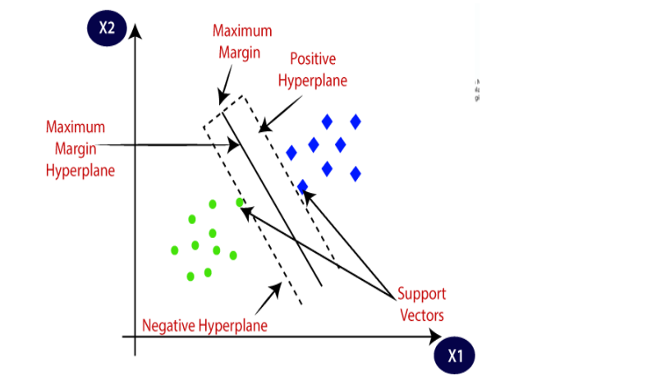
Fig 4.1.2.1: Support Vector Machine Working

Hyper plane
A hyper plane is a decision plane which separates between a set of objects having different class memberships. There can be multiple lines/decision boundaries to segregate the classes in n-dimensional space, but we need to find out the best decision boundary that helps to classify the data points. This best boundary is known as the hyper plane of SVM. The dimensions of the hyper plane depend on the features present in the dataset, which means if there are 2 features (as shown in image), then hyper plane will be a straight line. And if there are 3 features, then hyper plane will be a 2-dimension plane. We always 20 create a hyper plane that has a maximum margin, which means the maximum distance between the data points.
Margin
A margin is a gap between the two lines on the closest class points. This is calculated as the perpendicular distance from the line to support vectors or closest points. If the margin is larger in between the classes, then it is considered a good margin, a smaller margin is a bad margin. The main objective is to segregate the given dataset in the best possible way. The distance between the either nearest points is known as the margin. The objective is to select a hyper plane with the maximum possible margin between support vectors in the given dataset. SVM searches for the maximum marginal hyper plane in the following steps: • Generate hyper planes which segregates the classes in the best way. Left-hand side figure showing three hyper planes black, blue and orange. Here, the blue and orange have higher classification error, but the black is separating the two classes correctly. • Select the right hyper plane with the maximum segregation from the either nearest data points SVM Classifiers offer good accuracy and perform faster prediction compared to Naïve Bayes algorithm. They also use less memory because they use a subset of training points in the decision phase. SVM works well with a clear margin of separation and with high dimensional space.
TYPES OF SVM
SVM can be of two types:
• Linear SVM: Linear SVM is used for linearly separable data, which means if a dataset can be classified into two classes by using a single 21 straight line, then such data is termed as linearly separable data, and classifier is used called as Linear SVM classifier. • Non-linear SVM: Non-Linear SVM is used for non-linearly separated data, which means if a dataset cannot be classified by using a straight line, then such data is termed as non-linear data and classifier used is called as Non-linear SVM classifier.

4.2 ARCHITECTURE / OVERALL DESIGN OF PROPOSED SYSTEM
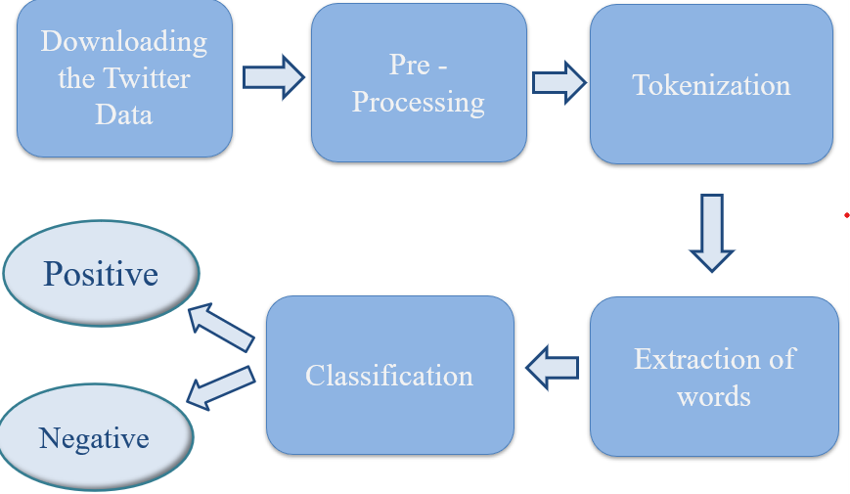

A diagram is a graphical presentation of a set of elements, most often is rendered as a graph of vertices and arcs. A UML diagram can contain nine types 25 in it where vertices are denoted as things and arcs are denoted as relationships. The Unified Modeling Language diagram is that is, the unified modeling language is probably the most widely known and used notation for objectoriented analysis and design. The Unified Modeling Language is used to visualize, specify, construct and document the artifacts. A Modeling language is a language whose vocabulary and rules focus on the conceptual and physical representation of a system. Modeling is the designing of software applications before coding. According to UML no one diagram can capture the different elements of a system in its entirety. We have represented them through diagrams:
• Use case diagram
• State diagram
• Activity diagram
• Sequence Diagram
• Class Diagram
• Collaboration Diagram
• Component Diagram
• Deployment diagram

4.2.1 USECASE DIAGRAM
Use cases:
A use case describes a sequence of actions that provide something of measurable value to an actor and is drawn as a horizontal ellipse.
Actors:
An actor is a person, organization, or external system that plays a role in one or more interactions with the system.

System boundary boxes (optional):
A rectangle is drawn around the use cases, called the system boundary box, to indicate the scope of system. Anything within the box represents functionality that is in scope and anything outside the box is not. Four relationships among use cases are used often in practice.

Include:
In one form of interaction, a given use case may include another. "Include is a Directed Relationship between two use cases, implying that the behavior of the included use case is inserted into the behavior of the including use case. The first use case often depends on the outcome of the included use case. This is useful for extracting truly common behaviors from multiple use cases into a single description. The notation is a dashed arrow from the including to the included use case, with the label "«include»". There are no parameters or return values. To specify the location in a flow of events in which the base use case includes the behavior of another, you simply write include followed by the name of use case you want to include, as in the following flow for track order.

Extend:
In another form of interaction, a given use case (the extension) may extend another. This relationship indicates that the behavior of the extension use case may be inserted in the extended use case under some conditions. The notation is a dashed arrow from the extension to the extended use case, with the label "«extend»". Modeller’s use the «extend» relationship to indicate use cases that are "optional" to the base use case.
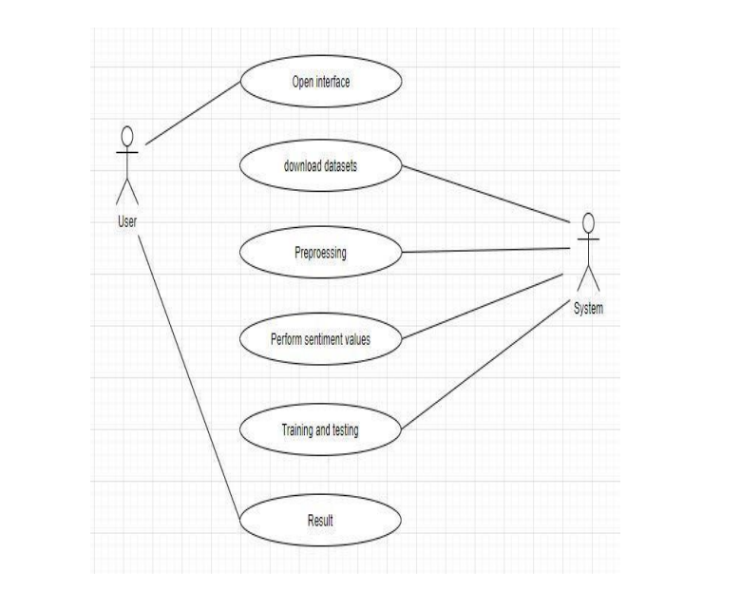
Fig 4.2.1.1: Use case diagram

4.2.2 ACTIVITY DIAGRAM
An activity diagram is a behavioral diagram i.e it depicts the behavior of a system. This is to illustrate the flow of control in a system and refer to the steps involved in the execution of a use case. We model sequential and concurrent activities using activity diagrams. So, we basically depict workflows visually using an activity diagram. An activity diagram focuses on condition of flow and the sequence in which it happens.
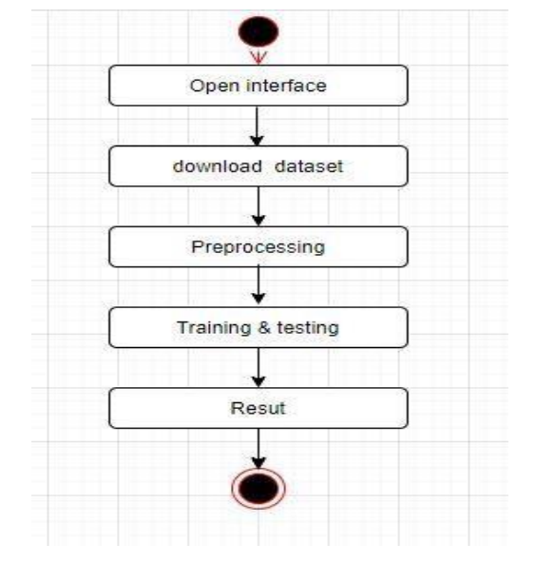
Fig 4.2.2.1: Activity Diagram

4.2.3 SEQUENCE DIAGRAM
A sequence diagram in Unified Modeling Language (UML) is a kind of interaction diagram that shows how processes operate with one another and in what order. It is a construct of a Message Sequence Chart. The important aspect of the sequence diagram is that it is time-ordered. This means that the exact sequence of the interactions between the objects is represented step by step. Different objects in the sequence diagram interact with each other by passing the “messages”.
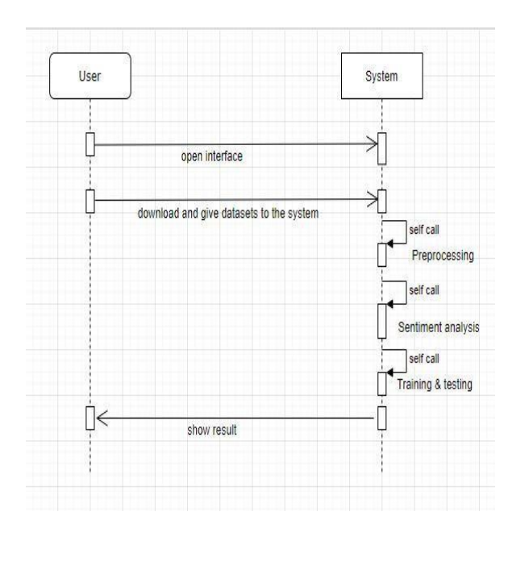
Fig 4.2.3.1: Sequence Diagram

4.3 DESCRIPTION OF SOFTWARE FOR IMPLEMENTATION AND TESTING PLAN
OF THE PROPOSED MODEL/SYSTEM

4.3.1 INTRODUCTION
Python is one of the most unique languages which seem to be literally simple yet you may find it more powerful and contemporary. It has efficient high-level data structures and a simple but effective approach to object-oriented programming. Python’s elegant syntax and dynamic typing, together with its interpreted nature, make it an ideal language for scripting and rapid application development in many areas on most of the platforms. Guido Van Rossum is the creator of the python language. Some of the features of python are:
• Simple
• Easy to Learn
• High level language
• Portable
• Interpreted
• Object Oriented

Python is open source and it is automatically included with Linux distributions, Macintosh computers and wide range of products and hardware, further clouding the user base picture.

Few points about the importance of Python:
• Python is great open source, interpreted, object-oriented programming language. There is no any concept of structure like C/C++ & Go language.
• Decorators, Generators provides much functionality. 33 • Great web frameworks like Django, Flask etc. that encourages rapid web development.
• With Flask, we can use loops, conditional statements etc. inside HTML document that adds dynamic nature to web pages.
• Python has a rich set of libraries/packages that we can use to create excellent applications, games etc.
• We can easily install libraries using pip.

You can create great projects using different Python libraries for web scrapping, calculators, text editor & other innovative apps.

• For aspiring Data Scientists, Python is probably the most important language to learn because of its rich ecosystem. Python's major advantage is its breadth. For example, R can run Machine Learning algorithms on a pre-processed dataset, but Python is much better at processing the data.
• Python is very easy to learn.
• List, Tuple & dictionary comprehensions makes our task easy while working with sequences & their related operations.

Python can be used in many ways like:

• App development: Python is one of the few languages that are not native to the Java world and yet can be used to develop apps easily for the android platform. Kivy is a framework available at Kivy Cross platform Python Framework for NUI that lets a developer design and test touch friendly applications for android. Python support extension available in Eclipse IDE for this purpose.

• Web Development: There are a number of python frameworks, most notable among them being Django, flask which are optimized to maximize the potential of web via the use of python

• Backend development: Python is a very powerful language with a lot of libraries built into it. These can be used to achieve nearly any activity that is needed via python, from cryptanalysis to GUI applications

• Python is an easy to learn programming language and is fun to use. It does not have the limitations of vast and restrictive syntax or type conversions. It is plain and simple. The perfect tool for a learner and a professional tool for the experienced.

• Google is planning to move much of its framework to python, and google is not alone to have recognized the value if python. The main reason is that unlike most other complex or targeted languages, python works perfectly on the web as well as in desktop application. There simply is too much use of python for the world to ignore.

It is generally considered to be in the top 5 most widely used programming languages in the world today. Python has been around for more than over two decades and has been widely used, it is also very stable and robust. It is useful for accomplishing real world tasks the sorts of things developers do day on and day out. It is commonly used in variety of domains.

4.4 PROJECT MANAGEMENT PLAN
Step1:
Initially Download the twitter data which contain tweets for analysis.
Step2:
The pre processing is performed on the data. Pre processing includes
Cleaning the data by removing duplicate data. Tweets which contain null values are removed. Stop words are eradicated from tweets
Step3:
Tokenization is the process of splitting of text into smaller units known as tokens.
The most common tokenization process is using delimiters like whitespace, semicolon, colon. Splitting is performed on data through delimiters.
Step4:
Words extraction is performed through tokenization. All the redundant information will be removed. Lemmatization is performed to convert words to meaningful base form which is used in classifying the tweet into polarity

Step5:
Classifying the data into polarity is performed by Support Vector Machine.
Step6:
Train the chosen model with trained dataset. This makes model to learn the pattern of words from tweets, which will be useful in predicting whether the given tweet is positive or negative
Step7:
Finally , based on the polarity we organize the data into graphical representation categorized as positive and negative.

.

REFERENCES:-

[1] S. Rammorthy et al.,” Safety Measures Against Women Violence in India using Sentimental Analysis “,International Journal of Innovative Technology and Exploring Engineering,ISSN:22782 3075,p.no:150 -154,April 2019
[2] MadhuraShrirodkar “Result Prediction using Twitter data”, International Research Journal Of Engineering And Technology,ISSN:2395-0056,2 Feb 2020
[3] AbdullahaAlasedi “Sentimental analysis of Twitter data”, International Journal of Computer Application,ISSN:2395-0072,2 Nov 2019
[4] EmanAlyami,”Mining Saudi Twitter sphere for expressive support towards women” Fourth World Conference on Smart Trends in system, 26 Oct 2020
[5] Sahayak V, Shete V & Pathan A (2015). “Sentiment analysis on twitter data.” International Journal of Innovative Research in Advanced Engineering (IJIRAE), 2(1), 178-183.
[6] Gupta B, Negi M, Vishwakarma K, Rawat G &Badhani P (2017). “Study of Twitter sentiment analysis using machine learning algorithms on Python.” International Journal of Computer Applications, 165(9) 0975-8887.
[7] Sahayak V, Shete V & Pathan A (2015). “Sentiment analysis on twitter data.” International Journal of Innovative Research in Advanced Engineering (IJIRAE), 2(1), 178-183.
[8] Soo-Min Kim and Eduard Hovy. "Determining the sentiment of opinions." Proceedings of the 20th international conference on Computational Linguistics. Association for Computational Linguistics, 2004.
[9] Michael Gamon. "Sentiment classification on customer feedback data: noisy data, large feature vectors, and the role of linguistic analysis." Proceedings of the 20th international conference on Computational Linguistics. Association for Computational Linguistics, 2004

