

Technical
Documentation

OMNI SQL DBA Documentation

Version | Created Date | Review Date
1 | 05/27/2025

INDEX

1 | OMNI Daily report
2 | OMNI Weekly report
3 | OMNI Monthly report
4 | OMNI Yearly report
5 | Replication jobs status mail
6 | DBA regular tasks-backup,restore,shrinking ,etc
7 | Database Patching Server Maintenance-restart
8 | Weekly Maintenance Procedure for Server Reboots and Service Checks
9 | Database tables purging & archiving the data
10 | Database Growth and Table Growth Report
11 | Monitoring Database Slowness and long running query
12 | Power BI Dashboard deployment and Gateway Settings
13 | Power BI Health check Dashboard

1.OMNI Daily report
2.OMNI Weekly report
3.OMNI Monthly report
4.OMNI Yearly report

OMNI Weekly report

During the week, the support team actively monitored and responded to critical system alerts, health checks, and routine operational tasks to ensure optimal performance and stability of production environments.
OMNI Daily tracker used for the monthly weekly report.
Key activities included:
- Monitoring Job Executions: Identified and escalated long-running jobs exceeding standard execution thresholds.
- Email Alert Handling: Triaged system-generated email alerts for timely incident resolution.
- Daily Health Check Reports: Reviewed and documented health status of critical production databases (e.g., DALDCEBIDBPROD, DALDCEEDWPROD).
- Replication and Subscription Monitoring: Validated the integrity of replication processes and subscription services across production systems.
- Development : Sharing the status of ongoing development task for OMNI Power BI Dashboard.
All reported incidents were analyzed, documented with proper time effort, and promptly resolved within established SLAs.

OMNI Monthly report

Over the past month, the team has consistently supported daily operations through proactive monitoring and structured escalation handling. Monthly highlights include:
- Consolidation of daily health check insights into a comprehensive health trend report.
- Root cause analysis and documentation of recurring alerts such as job overruns and subscription errors.
- Continuous improvements in job documentation formats and proactive recommendations to reduce repetitive incidents.
- Timely closure of all logged tickets with detailed categorization and effort estimation, helping to streamline monthly performance reporting.

Sample report format-

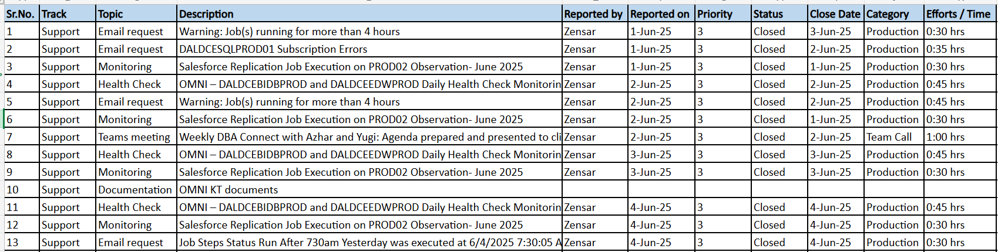
OMNI Yearly report

Over the course of the year, the support team consistently delivered on key operational objectives by executing a broad range of activities across system health monitoring, email alert management, issue resolution, and documentation efforts. The year was marked by:
- Systematic Daily Monitoring: Proactive health checks and alert reviews ensured uninterrupted operations across critical production environments like DALDCEBIDBPROD and DALDCEEDWPROD.
- Timely Incident Response: All reported issues, including job delays and subscription errors, were addressed promptly. Each incident was logged with details such as reported date, resolution timeline, category, and time efforts to ensure traceability and SLA compliance.
- Process Documentation & Refinement: Knowledge transfer sessions, job dependency mapping, and ongoing improvement of documentation formats contributed to team readiness and onboarding.
- Consistent Performance Metrics: Weekly and monthly reports were compiled into structured summaries that reflect support trends, recurring patterns, and action outcomes—laying the foundation for long-term performance benchmarking.

Replication jobs status mail

Introduction-

There are 8 main replication jobs running on the PROD02 server. The execution status of these jobs needs to be monitored to ensure completion before 4:00 AM.

- If any replication job fails, it must be re-run immediately.
- If all jobs run successfully, the dependent jobs should be disabled after 4:00 AM to allow the completion of the 8 main Salesforce replication jobs.
- Job execution alerts for these 8 replication jobs are received via email and also we can check the replication job execution by connecting them to PROD02 server.

Replication job status details on PROD02 server-

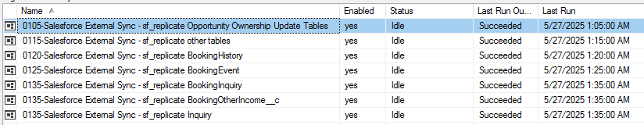

Replication job status details mail notification

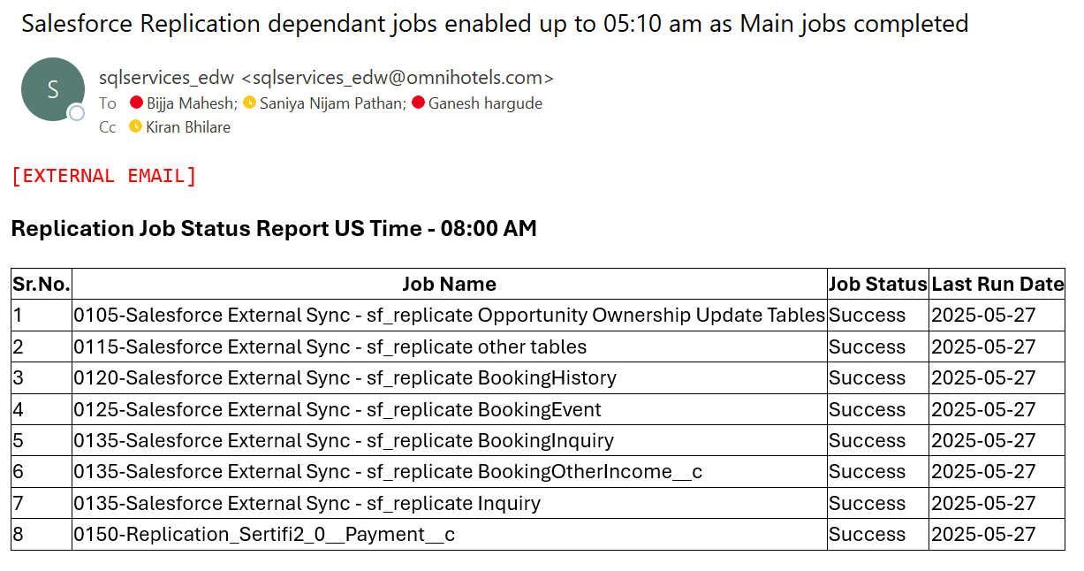

Backup and restore a database table in Microsoft SQL Server:

1. Backup a Table (Using SELECT INTO)
If you need to back up only a specific table, you can copy its data into another table:
sql
SELECT * INTO Backup Table
FROM Original Table;
📌 This creates a backup table with the same data as the original.
2. Backup Entire Database (Using BACKUP DATABASE)
For a full database backup, run this command:
sql
BACKUP DATABASE Your DatabaseName
TO DISK = 'C:\Backup\Your DatabaseName.bak'
WITH FORMAT, INIT, NAME = 'Full Backup';
📌 This saves the backup to a .bak file.
3. Restore a Table from Backup
If you have a backup copy of the table, you can restore it using:
sql
INSERT INTO OriginalTable
SELECT * FROM BackupTable;
📌 This copies all data from the backup back into the original table.
4. Restore a Database from Backup (Using RESTORE DATABASE)
If you need to restore the entire database from a .bak file:
sql
RESTORE DATABASE YourDatabaseName
FROM DISK = 'C:\Backup\YourDatabaseName.bak'
WITH REPLACE;

Database Patching-

SQL Server 2019 Patching Document

1. Overview
This document outlines the steps and precautions involved in patching a SQL Server 2019 instance. It covers pre-checks, the patching process, post-checks, and rollback steps.

2. Change Details
Field | Description
Change Request No
Requested by | BIJJA MAHESH
Change Date | [MM/DD/YYYY]
Maintenance Window | [Start Time] to [End Time]
SQL Server Version | SQL Server 2019
Patch Version | CU [e.g., CU23]
Affected Servers | Server1, [Server2], etc.
Type of Change | SQL Server Cumulative Update Installation

3. Pre-Patching Checklist
- Approved change ticket
- Backup of all user/system databases
- Capture SQL Server version
- Capture existing SQL jobs and statuses
- Confirm free disk space (> 5 GB)
- Download CU installer from Microsoft
- Always On / Cluster awareness check
- Failover planned (if Always On)
SQL Command to Check Current Version:
SELECT @@VERSION;

4. Patching Steps

Standalone Instance:
- Stop all SQL Agent Jobs.
- Run the CU installer as Administrator.
- Follow the GUI steps: Accept License → Select Instance → Install.
- Reboot the server.
- Start SQL Agent Services.
- Validate patch installation (see post-checks).

Always On / Clustered Instances:
- Failover to secondary node.
- Patch passive node first.
- Reboot passive node.
- Failover back to patched node.
- Repeat for the other node.
- Validate health of Availability Groups.

5. Post-Patching Checklist
- Verify SQL Server version
- Check SQL Agent Jobs status
- Validate application connectivity
- Check SQL Server error log
- Verify Always On dashboard.
- Run test queries

SQL Command to Confirm Patch:
SELECT SERVERPROPERTY('ProductVersion'), SERVERPROPERTY('ProductLevel'), SERVERPROPERTY('Edition');

6. Rollback Plan
Step | Description
1 | Restore full backups taken pre-patch
2 | Reinstall previous CU (if required)
3 | Restore system databases (if corruption is found)
4 | Reboot server and monitor

7. Additional Notes
- Patch tested on lower environments before production.
- Linked servers were tested for connectivity.
- Services using SQL (e.g., SSRS, SSIS) were restarted and verified.

Weekly Maintenance Procedure for Server Reboots and Service Checks

Introduction
This document outlines the weekly maintenance procedure for server reboots and service checks. The procedure includes rebooting the servers, verifying that all SQL Server Services are up and running, and ensuring that WhereScape and On-premises data gateway services are running fine on both the production servers.

Steps

Connect every Thursday 8:30 PM EST means Friday morning in India 6:30 AM or 7:30 AM depends on day light saving and perform the following steps:
Server reboot time are mentioned below.
PROD01- 8:15 PM
PROD02- 8:20 PM
Dev Server- 8:15 PM
RPT Prod 1- 8:15 PM
RPT Prod 2- 8:15 PM

1. PROD Servers rebooted or not:
Verify task scheduler job for weekly executed and start time of server from Task Manager.

2. Manually reboot the Dev server:
Check the task scheduler job for reboot. If it is not working, manually reboot the server.

3. Manually reboot report server:
Since the scheduler job is not working, manually reboot the report server.

4. Once reboot completed:
Check SQL Services are running fine along with WhereScape service and On-premises data gateway service.
PROD01 Services Snapshot:

PROD02 Services Snapshot:

5. Turn on Trace flags:
Execute the following commands to turn on trace flags on both production servers:
DBCC TRACEON (1204, -1)
DBCC TRACEON (1222, -1)

Database tables purging & archieving the data

This process ensures efficient database maintenance by:
✔ Removing outdated records without impacting dependent jobs
✔ Optimizing storage usage through file shrinking
✔ Enhancing query performance with index management
✔ Ensuring smooth Salesforce replication and reporting operations

Benefits
1. Improves Database Performance 🚀
✔ Removing old and unnecessary records reduces table size, allowing faster query execution. ✔ Optimizes index maintenance, preventing performance slowdowns.
2. Frees Up Storage Space 💾
✔ Reduces disk usage by clearing outdated records. ✔ Shrinks log and data files, preventing excessive storage consumption.
3. Ensures Compliance & Data Retention ✅
✔ Helps meet legal and regulatory requirements for data storage. ✔ Archives essential records for historical reference and audits.
4. Prevents System Overload ⚙️
✔ Eliminates unnecessary records, keeping database size manageable. ✔ Avoids memory overload and fragmentation issues.
5. Enhances Backup & Recovery 🔄
✔ Makes backups smaller and faster, reducing downtime. ✔ Helps with efficient data restores, since backups contain only necessary records.
6. Supports Scalability & Growth 📈
✔ Keeps databases optimized as they expand, ensuring smooth future operations. ✔ Prevents bottlenecks that slow down applications.
📌 Regular purging and archiving keep databases efficient, secure, and ready for future needs! Would you like me to suggest the best practices for implementation? 🚀

SQL Script- for data archival for PROD2 server database

Server Name DALDCESQLPROD02
Datbase Name SalesAutomation
Table OMNI_FDC_BOOKING_SNAPSHOT

Step-1 USE [SalesAutomation]
GO

begin
IF (SELECT count(*) FROM sys.indexes WHERE object_id = OBJECT_ID('dbo.omni_fdc_booking_snapshot') AND name='idxcs_daily_bkg_snapshot') > 0
begin
DROP INDEX [idxcs_daily_bkg_snapshot] ON [dbo].[omni_fdc_booking_snapshot]
end
end
GO

Delete Query

Step-2 use SalesAutomation
DELETE [dbo].[OMNI_FDC_BOOKING_SNAPSHOT]
WHERE asofdate BETWEEN '2019-01-01' AND '2019-06-30'

Step-3 DBCC SHRINKFILE(2, 2) ---To shrink log file of SalesAutomation database

Step-4 Check the log file size. If it hasn't shrunk, re-run the DBCC SHRINKFILE command (DBCC SHRINKFILE(2, 2) ) until the space is cleared.

Step-5 DBCC SHRINKFILE(1,2), DBCC SHRINKFILE(3,2) ---use this command to shrink the data file & check the E drive space.
,
Step-6 Use below SQL query to create columnstore index on OMNI_FDC_BOOKING_SNAPSHOT so that dependant jobs don’t have any issues while running.
USE [SalesAutomation]

GO
begin

IF (SELECT count(*) FROM sys.indexes WHERE object_id =
OBJECT_ID('dbo.omni_fdc_booking_snapshot')
AND name='idxcs_daily_bkg_snapshot') = 0

begin

CREATE NONCLUSTERED COLUMNSTORE INDEX [idxcs_daily_bkg_snapshot]
ON [dbo].[omni_fdc_booking_snapshot]

(

[asofdate] ,

[OMNI_Property_Abbreviation__c] ,

[nihrm__ArrivalDate__c] ,

[nihrm__BookingStatus__c]

)

WITH (ONLINE = ON);

END

END

GO

Below scenario depends on the case that how much time will be taken to delete 6 months data.
Repeat process 1 to 4 for next batch of six months ‘2019-07-01' and '2019-12-31'
Repeat for Years 2020, 2021 and 2022.

1.First Slot

DELETE [dbo].[OMNI_FDC_BOOKING_SNAPSHOT]
WHERE asofdate BETWEEN '2019-01-01' AND '2019-06-30'

2.Second Slot

DELETE [dbo].[OMNI_FDC_BOOKING_SNAPSHOT]
WHERE asofdate BETWEEN '2019-07-01' AND '2019-12-31'

3.Third Slot

DELETE [dbo].[OMNI_FDC_BOOKING_SNAPSHOT]
WHERE asofdate BETWEEN '2020-01-01' AND '2020-06-30'

4.Fourth Slot

DELETE [dbo].[OMNI_FDC_BOOKING_SNAPSHOT]
WHERE asofdate BETWEEN '2020-07-01' AND '2020-12-31'

5.Fifth Slot

DELETE [dbo].[OMNI_FDC_BOOKING_SNAPSHOT]
WHERE asofdate BETWEEN '2021-01-01' AND '2021-06-30'

6.Sixeth Slot

DELETE [dbo].[OMNI_FDC_BOOKING_SNAPSHOT]
WHERE asofdate BETWEEN '2021-07-01' AND '2021-12-31'

7.Seventh Slot

DELETE [dbo].[OMNI_FDC_BOOKING_SNAPSHOT]
WHERE asofdate BETWEEN '2022-01-01' AND '2022-04-30'

8.Eighth Slot

DELETE [dbo].[OMNI_FDC_BOOKING_SNAPSHOT]
WHERE asofdate BETWEEN '2022-05-01' AND '2022-8-31'

8.Eighth Slot
DELETE [dbo].[OMNI_FDC_BOOKING_SNAPSHOT]
WHERE asofdate BETWEEN '2022-09-01' AND '2022-12-31'

====================================================

USE [SalesAutomation]
GO
DBCC SHRINKFILE (N'SalesAutomation' , 2166395)
GO
===========================================================

1. Moves allocated pages from a data file's end to unallocated pages in a file's front with or without specifying target_percent of spaceusedinfile+100GB. This will not return the space to OS instead it will optimize the file.

--DBCC SHRINKFILE([FileName, nMB(Spaceusedbyfile+100GB), NOTRUNCATE)

2. Shrink the file so empty space is given back to the OS but Keep 100GB of empty space for faster writes.
--DBCC SHRINKFILE([FileName, nMB(Spaceusedbyfile+100GB), TRUNCATEONLY)

------------------------------Scripts for databases ---------------------------------

DBCC SHRINKFILE(SalesAutomation, 1338237.12, NOTRUNCATE) ---Db shrink pending
DBCC SHRINKFILE(SalesAutomation, 1338237.12, TRUNCATEONLY)

DBCC SHRINKFILE(SalesAutomation2, 1342296.75, NOTRUNCATE) ---Db shrink pending
DBCC SHRINKFILE(SalesAutomation2, 1342296.75, TRUNCATEONLY)

DBCC SHRINKFILE(Archive, 512224.68, NOTRUNCATE)
DBCC SHRINKFILE(Archive, 512224.68, TRUNCATEONLY)

DBCC SHRINKFILE(OmniAnalytics, 424152.5, NOTRUNCATE)
DBCC SHRINKFILE(OmniAnalytics, 424152.5, TRUNCATEONLY)

DBCC SHRINKFILE(OmniAnalytics2, 423891.44, NOTRUNCATE)
DBCC SHRINKFILE(OmniAnalytics2, 423891.44, TRUNCATEONLY)

DBCC SHRINKFILE(Salesforce, 455325.37, NOTRUNCATE) ----Done
DBCC SHRINKFILE(Salesforce, 455325.37, TRUNCATEONLY) ----Done

DBCC SHRINKFILE(Salesforce2, 447073.19, NOTRUNCATE) ----Done
DBCC SHRINKFILE(Salesforce2, 447073.19, TRUNCATEONLY) ----Done

Monthly Database Growth Report

Introduction
This database report is generated monthly and encompasses all databases hosted on the Prod01 and Prod02 servers. Any database exhibiting rapid growth is flagged for further analysis and highlighted within the report. Comprehensive details are provided to support informed decision-making. Additionally, the report includes a calculation of the total database growth in gigabytes (GB), offering a clear view of the overall growth trend across the servers.

Summary
The purpose of this report is to monitor the growth of databases on Prod01 and Prod02 servers. The report includes detailed information on the growth trends and highlights any databases that show rapid growth.

SQL Query
The following SQL query is used to fetch the database growth details for a particular month:
SELECT * FROM [dbo].[DB_Growth]
WHERE DateTime BETWEEN '02/01/2025' and '02/28/2025'

Charts
Below is a visual presentation of database growth report. This way we need to collect the growth details for each day.
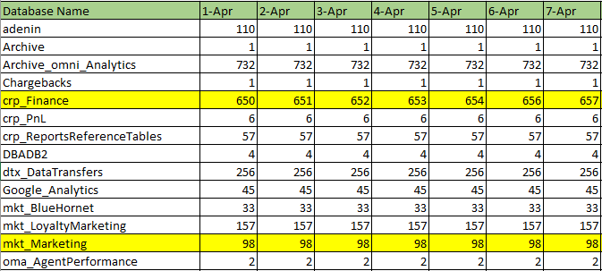

Monthly Table Growth Report

Introduction
This report focuses on identifying the specific tables that contribute to significant database growth. When a database exhibits rapid expansion, it is further analyzed to pinpoint the tables responsible for this increase. The Table Growth Report offers a detailed view of growth trends at the table level within these databases. To accurately assess table-level growth, current data is compared against the previous month's metrics, providing a clearer understanding of which tables are driving the change.

Summary
Monitoring table growth is crucial for maintaining database performance and optimizing storage. This report highlights the tables that are contributing to significant growth within rapidly expanding databases.

SQL Query
The following SQL query can be used to fetch the table growth details for a specific month:
SELECT * FROM [dbo].[TableSize]
WHERE convert(varchar(12),DateTime,105)='29-07-2024' and DBName in ('Salesforce')
order by Used_MB desc

Charts
Below is a visual presentation of database growth report. This way we need to collect the growth details for each table.
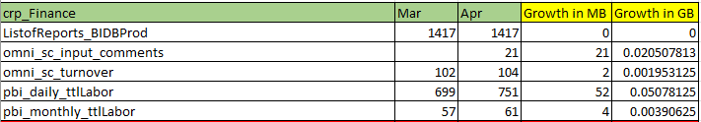

Key Highlights
- Monthly Monitoring: Both reports are generated monthly to ensure consistent tracking.
- Growth Detection: Databases with unusual or rapid growth are flagged for deeper analysis.
- Table-Level Insight: For flagged databases, the report drills down to identify which tables are contributing most to the growth.
- Comparative Analysis: Table sizes are compared with the previous month to highlight significant changes.
- SQL Queries: Standardized queries are used to extract relevant data for both database and table growth.
- Visual Aids: Charts are included to visualize growth trends over time.
- Total Growth Calculation: The database report includes a summary of total growth in GB to assess overall server impact.

SQL Query to Find Long-Running Queries

SELECT TOP 10
r.start_time,
s.text AS sql_text,
r.total_elapsed_time / 1000 AS elapsed_time_ms,
r.status,
r.session_id,
r.database_id
FROM sys.dm_exec_requests r
CROSS APPLY sys.dm_exec_sql_text(r.sql_handle) s
ORDER BY total_elapsed_time DESC;

📌 This helps: ✔ Find queries running for an extended period ✔ See execution time, SQL text, and session details

SQL Query to Identify Blocking Queries

SELECT blocking_session_id AS BlockingSession,
session_id AS BlockedSession,
wait_type,
wait_time / 1000 AS WaitTime_MS,
status
FROM sys.dm_exec_requests
WHERE blocking_session_id <> 0;

sp_who and sp_who2 are system stored procedures in SQL Server used for monitoring active sessions and troubleshooting performance issues. They provide valuable insights into the processes running on the server, helping DBAs analyze blocking, slow queries, and session activity.

1.sp_who
sp_who is a built-in stored procedure that retrieves information about current connections and processes.
Syntax:
sql
EXEC sp_who;

2.EXEC sp_who2;

sp_who2 provides additional insights, including CPU usage, disk IO, and memory consumption.

Power BI Dashboard deployment and Gateway Settings

Introduction To ensure seamless data connectivity and efficient report processing, we are migrating the Power BI gateway from DALDCEEDWPROD to DALDCESQLPROD02. This migration will enhance system performance, reduce dependency on a single gateway, and enable better load distribution.
Additionally, we will be configuring a gateway cluster by adding another gateway on PROD01. This setup ensures high availability, preventing any disruption in data access in case of failure.
The steps outlined below provide a detailed process for migration, configuration, and testing.

Migration of Gateway
From DALDCEEDWPROD To DALDCESQLPROD02 server

Steps -
1. Download standard gateway on PROD02 server
2. In the gateway installer, keep the default installation path, accept the terms of use, and then select Install.
3. Enter the email address for your Office 365 organization account, and then select Sign in.
(powerbi_service@omnihotels.com)
The gateway is associated with your Office 365 organization account. You manage gateways from within the associated service.
4. Select Migrate
a. Give - Available Gateway Clusters name
b. Select - Available Gateways
c. Give - Recovery Key (XsbBiTRIom3P6bBN) should be work.
d. Click on Configure
5. Review the information in the final window. Because this example uses the same account for Power BI, Power Apps, and Power Automate, the gateway is available for all three services. Select Close.
6. Test the Connect on powerbi portal for any semantic data source connection using the lineage view
7. Disable the Old Gateway.
8. After disabling the old gateway Test connection again.

Add another gateway to create a cluster (PROD01)
A cluster lets gateway admins avoid having a single point of failure for on-premises data access. If the primary gateway is unavailable, data requests are routed to the second gateway that you add and so on.
- Download the gateway on PROD01 install it.
- After you sign into your Office 365 organization account, register the gateway.
- Select Add to an existing cluster. In the Available gateway clusters list, select the primary gateway, which is the first gateway you installed
- Enter the recovery key for that gateway. Select Configure.
- Select Add to an existing cluster.
- Test the connections.

Refe.
https://app.powerbi.com/groups/c2df82df-cc64-4add-8035-7097cd66fcf2/lineage -- PBI connections

Install an on-premises data gateway | Microsoft Learn – Gateway installation

New Recovery Key - XsbBiTRIom3P6bBN

Gateway Name - omni_pbi_gateway_primary

Power BI Health check Dashboard

Link-

https://app.powerbi.com/groups/afa1694e-1cbb-47b6-9d84-7e8406436923/reports/9642b6d3-3a4a-4a0c-9f72-ae5d0db87ec0/ReportSection2ef6edc42e01e23c3579?experience=power-bi

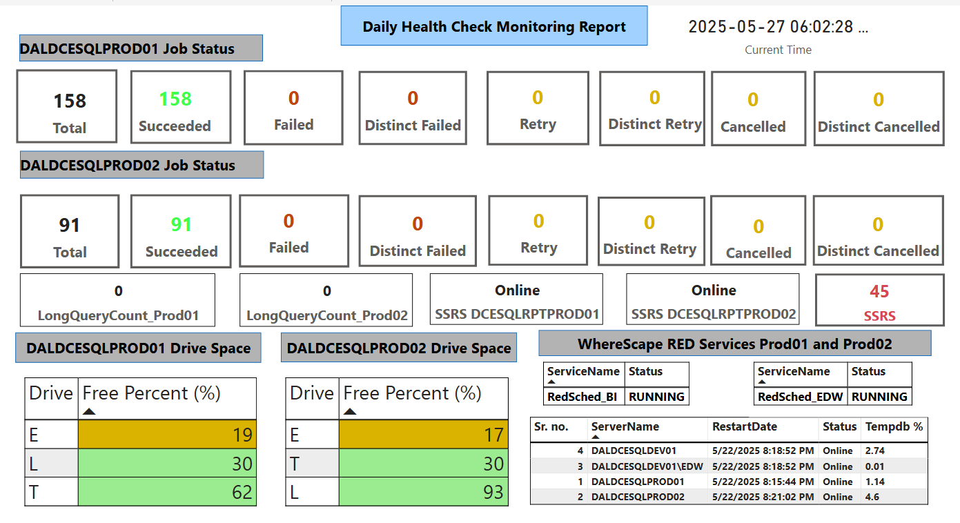

The above dashboard will provide the details below.

1. Job Status on Prod01 and Prod02
The dashboard will display the status of jobs running on Prod01 and Prod02, including:
- Success: Jobs that are executed successfully.
- Failed: Jobs that encountered errors and did not complete.
- Distinct Failed: Unique failed jobs to identify patterns.
- Retry: Jobs that were retried after failure.
- Distinct Retry: Specific attempts for failed jobs.
- Cancelled: Jobs that were manually or automatically canceled.
- Distinct Cancelled: Unique canceled jobs for trend analysis.

2. Drive Space Monitoring
- Prod01 and Prod02 Drive Space Usage: Displays available and used space for each server.
- Helps identify if additional storage is required or if cleanup is needed.

3. Server Details
- Server Name: Identifies the server being monitored.
- Restart Date: Tracks the last restart time for Prod01 and Prod02 servers.
- Status: Indicates whether the server is operational or has issues.
- TempDB Monitoring: Monitors TempDB usage to prevent performance bottlenecks.

4. Wherescape Red Services
- Displays the status of Wherescape Red ETL services, ensuring data pipelines are running smoothly.

5. Long-Running Job Count
- Shows the count of long-running jobs on both Prod01 and Prod02.
- Helps detect performance delays and optimization needs.

6. SSRS Report Server Status
- Monitors whether SSRS report servers on Prod01 and Prod02 are online or offline.
- Ensures report availability and accessibility.

7. Power BI Health Check Dashboard

The Power BI Health Check Dashboard will aggregate all the above metrics into a visualized format, providing:
- Real-time tracking of job execution status.
- Alerts for failures and issues.
- Historical trends for troubleshooting.
- Actionable insights for database and server performance.

