File names

Usually, the file names follow the rule:
ParticipantName_trial_training_EEG_PercentageofAccuracy[date-time].csv

Exemple:
Felipe_1a_treinamento_EEG_67%[2026.06.19-15.42.21].csv

CSV file description

The CSV files follow the standard save format from Open Vibe [link].

Timestamp and sampling rate:

The first header column contains two pieces of information:

- First column will contain timestamp information
- The sampling rate of the current file

The timestamp field will contain information about the time at which the matrix/events were received.

Epoch: Epoch index is the sequential numerical identifier assigned to each time window (epoch) extracted from the continuous EEG signal stream.

Matrix data: Matrix data columns simply carry the data information, recorded in floating format with arbitrary precision.

Event Id: Data will be a list of stimulations identifier separated by :

Stimulation identifiers can be consulted at the Open Vibe documentation [link]

Event Date: Data will be a list of date in seconds associated to the stimulations and separated by :

Event Duration (not working): Data will be a list of durations in seconds associated to the stimulations and separated by :

Channel Location

Each channel has a specified electrode on the EEG cap.

Channel | 1 | 2 | 3 | 4 | 5 | 6 | 7 | 8 | 9 | 10 | 11 | 12 | 13 | 14 | 15 | 16
Electrode | F1 | FC1 | C1 | CP1 | P1 | Fz | FCz | Cz | CPz | Pz | F2 | FC2 | C2 | CP2 | P2 | P2

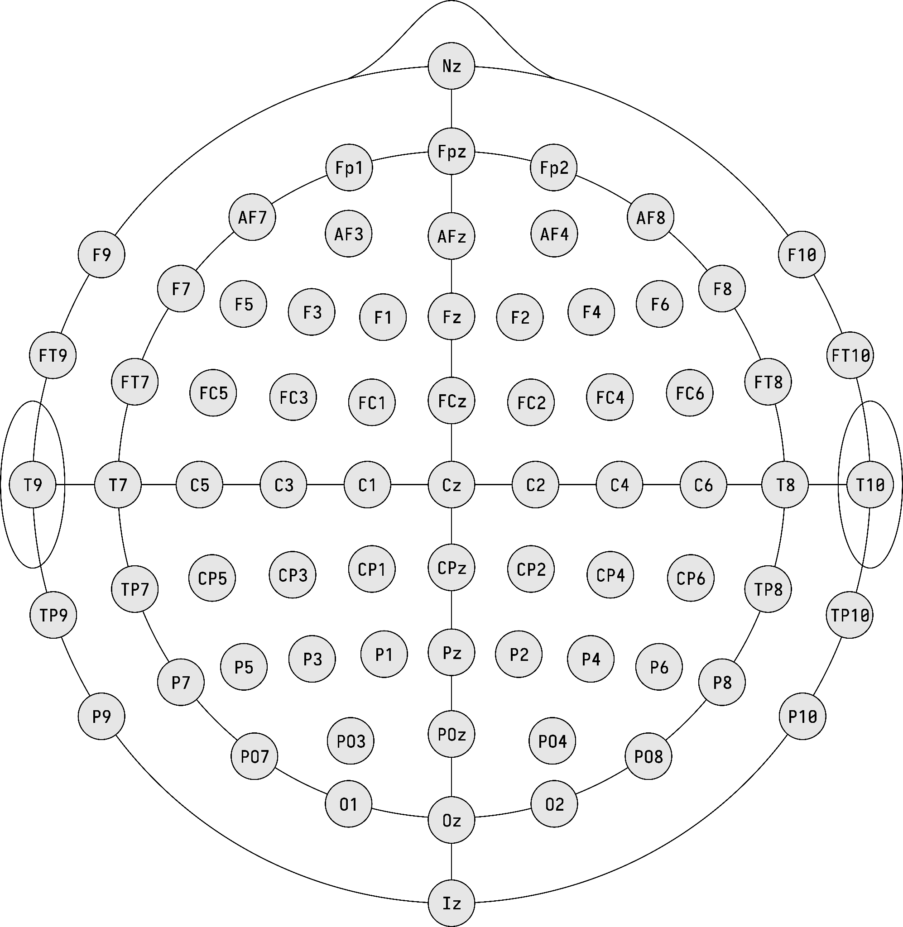

1
1
1

