ITP4506 Human Computer Interaction and GUI
Lab 10 - WPF Shapes

Q1 Defining layout using a grid

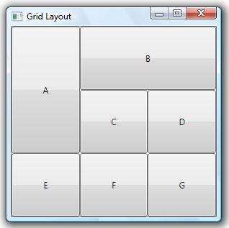
Design a grid which arranges several buttons as shown in the figure.

<Window x:Class="MainWindow"
xmlns="http://schemas.microsoft.com/winfx/2006/xaml/presentation"
xmlns:x="http://schemas.microsoft.com/winfx/2006/xaml"
Title="Grid Layout" Height="300" Width="300">
<Grid>
<Grid.RowDefinitions>

--- Complete this part ---

</Grid.RowDefinitions>
<Grid.ColumnDefinitions>

--- Complete this part ---

</Grid.ColumnDefinitions>
<Button Grid.Row="0" Grid.Column="0"
Grid.RowSpan="2">A</Button>

--- Complete this part ---

</Grid>

</Window>

Q2 Drawing 2D shapes in WPF
- Open Visual Studio 2010
- On the File menu, click New Project.
- In the New Project dialog box, select Project type Visual Basic. In the Templates pane, click WPF Application.
- In the Name box, type 2DGraphics, and then click OK.
- In the XAML editor, change the Title attribute of the Window element from MainWindow to 2D Shapes. Change the Height attribute from 300 to 400. Change the Width attribute from 300 to 500.
- Change the Grid element to a Canvas element. Add two lines and one ellipse inside the Canvas as follows.
<Window x:Class="MainWindow"
xmlns="http://schemas.microsoft.com/winfx/2006/xaml/presentation"
xmlns:x="http://schemas.microsoft.com/winfx/2006/xaml"
Title="2D Shapes" Height="400" Width="500">
<Canvas Height="300" Width="450" Margin="0, 0, 100, 0">

<Line
X1="20" Y1="20"
X2="80" Y2="80"
Stroke="Red"
StrokeThickness="5" />
<Line

--- Complete this part ---

/>
<Ellipse
Fill="Orange" Height="100" Width="200"
Canvas.Left="250"
StrokeThickness="3"
Stroke="Red"/>

</Canvas>
</Window>
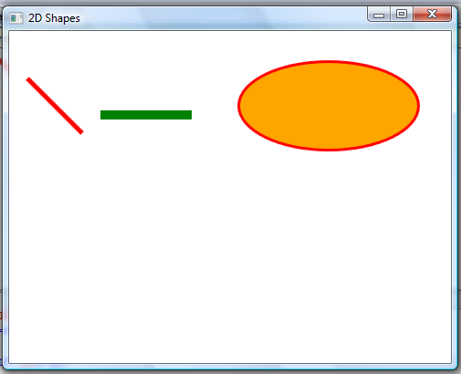
- Run the project to see what the shapes will be drawn.

- Add a rectangle inside the canvas and add the event handler for Rectangle_click in the code-behind page.
Add a rectangle
<Rectangle

--- Complete this part ---

/>
Add the event handler in the code-behind page
Private Sub Rectangle_Click(ByVal sender As Object, ByVal e As RoutedEventArgs)
MessageBox.Show("You have clicked the rectangle!")
End Sub
[Visual C#]
private void Rectangle_click(object sender, RoutedEventArgs e)
{
MessageBox.Show("You have clicked the rectangle!");
}
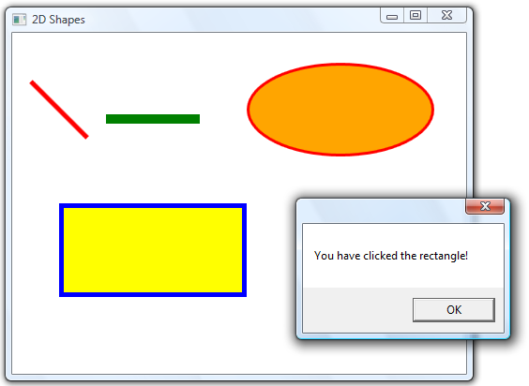
- Run the project and click on the rectangle.

- Add a path and a triangle as follows.
Add a path
<Path Stroke="Black" StrokeThickness="3"
Data="M 75,120 C 200,50 300,75 350,180" />
Add a triangle
<Polygon Fill="Green" Stroke="Red" StrokeThickness="3"
Points="350,200 300,280 400,280" />
- Run the project to see how the path and the triangle are drawn. Try to modify the points on the path and the triangle.

Q3. i) Given the following attributes of a 2D figure:
vertices : (150, 100), (200, 100), (200, 150),
(250, 150), (250, 200), (150, 200)
fill colour : orange
outline colour : blue
outline width : 5
Complete the following XAML file which draws the above square in a window using the Polygon shape:
<Window x:Class="MainWindow"
xmlns="http://schemas.microsoft.com/winfx/2006/xaml/presentation"
xmlns:x="http://schemas.microsoft.com/winfx/2006/xaml"
Title="Test" Height="500" Width="600">
<Canvas>

COMPLETE THIS PART

</Canvas>
</Window>

ii) Add XAML code to the program in part i) which draws a triangle beside the 2D figure as shown below.
Two sides of the triangle should coincide with those
of the 2D figure.
fill colour : red
outline colour : black
outline width : 5

