**4. New Input Types** (Chrome)

## HTML4 Sample pages

## <!DOCTYPE html>

## <html>

## <body>

## <form>

## <fieldset>

## <legend>Fieldset legend - a caption/title for this set of fields</legend>

## <ul>

## <li><label for="normal">Normal input box</label>

## <input id="normal" type="text" value="a 'normal' input box" /></li>

## <li><input id="checkbox" type="checkbox" />

## <label for="checkbox">I'm a checkbox</label></li>

## <li><input id="radio" type="radio" />

## <label for="radio">I'm a radio button</label></li>

## <li><label for="file">Upload</label>

## <input id="file" type="file" /></li>

## <li><label for="password">Password</label>

## <input id="password" type="password" value="mypassword" /></li>

## <li><label for="textarea">Textarea</label>

## <textarea id="textarea" rows="5" cols="40">This is a textarea</textarea></li>

## <li><label for="select">Select</label>

## <select id="select">

## <option>Option 1</option>

## <option>Option 2</option>

## <option>Option 3</option>

## <option>Option 4</option>

## </select></li>

## <li><input type="submit" value="Submit" />

## <label for="checkbox">I'm a checkbox</label></li>

## <li><input type="reset" value="Reset" /></li>

## </ul>

## </fieldset>

## </form>

## </body>

## </html>

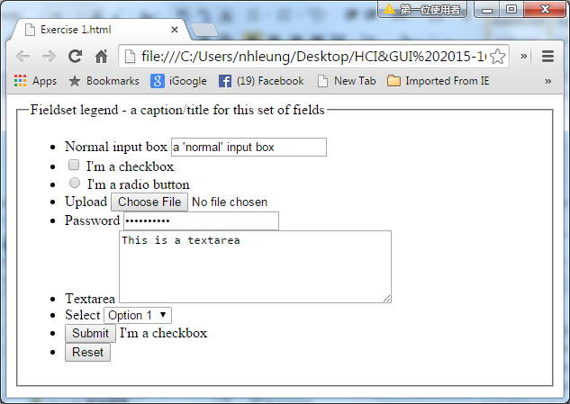

## HTML5 Codes

## Input Type: Color

<form >

Select your favorite color: <input type="color" name="favcolor"><br>

<input type="submit">

</form>

## Input Type: Email

<form>

E-mail: <input type="email" name="email">

<input type="submit">

</form>

## Input Type: URL

<form>

E-mail: <input type="url" name="url">

<input type="submit">

</form>

## Input Type: Search

<form>

<input type="search" results="5" id="search" name="search" />

</form>

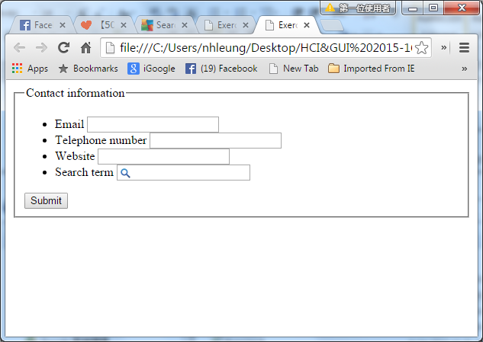

## Input Type: Date / Time

<form>

<fieldset>

<legend>Date information</legend>

Birthday1 : <input type="datetime-local" name="bday" min="2015-09-13"/><br><br>

Birthday2 : <input type="date" name="bday" min="2015-07-15"/><br><br>

Time1 : <input type="time" name="btime" min="02:12" /><br><br>

Month : <input type="month" name="bday" min="2015-08" max="2015-12"/><br><br>

Week : <input type="week" name="bday" min="2015-W25" /><br><br>

<input type="submit" value"Submit this" />

</fieldset>

</form>

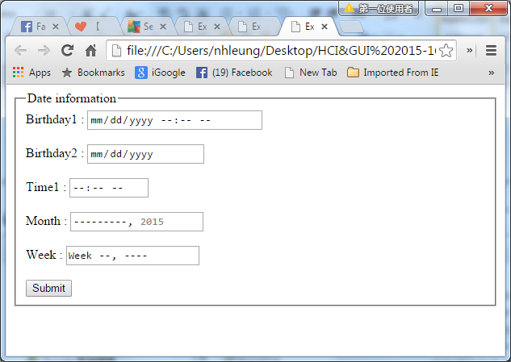

## Input Type: File Upload

<input multiple type="file" id="upload" name="upload" />

Attribute **multiple** indicates upload multiple files are allowed.

## Input Type: number

<form>

Quantity (between 1 and 5): <input type="number" name="quantity" min="1" max="5">

<input type="submit">

</form>

Input Type: range

<form >

Points: <input type="range" name="points" min="1" max="10">

<input type="submit">

</form>

Use the following attributes to specify restrictions:

* [max](http://www.w3schools.com/tags/att_input_max.asp) - specifies the maximum value allowed
* [min](http://www.w3schools.com/tags/att_input_min.asp) - specifies the minimum value allowed
* [step](http://www.w3schools.com/tags/att_input_step.asp) - specifies the legal number intervals
* [value](http://www.w3schools.com/tags/att_input_value.asp) - Specifies the default value

Placeholder for Textbox

<input type="text" placeholder="Input a number here" />

Output number for range

<form oninput="x.value=range.value">

<fieldset>

<legend>Number information</legend>Volume

<input required type="number" id="number" value="2" name="number"

step="0.5" min="0" max="10" /><br><br>

<input required type="range" id="range" value="2" name="range"

step="0.5" min="0" max="10" />

<output name="x" ></output><br><br>

<input type="text" placeholder="Input a number" /><br><br>

<input type="submit" />

</fieldset>

</form>

Type : Datalist

<label for="sport">What's your favourite sport?</label>

<input list="sportlist" type="text" id="sport" name="sport" />

<datalist id="sportlist">

<option label="Baseball" value="Baseball" />

<option label="Football (Soccer)" value="Soccer" />

<option label="Football" value="Football" />

<option label="Ice Hockey" value="Ice Hockey" />

</datalist><br><br>

Type : Progress Bar

<p>You are downloading a very important file, please wait.</p>

<progress value="45" max="100"><span>45</span>% complete</progress>

Type : Meter

<p>Your score is: <meter value="2" min="0" max="10">2 out of 10 </meter></p>

<p>Your score is: <meter value="91" min="0" max="100" low="40" high="90" optimum="100">A+</meter></p>

The meter element (shown in Figure 5.19) can be used to describe the current status of hard drive space:

<meter min="0" value="512" max="1024">You are using exactly 50% of your hard drive space</meter>

Possible attributes for meter:

min: The minimum allowed value. If no min attribute, the value is set as 0.

max: The maximum allowed value.

value: The actual value and must be present when using meter.

low: The low part of the value.

high: The high part of the value.

optimum: It is the optimum value. Its value must be between min and max.

However, it can be greater than high.

Color of the meter depends on the attributes:

* If low < optimum < high:
  + If the value is < low or > high, it is displayed as yellow,
  + Otherwise green (optimum has not effect).
* If low < high < optimum:
  + If the value is < low, it is displayed as red.
  + If the value is < high, it is displayed as yellow.
  + Otherwise green.
* If optimum < low < high:
  + If the value is > high, it is displayed as red.
  + If the value is > low, it is displayed as yellow.
  + Otherwise green.

**Exercise 4**

Design a web form which is similar to the following figure:

