ITP4507 Contemporary Topics in SE

Lab 4 – Creational Patterns (Answer)

Q1
(a)
abstract class Product
{
public abstract String getName();
}

class ConcreteProductA extends Product
{
public String getName() {return "ConcreteProductA";}
}

class ConcreteProductB extends Product
{
public String getName() {return "ConcreteProductB";}
}

abstract class Creator
{
public abstract Product factoryMethod();

public void anOperation()
{
Product p = factoryMethod();
System.out.println("Product Created : " + p.getName());
}
}

class ConcreteCreatorA extends Creator
{
public Product factoryMethod()
{
return new ConcreteProductA();
}
}

class ConcreteCreatorB extends Creator
{
public Product factoryMethod()
{
return new ConcreteProductB();
}
}

(b) abstract class AbstractProductA
{
public abstract String getName();
}

class ProductA1 extends AbstractProductA
{
public String getName() { return "ProductA1"; }
}

class ProductA2 extends AbstractProductA
{
public String getName() { return "ProductA2"; }
}

abstract class AbstractProductB
{
public abstract String getName();
}

class ProductB1 extends AbstractProductB
{
public String getName() { return "ProductB1"; }
}

class ProductB2 extends AbstractProductB
{
public String getName() { return "ProductB2"; }
}

abstract class AbstractFactory
{
public abstract AbstractProductA createProductA();
public abstract AbstractProductB createProductB();
}

class ConcreteFactory1 extends AbstractFactory
{
public AbstractProductA createProductA() { return new ProductA1(); }

public AbstractProductB createProductB() { return new ProductB1(); }
}
class ConcreteFactory2 extends AbstractFactory
{
public AbstractProductA createProductA() { return new ProductA2(); }

public AbstractProductB createProductB() { return new ProductB2(); }
}
class Client
{
public AbstractProductA createA(AbstractFactory factory)
{
return factory.createProductA();
}
public AbstractProductB createB(AbstractFactory factory)
{
return factory.createProductB();
}
}
(c) Factory Method : Define an interface for creating an object, but let subclasses decide which class to instantiate.
Abstract Factory : Provide an interface for creating families of related or dependent objects without specifying their concrete class. The client object only uses interfaces declared by AbstractFactory and AbstractProduct classes.

Q2

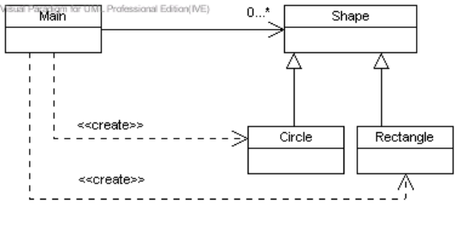
Problem: the main class needs to be modified for supporting additional shapes

Q3

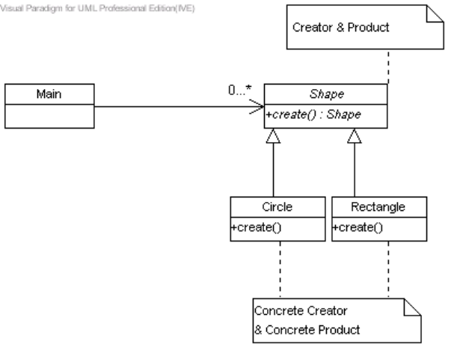

Code for Implementation:

// Main.java
public class Main {

public static void main(String[] args) {
Vector _shapes = new Vector();
Shape[] shapeCreators = { new Circle(0,0,0), new Rectangle(0,0,0,0) };
boolean cont = true;
InputStreamReader is = new InputStreamReader(System.in);
BufferedReader br = new BufferedReader(is);
try {
while (cont) {
System.out.println("Enter command: 0 = exit, 1 = draw all shapes, 2 = create circle, 3 = create square");
String line = br.readLine();
int command = Integer.parseInt(line);
if (command == 0)
cont = false;
else if (command == 1) {
for (int i = 0; i < _shapes.size(); i++)
( (Shape) _shapes.elementAt(i)).draw();
} else {
_shapes.add(shapeCreators[command-2].create());
}
}
} catch (Exception e) {
e.printStackTrace();
}
}

}

-------------------------
// Shape.java
public abstract class Shape {
protected int _x; // the x-coordinate of the top left hand corner
protected int _y; // the y-coordinate of the top left hand corner

public Shape(int x, int y) {
_x = x;
_y = y;
}

public abstract int getWidth();
public abstract int getHeight();
public abstract void draw();
public abstract Shape create() throws Exception;

public void setX(int x) {
_x = x;
}

public void setY(int y) {
_y = y;
}

public int getX() {
return _x;
}

public int getY() {
return _y;
}
}
// Circle.java
import java.io.*;

public class Circle extends Shape {
protected int _radius;
protected int _cx; // x-coordinate of the centre
protected int _cy; // y-coordinate of the centre
public Circle(int cx, int cy, int radius) {
super(cx - radius, cy - radius);
_cx = cx;
_cy = cy;
_radius = radius;
}

public Shape create() throws Exception {
InputStreamReader is = new InputStreamReader(System.in);
BufferedReader br = new BufferedReader(is);
System.out.println("Enter radius:");
String line = br.readLine();
int r = Integer.parseInt(line);
return new Circle(0,0, r);
}

public int getRadius() {
return _radius;
}

public int getCenterX() {
return _cx;
}

public int getCentreY() {
return _cy;
}

public void setRadius(int r) {
_radius = r;
}

public void setCenterX(int x) {
_cx = x;
_x = _cx - _radius;
}

public void setCenterY(int y) {
_cy = y;
_y = _cy - _radius;
}

public int getWidth() {
return _radius*2;
}

public int getHeight() {
return _radius*2;
}

public void draw() {
System.out.println("Circle at (" + _cx + ","+ _cy + "), raduis = " + _radius);
}
}
// Rectangle.java
import java.io.*;

public class Rectangle extends Shape {
protected int _width, _height;

public Rectangle(int x, int y, int width, int height) {
super(x,y);
_width = width;
_height = height;
}

public Shape create() throws Exception {
InputStreamReader is = new InputStreamReader(System.in);
BufferedReader br = new BufferedReader(is);
System.out.println("Enter width:");
String line = br.readLine();
int width = Integer.parseInt(line);
System.out.println("Enter height:");
line = br.readLine();
int height = Integer.parseInt(line);
return new Rectangle(0,0,width, height);
}

public void draw() {
System.out.println("Rectangle at (" + _x + "," + _y + "), width = " +_width + ", height = " + _height);
}

public int getWidth() {
return _width;
}

public int getHeight() {
return _height;
}
}

Q4

// Main.java
import java.util.*;
import java.io.*;

public class Main {

public static void main(String[] args) {
Vector _shapes = new Vector();
String [] shapeNames = {"Circle", "Rectangle" };
Shape[] shapeCreators = new Shape[shapeNames.length];
boolean cont = true;
InputStreamReader is = new InputStreamReader(System.in);
BufferedReader br = new BufferedReader(is);

try {
for (int i=0; i < shapeNames.length; i++)
shapeCreators[i] = (Shape) (Class.forName(shapeNames[i]).newInstance());
while (cont) {
System.out.println("Enter command: 0 = exit, 1 = draw all shapes, 2 = create circle, 3 = create square");
String line = br.readLine();
int command = Integer.parseInt(line);
if (command == 0)
cont = false;
else if (command == 1) {
for (int i = 0; i < _shapes.size(); i++)
( (Shape) _shapes.elementAt(i)).draw();
} else {
_shapes.add(shapeCreators[command-2].create());
}
}
} catch (Exception e) {
e.printStackTrace();
}
}

}

// Shape
public abstract class Shape {
protected int _x; // the x-coordinate of the top left hand corner
protected int _y; // the y-coordinate of the top left hand corner

public Shape() {
}

public Shape(int x, int y) {
_x = x;
_y = y;
}

public void setX(int x) {
_x = x;
}

public void setY(int y) {
_y = y;
}

public int getX() {
return _x;
}

public int getY() {
return _y;
}

public abstract int getWidth();
public abstract int getHeight();
public abstract void draw();
public abstract Shape create() throws Exception;
}

// Circle.java
import java.io.*;

public class Circle extends Shape {
protected int _radius;
protected int _cx; // x-coordinate of the centre
protected int _cy; // y-coordinate of the centre

public Circle() {
}

public Circle(int cx, int cy, int radius) {
super(cx - radius, cy - radius);
_cx = cx;
_cy = cy;
_radius = radius;
}

public Shape create() throws Exception {
InputStreamReader is = new InputStreamReader(System.in);
BufferedReader br = new BufferedReader(is);
System.out.println("Enter radius:");
String line = br.readLine();
int r = Integer.parseInt(line);
return new Circle(0,0, r);
}

public int getRadius() {
return _radius;
}

public int getCenterX() {
return _cx;
}

public int getCentreY() {
return _cy;
}

public void setRadius(int r) {
_radius = r;
}

public void setCenterX(int x) {
_cx = x;
_x = _cx - _radius;
}

public void setCenterY(int y) {
_cy = y;
_y = _cy - _radius;
}

public int getWidth() {
return _radius*2;
}

public int getHeight() {
return _radius*2;
}

public void draw() {
System.out.println("Circle at (" + _cx + ","+ _cy + "), raduis = " + _radius);
}
}

// Rectangle.java
import java.io.*;

public class Rectangle extends Shape {
protected int _width, _height;

public Rectangle() {
}

public Rectangle(int x, int y, int width, int height) {
super(x,y);
_width = width;
_height = height;
}

public Shape create() throws Exception {
InputStreamReader is = new InputStreamReader(System.in);
BufferedReader br = new BufferedReader(is);
System.out.println("Enter width:");
String line = br.readLine();
int width = Integer.parseInt(line);
System.out.println("Enter height:");
line = br.readLine();
int height = Integer.parseInt(line);
return new Rectangle(0,0,width, height);
}

public void draw() {
System.out.println("Rectangle at (" + _x + "," + _y + "), width = " +_width + ", height = " + _height);
}

public int getWidth() {
return _width;
}

public int getHeight() {
return _height;
}
}

