Hong Kong Institute of Vocational Education

Department of Information Technology
ITP4507 - Contemporary Topics in Software Engineering

Laboratory Exercise 9 – Dynamic HTML

Q1.
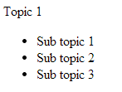
click ‘Topic 1’

click ‘Topic 1’

Figure 1

Write an HTML web page with JavaScript code to implement a dynamic web page. When the page is loaded, The left side of Figure 1 is shown. When ‘Topic 1” is clicked, ‘Topic 1” is expanded and the sub-topics are shown as the right side of Figure 1. When ‘Topic 1” is clicked again, the sub-topics are collapsed and hidden as shown in the left side of Figure 1.
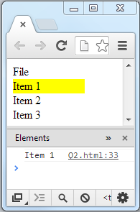

Q2.
mouse over ‘Item 1’
click ‘File’
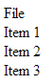

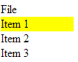

click ‘File’
click ‘Item 1’

Figure 2

Write an HTML web page with javascript code to implement a ‘File’ Menu:
- When the ‘File’ menu is clicked, the items (‘Item 1’, ‘Item 2’, ‘Item 3’) under the menu is shown.
- When the user mouse the mouse pointer over an item, the item is highlighted with yellow as the background color.
- When the user clicks an item, the item’s text is displayed in the console.
- When the user clicks ‘File’ again, the menu items are hidden.

