Hong Kong Institute of Vocational Education

Department of Information Technology
ITP4507 - Contemporary Topics in Software Engineering

Laboratory Exercise 10 – Dynamic HTML & JSON

Q1. Write an HTML web page with JavaScript code to implement a stack simulator.

- When the web page is loaded:
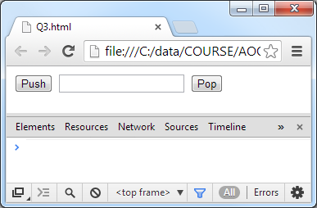

- The user enters ‘item 1’ and clicks the push button:
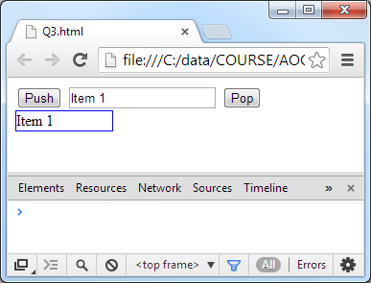

- The user enters ‘item 2’ and clicks the push button:
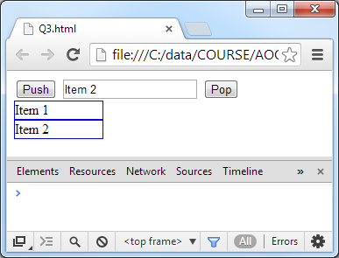

- The user clicks the pop button:
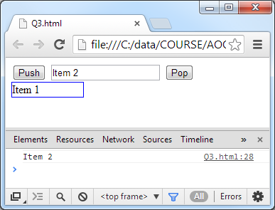

Q2. Write an HTML web page with JavaScript code to implement a simple demonstration for JSON conversion.

- When the page is loaded:
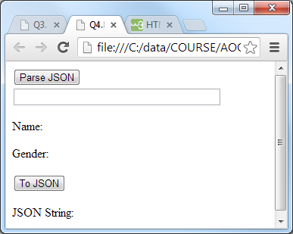

- When the user enters a JSON string and clicks the ‘Parse JSON’ button, the system parses the string in the input field to an object and displays the values of the name and gender attributes of the object.
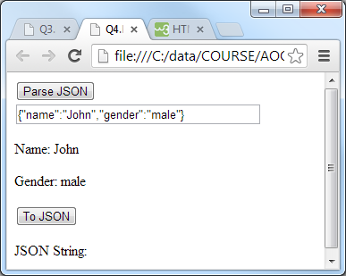

- When the user clicks the ‘To JSON’ button, the system displays the JSON string of the object which has been created in Step 2.
