 | IVE Information Technology
Information & Communications Technology

Programme Board

Instructions:
(a) This paper has a total of 6 pages including the covering page.  (b) This paper contains ONE Question (A1).  (c) The Question A1 is WORTH XX marks.  (d) Answer ALL sub-questions.  Note: The result of this assessment will not be counted if you do not meet the minimum attendance requirement (if any) governed by the general academic regulations of your programme/course unless approval of the campus principal has been granted. | HIGHER DIPLOMA IN  SOFTWARE ENGINEERING  (IT114105)  MODULE TITLE:  ENTERPRISE SYSTEMS DEVELOPMENT  MODULE CODE: ITP4511
SEMESTER TWO
PRACTICAL TEST

SAMPLE PAPER

Answer ALL sub-questions.
General Demands
- Download the answer template file (docx) format from moodle.
- Create a web application project based on the provided project specification.
- Work on the web application, adhering to the requirements and instructions, to find out the answer.
- Transfer your completed answer to the answer template (docx), including your name and student ID.
- Submit the completed template to Moodle*.
- You MUST NOT use your own computer.
- The use of notes, AI, and Internet connectivity is STRICTLY PROHIBITED, except the permitted one-page note.
- Cheating and plagiarism may result in DISCIPLINARY ACTION.
* You are not required to submit the completed source code and web project.

Permitted Pre-installed Software
- NetBeans IDE.
- Microsoft Word
- XAMPP / MAMP / SQL Server.
- phpMyAdmin / offline SQL database manipulation software.
- Browser (Other than phpMyAdmin & VTC Moodle, for system test and debug ONLY).
- VTC Moodle (for downloading time and submission time ONLY).
Project Specification
Project Name | EventSphere
Artifact Id | com.eventsphere
Java EE version | Java EE 8 Web / Jakarta EE 10 Web
Database username | root (XAMPP) / root (MAMP)
Database password | (empty string) (XAMPP) / root (MAMP)
Database server port | 3306 (XAMPP) / 8889( MAMP)
Database name | EVENTSDB
MySQL JDBC Dependency for Maven | <dependency>  <groupId>com.oracle.database.jdbc</groupId>  <artifactId>ojdbc5</artifactId>  <version>11.2.0.4</version>  </dependency>  <dependency>  <groupId>mysql</groupId>  <artifactId>mysql-connector-java</artifactId>  <version>5.1.49</version>  </dependency>
Database Schema (eventTable)
Column Name | Type | Size | Key | Description
eventID | int | 10 | Primary Key | NOT NULL
eventName | varchar | 255 |  | NOT NULL
eventDate | varchar | 255 |  | NOT NULL
venue | int | 10 |  | NOT NULL
ticketPrice | int | 1 |  | NOT NULL
seatsAvailable | Int | 5 |  | NOT NULL

SQL Commands to Create Database, Tables and Insert Sample Data
-- Create Database
CREATE DATABASE EVENTSDB;
USE EVENTSDB;

-- Create eventTable
CREATE TABLE eventTable (
eventID INT(10) PRIMARY KEY NOT NULL,
eventName VARCHAR(100) NOT NULL,
eventDate DATE NOT NULL,
venue VARCHAR(150) NOT NULL,
ticketPrice INT NOT NULL,
seatsAvailable INT(5) NOT NULL
);

-- Insert Sample Data
INSERT INTO eventTable VALUES
(1, 'Tech Conference 2025', '2025-06-15', 'Convention Center', 50, 400),
(2, 'Music Fest', '2025-07-20', 'Harbour Park', 80, 150),
(3, 'Art Exhibition', '2025-08-10', 'City Gallery', 30, 50),
(4, 'Food Carnival', '2025-09-05', 'Harbour Park', 20, 0),
(5, 'Startup Summit', '2025-10-01', 'Convention Center', 60, 300);

The EventSphere Event Booking System

A company is developing a web application to allow users to search for upcoming events based on their preferred venue and maximum ticket price. The system uses Java EE technologies (Servlet, JSP, Java Bean) with a MySQL database, following the Model-View-Controller (MVC) pattern. The search page layout is described below:

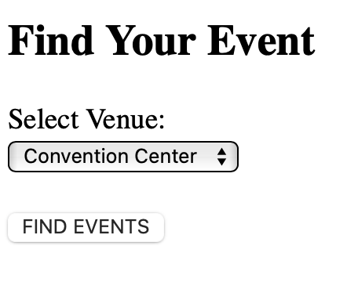

Figure 1a: A sample output of searchEvents.jsp

Users can search for events by inputting their budget and selecting at one location. Ans error page will be shown if budget and/or location is missing after clicking the search button.

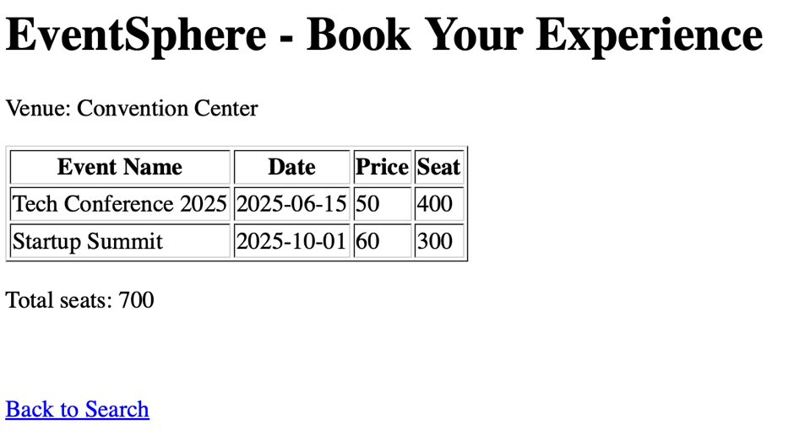

Figure 1b: A sample output of list.jsp.

(a) Search Input Page (searchEvents.jsp) [x marks]
Create the JSP page searchEvents.jsp. Complete the HTML code for searchEvents.jsp as shown the Figure 1a

In searchEvents.jsp, create the input form according to the following table. The input form will send a GET request to searchEventServlet.
Form Control | Field Name | Remark
Dropdown | venue | Options: Convention Center, Harbour Park, City Gallery
Input |  | Submit button with value “FIND EVENTS”

(b) Data Model (EventBean.java) [x marks]
Define a Java Bean Class EventBean (EventBean.java) in package com.bean with a default constructor, private properties, and getter/setter methods for: int eventID, String eventName, String eventDate, String venue, int ticketPrice, int seatsAvailable.
package com.bean;

//class definition here

(c) DB class (EventDB.java) [x marks]
Create and complete the EventDB class in package com.db according to the following requirements. You can skip handling exception unless the code fragment asks you to do so.

JDBC Driver name: com.mysql.jdbc.Driver
JDBC Connection String: (XAMPP version) jdbc:mysql://localhost:3306/EVENTSDB
(MAMP version) jdbc:mysql://localhost:8889/EVENTSDB

(i). Define necessary variable and constructor of the class.

(ii). Define a getConnection() with driver loading and connection return.

(iii). Implement getEvents(String venue) to query the event (criteria venue) within the database and return an ArrayList of EventBean using Statement.

(d) Controller class (ListEventServlet.java) [x marks]
Create the controller class (ListEventServlet) in package com.servlet mapped to /searchEventServlet.

(i). Define and map the servlet to the required route.

(ii). Define the eventDB (datatype: EventDB), override init() and instantate the eventDB variable.

(iii). Complete the appropriate doGet/doPost function, retrieve the data and forward to list.jsp for display using the “request” scope.

(e) Design and implement the view (list.jsp) [x marks]

(i). Use JSP Action to get the forwarded arraylist. (hints, import necessary class using directive)

(ii). Use Script to display the event according to the given design.

(iii) Calculate the total seats available and display using Expression.

(f) Understanding on system architecture [x marks]
Taking Eureka Naming server as an example, what is the use of naming server in microservices architecture?

***** END OF SAMPLE PAPER *****

