Dissertation Submitted to Zhejiang Gongshang University for Master’s Degree of Science

Parameter Estimation Of Finite Mixture Model Based On Modified DA-EM Algorithm
Author： Yang Shengjie
Major： Statistics
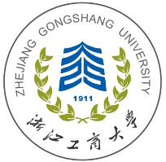
Supervisor： Prof. Wang Weigang

Jan. 2020
School of Statistics and Mathematics
Zhejiang Gongshang University
Hangzhou, 310018, P. R. China

