  
Parcel Delivery Tracking

Requirement Specification Document

*Table of Contents*

Overall Description 2

Purpose 2

Intended Audience 2

Intended Use 3

Scope 4

Definition and Acronyms 4

User Stories 4

Project Backlog Item 6

Entity Relationship Diagram 7

Table Descriptions 8

Use Case Diagram 9

System Features 10

Functional Requirements 11

Non-Functional Requirements 11

Security Log in 11

User Registration and Login 11

Technology Stack 12

API Swagger Endpoint List 13

Parcel Information Endpoints 14

Personnel Information Endpoints 14

Delivery Information Endpoints 16

Wireframe 17

Home Page 17

Admin Page 17

Driver page 18

Log in and Registration Page 18

Lesson Learned 19

# Overall Description

Parcel Delivery Tracking System is a comprehensive software application designed to streamline and enhance the logistics and delivery processes for a delivery company. This system is built to cater to a diverse clientele, including businesses, shops, warehouses, and individual customers, who require efficient parcel tracking and delivery services.

# Purpose

The purpose of the Parcel Delivery Tracking System is to provide a comprehensive and efficient software solution for managing parcel tracking and delivery logistics for a delivery company. This system aims to streamline the entire parcel lifecycle, from creation to delivery, while ensuring ease of use.

# Intended Audience

The intended audience for the Parcel Delivery Tracking System include:

* **Delivery Company**: The system is designed for the delivery company, enabling it to optimise its parcel management, delivery operations and client interaction.
* **Clients**: Businesses, Shops, Warehouses, and individual customers who require parcel delivery services are the primary end-users of the system. Clients can request parcel deliveries and track the status of their parcels.
* **Delivery Personnel**: Delivery drivers, managers, other personnel responsible for handling deliveries will use the system to access delivery details, update statuses.
* **Administrators**: System administrators will have access to administrative features for user managements.

# Intended Use

The intended use of the Parcel Delivery Tracking System is to:

* Facilitate clients in requesting parcel deliveries providing parcel details, and tracking parcel statuses.
* Allow delivery personnel to access delivery assignments, update delivery statuses, and manage their availability.

# Scope

The scope of the Parcel Delivery Tracking System includes the following key functionalities:

* **Parcel Management**: Creation, update, and tracking of parcels, including sender and receiver information, parcel weights, statuses, and delivery dates.
* **Client Management**: Registration, profile management.
* **Delivery Management**: Assignment of delivery personnel to parcel, real-time status update, and tracking of deliveries.

# Definition and Acronyms

* EF – Entity Framework
* ERD – Entity Relationship Diagram
* API – Application Programming Interface
* DB/Db – Database
* ORM – Object Relational Mapper
* DBMS – Database Management System
* SDK – Software Development Kit

# User Stories

|  |  |  |
| --- | --- | --- |
| As a <User> | I want <Something> | So, I can <Benefit> |
| As an administrator | I want to view a list of all deliveries | So, I can have an overview of current delivery status. |
|  | I want to delete a delivery | So, I can remove erroneous or unnecessary delivery records from the system |
|  | I want to update delivery details | So, I can correct any inaccuracies or make necessary changes to delivery information |
|  | I want to retrieve information about a specific parcel | So, I can monitor the entire parcel inventory |
|  | I want to delete a parcel | So, I can remove parcel that are no longer relevant or in stock |
|  | I want to update parcel details | So, I can keep parcel information up to date |
|  | I want to retrieve information about specific personnel | So, I can have access to their details |
|  | I want to view a list of all personnel | So, I can manage and monitor personnel within the system |
|  | I want to delete a personnel record | So, I can remove personnel who are longer associated with the organisation |
|  | I want to update personnel details | So, I can keep personnel information accurate and current |
| As a manager |  |  |
|  | I want to view a list of all deliveries | So, I can oversee the progress and status of deliveries |
|  | I want to retrieve information about a specific delivery | So, I can quickly access details about a particular delivery when needed |
|  | I want to update delivery details | So, I can make necessary adjustments or corrections to delivery information as required. |
|  | I want to retrieve information about a specific personnel member | So, I can access their details when necessary |
|  | I want to view a list of all personnel | So, I can manage and monitor the personnel under my supervision |
|  | I want to update personnel details | So, I can ensure that personnel information remain accurate and up to date |
| As a driver | I want to view a list of all deliveries assigned to me | So, I can see which deliveries I need to complete |
|  | I want to update the status of deliveries I’m responsible for | So, I can indicate when a delivery has been completed or if there are any issues. |

# Project Backlog Item

|  |  |  |  |  |
| --- | --- | --- | --- | --- |
| ID | User | Item | Priority | Status |
| 1 | Admin | Read a list of deliveries | 1 | Completed |
| 2 | Admin | Read a list of parcels | 1 | Completed |
| 3 | Admin | Read a list of personnel | 1 | Completed |
| 4 | Admin | Read a list of parcels by parcel status (Delivered/In Transit/On hold) | 1 | Completed |
| 5 | Admin | Remove a Parcel from the system | 3 | Completed |
| 6 | Admin | Update a Delivery, Parcel, or Personnel | 3 | Completed |
| 7 | Manager | Read a list of Personnel | 1 | Not Started |
| 8 | Manager | Display a list of deliveries | 1 | Completed |
| 9 | Manager | Create a new delivery – assign a driver | 1 | Not Started |
| 10 | Manager | Display delivery details | 1 | Completed |
| 11 | Manager | Read a list of by delivery status (Complete/In Progress/Scheduled) | 2 | In Progress |
| 12 | Driver | Read a list of deliveries, assigned to me | 1 | Completed |
| 13 | Driver | Update delivery status | 1 | Completed |
| 14 |  | Change the ID’s data type from int to guid for security | 3 | Not Started |
| 15 |  | Test all the action methods in the Controller of Admin, Driver, and Manager areas | 3 | In Progress |
| 16 |  | Add logging for all the controllers | 3 | In Progress |
| 17 |  | Read User Details to their respective page | 3 | Completed |
| 18 |  | Use Security in terms of Authentication, Authorization, and Accounting (AAA) | 2 | In Progress |

# Entity Relationship Diagram

The major features of the parcel delivery tracking database system as shown in below ERD.

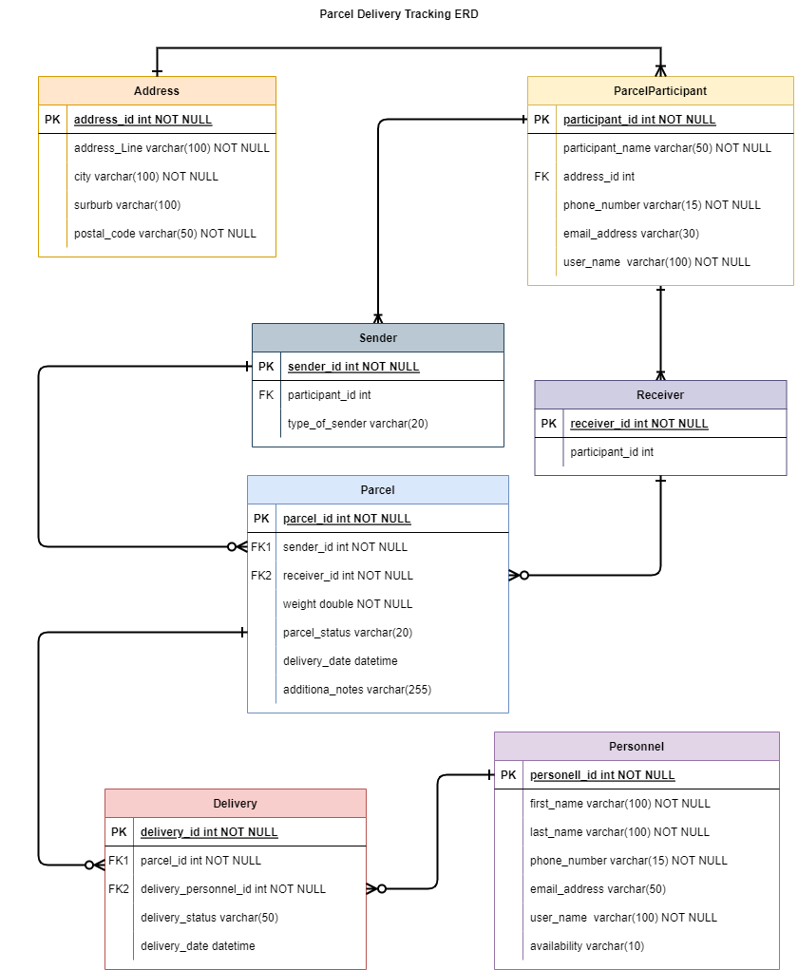

## Table Descriptions

1. Address Table:

* Contains information about addresses including address line, city, suburb, and postal. code. The table will be used to store address details for parcel participants (sender/receiver).

1. Parcel Participations Table:

* Represents participants (either sender or receiver) involved in parcel transactions.
* References Address table to store address information.
* Include fields for participant name, phone number, and email address.

1. Sender Table:

* Represent senders of parcels.
* References the ParcelParticipant table for sender details.
* Includes a “type” field, which can specify the type of sender (e.g., individual, business).

1. Receiver Table:

* Represent receivers of parcels.
* References the ParcelParticpartion Table for receive details.

1. Parcel Table:

* Contain information about parcels, including details such as sender, receiver, parcel weight, status, delivery date, and additional notes.
* References the Sender and Receiver Tables to establish relationships.

1. Personnel Table:

* Represents personnel involved in parcel delivery.
* Incudes fields for first name, last name, phone number, email address, role, and availability.

1. Delivery Table:

* Represents delivery transactions.
* References the Parcel Table for the parcel being delivered and the Personnel table for the delivery personnel.
* Includes fields for delivery status and deliver date.

# Use Case Diagram

The use case diagram of the parcel delivery tracking application is shown below.

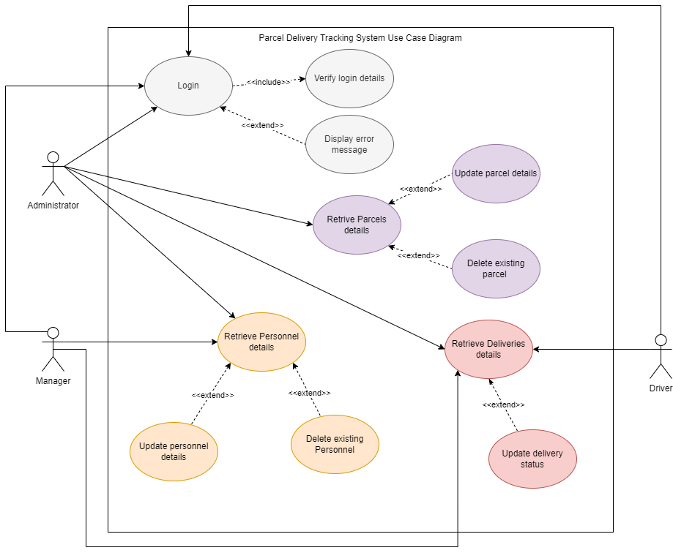

# System Features

## Functional Requirements

* **Parcel Management**: The system allows for the efficient management of parcels, capturing details such as sender and receiver information, parcel weight, and status (In Transit, Delivered, On Hold, Cancelled)
* **Client Management**: Client, whether businesses or individuals, can register and access the system. They can maintain their profiles, including contact information and relevant details.
* **User Authentication**: The system incorporates user authentication and role-based access control. Clients register as users with unique usernames and passwords, allowing them to log in to access their accounts and request parcel deliveries.
* **Parcel Tracking:** Clients can request parcel deliveries by providing parcel details. They can track the status of their parcel in real-time
* **Delivery Management:** The system assigns delivery personnel based on availability. Delivery personnel update the delivery status as they complete deliveries or encounter issues.

## Non-Functional Requirements

* **Security**: The system incorporates user authentication and authorization and role-based access control.
* **Monitoring and Logging**: The system log relevant events, errors, and user activities for auditing and troubleshooting purposes.
* **Data Integrity:** Data stored in the application database should maintain its accuracy, and consistency.

### Security Log in

|  |  |  |  |  |
| --- | --- | --- | --- | --- |
|  | Security |  |  |  |
|  |  | Username | Password | Role |
|  | Admin | AdminOne | Admin123 | Administrator |
|  | Manager | ManagerOne | Manager123 | Manager |
|  | Driver | DriverOne | Driver123 | Driver |

### User Registration and Login

|  |  |
| --- | --- |
| Registration | Login |
| {  "userName": "LorrySmith",  "email": "Smith.Lorry@gmail.com",  "password": "Lo@134Sm",  "firstName": "Lorry",  "lastName": "Smith",  "role": "Administrator"  } | Login  {  "userName": "LorrySmith",  "password": "Lo@134Sm"  } |

## Technology Stack

|  |  |  |
| --- | --- | --- |
| Backend |  |  |
|  | Technology | Package and Version |
|  | Programming language | C# |
|  | ORM Framework | Entity Framework 6.4.4 |
|  | Authentication Middleware | Microsoft.AspNetCore.Authentication.JwtBearer 6.0.1 |
|  | Identity Framework | Microsoft.AspNetCore.Identity.EntitFramework 6.0.1 |
|  | Identity UI | Microsoft.AspNetCore.Identity.UI 6.0.1 |
|  | Database ORM | Microsoft.EntityFrameworkCore 6.0.1 |
|  | Database Design Tool | Microsoft.EntityFrameworkCore.Design 6.0.1 |
|  | Database Provider | Microsoft.EntityFrameworkCore.SqlServer 6.0.1 |
|  | EF Tools | Microsoft.EntityFrameworkCore.Tools 6.0.1 |
|  | Code Generation Design | Microsoft.VisualStudio.Web.CodeGeneration.Design 6.0.1 |
|  | API Documentation | Swashbuckle.Asp.NetCore 6.2.3 |
|  | JWT Token Management | System.IdentityModel.Token.Jwt 6.15.1 |

|  |  |  |  |
| --- | --- | --- | --- |
| Frontend |  |  |  |
|  | Technology | Package and Version | Path |
|  | Web Technologies | ASP.NET MVC, JavaScript, HTML, and CSS |  |

|  |  |  |
| --- | --- | --- |
| Database |  |  |
|  | Technology | Package and Version |
|  | Microsoft SQL Server Management Studio |  |

|  |  |  |
| --- | --- | --- |
| Testing |  |  |
|  | Technology | Package and Version |
|  | In-Memory Db Testing | Microsoft.EntityFrameworkCore.InMemory 7.0.11 |
|  | Unit Testing Framework | Nunit 3.13.3 |
|  | Testing SDK | Nunit3TestAdapter 4.2.1 |
|  | Nunit Analyzer | Nunit.Analyzer 3.3.0 |
|  | XUnit Testing Framework | Xunit 2.4.2 |

# API Swagger Endpoint List

## Parcel Information Endpoints

|  |  |  |  |
| --- | --- | --- | --- |
| 1 | HTTP Method | Endpoint: Parcels | Description |
|  | GET | https://localhost:7200/api/Parcels | Get all the parcels |
|  | POST | https://localhost:7200/api/Parcels | Post Parcel |
|  | GET | https://localhost:7200/api/Parcels/1 | Get a Parcel by ID. Return Parcel |
|  | PUT | https://localhost:7200/api/Parcels/17 | Put parcel by id. Returns the updated parcel details |
|  | DELETE | https://localhost:7200/api/Parcels/17 | Delete a parcel by Id. Delete parcel Id |
|  | GET | https://localhost:7200/api/Parcels/Delivered | Get all the parcels with a parcel status “Delivered” |
|  | GET | https://localhost:7200/api/Parcels/InTransit | Get all the parcels with a parcel status “In Transit” |
|  | GET | https://localhost:7200/api/Parcels/OnHold | Get all the parcels with a parcel status “On Hold” |
|  | GET | https://localhost:7200/api/Parcels/3/parcels | Get all the parcels for a specific sender, by using the sender Id |

## Personnel Information Endpoints

|  |  |  |  |
| --- | --- | --- | --- |
| 1 | HTTP Method | Endpoint: Personnel | Description |
|  | GET | https://localhost:7200/api/Personnel | Get all the Personnel |
|  | POST | https://localhost:7200/api/Personnel | Post new Personnel |
|  | GET | https://localhost:7200/api/Personnel/18 | Get a Personnel by ID. Return Personnel |
|  | PUT | https://localhost:7200/api/Personnel/18 | Put Personnel by id. Returns the updated personnel details |
|  | DELETE | https://localhost:7200/api/Personnel/18 | Delete Personnel by Id. Delete Personnel with ID 18 |
|  | GET | https://localhost:7200/api/Personnel/fullname?firstName=Mark&lastName=tomalson | Get a Personnel by first and last name. Returns Mark Tomalson |
|  | GET | https://localhost:7200/api/Personnel/offduty | Get all Personnel on duty |
|  | GET | https://localhost:7200/api/Personnel/offduty | Get all Personnel off duty |

## Delivery Information Endpoints

|  |  |  |  |
| --- | --- | --- | --- |
| 1 | HTTP Method | Endpoint: Personnel | Description |
|  | GET | https://localhost:7200/api/Deliveries | Get all the Deliveries |
|  | GET | https://localhost:7200/api/Deliveries/9 | GET a Delivery by Id |
|  | PATCH | https://localhost:7200/api/Deliveries/9 | PATCH Delivery by Id. Update the personnel and delivery status |
|  | GET | https://localhost:7200/api/Deliveries/InProgress | Get all Deliveries with a delivery status “Progress” |
|  | GET | https://localhost:7200/api/Deliveries/Completed | Get all Deliveries with a delivery status “Completed” |
|  | GET | https://localhost:7200/api/Deliveries/Scheduled | Get all Deliveries with a delivery status “Scheduled” |
|  | GET | https://localhost:7200/api/Deliveries/1/deliveries | Get all Deliveries for a specific personnel |

# Wireframe

## Home Page

The home page serves as the entry point for users. It provide a welcoming and intuitive interface with easy access to essential features and information.

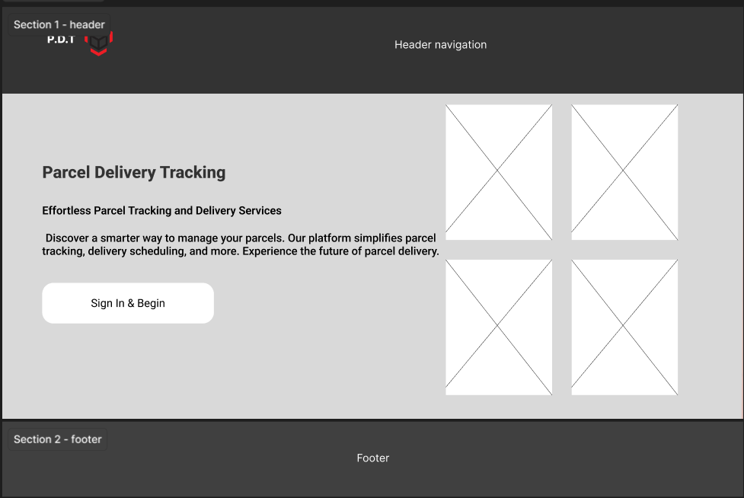

## Admin Page

This page is accessible only to administrators and provides tools for user management and system administration.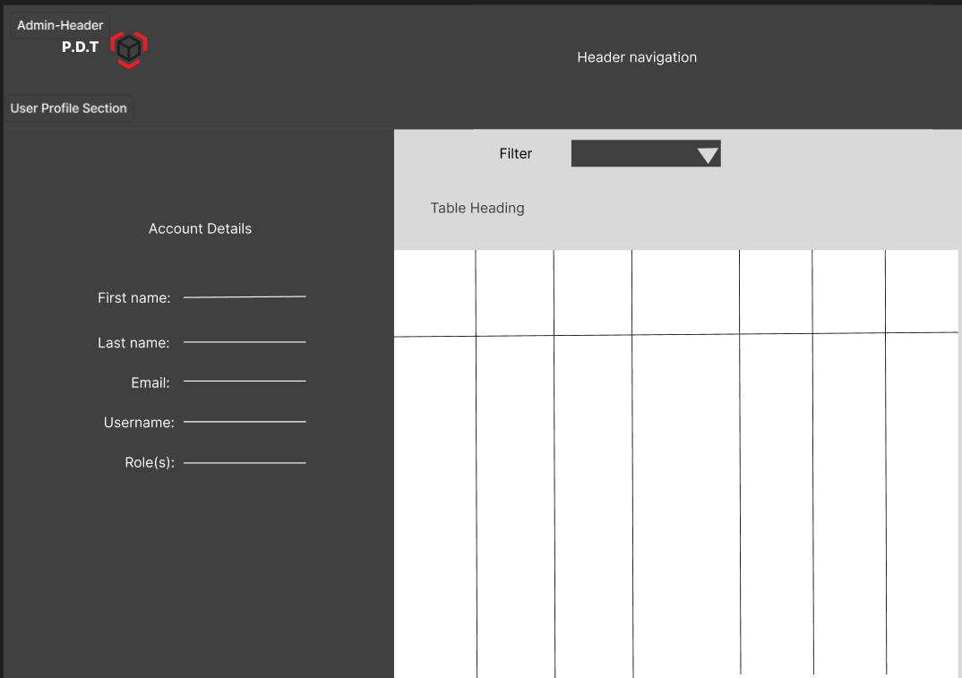

## Driver page

This page is accessible only to drivers and provide tool for driver such as updating the status of a delivery and view all the deliveries associated to a driver.

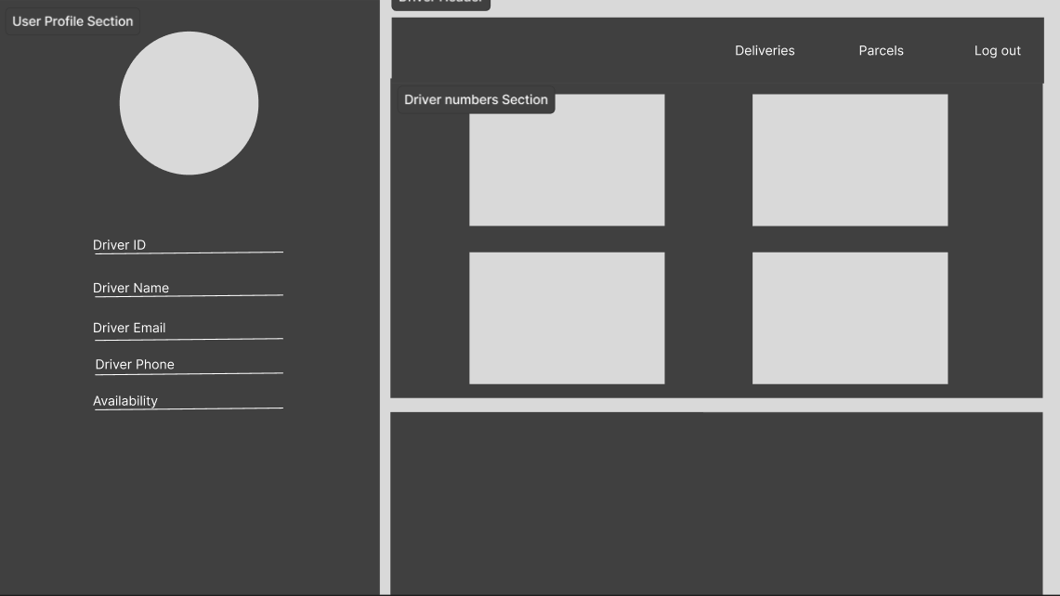

## Log in and Registration Page

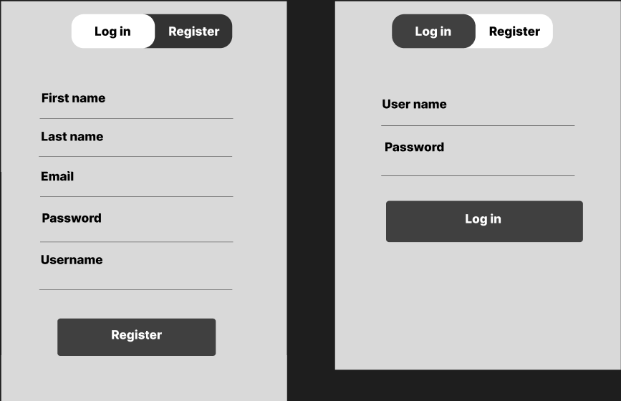

# Lesson Learned

* I learned how to build a full stack application – using the Model-view-controller pattern
* Serialization: I learned how to serialize and deserialize object to and from JSON
* Role-Based Redirections: Redirecting users based on their roles after login
* Code organization using Areas