## DC Jack

The PCB requires 12VDC and can be powered by either a DC barrel jack or a USB C connector via Power Delivery (PD).

## USB-C Connector

The USB C receptacle is connected to a PD chip allowing for 12VDC on the USBC_VBUS line. A selector switch is present to manually choose powering the PCB via the USB or via the barrel jack. Note that there are two switches in the package; only the upper one is used.

## USB ESD Protection

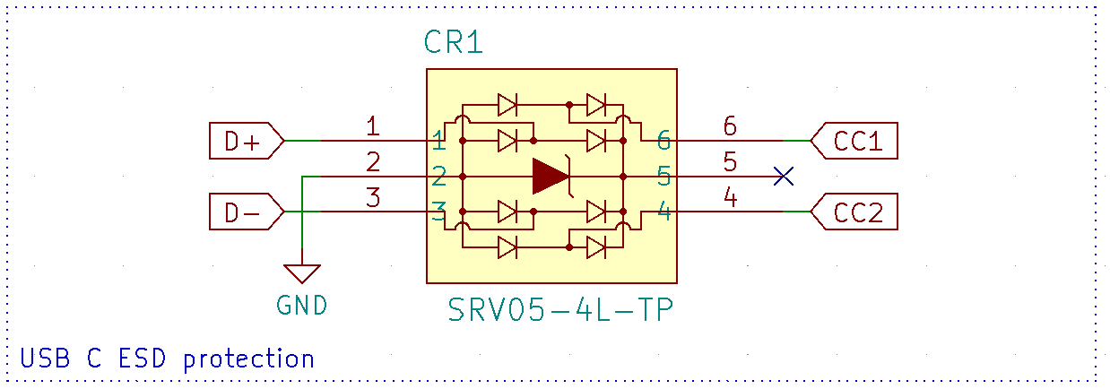

This component exists to prevent any ESD spikes from damaging downstream hardware. While it looks like a series element, the chip is just several TVS diodes connected to GND.

## USB C PD Controller

The PCB has an I2C controlled PD controller to negotiate USB voltage. The INT_N pin is used to signal to the microcontroller to read the I2C register bits. Note that there are no pullups on the I2C lines; the microcontroller will enable these in software.

