Internal report - Shopping malls

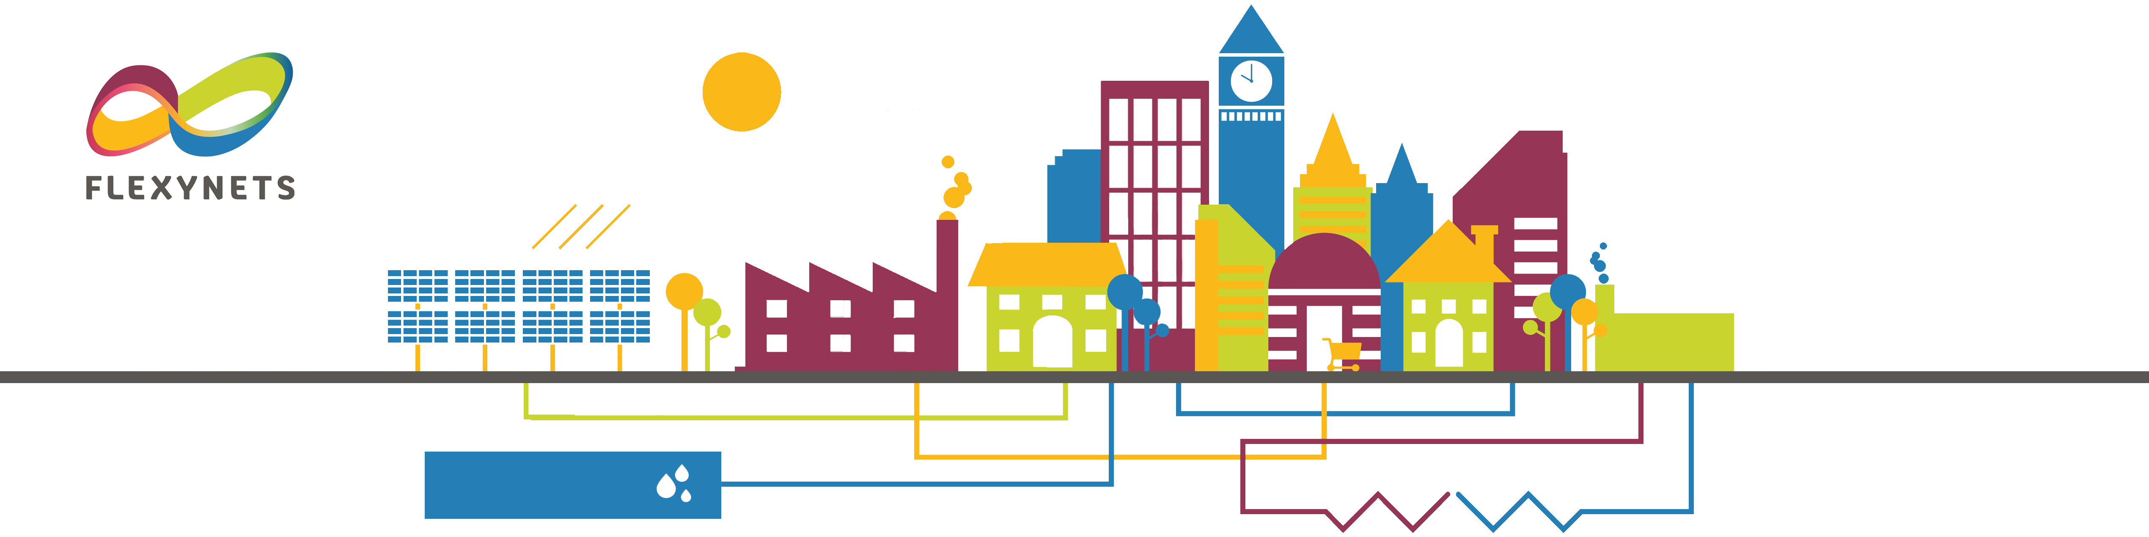

**Fifth generation, low temperature, high exergy district heating and cooling networks**

**FLEXYNETS**

**Project Title:** Fifth generation, low temperature, high exergy district heating and cooling networks

**Project Acronym**: FLEXYNETS

**Document Title**:

Internal report – Shopping malls

Dissemination Level: RE

Lead beneficiary: EURAC

**Marco Cozzini, EURAC**

**Date:** 08 May 2017

This document has been produced in the context of the FLEXYNETS Project.

This project has received funding from the European Union’s Horizon 2020 research and innovation programme under grant agreement No. 649820. The European Commission has no liability for any use that may be made of the information it contains.

Table of Contents

1 Summary 1

2 Introduction 1

3 Estimates 1

4 Literature references 7

# Summary

Notes about consumption and waste heat profiles for shopping malls.

# Introduction

The purpose of this document is to report the background related to the shopping mall profiles used for simulations in FLEXYNETS.

The main issue is related to the evaluation of their waste heat profiles. In order to build a reasonable scenario for FLEXYNETS, one should:

* Assess the amount of low-temperature waste heat sources. Shopping malls represent a major candidate in this context.
* Assess the time profile of these sources.

The adopted approach is the following:

* Try to assess the typical number and size of shopping smalls.
* Try to assess the typical energy consumptions of shopping malls.
* Try to assess the typical time profile of energy consumption.
* Try to assess the amount of recoverable energy.
* Try to assess its potential impact on the residential energy demand.

Note that the number of shopping malls per city is interesting for the estimation of the possible FLEXYNETS overall impact. However, single networks could be located just close to a single shopping mall, thereby exploiting a share of low temperature heat much higher than the typical city average.

Concerning the impact for FLEXYNTS in general, some other comments are in order:

* Waste heat from shopping malls could be in large part reused internally. In this case, the waste heat fraction available for district heating (DH) would be reduced [Kristensen, 2017].
* The phasing out of several currently used refrigerants (due to their global warming potential) is expected to increase the use of CO2 heat pumps. These heat pumps have a rather high condensing temperature, which could be directly coupled to traditional (or at least 4th generation) DH.

# Estimates

In this section, the above points are considered one by one. This analysis is focused on shopping malls (centres including different types of shops) rather than on supermarkets, though from the point of view of heat recovery also small/independent food shops could be of interest. In practice, the estimated overall amount of waste heat is expected to be a subset of the available one.

For completeness, it is useful to recall the typical shopping mall classification according to the International Council of Shopping Centers (ICSC) [RSE, 2011][CommONEnergy D2.1, 2104]:

* Small shopping mall: 500020000 m2 of gross leasable area (GLA).
* Medium shopping mall: 2000040000 m2 of GLA.
* Large shopping mall: 2000080000 m2 of GLA.
* Very large shopping mall: > 80000 m2 of GLA.

One category is typically added, namely:

* Neighbourhood centre: < 5000 m2 of GLA.

For the Italian data retrieved from [RSE, 2011], also neighbourhood centres are included. They represent however only 3 % of the considered GLA. Consequently, the average figures can be considered fairly representative of the Italian shopping mall sector, in spite of the inclusion of shops outside of the strict shopping mall classification.

The following analysis will not distinguish between the above typologies of shopping malls and will only provide average figures.

* Try to assess the typical number and size of shopping smalls. In principle, this could differ depending on the settlement typology. It is however difficult to get detailed data about this point. It is however possible to get general data about the number of square meters per inhabitant (m2/inhab). In this way, one can get a rough estimate of the total amount of shopping mall area in a city. An Italian survey [RSE, 2011] reports an average shopping mall density of about 0.3 m2/inhab. Depending on the settlement typology, one could try to vary this value on a common sense basis (shopping malls are typically not located in the city centre).
* Try to assess the typical energy consumptions of shopping malls. These consumptions differ depending on the actual type of shops included in the mall. It is however possible to rely on general statistic about shopping mall composition. According to the CommONEnergy project [CommONEnergy D2.1, 2104], one has that:
  + Food shops exhibit much larger energy consumptions than other shop types, due to refrigeration. From the point of view of waste heat, they provide the most interesting application. Food shops cover on average a fraction = 20 % of the GLA of shopping malls. In food shops, about 50 % of the consumptions are due to refrigeration, 25 % to lighting, 20 % to HVAC (of which about 25 % is used for ventilation), 5 % to other needs (e.g., lifts). The overall consumption is in the range 5001000 kWh/(m2a). Consequently, the refrigeration consumption (electric only) is of the order of 250500 kWhe/(m2a). The cooling consumption can vary significantly, it can be basically zero in some regions, but it can reach 1015 kWhe/(m2a) in Mediterranean countries. It is anyway clear that cooling consumptions are much smaller than refrigeration ones (moreover they exhibit much more seasonality).
  + In other shops refrigeration is absent, they are otherwise more or less similar to food shops. Therefore, one has that 50 % of energy consumptions are due to lighting, 40 % to HVAC, 10 % to other needs. The overall consumption is typically of the order of 250 kWh/(m2a).
* Try to assess the typical time profile of energy consumption. Some hypothetical profile is provided by JRC [JRC, 2013], see Figure 1. Qualitatively, one has that refrigeration consumptions are rather constant (with a small difference between day and night). Conversely, HVAC and especially lighting consumptions have a strong difference between day and night. Open (or at least occupancy) hours are typically in the range 12-16 hours. While it would be recommendable to modulate HVAC consumptions according to occupancy, in practice this is typically not done. Therefore, one can assume the following:
  + 12 occupancy hours, from 8:00 to 20:00.
  + Refrigeration. Constant load equal to peak load during occupancy hours, reduction of 20 % during closing hours. See however also Figure 2 and Figure 3 [Bacher, 2013].
  + Lighting. Constant load equal to peak load during occupancy hours, no load during closing hours.
  + Heating and cooling. Constant load driven by daily average outdoor temperature during occupancy hours, reduction of 50 % during closing hours.
  + Ventilation. Constant load equal to peak load during occupancy hours, no load during closing hours.
* Try to assess the amount of recoverable energy. Some data are available, but it is difficult to get a general overview. Refrigeration systems seem to have a COP (for waste heat) of the order of 35 depending on the return temperature. For FLEXYNETS temperatures, an average COP of 4 seems to be easily achievable (probably, even 5 is realistic). Cooling systems have a rather low COP (e.g., in the range 22.5) when using air-based HPs, but they could again reach a COP of 4 in a FLEXYNETS application. Concerning the fraction of recoverable energy with respect to the available waste energy, , a common-sense approach could be to adopt a sensitivity analysis for at least three scenarios:
  + Optimistic scenario. In this case, one assumes that 90 % of the current estimated waste heat coming from refrigeration and cooling can be recovered (100 % of heating can be assumed to be covered by DH).
  + Average scenario. In this case, one assumes that 50 % of the current estimated waste heat coming from refrigeration and cooling can be recovered (100 % of heating can be assumed to be covered by DH).
  + Conservative scenario. In this case, one assumes that 10 % of the current estimated waste heat coming from refrigeration and cooling can be recovered (100 % of heating can be assumed to be covered by DH).

From an energy balance point of view, one can conclude the following:

* The residential heating consumption is of the order of 100 kWh/(m2a). Assuming an average dwelling occupancy of 0.025 inhab/m2 (i.e., 2.5 inhabitants for a dwelling of 100 m2; this is reasonable according to Eurostat data), one gets 4000 kWh/(inhaba). This of course depends on the geographical zone and on the building type. Similarly, one can estimate cooling consumptions, which for Mediterranean countries (e.g., Italy) can be of the order of 10 % of heating consumptions (as thermal energy).
* As reported above, refrigeration consumptions are much higher than cooling ones (about 20 times). On the other hand, refrigeration is present only in food shops, which cover roughly 20 % of shopping mall GLA. Taking into account only this fraction of waste heat, one gets 20 % 500 kWh/(m2a) 50 % 4 = 200 kWh/(m2a). One then can apply different recovery factors, according to the above scenarios: = 90 %, 50 %, 10 %. At 90 % recovery one gets 180 kWh/(m2a) and converting into consumptions per inhabitant with = 0.3 m2/inhab one gets 600 kWh/(inhaba). This is 15 % of the above residential consumptions. Note that however, while refrigeration consumptions are rather constant during the year, residential heating consumptions are concentrated in winter. A seasonal storage would hence be needed to reach this high recovery factor. At 50 % recovery one would get 100 kWh/(m2a) = 333 kWh/(inhaba), which is about 8 % of the above residential consumptions. Finally, at 10 % recovery one would get 20 kWh/(m2a) = 67 kWh/(inhaba), which is about 1.7 % of the above residential consumptions.

Of course, for small thermal grids located nearby shopping malls this share could be higher.

The considered variables are reported in Table 1.

Table 1. Some variables and reference values found in the literature. Strong variability to be expected..

|  |  |  |  |
| --- | --- | --- | --- |
| **Variable description** | **Symbol** | **Unit** | **Ref. value** |
| Recoverable fraction |  | % | 10/50/90 |
| Shopping mall density |  | m2/inhab. | 0.3 |
| Food shop fraction |  | % | 20 |
| Food shop overall specific consumptions |  | kWh/(m2a) | 500 |
| Other (non-food) shop overall specific consumptions |  | kWh/(m2a) | 250 |
| Refrigeration electric consumption fraction in food shops |  | % | 50 |
| HVAC electric consumption fraction in food shops |  | % | 10 |
| Refrigeration electric consumption fraction in other shops |  | % | 0 |
| HVAC electric consumption fraction in other shops |  | % | 20 |
| Ventilation/HVAC consumption fraction |  | % | 40 |
| Heating/HVAC consumption fraction |  | % | 40 |
| Cooling/HVAC consumption fraction |  | % | 20 |
| Refrigeration COP |  | a.u. | 4 |
| Cooling COP |  | a.u. | 4 |

The calculation formula for the recoverable specific waste heat is reported in Eq. 1:

(1)

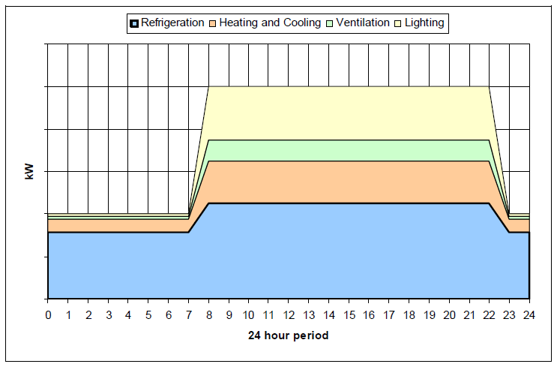

Figure 1. Hypothetical daily consumption of a representative European food retailer store [JRC, 2013].

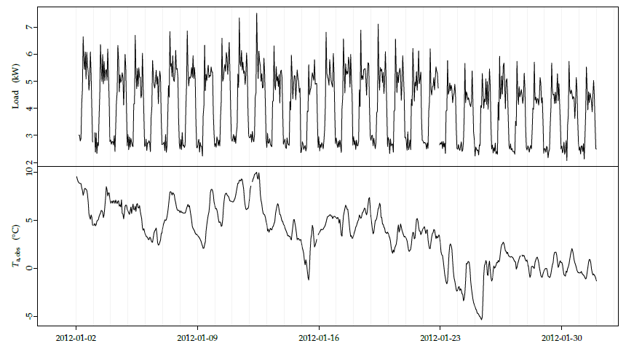

Figure 2. Example of time series (load and temperature) for winter (January, Denmark), taken from [Bacher, 2013].

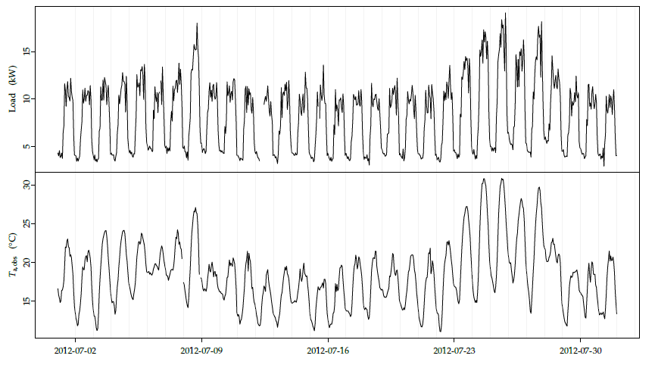

Figure 3. Example of time series (load and temperature) for summer (July, Denmark), taken from [Bacher, 2013].

# Literature references

* Bacher, 2013. P. Bacher, H. Madsen, and H. Aalborg Nielsen, “Load forecasting for supermarket refrigeration”, DTU Compute (Technical Report; No. 2013-08).
* CommONEnergy D2.1, 2014. CommONEnergy, Deliverable 2.1, “Shopping malls features in EU-28 + Norway”.
* JRC, 2013. JRC, “Best Environmental Management Practice in the Retail Trade Sector. Average consumptions and hypothesis of load profiles”.
* Kristensen, 2017. T. F. Kristensen, L. F. S. Larsen, J. E. Thorsen, “Integration of the hidden refrigeration capacity as heat pump in smart energy systems”, Heat Pump Conference 2017, Rotterdam.
* RSE, 2011. RSE, Report RdS/2011/161, "Determinazione dei fabbisogni e dei consumi energetici dei sistemi edificio-impianto. Caratterizzazione del parco immobiliare ad uso centro commerciale".

*This shall be the last line in the document, on the last page! Don’t erase it: it will not be printed to the pdf, but it contains the* *bookmark that marks the page numbering.*