Dear Intern

Project report is an inherent component of your internship. We are enclosing a reference table of content for the project report. Depending on the internship project (IT/Non-IT, Technical/Business Domain), you may choose to include or exclude or rename sections from the table of content mentioned below. You can also add additional sections. The key objective of this report is for you to systemically document the project work done.

|  |  |
| --- | --- |
| Internship Project Title | TCS iON RIO-125: Functional Testing using Selenium WebDriver |
| Name of the Company | TCS iON |
| Name of the Industry Mentor | Debashis Roy |
| Name of the Institute | ICT Academy,Kerala |

|  |  |  |  |  |
| --- | --- | --- | --- | --- |
| Start Date | End Date | Total Effort (hrs.) | Project Environment | Tools used |
| 03-01-2023 | 01-02-2023 | 125 | Eclipse IDE | Selenium WebDriver |

Prepared By: Lesitha Puthussery

**TABLE OF CONTENT**

**1)Acknowledgements**

* Firstly, I am thankful to the ICT Academy of Kerala, for providing me the opportunity to do a one-month virtual internship under TCS iON as part of a Certification course in Software Testing.
* Secondly, I would also like to thank TCS Digital Learning Hub for providing a Virtual Internship program to students who are aspiring to make a career in the IT industry. It was a great opportunity that helps me to experience an Industry working atmosphere as well as a great chance for learning.
* As I developed my internship project on “***Functional Testing using Selenium WebDriver”*** I have been fortunate to receive assistance, suggestions and support from numerous friends and faculty.
* I would also like to thank Industry mentor **Mr.Debashis Roy & Community Admin,** I express my willing of his immense gratitude for his guidance and kind help.I take this opportunity to thank all my friends who were of great help in the process of completion of this project.

**2)Objective**

Develop automated functional testing using Selenium WebDriver with the following objectives

* Perform automated functional testing on the site <https://phptravels.com/demo/> available on public domain.
* Design the functional testing project using java-based Selenium WebDriver API.
* End to End functional testing need to be performed on all web elements and appropriate test design and test case templates need to be populated with defect log.

Automation Testing is a technique in software testing which makes use of Test Automation Tools for executing a test case suite. The Test Automation Framework is so designed that it feeds data into the system and compares the actual outcome with the expected result, followed by generating a detailed test report. Regression Tests that are essentially repetitive in nature are usually automated.Development cycles that run in a successive manner involve the execution of the same test suite in a repeated manner. An Automation Testing Tool can help in recording this test suite and re-playing it as and when required. Automation of the test suite removes the need for human intervention. The objective of Automation Testing is to lessen the number of test cases that are required to be executed manually and not necessarily to be a replacement for Manual Testing.

**3)Introduction**

• PHPTRAVELS is an online reservations solution that acts as your work of travel platform. It functions as a combination of both booking and reporting programs and can work on any device. With it, you can make pages for content and travel guides.

• PHPTRAVELS is an international travel technology company and it serve travel companies from 50 countries across four continents.

• PHPTRAVELS platform is powered by 70+ suppliers across flight, hotels, car, sightseeing, vacations and other ground services. It provides strong distribution capabilities - B2B/B2C / B2B2C, automate travel business process, powerful back-office system, flexible content management system and feature a unique standardization element.

• PHPTRAVELS develop and enable access to extensive range of travel suppliers which includes all GDS, LCCs, 200000+ Hotels, 25000+ Packages, 30000+ Car rental locations, Cruises, Eurail, Bus, Insurance and tours and travel experiences worldwide.

• Once PHPTRAVELS is installed, no programming skills are required to manage settings. Below you'll find features being used by our software.PHPTRAVELS has entirely built and automated modules which are specific for online travel business. PHPTRAVELS has been meticulously designed for hotels, tours, vacations, car rental, cruises, travel agencies, restaurants, apartments, villas, bungalows and rooms where online bookings are the key element to give momentum to the business. Moreover, PHPTRAVELS comes with packs in many essential features. which are described below.

The site has 4 parts to test like

• Customer Front End

• Agent Front End

• Admin Back End

• Supplier Back End

In this project we need to develop java-based code for automation testing that would test all components like an actual user and create reports in template accordingly. The automated functional test would be controlled by Test Design, Test Scenario and Test cases which needs to be developed as part of the project and would be an important component of the deliverables of this project.

First, I understood the functionalities provided under all the 4 modules. Then I performed Exploratory Testing on the “PHP Travels” website and understood the workflow as well as the functionalities of each module. Later started to analyze the given Software Requirement Specification Document of each module specified under the Industry Project section and started identifying Test Scenarios based on the “SRS Functionalities”. With the analyzed Test Scenarios, I created the documents required like, “Test Design, Test Scenario, Test Cases” which will be one of the deliverables of our project.”

Based on the Test Cases, I started to perform Automation Testing on each requirement specified in SRS, by writing scripts using Selenium WebDriver, TestNG, and Maven. After performing the Automation Testing on each Test Case, I analyzed the actual result with the expected result, and based on that I started to create a Test Report to define the status of all the Test Cases as well as to report bugs of the failure Test Cases.

Project Document includes:

• Test Design Document

• Test Scenario Document

• Test Case Document

• Test automation Scripts

• Test Deliverables etc.

**4)Description of Internship**

• As per the day wise plan spending time for self-learning and industry project

• Daily Activity reports are submitting

• Covered milestone 1 by 07/01/2023

• 1)Test case

2)Test Design

3)Test Scenario

• Started to work on automation scripts

• Completed automation Of Customer module

• Completed automation of Agent module

• Completed automation of admin module

• Completed automation of supplier module

• Covered milestone 2 by 17/01/2023

• Started working on Project related documents

1) Created Interim Report 1 and 2

2) Attended Project Test

3) Developed Defect Report

4) Submitted all daily activity Report

•Finally uploaded all the documents, automation scripts, and video onto GitHu

**5)Internship Activities**

1)Daily Activity reports are submitted

2) Created Interim Report 1 and 2

3) Attended Project Test

4) Developed Defect Report

5) Submitted all daily activity Report

6) Finally uploaded all the documents, automation scripts, and video onto GitHub

**6)Approach / Methodology**

PHP Travel website has 4 modules

1)Customer Module

2)Agent Module

3)Supplier Module

4)Admin Module

For Automation of these 4 modules I have been followed Data Driven Framework.

DATA DRIVEN FRAMEWORK

• Data Driven framework is used to drive test cases and suites from an external data feed. The data feed can be data sheets like xls, xlsx, and csv files.

• Data driven framework has more test coverage, reusable features and is easy to maintain. Test execution can be triggered by only modifying the test data. Since the test logic and data are separated from each other, there is no effect on modifying the data.

• Data driven framework development requires skilled programming knowledge. The test case gets the required input data from the external resources like excel, csv, txt, xml and so on files and holds them in a variable as a key value pair.

The advantages of data driven framework are listed below –

• Reduces the number of test scripts that need to be developed since data in multiple combinations can be used to cover the scenarios.

• Any modification in test data input does not require any code changes.

• Scalable and easy to maintain.

• More than one set of data in more than one combinations can be used to test any functionality.

There are numerous steps involved in the automated functional testing of a web app, such as:

• Determining the functional components of the web app that needs to be tested, which includes basic usability, accessibility, main functions of the application, and error conditions.

• Creating the input data for functionality testing after determining the main components of testing.

• Determining the expected outcome for the functionality based on the input data.

• Executing test cases that are created for functional testing.

• Comparing the output results with the expected results, and if the outcome is similar to expected results, then your functional testing is successful.

Identifying WebElements

All web pages consist of elements like textbox, checkbox, radio button, dropdowns, etc. These elements are known as web elements. To interact with these elements or to perform any operation(action) like writing in a text box or selecting a checkbox or selecting an option from a drop-down etc. they need to be identified or located first. To identify these elements, Selenium provides eight Identifier or locators.

It is essential to identify these web elements uniquely.

● Locators or Identifiers in Selenium:

There are different strategies for locating elements on a page, and some are certainly better than others. Selenium provides us eight types of locators or Identifiers which are as follows:

• Id

• Name

• Class Name

• Tag Name

• Link Text

• Partial Link Text

• CSS

• XPath

**6.1.Test Scenario & In Scope**

|  |  |  |
| --- | --- | --- |
| Module Name | Scenarios (In Scope) | Testing |
| Customer Front-End | •Login Functionality.  •Links verification – “My Bookings, Add Funds, My profile & Logout”.  •Voucher Displaying Functionality – to know the booking invoice & status.  •Profile - Address Updating Functionality  •PayPal Payment Functionality -Manual | Automation |
| Agent Front-End | •Login Functionality.  •Links verification – “My Bookings, Add Funds, My profile & Logout”.  •Links verification – “Home, Hotel, Flight, Tour, Visa, Blog, Offer”.  •Search Hotel Functionality.  •Currency Changing Functionality – USD to INR | Automation |
| Admin Back-End | •Login Functionality.  •Test the Bookings & display of Booking Invoice where payment is Successful.  •Script to delete a record having booking status as canceled.  •Script to change the booking status from “Pending to Confirmed” and verify the count in the Dashboard.  •Verifying the Website link. | Automation |
| Supplier Back-End | •Login Functionality.  •Checking the Dashboard view.  •Verifying the text “Sales overview & Summary”.  •Revenue Breakdown.  •Script to change the booking status from “Pending to Confirmed” and verify the count in the Dashboard.  •Checking the modules – Flights, Visa, Tours, Bookings | Automation |

**6.2.Test Strategy**

As per the requirements specified under project guidelines in the Industry Project, I need to perform “Functional Testing” of all the functionalities mentioned in the above Scope section. As part of Functional Testing, planning to do the following steps:

**Step 1:** **Creation of Test Scenarios & Test Cases** for different features in scope

• For that I have done Exploratory Testing.

• Identify the Test Scenarios & then write the Test Cases & Test designs.

**Step 2:** **Test Execution**

• **Writing Test Scripts** for each Test Case to perform Selenium WebDriver based automation

• **Performing: Functional Testing** on functionalities specified under the scope.

• Then will do “**End-to-End Functional Testing**” on all web elements to simulate the end-user flows.

**Step 3:** **Test Report** which includes the Bugs/ Defects, found while performing the functional testing.

* Assumptions

**7.Exceptions / Exclusions**

|  |  |  |
| --- | --- | --- |
| MODULE | TEST SCENARIO | REASON FOR EXCLUSION |
| Customer | Payment gateway | Testing only for dummy values |
| SUPPLIER | VISA MODULE | NOT PRESENT |
| SUPPLIER | FLIGHT MODULE | FLIGHT MODULE |
| SUPPLIER | BOOKINGS LINK | SHOWING ERROR |
|  |  |  |

**8.Challenges & Opportunities**

1**)Handling dynamic webelement**

One of the top challenges faced in Selenium automation is the handling of dynamic web content. Selenium solves for it using the explicit wait feature, where you specify a pre-defined time for the automation testing process to wait for new content to load.

**2)Synchronizing Events**

Sync issues are one of the primary reasons for our automation script failure. The sync issues may arise when we expect some event to occur. However, it might get delayed or might not happen due to some unknown reason, which further causes our test case to fail. For example, when we are running an automation script, just after launching the website, we expect a “accept/decline cookies” prompt to come up, but due to some reason, it got delayed, or it didn’t even occur. This type of synchronization becomes the reason for our test script failure.

To handle this, we generally use waits defined in Selenium like Implicit wait and Explicit wait.

**3)NoSuchElementException**

The NoSuchElementException is thrown when the locator being used to access the element is invalid or an attempt is made to perform action on an element which is not on the DOM. In either of the cases, the element would not be found.

To handle this Selenium exception, you should check whether the selector is correct and if it is correct, have an additional wait to ensure the appearance of the WebElement.

**4) Page not found error &error 524**

A 404 error is an HTTP status code that means that the page you were trying to reach on a website couldn't be found on their server. To be clear, the 404 error indicates that while the server itself is reachable, the specific page showing the error is not.

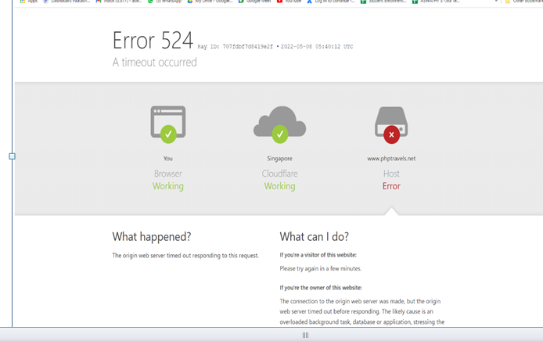

**9.Outcome / Conclusion**

**9.1.Screenshots**

1. **PayPal Button – Unable to locate & screenshot taken when assertion failed.**

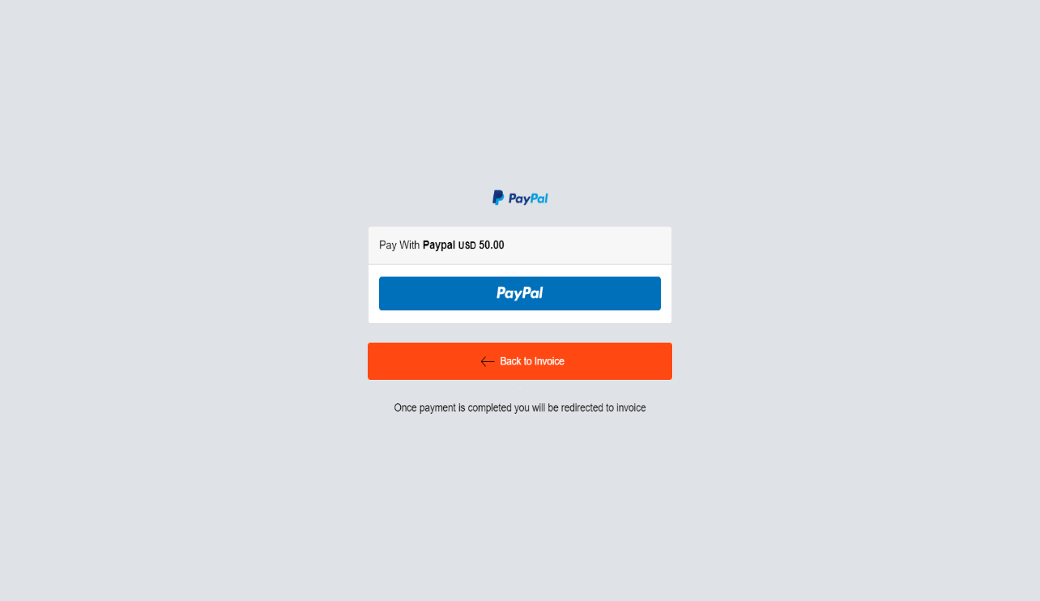

**b.Supplier Module – Missing “Flight Module”, screenshot taken when assertion failed.**

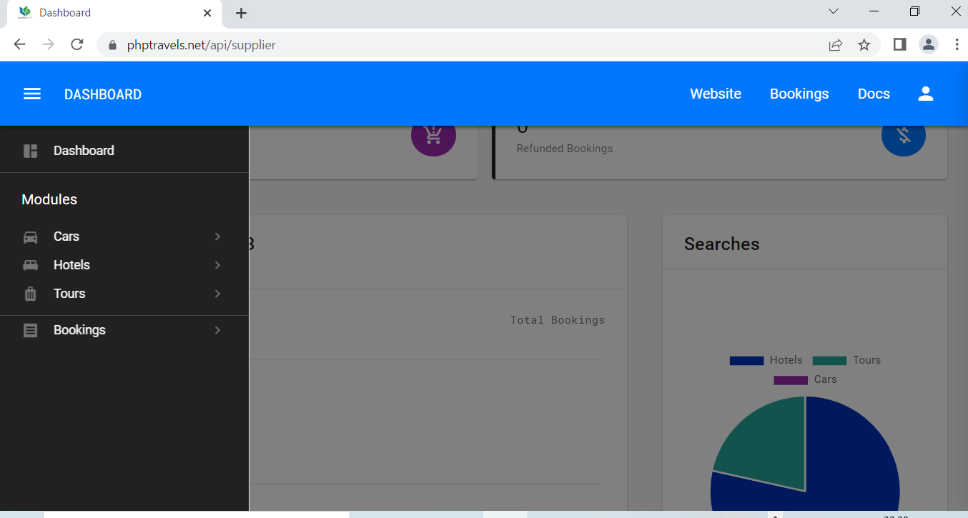

**c.Supplier Module – Missing “Visa Module”, screenshot taken when assertion failed**

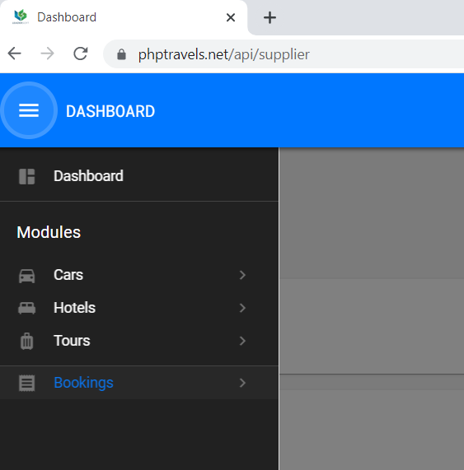

**d).Supplier Module – Bookings Page Error.**

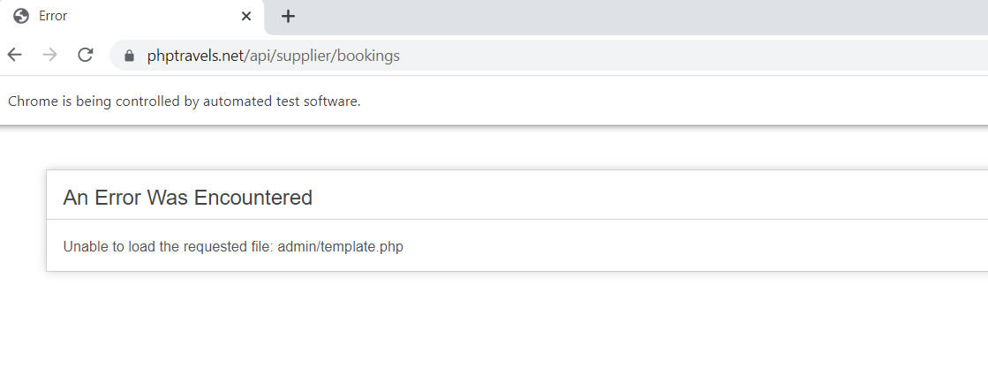

**9.2.Automation video**

[**https://drive.google.com/drive/folders/1JWU3yfIFFj_5AN6onjTHefvAfyiX4Ybw?usp=share_link**](https://drive.google.com/drive/folders/1JWU3yfIFFj_5AN6onjTHefvAfyiX4Ybw?usp=share_link)

**10.Link to code and executable file**

**10.1.TestReport**

**Drive Link**

[**https://docs.google.com/spreadsheets/d/1Fqby4niRYora9L460a5q2a9F-EaHryjD/edit?usp=share_link&ouid=111289771691796442493&rtpof=true&sd=true**](https://docs.google.com/spreadsheets/d/1Fqby4niRYora9L460a5q2a9F-EaHryjD/edit?usp=share_link&ouid=111289771691796442493&rtpof=true&sd=true)

**10.2.Test Design, Test Scenario & Test Case Document**

**Drive Link**

[**https://docs.google.com/spreadsheets/d/1roA_8PETDmN3dH_4GkgbPlCLKPg_Reqp/edit?usp=share_link&ouid=111289771691796442493&rtpof=true&sd=true**](https://docs.google.com/spreadsheets/d/1roA_8PETDmN3dH_4GkgbPlCLKPg_Reqp/edit?usp=share_link&ouid=111289771691796442493&rtpof=true&sd=true)

**10.3.** **Selenium WebDriver Automation Scripts**

**Drive Link**

<https://drive.google.com/drive/folders/1QH2t1ShkcRFlIjKUnsWQIHYDkf_DDGtw?usp=share_link>

**11.Recommendations**

Frequently getting 404 Error in project server

Whenever I opened my project server site(PHPTRAVELS | Travel Technology Partner - PHPTRAVELS) sometimes I am getting 404 error, so I need to restart the server then only the site will work.

**12.CONCLUSION**

My overall experience in my Internship at Tata Consultancy Services has been highly enriching. I have learned about the modular approach to Software Testing. This experience in the real world, outside the bounds of my books, has taught me a lot about what automation software testing truly is.