C++ Stock Analysis Program - Line by Line Explanation

These are preprocessor directives that include necessary C++ standard library headers:
- iostream for input/output operations
- fstream for file handling
- sstream for string streaming
- vector for dynamic arrays
- string for string manipulation
- limits for numeric limits
- iomanip for output formatting
- stdexcept for exception handling
- algorithm for algorithms like remove
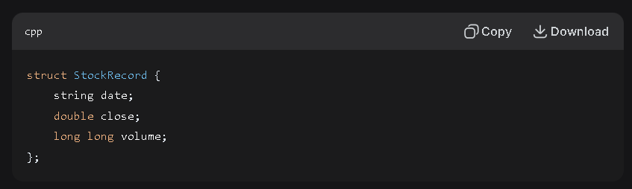
This defines a structure called StockRecord that groups together three pieces of data:
- date as a string
- close as a double for closing price
- volume as a long long integer for trading volume
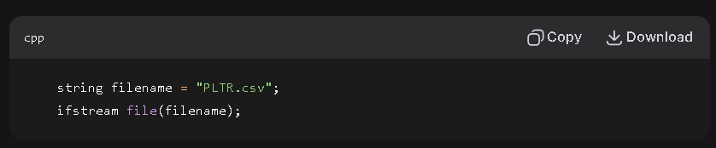
This creates a string variable called filename and an input file stream object that attempts to open that file.
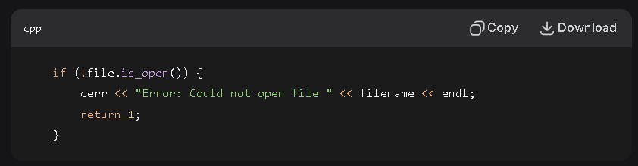
This checks if the file failed to open, prints an error message if it did, and returns 1 to indicate program failure.
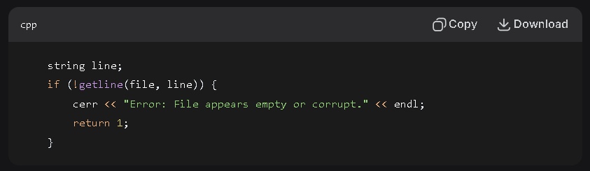
This reads and ignores the header line from the CSV file, checking if the file is empty.
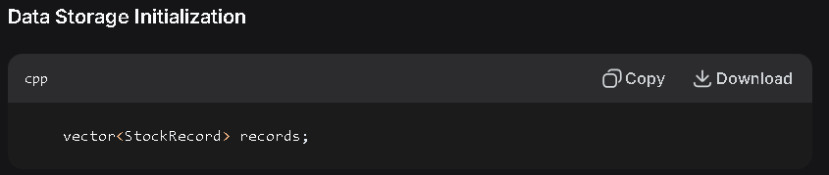
This creates an empty vector container that will hold StockRecord objects.
