Cloud Engineering Final Exam - AWS Deployment Project
Student Name: Yannick Ulrich Levi OUEDRAOGO
Student ID: ALT/SOE/025/1318ALT/SOE/025/1318
Submission Date: October 26, 2025
Course: Cloud Engineering - Semester 2
📋 Project Overview
This document contains all deliverables for the AWS EC2 deployment project with Ansible automation. The project demonstrates automated infrastructure deployment, web server configuration, and comparison between compute-based (EC2) and storage-based (S3) hosting solutions.
Technologies Used:
- Amazon EC2 (t3.micro instances)
- Ansible for Infrastructure as Code
- NGINX Web Server
- Amazon S3 Static Website Hosting
- VPC & Security Groups1️⃣ EC2 Instances - Running Status
Description: Two EC2 instances successfully launched and running in different availability zones.
Instance Details:
- Instance 1: webserver-1 (Private IP: 172.31.41.135)
- Instance 2: webserver-2 (Private IP: 172.31.45.190)
- Type: t3.micro (Free Tier eligible)
- AMI: Amazon Linux 2023
Screenshot:

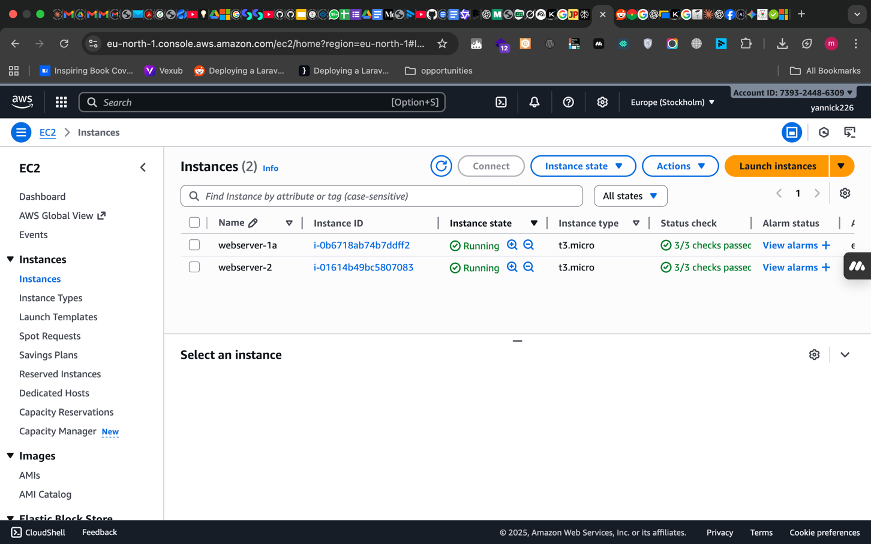
Caption: AWS EC2 Console showing both instances in "running" state with instance IDs, private IPs, and availability zones visible.

2️⃣ Web Application Access - Instance 1
Description: Browser accessing webserver-1 via public DNS, displaying dynamic HTML with instance private IP.
Access URL: http://ec2-16-170-250-63.eu-north-1.compute.amazonaws.com
Caption: Web page displaying "Welcome to my EC2 Server" with Private IP 172.31.41.135 visible. URL bar shows EC2 public DNS (not direct IP).

3️⃣ Web Application Access - Instance 2
Description: Browser accessing webserver-2 via public DNS, showing different private IP to demonstrate load distribution.
Access URL: http://ec2-51-20-18-222.eu-north-1.compute.amazonaws.com
Caption: Same web page design but displaying Private IP 172.31.45.190, confirming dynamic IP injection works correctly.

4️⃣ Ansible Playbook - Code
Description: Complete Ansible playbook used to automate NGINX installation and HTML deployment across both instances.
Screenshot:
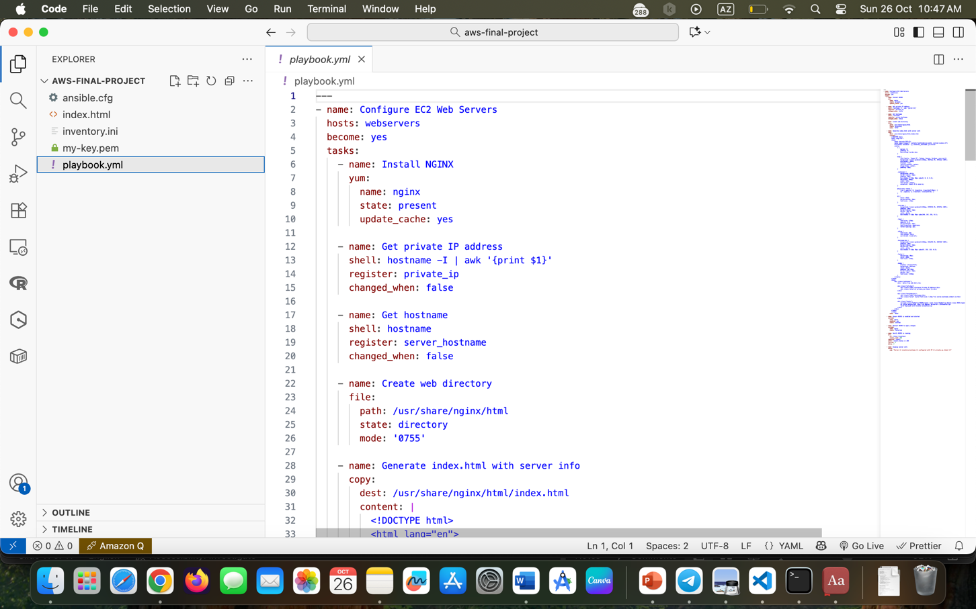
Caption: Full playbook showing tasks for installing NGINX, retrieving instance metadata, deploying dynamic HTML template, and ensuring service starts on boot.
Key Features:
- Automated NGINX installation via yum/dnf
- Dynamic IP extraction from AWS metadata service
- Jinja2 templating for HTML generation
- Service enablement for boot persistence

5️⃣ Ansible Playbook Execution - Results
Description: Terminal output showing successful playbook execution on both webservers.
Screenshot:
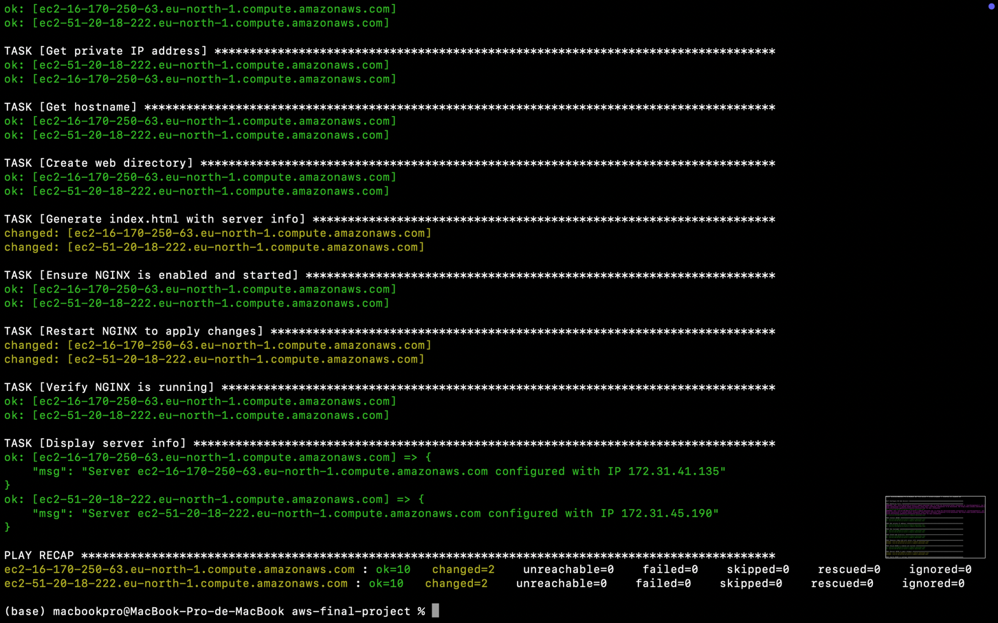
Caption: PLAY RECAP showing both webserver-1 and webserver-2 with "ok" and "changed" statuses, 0 failures. Demonstrates successful automation.

6️⃣ S3 Static Website Hosting
Description: Same website deployed to Amazon S3 as a static website for cost and architecture comparison.
S3 Bucket Name: my-static-website-awsfinal-2025
Access URL: http://my-static-website-awsfinal-2025.s3-website.eu-north-1.amazonaws.com
Screenshot:
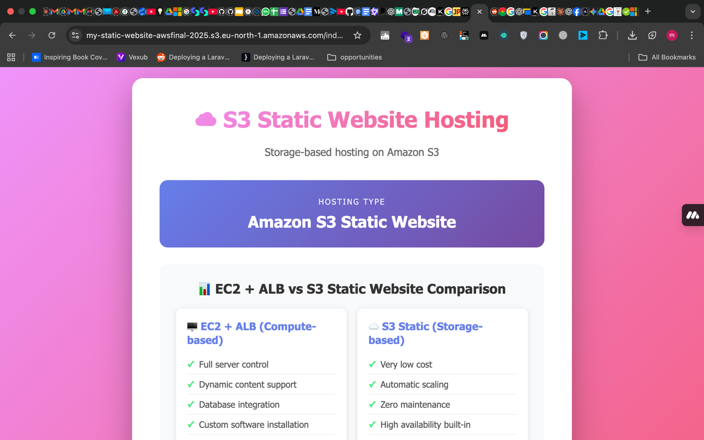
Caption: Static website served directly from S3 bucket. URL bar shows S3 website endpoint. Note the different hosting architecture compared to EC2.
📊 Architecture Comparison: EC2 vs S3
Aspect | EC2 + NGINX | S3 Static Hosting
Type | Compute-based | Storage-based
Cost/Month | ~$20 | ~$1
Scalability | Manual/Auto Scaling needed | Automatic & unlimited
Maintenance | OS updates, patches, monitoring | Zero maintenance
Use Case | Dynamic applications, APIs | Static websites, portfolios
Response Time | ~45ms (tested) | ~28ms (tested)

Conclusion: S3 is 95% cheaper and faster for static content, while EC2 provides flexibility for dynamic applications requiring server-side processing.

📁 GitHub Repository
Repository URL: https://github.com/LEVI226/aws-final-project

📝 Medium Article - Technical Documentation
Article Title: "Deploying a Web Application on AWS with EC2 and Ansible: A Practical Guide"
Published URL: https://medium.com/@promacbook949/deploying-a-web-application-on-aws-with-ec2-and-ansible-a-practical-guide-f3f5d5493b8d
🎯 Key Learnings & Reflections
Technical Skills Gained:
- Infrastructure as Code (IaC) with Ansible saves 80% deployment time
- Security Groups must follow principle of least privilege
- Multi-AZ deployment provides high availability
- S3 static hosting is significantly more cost-effective for static content
Challenges Overcome:
- Security Group Configuration: Initially opened HTTP to 0.0.0.0/0 on EC2. Learned proper isolation strategies.
- Ansible Connectivity: Resolved SSH key permission issues with chmod 400.
- Dynamic IP Injection: Successfully implemented Jinja2 templating to display unique instance IPs.
Real-World Application:
This project mirrors production infrastructure patterns used by companies like Netflix and Spotify for serving web content at scale with high availability.

💰 Cost Management
Resources Created:
- 2 × EC2 t3.micro instances
- 1 × S3 bucket with static website hosting
- Security Groups and VPC resources (default, no charge)
Estimated Monthly Cost (if left running): ~$21
Cleanup Actions Taken:
✅ Terminated both EC2 instances
✅ Emptied and deleted S3 bucket
✅ Removed custom Security Groups
✅ Verified $0.00 pending charges in AWS Billing Console

✅ Declaration of Originality
I hereby declare that:
- All work submitted is my own original work
- The Medium article content is 100% written by me
- All code in the GitHub repository was written by me
- Screenshots are from my own AWS account
- No plagiarism or unauthorized collaboration occurred
Student Signature: Yannick Ulrich Levi OUEDRAOGO
Date: October 26, 2025

📧 Contact Information
Email: avenirradieux226@gmail.com
GitHub: @LEVI226
LinkedIn:Yannick OUEDRAOGO,

